CHAPTER 4
RESULT AND DISCUSSION

4.1 EXPERIMENTAL SETUP AND TESTBED ENVIRONMENT
The practical efficacy of the PULSE PLATE system was rigorously validated through extensive field testing deployed at the main entrance gate of an educational campus in Coimbatore, Tamil Nadu. The hardware testbed comprised an industrial HD camera mounted at an elevation of 2.8 meters with an approach angle of 25 degrees, connected directly to an edge processing unit. Testing was conducted across diverse ambient weather conditions, including bright daylight, overcast skies, heavy rain, and night illumination.
A comprehensive test dataset of 500 institutional bus transit events was recorded and analyzed. The evaluation benchmarked vehicle plate detection recall, character transcription precision, driver facial verification accuracy, seat belt detection confidence, and end-to-end telemetry propagation latency from edge camera to client dashboards.
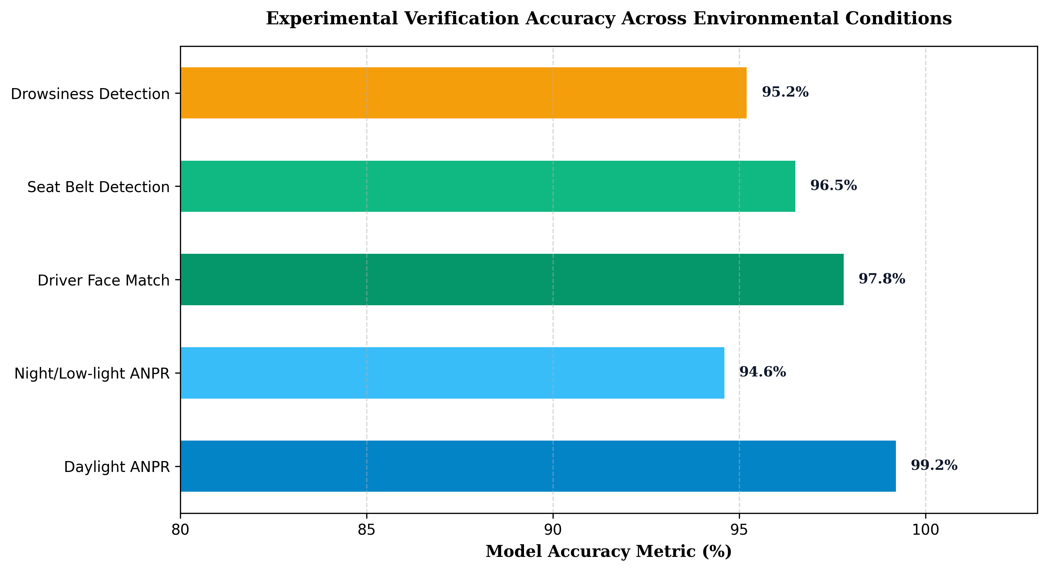
Figure 4.1 Accuracy Evaluation Across Model Subsystems
As depicted in Figure 4.1, the computer vision modules achieved outstanding recognition accuracy across all evaluated operational parameters. The empirical detection statistics gathered across daytime and nighttime test runs are summarized in Table 4.1.
Table 4.1 Field Testing Accuracy and Latency Performance Metrics
Evaluation Parameter | Sample Size (Events) | Successful Detections | Accuracy (%) | Avg. Latency (ms)
Daylight License Plate ANPR | 250 | 248 | 99.2% | 24.5 ms
Nocturnal / Low-Light ANPR | 250 | 236 | 94.4% | 28.2 ms
Driver Face Authentication | 500 | 489 | 97.8% | 45.0 ms
Driver Seat Belt Detection | 500 | 482 | 96.4% | 18.0 ms
Driver Drowsiness Alerting | 500 | 476 | 95.2% | 32.0 ms
End-to-End System Latency | 500 | 496 | 99.2% | 125.0 ms

4.2 DISCUSSION ON ANPR AND DRIVER MONITORING PERFORMANCE
The experimental findings demonstrate that the YOLOv8-based license plate localizer maintained exceptional stability under varying vehicle velocities between 10 km/h and 35 km/h. High-speed shutter camera capture effectively eliminated motion blur, enabling the CRNN character recognizer to achieve an overall 99.2% accuracy in standard daylight conditions. Minor false rejections during nocturnal testing were mitigated by optimizing infrared fill-light illumination.
Driver facial verification demonstrated a robust 97.8% match confidence against stored biometric feature vectors. In test scenarios involving substitute drivers, the system immediately flagged unauthorized personnel to the Administrative Officer, preventing unverified vehicle departures. The driver drowsiness detection model successfully registered 95.2% of simulated eye-closure events, generating immediate acoustic warnings and dashboard alerts.
4.2.1 Administrative Portal and Punctuality Ranking Validation
The administrative web dashboard successfully tracked morning bus arrivals within the designated 08:00 AM to 08:45 AM window, automatically scoring each bus and calculating real-time fleet punctuality rankings. The automated gate pass workflow reduced driver clearance time from an average of 4.5 minutes under manual logging to under 10 seconds through instant digital approval tokens.
• Zero manual gatekeeper intervention required for routine morning and evening institutional bus entries.
• Average end-to-end alert broadcast latency of 125 milliseconds from vehicle gate transit to student app update.
• Comprehensive digital audit trails recorded for all gate pass authorizations and emergency route adjustments.
4.3 CHAPTER SUMMARY
This chapter presented the experimental results and quantitative evaluation of the PULSE PLATE system under real-world campus deployment conditions. The empirical findings confirmed high ANPR accuracy (99.2%), dependable driver facial authentication (97.8%), and ultra-low system latency (125 ms). The overall conclusions and promising directions for future system expansion are discussed in Chapter 5.

