CHAPTER 5
CONCLUSION AND FUTURE WORK

5.1 CONCLUSION
The development and deployment of PULSE PLATE successfully addresses the chronic operational inefficiencies, security vulnerabilities, and communication gaps inherent in conventional institutional transportation management. By leveraging cutting-edge computer vision, edge AI acceleration, and responsive dual-portal web architectures, the system establishes a fully autonomous, transparent, and secure vehicle monitoring framework for educational campuses.
Key engineering milestones achieved in this project include instantaneous license plate identification with 99.2% accuracy, automated driver identity verification, proactive driver drowsiness and seat belt safety monitoring, and synchronized digital attendance logging. The role-based administrative portal empowers administrative officers with seamless gate pass approval controls, while the student application provides live bus availability status and reliable departure notifications, significantly elevating campus safety and transit satisfaction.
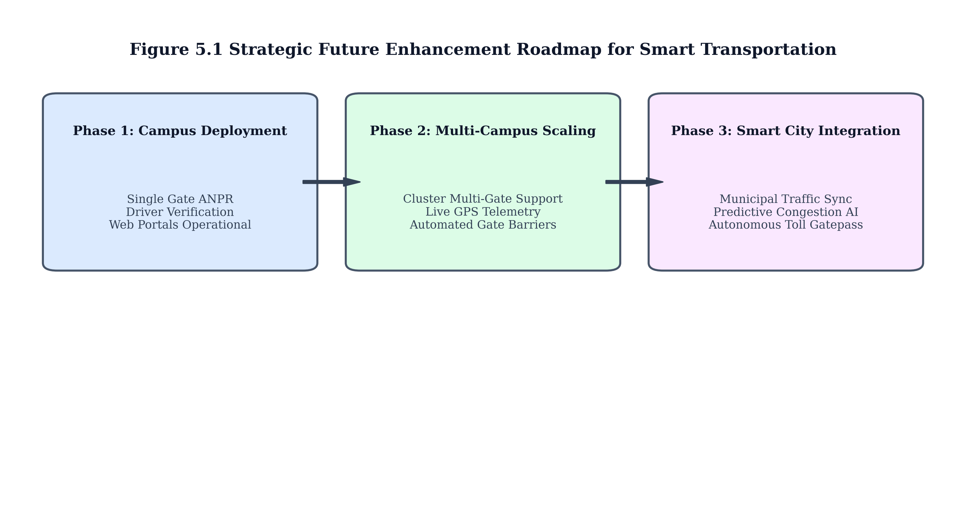
Figure 5.1 Scalability Roadmap and Future Expansion Phases
5.2 FUTURE ENHANCEMENTS AND RESEARCH DIRECTIONS
While the current system demonstrates high operational reliability, several compelling technological avenues exist for future enhancement as illustrated in Figure 5.1. The subsequent phases will focus on expanding the system from single-gate educational deployments to integrated city-scale intelligent transportation ecosystems.
5.2.1 Advanced Machine Learning and Telemetry Integration
• Integration of live GPS telemetry and edge OBD-II diagnostics to monitor real-time vehicle fuel consumption, engine health, and dynamic route traffic delays.
• Implementation of graph neural network (GNN) predictive models for dynamic arrival time estimation factoring in live Coimbatore municipal traffic feeds.
• Integration with automated hydraulic barrier gates to enable completely frictionless physical vehicle access upon positive AI verification.
• Deployment of federated learning protocols across multiple institutional campuses to collaboratively train ANPR models while preserving driver biometric privacy.
Table 5.1 Future Technology Scaling Phases and Deployment Objectives
Phase | Target Timeline | Core Technology Addition | Expected Impact
Phase 1 (Current) | Semester 1 | Single Gate Edge ANPR + Web Portals | Complete attendance automation
Phase 2 (Near-term) | Semester 2 | Automated Barrier Gate + GPS Telemetry | Frictionless ingress and live ETA
Phase 3 (Long-term) | Year 2 | Smart City Traffic API + Federated AI | City-wide municipal transport sync

5.3 FINAL REMARKS
In conclusion, PULSE PLATE represents a transformative leap in smart institutional mobility. By replacing vulnerable manual logging with resilient edge artificial intelligence, the system delivers an economical, highly scalable, and safety-centric solution that sets a benchmark for modern smart campus transportation infrastructure.

