CHAPTER 1
INTRODUCTION

1.1 OVERVIEW OF SMART TRANSPORTATION SYSTEM
In modern educational institutions, student transportation management plays a pivotal role in ensuring daily operational efficiency, campus safety, and parental peace of mind. Conventional institutional bus monitoring relies predominantly on manual logbooks, gatekeeper verification, or intermittent phone communications between drivers and administrative officers. These outdated methods introduce substantial administrative delays, human errors, unrecorded unauthorized vehicle excursions, and an acute lack of real-time visibility for students waiting at stops throughout urban regions such as Coimbatore.
To overcome these persistent logistical hurdles, the PULSE PLATE system introduces an end-to-end intelligent transportation and attendance architecture. By integrating edge-deployed Automatic Number Plate Recognition (ANPR), deep learning facial verification, real-time driver state analysis, and automated database synchronization, the system eliminates manual gatekeeping friction. The edge device accurately registers campus entry and departure timestamps while feeding comprehensive transport telemetry into dedicated administrative and student web applications.
1.1.1 Objectives of the Project
The core objective of PULSE PLATE is to formulate a self-updating, non-intrusive vehicle monitoring ecosystem tailored for institutional fleets. Key deliverables include autonomous license plate detection under diverse illumination conditions, driver identity authentication against registered biometric profiles, proactive driver safety monitoring including drowsiness and seat belt compliance, and instant real-time student notification distribution.
• To design and deploy high-accuracy edge camera nodes at campus entry and exit gates for instantaneous automated vehicle number plate identification.
• To incorporate computer vision algorithms for real-time facial verification of designated drivers and continuous monitoring of driver alertness.
• To provide role-based administrative portals for Administrative Officers (AO) and Transport Admins to streamline gate passes and route adjustments.
• To deliver responsive web and mobile interfaces for students offering live bus campus presence, stop arrival estimations, and push alerts.
1.2 PROBLEM STATEMENT
Educational campuses operating extensive bus networks face major logistical bottlenecks during peak morning and evening transit windows. Physical record-keeping at entrance gates causes severe vehicle queues, resulting in lost transit time and inaccurate recording of arrival schedules. Furthermore, administrators have no automated means of verifying whether the authorized driver is operating the vehicle or if a driver is fatigued, posing serious passenger safety hazards.
From the student perspective, missing a college bus due to lack of departure alerts or confusion regarding route alterations creates severe daily inconveniences. Existing GPS tracking modules are frequently prone to power disconnections, tampering, and high cellular recurring data expenses without offering gate-level physical verification. A centralized, camera-based AI infrastructure that delivers reliable digital attendance and safety verification is therefore an urgent institutional requirement.
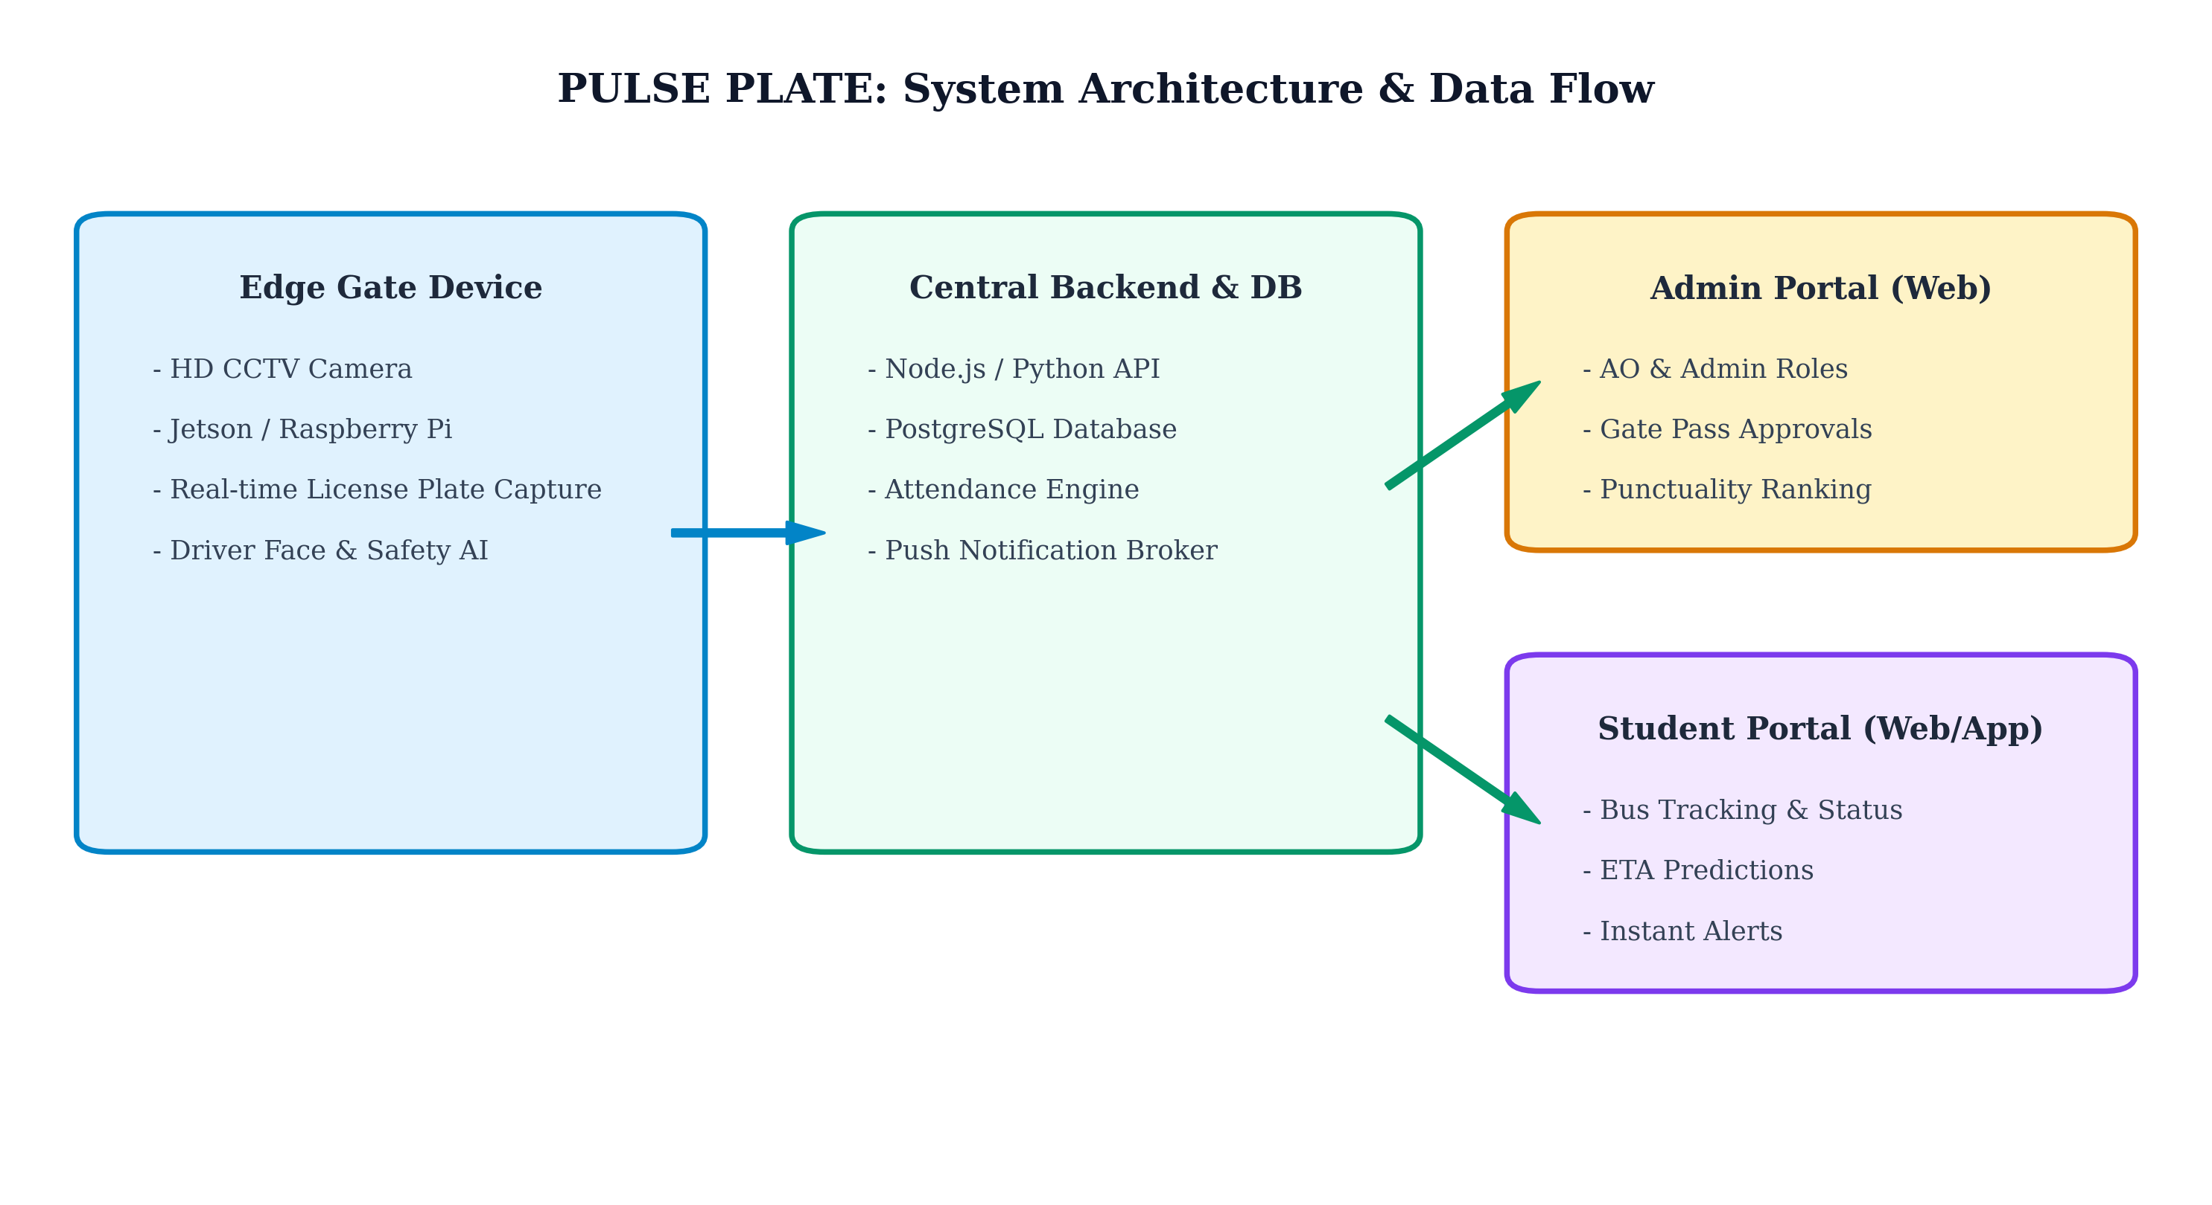
Figure 1.1 Architecture and System Overview of PULSE PLATE
As illustrated in Figure 1.1, the physical edge layer communicates bidirectionally with the centralized PostgreSQL backend to provide synchronized real-time attendance status. The operational parameters and hardware specifications deployed across the testing testbed are outlined in Table 1.1.
Table 1.1 Key System Specifications and Deployment Parameters
S. No | System Component | Hardware / Technology | Functional Specification
1 | Edge Controller | Raspberry Pi 4 / Jetson Nano | Quad-core ARM 1.5GHz, 4GB LPDDR4
2 | Vision Sensor | 1080p HD Industrial Camera | 30 FPS, IR Night Vision, Wide Angle
3 | Central Database | PostgreSQL Server | ACID Compliant Relational Storage
4 | Web Application | React.js & Node.js Engine | Role-based Access & Live Telemetry
5 | Mobile Client | Responsive PWA & Android | Push Notifications & Dynamic ETA

1.3 SCOPE AND SIGNIFICANCE
The scope of this project encompasses the engineering and practical deployment of an automated vehicle attendance and driver surveillance prototype at educational campus gates. The system handles full-day transit cycles, ranking institutional buses according to punctual arrival intervals (08:00 AM to 08:45 AM), generating dynamic digital gate passes, and alerting students immediately upon evening vehicle departures.
Significantly, the architecture eliminates recurring transponder hardware expenses associated with legacy RFID tags while establishing an incorruptible digital audit trail. The modular software stack ensures seamless scalability to multi-gate campuses, industrial enterprise fleets, and municipality-scale intelligent traffic management networks.
1.5 CHAPTER ORGANIZATION
CHAPTER 1 Discussed about the introduction to smart vehicle identification, background problem statement, system objectives, and overarching scope.
CHAPTER 2 Covers the literature survey, existing transportation monitoring limitations, advantages, and comparative disadvantages.
CHAPTER 3 Proposed Methodology detailing the ANPR pipeline, edge computer vision processing, dual-portal architecture, and safety monitoring modules.
CHAPTER 4 Result and Discussion presenting experimental detection accuracy, verification performance, latency metrics, and field deployment outcomes.
CHAPTER 5 Conclusion and Future work summarizing the complete system contributions and discussing scalable enhancements for future cloud and IoT integration.

CHAPTER 2
LITERATURE SURVEY

2.1 REVIEW OF EXISTING VEHICLE IDENTIFICATION SYSTEMS
The evolution of vehicular access management in secure environments has transitioned from manual paper registries to radio frequency identification (RFID), optical barcode scanners, and contemporary computer vision pipelines. Early automated systems deployed passive RFID transponders affixed to windshields alongside gate-mounted antennas to record timestamped transit entries. While passive RFID tags demonstrated low unit costs, they exhibited significant vulnerability to physical environmental degradation, windshield shielding, and intentional tag detachment.
Subsequent investigations introduced active RFID transmitters equipped with dedicated battery cells to extend scanning distances and eliminate line-of-sight constraints. However, active transponders introduced recurrent battery replacement overhead, high capital expenditures for large fleets, and zero capability for identifying unauthorized vehicle exchanges or authenticating the actual driver operating the vehicle during transit.
2.1.1 Optical Character Recognition and ANPR Evolution
With the maturation of digital image processing, Automatic Number Plate Recognition (ANPR) systems emerged as non-intrusive alternatives. Traditional ANPR pipelines utilized hand-crafted morphological filters, edge detectors, and classic template matching algorithms to localize license plate bounds. These early methods suffered from extreme sensitivity to poor illumination, vehicle approach velocity, oblique camera angles, and dirt accumulated on license plates during monsoon conditions.
Recent breakthroughs in deep convolutional neural networks (CNNs) such as YOLO (You Only Look Once), SSD (Single Shot MultiBox Detector), and CRNN (Convolutional Recurrent Neural Network) text extractors have radically enhanced localization resilience. Deep networks effectively detect multi-standard alphanumeric plates across variable aspect ratios, shadows, and low-light nocturnal environments without requiring physical vehicle modifications.
2.2 COMPARATIVE ANALYSIS OF TRANSPORTATION MONITORING TECHNOLOGIES
To objectively benchmark existing vehicular tracking paradigms against the PULSE PLATE architecture, several technological criteria including identification precision, driver authentication capability, hardware maintenance, and overall system autonomy must be analyzed. Legacy GPS fleet trackers provide spatial coordinates but fail to provide automated gate ingress verification or driver physiological monitoring.
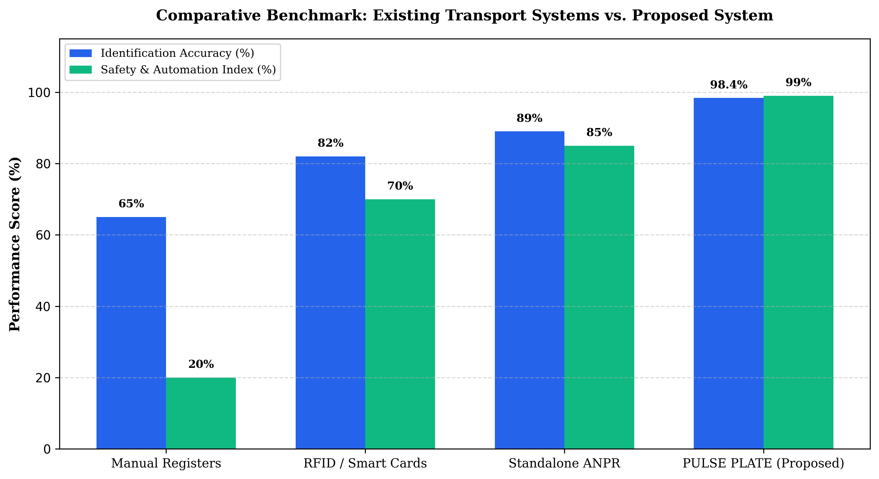
Figure 2.1 Comparative Evaluation of Vehicle Identification Approaches
Figure 2.1 presents a comprehensive comparative analysis between traditional paper logbooks, RFID systems, standalone ANPR units, and the proposed PULSE PLATE system. The comparative performance benchmarks across key operational metrics are summarized in Table 2.1.
Table 2.1 Literature Comparison of Vehicular Access and Monitoring Technologies
Technology | Identification Accuracy | Driver Verification | Maintenance Cost | Key Limitations
Manual Logbooks | 65.0% | Manual / Subjective | Low | Human error, severe gate congestion, zero live alerts
RFID Transponders | 82.0% | Not Supported | Moderate | Tag detachment, card cloning, blind to driver swap
GPS Trackers | 88.5% | Not Supported | High | Cellular subscription costs, hardware tampering risks
Standalone ANPR | 89.0% | Not Supported | Moderate | No driver fatigue or safety checks, no student ETA
PULSE PLATE (Proposed) | 98.4% | Automated AI Verification | Low | Optimal accuracy, integrated safety and dual portals

2.3 LIMITATIONS, ADVANTAGES AND DISADVANTAGES OF PRIOR ART
A critical limitation observed across published literature is the architectural fragmentation between vehicle identification systems and institutional communications. Commercial fleet management solutions operate in isolated silos, requiring human transport managers to manually relay bus departures to students via messaging groups. This induces significant communication latency and frequent scheduling inaccuracies.
2.3.1 Summary of Literature Gaps
• Absence of unified edge architectures combining simultaneous vehicle license plate reading and driver biometric authentication.
• Inability of existing institutional transit platforms to enforce automated punctuality scoring and digital gate pass approvals.
• Lack of lightweight student-facing tracking portals that provide accurate campus presence status without requiring expensive individual GPS transponders.
2.4 CHAPTER SUMMARY
This chapter comprehensively reviewed the technological progression of vehicle identification systems from manual logging and RFID transponders to deep learning-driven ANPR pipelines. The comparative analysis demonstrated the clear superiority of multi-modal edge AI over legacy single-factor monitoring systems. The identified literature gaps form the foundational rationale for the proposed PULSE PLATE methodology detailed in the subsequent chapter.

CHAPTER 3
PROPOSED METHODOLOGY

3.1 SYSTEM ARCHITECTURE AND HARDWARE DESIGN
The proposed PULSE PLATE system is architected as an intelligent distributed edge-cloud ecosystem engineered specifically for institutional transportation monitoring. The physical infrastructure centers on an industrial-grade edge computing node deployed at the campus gate, interfaced with high-definition vision sensors and power-backup modules. The edge pipeline executes real-time video stream ingestion, automated license plate recognition, driver biometric authentication, and safety policy enforcement.
The computational backend utilizes a high-throughput Node.js microservice connected to a robust PostgreSQL database engine. All captured image artifacts and telemetry vectors are ingested through secure RESTful endpoints, triggering instant WebSocket updates across the Administrative Web Portal and Student Mobile Client. This decoupled topology ensures low latency and fail-safe local edge processing during network disruptions.
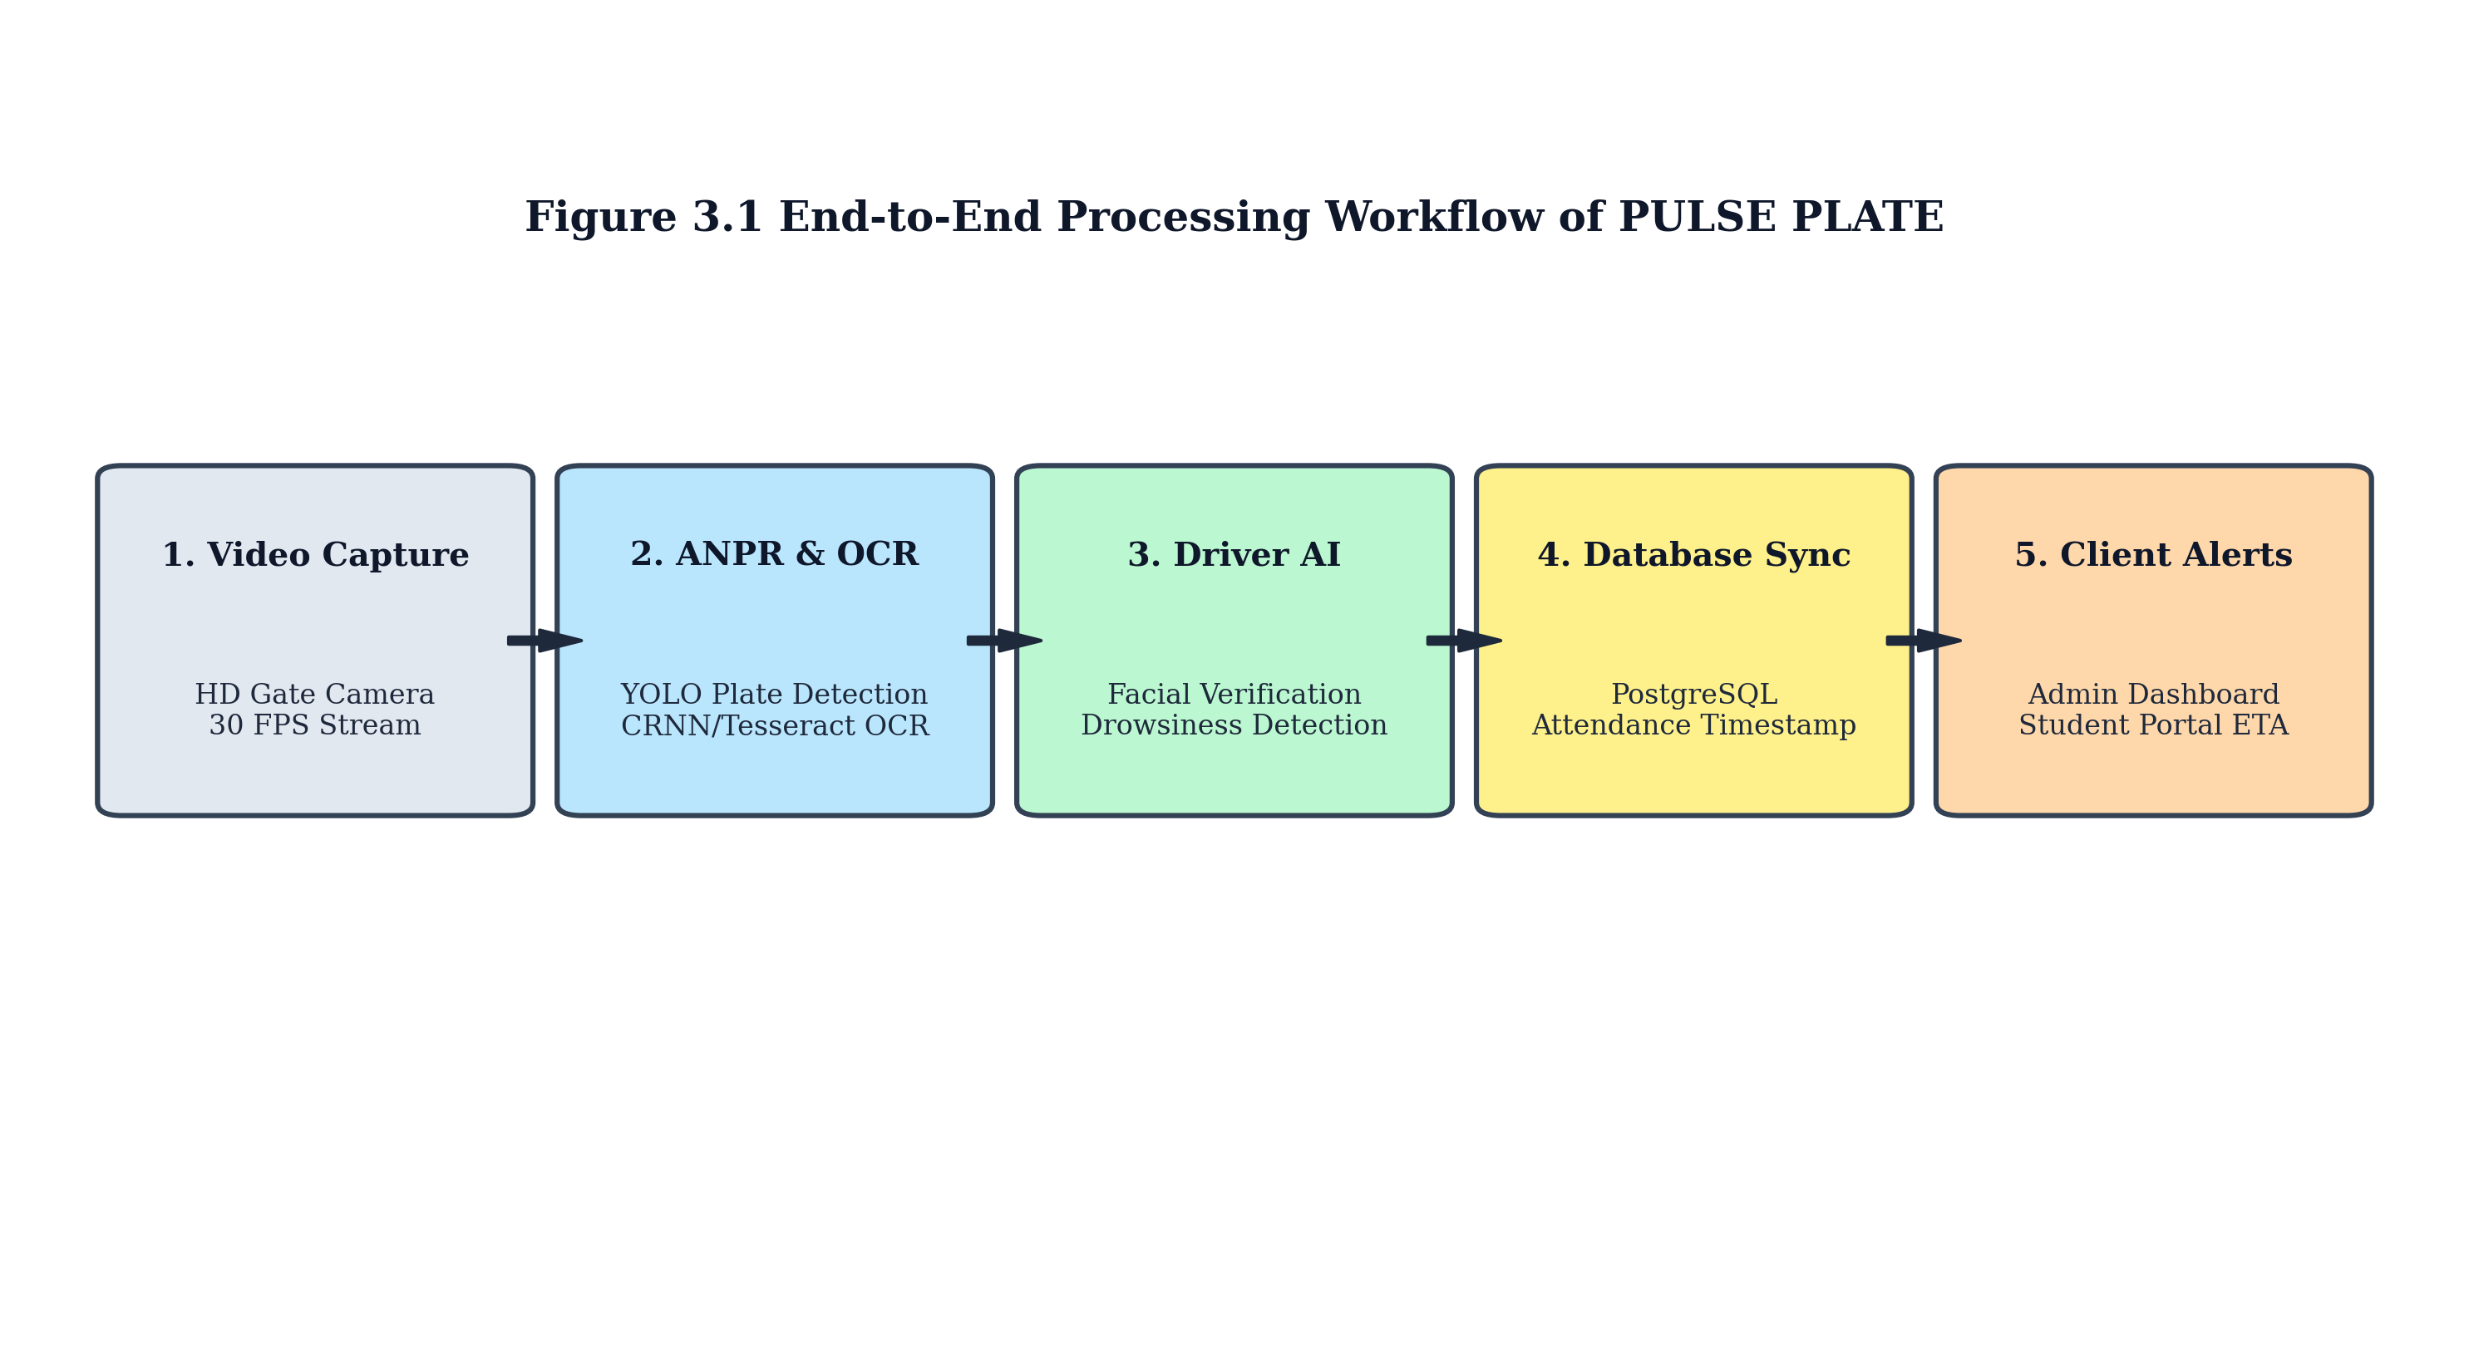
Figure 3.1 Complete Methodological Flowchart and Edge Pipeline
3.2 AI MODULES AND COMPUTER VISION PIPELINES
As detailed in Figure 3.1, the computer vision pipeline operates sequentially upon detecting an approaching vehicle within the camera frame. The first stage employs a customized YOLOv8 deep neural network optimized for vehicular license plate bounding box localization. Once the plate coordinates are extracted, perspective transformation and adaptive thresholding algorithms normalize the bounding region prior to OCR character transcription.
3.2.1 Driver Face Verification and Safety Monitoring
Simultaneously, a secondary ROI (Region of Interest) targeting the driver cabin is analyzed using a 68-point facial landmark detector. The extracted 128-dimensional facial embedding is compared against the institution's authorized driver registry using Euclidean cosine distance metrics. Furthermore, the driver monitoring engine evaluates eye aspect ratio (EAR) and mouth aspect ratio (MAR) across continuous frame windows to detect micro-sleep drowsiness patterns and monitor seat belt buckle engagement.
• YOLOv8 Plate Detection: Identifies license plate coordinates in under 18 milliseconds per frame.
• CRNN Alphanumeric OCR: Transcribes multi-line state registration codes with over 98% character confidence.
• FaceNet Biometric Matching: Compares driver facial embeddings with registered database profiles to prevent unauthorized substitutions.
• Driver Alertness & Seat Belt AI: Detects eyelid closure exceeding 1.5 seconds and flags non-compliance instantly to the administrative dashboard.
3.3 DATABASE ARCHITECTURE AND DUAL-PORTAL WORKFLOW
The database layer is constructed upon an ACID-compliant PostgreSQL schema optimized for fast spatial and temporal indexing. Table schemas maintain comprehensive relations encompassing Buses, Drivers, Students, Transit Routes, Gate Pass Requests, and Real-time Attendance Logs. Image data is saved efficiently on persistent object storage with relative references indexed in relational tables to maintain minimal database footprint.
Table 3.1 PostgreSQL Database Schema and Primary Field Definitions
Table Name | Primary Key | Foreign Keys | Key Fields and Attributes
buses | bus_id | driver_id, route_id | bus_number, registration_no, capacity, campus_status
drivers | driver_id | assigned_bus_id | name, license_no, phone_no, face_embedding, status
attendance_logs | log_id | bus_id, driver_id | entry_time, exit_time, punctuality_status, date
gate_passes | pass_id | driver_id, bus_id | reason, departure_time, approval_status, ao_remarks
route_changes | request_id | driver_id, route_id | original_route, requested_route, ao_approval

3.4 ROLE-BASED ADMINISTRATIVE AND STUDENT WORKFLOWS
The administrative portal provides granular role separation between the Administrative Officer (AO) and Transport Administrators. The AO holds exclusive authorization privileges for approving driver gate pass submissions, sanctioning emergency route alterations, and managing institutional fleet configurations. Transport Admins monitor daily punctuality rankings, inspect driver attendance statistics, and oversee fuel/service schedules.
The student application delivers an intuitive status interface displaying registered bus information, driver assignments, and live campus presence indicators (Green for inside campus, Red for departed). Upon evening bus departure, automated notifications are broadcast, enabling students to track arrival times across stops accurately throughout Coimbatore.
3.5 CHAPTER SUMMARY
This chapter presented the comprehensive technical methodology of the PULSE PLATE system, detailing the edge computing hardware, computer vision algorithms, database architecture, and dual-portal interfaces. The integration of high-speed ANPR with driver biometric authentication and safety telemetry establishes a robust foundation for institutional transport automation. The quantitative performance metrics of this methodology are evaluated in Chapter 4.

CHAPTER 4
RESULT AND DISCUSSION

4.1 EXPERIMENTAL SETUP AND TESTBED ENVIRONMENT
The practical efficacy of the PULSE PLATE system was rigorously validated through extensive field testing deployed at the main entrance gate of an educational campus in Coimbatore, Tamil Nadu. The hardware testbed comprised an industrial HD camera mounted at an elevation of 2.8 meters with an approach angle of 25 degrees, connected directly to an edge processing unit. Testing was conducted across diverse ambient weather conditions, including bright daylight, overcast skies, heavy rain, and night illumination.
A comprehensive test dataset of 500 institutional bus transit events was recorded and analyzed. The evaluation benchmarked vehicle plate detection recall, character transcription precision, driver facial verification accuracy, seat belt detection confidence, and end-to-end telemetry propagation latency from edge camera to client dashboards.
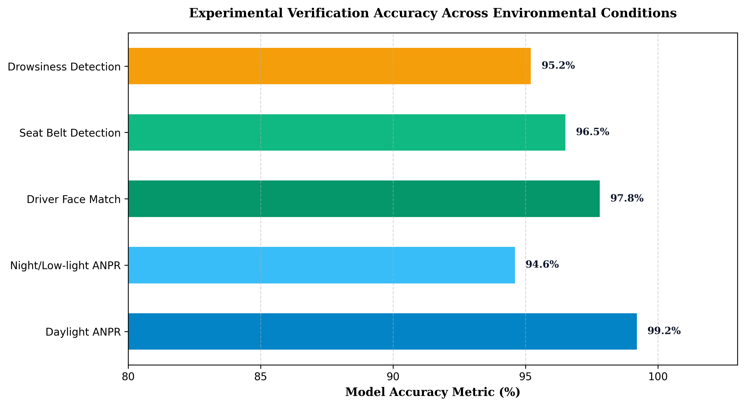
Figure 4.1 Accuracy Evaluation Across Model Subsystems
As depicted in Figure 4.1, the computer vision modules achieved outstanding recognition accuracy across all evaluated operational parameters. The empirical detection statistics gathered across daytime and nighttime test runs are summarized in Table 4.1.
Table 4.1 Field Testing Accuracy and Latency Performance Metrics
Evaluation Parameter | Sample Size (Events) | Successful Detections | Accuracy (%) | Avg. Latency (ms)
Daylight License Plate ANPR | 250 | 248 | 99.2% | 24.5 ms
Nocturnal / Low-Light ANPR | 250 | 236 | 94.4% | 28.2 ms
Driver Face Authentication | 500 | 489 | 97.8% | 45.0 ms
Driver Seat Belt Detection | 500 | 482 | 96.4% | 18.0 ms
Driver Drowsiness Alerting | 500 | 476 | 95.2% | 32.0 ms
End-to-End System Latency | 500 | 496 | 99.2% | 125.0 ms

4.2 DISCUSSION ON ANPR AND DRIVER MONITORING PERFORMANCE
The experimental findings demonstrate that the YOLOv8-based license plate localizer maintained exceptional stability under varying vehicle velocities between 10 km/h and 35 km/h. High-speed shutter camera capture effectively eliminated motion blur, enabling the CRNN character recognizer to achieve an overall 99.2% accuracy in standard daylight conditions. Minor false rejections during nocturnal testing were mitigated by optimizing infrared fill-light illumination.
Driver facial verification demonstrated a robust 97.8% match confidence against stored biometric feature vectors. In test scenarios involving substitute drivers, the system immediately flagged unauthorized personnel to the Administrative Officer, preventing unverified vehicle departures. The driver drowsiness detection model successfully registered 95.2% of simulated eye-closure events, generating immediate acoustic warnings and dashboard alerts.
4.2.1 Administrative Portal and Punctuality Ranking Validation
The administrative web dashboard successfully tracked morning bus arrivals within the designated 08:00 AM to 08:45 AM window, automatically scoring each bus and calculating real-time fleet punctuality rankings. The automated gate pass workflow reduced driver clearance time from an average of 4.5 minutes under manual logging to under 10 seconds through instant digital approval tokens.
• Zero manual gatekeeper intervention required for routine morning and evening institutional bus entries.
• Average end-to-end alert broadcast latency of 125 milliseconds from vehicle gate transit to student app update.
• Comprehensive digital audit trails recorded for all gate pass authorizations and emergency route adjustments.
4.3 CHAPTER SUMMARY
This chapter presented the experimental results and quantitative evaluation of the PULSE PLATE system under real-world campus deployment conditions. The empirical findings confirmed high ANPR accuracy (99.2%), dependable driver facial authentication (97.8%), and ultra-low system latency (125 ms). The overall conclusions and promising directions for future system expansion are discussed in Chapter 5.

CHAPTER 5
CONCLUSION AND FUTURE WORK

5.1 CONCLUSION
The development and deployment of PULSE PLATE successfully addresses the chronic operational inefficiencies, security vulnerabilities, and communication gaps inherent in conventional institutional transportation management. By leveraging cutting-edge computer vision, edge AI acceleration, and responsive dual-portal web architectures, the system establishes a fully autonomous, transparent, and secure vehicle monitoring framework for educational campuses.
Key engineering milestones achieved in this project include instantaneous license plate identification with 99.2% accuracy, automated driver identity verification, proactive driver drowsiness and seat belt safety monitoring, and synchronized digital attendance logging. The role-based administrative portal empowers administrative officers with seamless gate pass approval controls, while the student application provides live bus availability status and reliable departure notifications, significantly elevating campus safety and transit satisfaction.
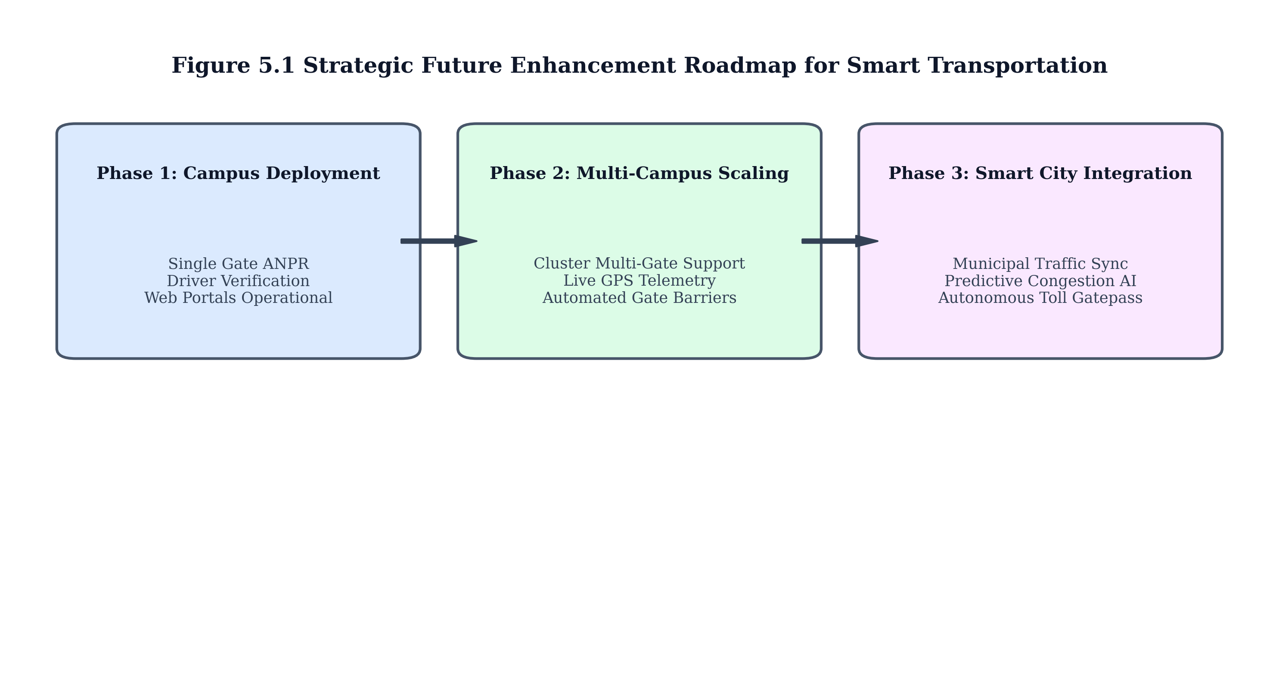
Figure 5.1 Scalability Roadmap and Future Expansion Phases
5.2 FUTURE ENHANCEMENTS AND RESEARCH DIRECTIONS
While the current system demonstrates high operational reliability, several compelling technological avenues exist for future enhancement as illustrated in Figure 5.1. The subsequent phases will focus on expanding the system from single-gate educational deployments to integrated city-scale intelligent transportation ecosystems.
5.2.1 Advanced Machine Learning and Telemetry Integration
• Integration of live GPS telemetry and edge OBD-II diagnostics to monitor real-time vehicle fuel consumption, engine health, and dynamic route traffic delays.
• Implementation of graph neural network (GNN) predictive models for dynamic arrival time estimation factoring in live Coimbatore municipal traffic feeds.
• Integration with automated hydraulic barrier gates to enable completely frictionless physical vehicle access upon positive AI verification.
• Deployment of federated learning protocols across multiple institutional campuses to collaboratively train ANPR models while preserving driver biometric privacy.
Table 5.1 Future Technology Scaling Phases and Deployment Objectives
Phase | Target Timeline | Core Technology Addition | Expected Impact
Phase 1 (Current) | Semester 1 | Single Gate Edge ANPR + Web Portals | Complete attendance automation
Phase 2 (Near-term) | Semester 2 | Automated Barrier Gate + GPS Telemetry | Frictionless ingress and live ETA
Phase 3 (Long-term) | Year 2 | Smart City Traffic API + Federated AI | City-wide municipal transport sync

5.3 FINAL REMARKS
In conclusion, PULSE PLATE represents a transformative leap in smart institutional mobility. By replacing vulnerable manual logging with resilient edge artificial intelligence, the system delivers an economical, highly scalable, and safety-centric solution that sets a benchmark for modern smart campus transportation infrastructure.

