ASP.NET MVC (.NET Framework)
HTML Helpers, URL Helpers & Model Binding

1. MVC Request Lifecycle
This is the foundation every other topic in this document builds on, so start here.
Browser (View) -> HTTP Request -> Routing -> Controller -> Action Method -> Response -> Browser
When a user clicks Submit, the browser sends an HTTP request. MVC routing finds the correct controller and action. The action executes and returns a View or a Redirect.

2. Strongly Typed Views

2.1 What is a Strongly Typed View?
A Strongly Typed View in ASP.NET MVC is a view that is directly bound to a specific model class. Instead of using ViewBag, ViewData, or TempData (which create loosely typed views), a strongly typed view receives a model object from the controller, making it easier and safer to access data.

2.2 Quick Reference: ViewBag / ViewData / TempData
These are the three loosely typed ways of passing data that strongly typed views are compared against. Good to know before moving on:
Mechanism | Type | Lifetime | Typical Use
ViewBag | dynamic | Current request only | Quick, one-off values passed to a view
ViewData | Dictionary<string, object> | Current request only | Same as ViewBag, but requires casting
TempData | Dictionary<string, object> | Survives one redirect | Passing data across a redirect (e.g., success messages)

2.3 How to Create a Strongly Typed View
- In the controller, pass the model object to the View() method:
return View(employee);
- In the view (.cshtml), specify the model type using the @model directive:
@model FirstMVCDemo.Models.Employee
- Access model properties using the @Model object:
@Model.Name
@Model.City
@Model.Salary

2.4 Key Points
- @model (lowercase m) defines the model type used by the view.
- @Model (uppercase M) is used to access the model's properties.
- The controller passes an object (such as an Employee) to the view.

2.5 Advantages of Strongly Typed Views
- Compile-time error checking helps detect mistakes before the application runs.
- IntelliSense support provides code suggestions and improves development speed.
- Type safety ensures only valid model properties can be accessed.
- Reduces runtime errors caused by misspelled property names.

3. HTML Helpers

3.1 What are HTML Helpers in ASP.NET MVC?
An HTML Helper in ASP.NET MVC is an extension method of the HTML Helper class, which is used to generate HTML content in a view. For example, if you want to generate a textbox with id="firstname" and name="firstname" then you can type all the required HTML in a view as shown below:
<input type="text" name="firstname" id="firstname" />
But in ASP.NET MVC, you can use the following TextBox HTML helper method in the view to generate a text box instead:
@Html.TextBox("firstname")

3.2 Types of HTML Helper Methods
In ASP.NET MVC, there are two types of HTML Helper methods:
- Simple HTML Helper Methods
- Strongly Typed HTML Helper Methods
The difference is what they bind to — simple helpers take a string field name, while strongly typed helpers use a lambda expression bound to the model, giving compile-time checking and IntelliSense (the same benefit strongly typed views give you):
Style | Example | Bound To
Simple HTML Helper | @Html.TextBox("firstname") | A string name (no compile-time check)
Strongly Typed HTML Helper | @Html.TextBoxFor(m => m.FirstName) | A model property via lambda (compile-time checked)

Diagram — Types of HTML Helpers in MVC:
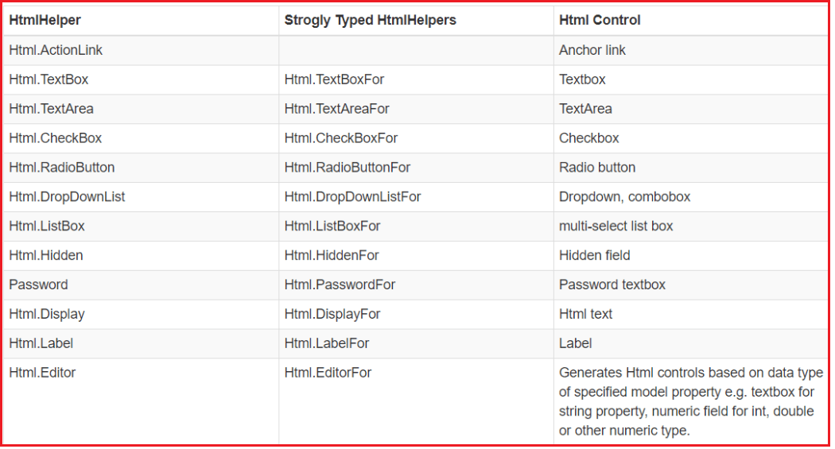

4. Passing Data from View to Controller
There are three generations of getting form data in ASP.NET MVC, from most manual to most automatic:
- Request
- FormCollection
- Model Binding (recommended)

4.1 Reading from Request
[HttpPost]
public ActionResult Create()
{
string name = Request["Name"];
string email = Request["Email"];
return View();
}
You read each field manually, one at a time, by its key. No type safety, and every field name is a magic string.

4.2 FormCollection
Instead of reading one field at a time from Request, MVC bundles all form fields into a FormCollection.
[HttpPost]
public ActionResult Create(FormCollection form)
{
string name = form["Name"];
string email = form["Email"];
return View();
}

4.3 Model Binding (Best)
[HttpPost]
public ActionResult Create(Student student)
{
// student.Name and student.Age are already populated
}
MVC automatically creates a Student object and fills its matching properties — no manual reading required.

4.4 Comparing the Three Approaches
Approach | Type Safety | Effort | Recommended?
Request["key"] | None (string only) | High — read every field by hand | No
FormCollection | None (string only) | Medium — one bundle, still manual lookups | Not preferred
Model Binding | Full (strongly typed object) | Low — MVC fills the object for you | Yes

4.5 Easy Way to Remember
Analogy: A Courier Delivers a Package
Request = the entire package (form data, query string, cookies, headers).
FormCollection = just the form inside the package.
Model Binding = someone has already unpacked the form and filled a Student object for you.

5. How the Model Binder Works
The model binder matches incoming field names to property names automatically:
HTML:
<input name="Name">
<input name="Age">

Browser sends:
Name=Onkar
Age=25

Model Binder produces:
Student.Name = "Onkar"
Student.Age = 25
Rule to Remember
Property names must match HTML input names exactly (case-insensitive) — otherwise that property is left at its default value.

6. Session
Session stores data for one user across multiple requests.
Session["UserName"] = "Onkar";
Later, in another request:
string name = Session["UserName"].ToString();

6.1 Use Session For
- Logged-in user
- Shopping cart
- Language preference
- Theme

6.2 Avoid
- Storing large collections in Session — it consumes server memory per user and hurts scalability.

7. URL Helpers
Url.Action() generates only a URL (no HTML tag).
@Url.Action("Details", "Student", new { id = 5 })
Output:
/Student/Details/5
It uses MVC routing instead of a hardcoded URL, so it automatically stays correct if routes change.

8. Html.ActionLink
Creates a complete hyperlink, not just a URL.
@Html.ActionLink("Details", "Details", new { id = 5 })
Output:
<a href="/Student/Details/5">Details</a>

8.1 Difference
Helper | Produces
Url.Action() | URL only
Html.ActionLink() | Complete <a> anchor tag

9. Bind Include / Exclude
Protects against over-posting attacks, where a malicious user adds extra fields to a form post that map to properties you never intended to expose (e.g., an IsAdmin flag).
[Bind(Include = "Name,Age,City")]
Only these properties bind.
[Bind(Exclude = "IsAdmin")]
Everything except IsAdmin binds.
Security Note
Always prefer Include over Exclude when possible: an explicit allow-list stays safe even if someone later adds a new sensitive property to the model and forgets to update the Bind attribute.

10. Summary — Key Takeaways
- Request lifecycle: Browser -> Routing -> Controller -> Action -> Response.
- Strongly typed views beat ViewBag/ViewData/TempData for compile-time safety and IntelliSense.
- HTML Helpers generate HTML; the strongly typed versions (…For) are preferred over string-based ones.
- Model Binding is the recommended way to receive form data — safer and less code than Request or FormCollection.
- Session is per-user, cross-request storage — use it sparingly.
- Url.Action() returns a URL; Html.ActionLink() returns a full anchor tag.
- Bind Include/Exclude protects against over-posting — prefer Include as an allow-list.

