UNIVERSITY INSTITUTE OF COMPUTING

PROJECT REPORT ON
User & Group Management with Access Control
Linux Administration

SUBMITED BY:

Name : Riya
Branch : BCA Semester : 5th Semester
UID : 23BCA10126
Section/ Group: 23BCA-2’B’
D.O.SUBMITION :

SUBMITED TO:
Name : Mr. Rajat Kapoor D.O.SUBMITION :

Desigination: Assistant Professor Sign:
\


BONAFIDE CERTIFICATE

Certified that this project report “User & Group Management with Access Control” is the Bonafide work of “Riya” under UID “23BCA10126” who carried out the project work under my supervision.

………………………………………

SIGNATURE

UIC DEPARTMENT ASSISTANT PROFESSOR RAJAT PATIAL

Linux Administration

User & Group Management with Access Control Aim of the Project:
To manage users, groups, and file permissions effectively in Linux using commands like useradd, groupadd, chmod, chown, and setfacl.

Performing Task :

Introduction:-
In Linux, user and group management is an essential part of system administration. It ensures that only authorized users have access to specific files or directories.
Access control mechanisms like permissions and ACLs (Access Control Lists) help protect system resources from unauthorized access.
This project demonstrates how to create, modify, and delete users and groups, and how to assign permissions and access rights.

Objectives:-
- To create and manage users and groups in Linux.
- To assign file and folder permissions.
- To understand and use the chmod, chown, and setfacl commands.
- To control access to files using ACLs.
- To learn the basics of Linux system security.

Tools and Command Used
- useradd – Create a user.
- groupadd – Create a group.
- chmod – Change file/folder permissions.
- chown – Change file ownership.
- setfacl – Set Access Control List for advanced permissions.
- getfacl – View Access Control List.

System Requirements

Hardware Requirements:
- Minimum 2GB RAM (4GB Recommended)
- Dual Core Processor or higher
- 20GB Hard Disk Space
- Personal Computer / Laptop

Software Requirements:
- Operating System: Linux (Ubuntu / Kali / RedHat / CentOS)
- VirtualBox / VMware (if using virtual machine)
- Bash Shell
- File System supporting ACL (ext4 recommende

STEPS INCLUDE :

S1) Create a group named 23BCA
sudo groupadd 23BCA
S2) Create users 23vr and add them to the group
sudo useradd -m -g 23BCA 23vr
S3) Set passwords for users
sudo passwd 23vr
S4) Create a shared directory
sudo mkdir /shared_folder
S5) Change group ownership of the directory
sudo chown :23BCA /shared_folder

S6) Set read, write, and execute permissions for the group
sudo chmod 770 /shared_folder
S7) Use ACL to provide special access
sudo setfacl -m u:student:rwx /shared_folder
S8) View ACL details
getfacl /shared_folder
S9) Delete users or groups when needed
sudo userdel -r 23vr
sudo groupdel 23BCA

Project Methodology (Detailed Explanation)
- Planning: Identify users, groups, and access requirements.
- Environment Setup: Configure Linux environment for user management.
- Implementation: Execute user, group, and permission commands.
- Testing: Verify user access and ACL settings.
- Documentation: Record all commands and outputs.

Algorithm / Logic / Flow chart:

Algorithm:
Start → Create Group → Create Users → Assign Group → Create Folder → Set Permissions → Apply ACL → Verify Access → Delete Users/Groups → End.
OUTPUTS:-
CREATE GROUP:-
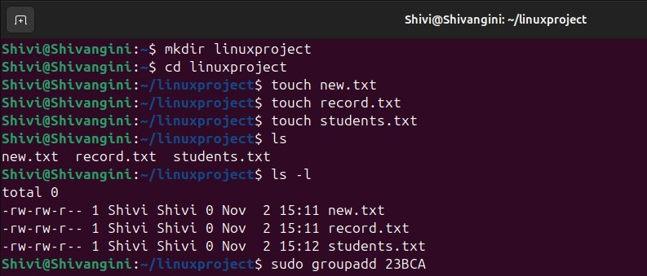

Create Users:-

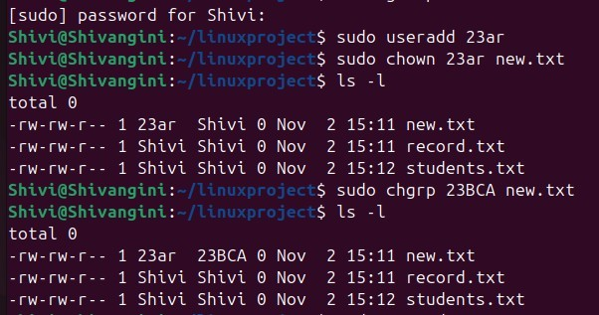

Set Password For Users:-
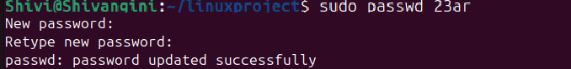

Create a shared directory:-
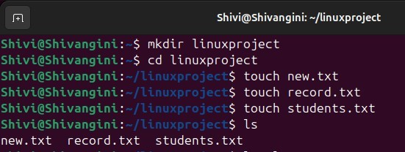

Change group ownership of the directory:-
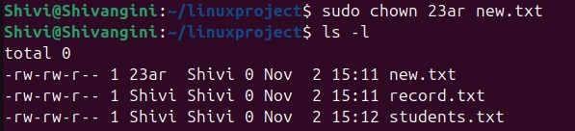

Set read, write, and execute permissions for the group:-

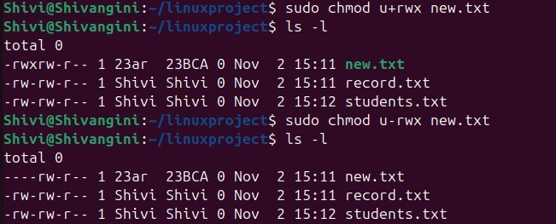

Use ACL to provide special access and View ACL details:-
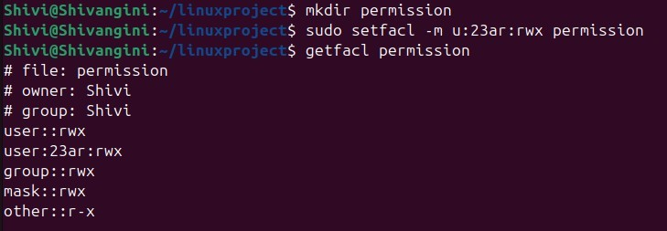

Delete users and Groups:-
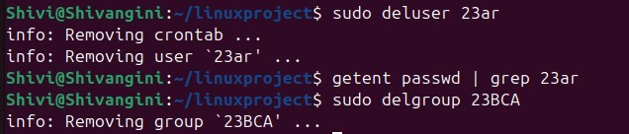

Challenges Faced:
- Understanding Linux permission structure initially.
- Handling permission conflicts between groups and ACLs.
- Remembering correct command syntax.
- Troubleshooting errors while deleting users with active directories.

Conclusion:
This project demonstrated how to create, modify, and delete users and groups and manage file permissions using basic Linux commands.
By applying Access Control Lists (ACLs), we learned how to give specific permissions to individual users, making Linux a secure and flexible multi-user operating system.
It improved our understanding of Linux security and permission handling.

LEARNING OUTCOMES:

- Learned to use Linux user and group management commands.
- Understood file and directory permission systems.
- Gained hands-on experience with chmod, chown, and setfacl.
- Understood practical aspects of Linux access control.

Linkdin:

Link:

