Java - Collections Framework
1. What is Collection framework in java? Discuss different interfaces and classes in java.util package and their usage.
Collection framework is a very popular framework in java; important in the sense that using this we can write object oriented application using Data structre, Linkedlist, Hashtable. The Collection framework is bound with the java.util package.So while creating applications which need collection of objects we need to import the util package in our application.
- The collection is a single object managing a group of objects.
- Those objects in the collection are called as elements.
- In general collections can hold objects but not primitives.
- Prior to java 5 platform a very common use of wrapper class is to provide a way to get a primitive into a collection.
- As per this you had to wrap a primitive by hand before you put it into the collection but now autoboxing will take care of it.
- The collection framework in java was took place in java 1.2, and was expanded in 1.5,
again it was enhanced in next versions and recently in java 1.7 it has some new features which i'll mention after some time.
- There are some basic operations that we perform in using Collection,i.e
*add object to a collection.
*remove object from collection.
*find object(or a group of objects) from a collection.
*retrieve an object from the collection without removing it.
*iterate an object from the collection, looking at each object one after another.

- The collection API that contains interfaces that group objects are Collection, List, Set, Map, Queue, NavigableSet, NavigableMap, SortedSet, SortedMap etc.
- Not all the collections in the collection framework actually implements the Collection interface.
Specifically none of the Map related classes inherited from the Collection.
- So while the SortedMap, HashMap, HashTable, LinkedHashMap, TreeMap are all considered to be a collection but are not extended from the Collection with a capital 'C'.
- There is little confusion with the word collection in java.
I am trying to resolve this confusion with the following,
* colletion(lowercase c)represents any of the datastructre in which objets are stored and iterated over and over.
* Colletion(uppercase C)represents actually the java.util.Colletion interface from which all the Set,List etc are extended and there is no direct implementation of the Collection.
* Colletions(ending with s)represents the java.util.Collections class that holds a pile of static utility methods those are get utilized in the collections.
Figure 1.1 describes the Collection framework structure.
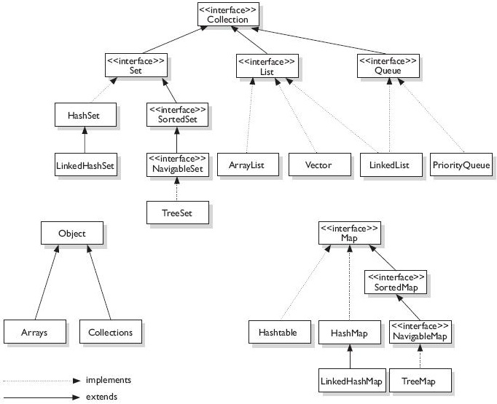
• Collection comes in 4 natural flavors,
1. List
2. Set
3. Map
4. Queue
But there are subFlavours inside the above mentioned flavours (i.e)
a. sorted(means the ordering of the elements in the collection is done according to some rules may be some sorting rule)
b. unsorted
c. ordered(means you can iterate the elements from collection in a specific order not in random)
d. unordered
Well now i'll discuss all about the flavours and the sub-flavours! wow! its intresting,
List Interface-
• It cares about the index. The one thing list has that differs it from others are the set of methods related to index.
• Those methods are get(int index),indexOf(Object o),add(int index,Object O) and so on.
• This interface allows duplicate elements to added in the collection.
• This interface and all the classes Implementing it are ordered by index position.
• There are 3 basic List implementation, those are likely
ArrayList-
• This is generally termed as the growable array.
• This gives you faster iteration and faster random access.
• This is a ordered list(ordered by index position) but not sorted.
• This also implements the marker interface (i.e)RandomAccess interface[marker interface means interface that does't hava any method].
• This is preferred to use when you need faster iteration and you don't need lots of insertion or deletion.
LinkedList-
• It is also seems to be an ArrayList except the elements are doublly linked to each other.
• These linkage provides you easy methods for adding and deleting elements.
• From java 5 platform LinkedList class also implements the Queue interface so it also supports the common Queue methods like pick(),poll(),offer().
• But iterating through LinkedList is not faster as compared to ArrayList.So its preferable to use when you need to add and remove elements from the list frequently.
Vector-
• The vector is associated to collection from ancient days.
• It has same functionality as ArrayList but the Vector methods are all synchronized for thread safety.
• This class is another class after ArrayList that also implements the RandomAccess interface.
Set Interface-
• The main thing about set interface is that it doesn't allows duplicate elements to be added into the collection.
i.e you can say it cares about the uniqueness in the collection.
The Set implementations are,
HashSet-
• This is a unsorted and un ordered Set.
• It uses the hashcode of the object being inserted, so the more efficient your hashCode() the better access performance you will get.
• This is preferable to be used when you don't need duplicates to be added in the collection and you don't care about the order of the elements while iterating.
LinkedHashSet-
• This is the ordered version of HashSet that maintains a doubly LinkedList across all elements.
• Use this class instead of HashSet when you care about the iteration order.
• In HashSet the iteration order is un predictable, but in LinkedHashSet the order is as per the order in which the elements are added.
TreeSet-
• This class is one of the sorted collections.
• It uses a tree structure and ensures the elements are in ascending order.
• Optionally you can create a TreeSet constructor the enables you to sort the elements as per your own rules.
• This class also implements NavigableSet interface.
Map interface-
• This interface cares about the unique identifiers.
• Here a unique key(ID) is mapped with a value where both key and value pairs are objects.
• The Map implementation classes let you search elements based on keys,search all keys or search all values.
Let us discuss on some Map implementations,
HashMap-
• The HashMap gives you unsorted and unordered collections.
• HashMap allows one null key and multiple null values in the collection.
• The key's performance is based on the hashcode; so like HashSet the more efficient the hashCode() better performance you will get.
• This is preferable when you need a Map and you don't care about the order.
Hashtable-
• This Map implementation exists from prehistoric java times like Vector.
• It has all the methods synchronized for thread safety.
• The Hashtable class doesn't allows anyone to insert null key or null values in the collection.
LinkedHashMap-
• This class mentains insertion order(or optionally access order) in the collection.
• This is not suitable for frequent insertion and removing of elements,because it performs little slower than HashMap.
• But you can iterate elements from it and expect a faster performance from it.
TreeMap-
• This is probably a sorted Map.
• You can also custom your own order in it using Comparable or Comparator interfaces.
• As from java 6 TreeMap implements NavigableMap interface.
Queue interface-
• A Queue is a collection for holding elements prior to processing.
• Besides basic Collection operations, queues provide additional insertion, removal, and inspection operations.
• A queue is designed to have elements inserted (typically, but not necessarily) at the end of the queue, and elements removed from the beginning of the queue, Just like a queue in a supermarket.
Let us now take a look at the Queue implementations,
PriorityQueue-
• This class has come to play from java 5 platform.
• Since the LinkedList class has implemented the Queue interface so the basic Queue operations are also done through it.
• The basic operations done through it to create priority-in, priority-out operations as opposed to a typical FIFO queue.
• This class is ordered as per natural ordering(FIFO) or customized ordering through the Comparator.
• In each ordering the elements ordering represents their relative priority.
The figure 1.2 shows the collection classes an implementations,

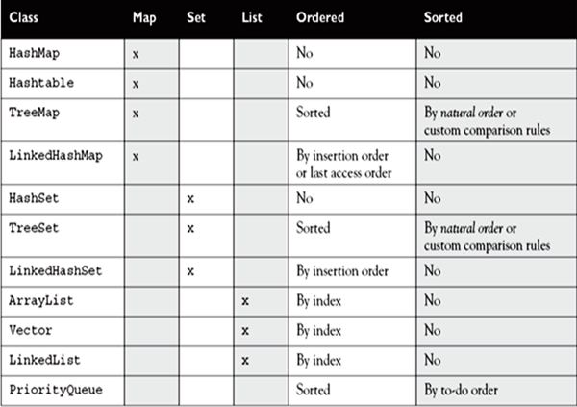

- Sorting with Collection-
- The collection framework gives you a way for sorting the elements.
- The Collection class has the sort() that takes a list as argument can sort elements alphabetically.
Example-
public class ListTest
{
public static void main(String[] ar)
{
ArrayList<String> ali=new ArrayList<String>();
ali.add("Sneha");
ali.add("Siba");
ali.add("Rita");
ali.add("Amit");
ali.add("Bandita");
System.out.println("Unsorted order="+ali);
Collections.sort(ali);
System.out.println("Sorted order="+ali);
}
}
This will give an output similar,
Unsorted order=[Sneha,Siba,Rita,Amit,Bandita]
Sorted order=[Amit,Bandita,Rita,Siba,Sneha]
- If you take a look at the one argument sort() then you will find that it will take a List argument and that the objects
in the List must implement the interface called Comparable.
- There is another interface caleed as Comparator.
- The sort() of Collection class takes both a List and something called as Comparator.
- The Comparator interface gives you mean to sort a given collection in any number of different ways.
- The another thing associated with Comparator interface is that you can use it to sort instances of any class.
- The Comparable interface has a method called compareTo()
Let us now do some exercise on Colletion,
public class ListTest
{
public static void main(String[] ar)
{
List<String> li=new ArrayList<String>();
String s="JayHo";
li.add(s);
li.add(s+s);
li.add("String");
System.out.println(li.size());
System.out.println(li.contains(8));
System.out.println(li.contains("JayHOJayHo"));
}
}
What will be the output while compiling and running the above code?
1. 2 true false
2. 2 false true
3. 3 true false
4. 3 false true
5. 2 false false
Ans.4
public class ListTest
{
public static void main(String[] ar)
{
List li=new ArrayList();
li.add(new Integer(76));//1
li.add(86);//2
System.out.println(li);
}
}
What will be the output while compiling and running the above code?
1. [76,86]
2. compilation error at line 1.
3. compilation error at line 2.
4. runtime error.
Ans.1

2 . What are the new features added in Java 1.7 in Collection framework ?
The Collection frame work gives new Flexible feature in java 1.7 .
-This is all about writing less code when you create a List, a Set or a Map.
You don't have to instantiate the Object and then add the element to the Collection. You can now do it in 1 line.
Example:
List<String> list = ["item"];
String item = list[0];
Set<String> set = {"item"};
Map<String, Integer> map = {"key" : 1};
int value = map["key"];
-Improved Type Inference for Generic Instance Creation (diamond)
Same thing, today you specify the Generic when you declare the interface of your object and then you have to repeat yourself when you instantiate the object.
You won't have to do now as you can do it as:
Example:
Map<String, List<String>> map = new HashMap<>();

3 . class CollDemo
{
public static void main(String[] ar)
{
// Some code here; //
for(int i=0;i<=10;i++)
{
List<Integer> love=new ArrayList<Integer>();
for(int j=0;j<=10;j++)
love.add(i*j);
game.add(love);
}
for(List<Integer> love:game)
System.out.println(love);
}
}
Which statement below could be inserted in the above comment line to make the above code run fine?
1. List<List<Integer>> game=new List<List<Integer>>();
2. List<List<Integer>> game=new ArrayList<List<Integer>>();
3. List<List<Integer>> game=new ArrayList<ArrayList<Integer>>();
4. List<List,Integer> game=new ArrayList<List,Integer>();
5. List<List,Integer> game=new List<List,Integer>();
6. Non of the above.
Ans. 2
Because option 1,5 cann't be possible as it instatiates an inteface.option 4 is not possible as List< , >deosn't takes two generic types nad option 3 is incorrect as two side of the generic arguments are not same.
4 . class TreeSetDemo
{
public static void main(String[] ar)
{
Set s1=new TreeSet();
s1.add("3"); //1
s1.add("vodafone"); //2
s1.add("Three"); //3
s1.add(3); //4
Iterator it=s1.iterator();
while(it.hasNext())
System.out.print(it.next()+" ");
}
}
What will be the output while compiling and running the above code?
1. 3 Three Vodafone
2. 3 Three Vodafone 3
3. This code will give a compiletime error.
4. This will compile but give runtime ClassCastException.
5. Three Vodafone.

Ans. 4
Because we are adding 3String objects and an integer into the Set.This code will compile successfully but at the runtime when the TreeSet tries to sort the elements as they have added Collection, it encounters problem at line no.4; as it has to compare the String with an Integer.
Java 6.0 : Whats new in Collection Framework

Some of the new collections APIs have been introduced in Java 6.0. These are:
1. Deque: It is used to represent Double ended queue. With the help of this collection we can add or remove elements at both the ends. Deque implementation can be used as Stack (Last in first out) or Queue (First in First Out). There are two methods in Deque, which are used for insertion, retrieval and removal of elements. One returns status or special value for each operation and the other will throw exception if it fails in an operation.
2. BlockingDeque: It is similar to Deque but with added functionality. When we try to insert an element in a BlockingDeque and if the BlockingDeque is already full then the element can wait till the space becomes available to insert an element. There are four methods available for BlockingDeque.
• Methods throws exception
• Methods that times out (Waits for a given time for space to available)
• Methods that blocks (Waits indefinitely for space to available)
• Methods returns special value
3. NavigableSet: It is used to return the closest matches of elements. For instance if we want retrieve the element, which is immediately greater than, or lower than element 20 or if we want to retrieve all elements greater than or lower than 35 from sorted set elements [10,20,35,5] we can use NavigableSet methods that becomes just a method call. ConcurrentSkipListSet is one of the class that implements NavigableSet.
4. NavigableMap: In NavigableSet, methods use to return values, but in NaviagableMap methods used to return the key,value pair. ConcurrentSkipListMap is the one of the class which implements NaviagableMap
Some of the new Classes are:
1. ArrayDeque: ArrayDeque is a class that implements Deque. If used as a stack or linked list, it performs much faster than before. It is neither thread safe nor has capacity restrictions.
2. LinkedBlockingDeque: It implements BlockingDeque. Maximum capacity can be specified by using BlockingDeque interface. However the maximum capacity will be Integer.MAX_VALUE if not specified.
3. ConcurrentSkipListSet: ConcurrentSkipListSet is one of the class that implements NavigableSet. It is used to return the closest matches of elements.
4. ConcurrentSkipListMap: ConcurrentSkipListMap is the one of the class which implements NaviagableMap. In NavigableSet, methods use to return values.
5. AbstractMap.SimpleEntry: The key value pair of one single entry in a Map is held by the instance of this class. Moreover it is a static nested class nested inside abstractMap class.

6. AbstractMap.SimpleImmutableEntry: This class is similar toAbstractMap.SimpleEntry class however it has one difference that it throws the exceptionUnsupportedOperationException when we try to set a value whileAbstractMap.SimpleEntry doesn?t.
Updated Classes in Java 6.0
•LinkedList
•TreeSet
•TreeMap
•Collections
Modified classes
To implement the new interfaces we modify some classes like TreeSet is modified to implement NavigableSet, LinkedList is modified to implement Deque, TreeMap is modified to implement NavigableMap etc. Some of the new methods like newSetFromMap and asLifoQueue have been added to Collections 2.
Hence the bi- directional traversal has become easier with java6.0 collections. We can even retrieve elements as desired.

