# var, let, and const in JavaScript – the Differences Between These Keywords Explained

In JavaScript, you can declare variables with the var, let and keywords. But what are the differences between them? That's what I'll explain in this tutorial.

I have a [video version of this topic](https://youtu.be/Gd_JG3e1g4A) you can check out as well. 😇

If you're just starting out using JavaScript, a few things you may hear about these keywords are:

* var and let create variables that can be reassigned another value.
* const creates "constant" variables that cannot be reassigned another value.
* developers shouldn't use var anymore. They should use let or const instead.
* if you're not going to change the value of a variable, it is good practice to use const.

The first two points are likely pretty self-explanatory. But what about why we shouldn't use var, or when to use let vs const? As we go through this tutorial, hopefully this will all make sense to you.

## **var** vs **let** vs **const** – What's the Difference?

To analyze the differences between these keywords, I'll be using three factors:

* Scope of variables
* Redeclaration and reassignment
* Hoisting

Let's start by looking at how these factors apply to variables declared with var.

## How to Declare Variables with **var** in JavaScript

### The scope of variables declared with **var**

Variables declared with var can have a **global** or **local** scope. Global scope is for variables declared outside functions, while local scope is for variables declared inside functions.

Let's see some examples, starting from global scope:

var number = 50

function print() {

var square = number * number

console.log(square)

}

console.log(number) // 50

print() // 2500

The number variable has a global scope – it's declared outside functions in the global space – so you can access it everywhere (inside and outside functions).

Let's see an example of local scope:

function print() {

var number = 50

var square = number * number

console.log(square)

}

print() // 2500

console.log(number)

// ReferenceError: number is not defined

Here, we declared the number variable in the function print, so it has a local scope. This means that the variable can only be accessed inside that function. Any attempt to access the variable outside the function where it was declared will result in a **variable is not defined** reference error.

### How to redeclare and reassign variables declared with **var**

Variables declared with var can be redeclared and reassigned. I'll explain what I mean with examples.

Here's how to declare a variable with var:

var number = 50

You have the var keyword, the name of the variable number, and an initial value **50**. If an initial value is not provided, the default value will be **undefined**:

var number

console.log(number) // undefined

The var keyword allows for redeclaration. Here's an example:

var number = 50

console.log(number) // 50

var number = 100

console.log(number) // 100

As you can see, we have redeclared the variable number using the var keyword and an initial value of **100**.

The var keyword also allows for reassignment. In the code var number = 50, we assigned the **50** value to number. We can reassign another value anywhere in the code since it was declared with var. Here's what I mean:

var number = 50

console.log(number) // 50

number = 100

console.log(number) // 100

number = 200

console.log(number) // 200

Here, we're not redeclaring – rather, we're reassigning. After declaring the first time with an initial value of **50**, we reassign a new value of **100** and later on with a new value of **200**.

### How to hoist variables declared with **var**

Variables declared with var are hoisted to the top of their global or local scope, which makes them accessible before the line they are declared. Here's an example:

console.log(number) // undefined

var number = 50

console.log(number) // 50

The number variable here has a global scope. Since it is declared with var, the variable is hoisted. This means that we can access the variable before the line where it was declared without errors.

But the variable is hoisted with a default value of **undefined**. So that's the value returned from the variable (until the line where the variable is declared with an initial value gets executed).

Let's see a local scope example:

function print() {

var square1 = number * number

console.log(square1)

var number = 50

var square2 = number * number

console.log(square2)

}

print()

// NaN

// 2500

In the print function, number has a local scope. Due to hoisting, we can access the number variable before the line of declaration.

As we see in square1, we assign **number * number**. Since number is hoisted with a default value of **undefined**, square1 will be **undefined * undefined** which results in **NaN**.

After the line of declaration with an initial value is executed, number will have a value of **50**. So in square2, **number * number** will be **50 * 50** which results in **2500**.

## **How to Declare Variables with let in JavaScript**

### The scope of variables declared with **let**

Variables declared with let can have a **global**, **local**, or **block scope**. Block scope is for variables declared in a block. A block in JavaScript involves opening and closing curly braces:

{

// a block

}

You can find blocks in ***if, loop, switch, and a couple of other statements***. Any variables declared in such blocks with the let keyword will have a block scope. Also, you can't access these variables outside the block.

Here's an example showing a global, local, and block scope:

let number = 50

function print() {

let square = number * number

if (number < 60) {

var largerNumber = 80

let anotherLargerNumber = 100

console.log(square)

}

console.log(largerNumber)

console.log(anotherLargerNumber)

}

print()

// 2500

// 80

// ReferenceError: anotherLargerNumber is not defined

In this example, we have a global scope variable number and a local scope variable square. There's also block scope variable anotherLargerNumber because it is declared with let in a block.

largerNumber, on the other hand – though declared in a block – does not have a block scope because it is declared with var. So largerNumber has a local scope as it is declared in the function print.

We can access number everywhere. We can only access square and largerNumber in the function because they have local scope. But accessing anotherLargerNumber outside the block throws an **anotherLargerNumber is not defined** error.

### **How to redeclare and reassign variables declared with let**

Just like var, variables declared with let can be reassigned to other values, but they cannot be redeclared. Let's see a reassignment example:

let number = 50

console.log(number) // 50

number = 100

console.log(number) // 100

Here, we reassigned another value **100** after the initial declaration of **50**.

But redeclaring a variable with let will throw an error:

let number = 50

let number = 100// SyntaxError: Identifier 'number' has already been declared

You see we get a syntax error: **Identifier 'number' has already been declared**.

### How to hoist variables declared with **let**

Variables declared with let are hoisted to the top of their global, local, or block scope, but their hoisting is a little different from the one with var.

var variables are hoisted with a default value of **undefined**, which makes them accessible before their line of declaration (as we've seen above).

But, let variables are hoisted without a default initialization. So when you try to access such variables, instead of getting **undefined**, or **variable is not defined** error, you get **cannot access variable before initialization**.

Let's see an example:

console.log(number) // ReferenceError: Cannot access 'number' before initialization

let number = 50

Here, we have a global variable, number declared with let. By trying to access this variable before the line of declaration, we get **ReferenceError: Cannot access 'number' before initialization**.

Here's another example with a local scope variable:

function print() {

let square = number * number

let number = 50

}

print() // ReferenceError: Cannot access 'number' before initialization

Here we have a local scope variable, number, declared with let. By accessing it before the line of declaration again, we get the **cannot access 'number' before initialization** reference error

## **How to Declare Variables with const in JavaScript**

### The scope of variables declared with **const**

Variables declared with const are similar to let in regards to **scope**. Such variables can have a **global**, **local**, or **block** scope.

Here is an example:

const number = 50

function print() {

const square = number * number

if (number < 60) {

var largerNumber = 80

const anotherLargerNumber = 100

console.log(square)

}

console.log(largerNumber)

console.log(anotherLargerNumber)

}

print()

// 2500

// 80

// ReferenceError: anotherLargerNumber is not defined

This is from our previous example, but I've replaced let with const. As you can see here, the number variable has a global scope, square has a local scope (declared in the print function), and anotherLargeNumber has a block scope (declared with const).

There's also largeNumber, declared in a block. But because it is with var, the variable only has a local scope. Therefore, it can be accessed outside the block.

Because anotherLargeNumber has a block scope, accessing it outside the block throws an **anotherLargerNumber is not defined**.

### How to redeclare and reassign variables declared with **const**

In this regard, const is different from var and let. const is used for declaring **constant** variables – which are variables with values that cannot be changed. So such variables cannot be redeclared, and neither can they be reassigned to other values. Attempting such would throw an error.

Let's see an example with redeclaration:

const number = 50

const number = 100 // SyntaxError: Identifier 'number' has already been declared

Here, you can see the **Identifier has already been declared** syntax error.

Now, let's see an example with reassignment:

const number = 50

number = 100 // TypeError: Assignment to constant variable

Here, you can see the **Assignment to constant variable** type error.

### How to hoist variables declared with **const**

Variables declared with const, just like let, are hoisted to the top of their global, local, or block scope – but without a default initialization.

var variables, as you've seen earlier, are hoisted with a default value of **undefined** so they can be accessed before declaration without errors. Accessing a variable declared with const before the line of declaration will throw a **cannot access variable before initialization** error.

Let's see an example:

console.log(number) // ReferenceError: Cannot access 'number' before initialization

const number = 50

Here, number is a globally scoped variable declared with const. By trying to access this variable before the line of declaration, we get **ReferenceError: Cannot access 'number' before initialization**. The same will occur if it was a locally scoped variable.

Here's an article to learn more about [Hoisting in JavaScript with let and const – and How it Differs from var](https://www.freecodecamp.org/news/javascript-let-and-const-hoisting/).

## Wrap up

Here's a table summary showing the differences between these keywords:

|  |  |  |  |
| --- | --- | --- | --- |
| KEYWORD | SCOPE | REDECLARATION & REASSIGNMENT | HOISTING |
| var | Global, Local | yes & yes | yes, with default value |
| let | Global, Local, Block | no & yes | yes, without default value |
| const | Global, Local, Block | no & no | yes, without default value |

These factors I've explained, play a role in determining how you declare variables in JavaScript.

If you never want a variable to change, const is the keyword to use.

If you want to reassign values:

* and you want the hoisting behavior, var is the keyword to use
* if you don't want it, let is the keyword for you

The hoisting behavior can cause unexpected bugs in your application. That's why developers are generally advised to avoid var and stick to let and cost.

# When (and why) you should use ES6 arrow functions — and when you shouldn’t

Arrow functions (also called “fat arrow functions”) are undoubtedly one of the more popular features of ES6. They introduced a

new way of writing concise functions.

Here is a function written in ES5 syntax:

function timesTwo(params) {

return params * 2

}

timesTwo(4); // 8

Now, here is the same function expressed as an arrow function:

var timesTwo = params => params * 2

timesTwo(4); // 8

It’s much shorter! We are able to omit(to not include) the curly braces and the return statement due to implicit returns (but only if there is no block — more on this below).

It is important to understand how the arrow function behaves differently compared to the regular ES5 functions.

### Variations

One thing you will quickly notice is the variety of syntaxes available in arrow functions. Let’s run through some of the common ones:

#### 1. No parameters

If there are no parameters, you can place an empty parentheses before =&gt;.

( ) => 42

In fact, you don’t even need the parentheses!

_ => 42

#### 2. Single parameter

With these functions, parentheses are optional:

x => 42 || (x) => 42

#### **3. Multiple parameters**

Parentheses are required for these functions:

(x, y) => 42

#### **4. Statements (as opposed to expressions)**

In its most basic form, a function expression produces a value, while a function statement performs an action.

With the arrow function, it is important to remember that statements need to have curly braces. Once the curly braces are present, you always need to write return as well.

Here is an example of the arrow function used with an if statement:

var feedTheCat = (cat) => {

if (cat === 'hungry') {

return 'Feed the cat';

} else {

return 'Do not feed the cat';

}

}

#### **5. “Block body”**

If your function is in a block, you must also use the explicit return statement:

var addValues = (x, y) => {

return x + y

}

#### **6. Object literals**

If you are returning an object literal, it needs to be wrapped in parentheses. This forces the interpreter to evaluate what is inside the parentheses, and the object literal is returned.

x =>({ y: x })

### Syntactically anonymous

It is important to note that arrow functions are anonymous, which means that they are not named.

This anonymity creates some issues:

1. Harder to debug

When you get an error, you will not be able to trace the name of the function or the exact line number where it occurred.

2. No self-referencing

If your function needs to have a self-reference at any point (e.g. recursion, event handler that needs to unbind), it will not work.

### Main benefit: No binding of ‘this’

In classic function expressions, the this keyword is bound to different values based on the context in which it is called. With arrow functions however, this is lexically bound. It means that it uses this from the code that contains the arrow function.

For example, look at the setTimeout function below:

// ES5

var obj = {

id: 42,

counter: function counter() {

setTimeout(function() {

console.log(this.id);

}.bind(this), 1000);

}

};

In the ES5 example, .bind(this) is required to help pass the this context into the function. Otherwise, by default this would be undefined.

// ES6

var obj = {

id: 42,

counter: function counter() {

setTimeout(() => {

console.log(this.id);

}, 1000);

}

};

ES6 arrow functions can’t be bound to a this keyword, so it will lexically go up a scope, and use the value of this in the scope in which it was defined.

### When you should not use Arrow Functions

After learning a little more about arrow functions, I hope you understand that they do not replace regular functions.

Here are some instances where you probably wouldn’t want to use them:

1. Object methods

When you call cat.jumps, the number of lives does not decrease. It is because this is not bound to anything, and will inherit the value of this from its parent scope.

var cat = {

lives: 9,

jumps: () => {

this.lives--;

}

}

2. Callback functions with dynamic context

If you need your context to be dynamic, arrow functions are not the right choice. Take a look at this event handler below:

var button = document.getElementById('press');

button.addEventListener('click', () => {

this.classList.toggle('on');

});

If we click the button, we would get a TypeError. It is because this is not bound to the button, but instead bound to its parent scope.

3. When it makes your code less readable

It is worth taking into consideration the variety of syntax we covered earlier. With regular functions, people know what to expect. With arrow functions, it may be hard to decipher what you are looking at straightaway.

### When you should use them

Arrow functions shine best with anything that requires this to be bound to the context, and not the function itself.

Despite the fact that they are anonymous, I also like using them with methods such as map and reduce, because I think it makes my code more readable. To me, the pros outweigh the cons.

**************************************************************************************************

JavaScript Array Methods

|  |  |
| --- | --- |
| Array length Array toString() Array pop() Array push() Array shift() Array unshift() | Array join() Array delete() Array concat() Array flat() Array splice() Array slice() |
| The methods are listed in the order they appear in this tutorial page | |

## **1] JavaScript Array length**

The length property returns the length (size) of an array:

const fruits = ["Banana", "Orange", "Apple", "Mango"];

let size = fruits.length;

## **2] JavaScript Array toString()**

The JavaScript method toString() converts an array to a string of (comma separated) array values.

const fruits = ["Banana", "Orange", "Apple", "Mango"];

console.log(fruits.toString()); // Banana,Orange,Apple,Mango

## **3] JavaScript Array join()**

The **join()** method also joins all array elements into a string.

It behaves just like toString(), but in addition you can specify the separator:

const fruits = ["Banana", "Orange", "Apple", "Mango"];

console.log(fruits.join(" * ")); // Banana * Orange * Apple * Mango

console.log(fruits.join(" - ")); // Banana - Orange - Apple - Mango

## **Popping and Pushing**

When you work with arrays, it is easy to remove elements and add new elements.

This is what popping and pushing is:

Popping items **out** of an array, or pushing items **into** an array.

## **4] JavaScript Array pop()**

The pop() method removes the last element from an array:

const fruits = ["Banana", "Orange", "Apple", "Mango"];

fruits.pop();

The pop() method returns the value that was "popped out":

const fruits = ["Banana", "Orange", "Apple", "Mango"];

let fruit = fruits.pop();

console.log(fruit); //Mango

## **5] JavaScript Array push()**

The push() method adds a new element to an array (at the end):

const fruits = ["Banana", "Orange", "Apple", "Mango"];  
fruits.push("Kiwi");

The push() method returns the new array length:

const fruits = ["Banana", "Orange", "Apple", "Mango"];  
let length = fruits.push("Kiwi"); //5

## **6] JavaScript Array shift()**

The shift() method removes the first array element and "shifts" all other elements to a lower index.

const fruits = ["Banana", "Orange", "Apple", "Mango"];  
fruits.shift();

The shift() method returns the value that was "shifted out":

const fruits = ["Banana", "Orange", "Apple", "Mango"];  
let fruit = fruits.shift();

## **7] JavaScript Array unshift()**

The unshift() method adds a new element to an array (at the beginning), and "unshifts" older elements:

const fruits = ["Banana", "Orange", "Apple", "Mango"];  
fruits.unshift("Lemon");

The unshift() method returns the new array length:

const fruits = ["Banana", "Orange", "Apple", "Mango"];  
fruits.unshift("Lemon");

## **8] Changing Elements**

Array elements are accessed using their **index number**:

Array **indexes** start with 0:

[0] is the first array element  
[1] is the second  
[2] is the third ...

const fruits = ["Banana", "Orange", "Apple", "Mango"];  
fruits[0] = "Kiwi";

## **9] JavaScript Array length**

The length property provides an easy way to append a new element to an array:

const fruits = ["Banana", "Orange", "Apple", "Mango"];  
fruits[fruits.length] = "Kiwi";

## **10] JavaScript Array delete()**

### **Warning !**

Array elements can be deleted using the JavaScript operator delete.

Using delete leaves undefined holes in the array.

Use pop() or shift() instead.

const fruits = ["Banana", "Orange", "Apple", "Mango"];  
delete fruits[0];

## **11] Merging (Concatenating) Arrays**

The concat() method creates a new array by merging (concatenating) existing arrays:

Merging two arrays

const myGirls = ["Cecilie", "Lone"];  
const myBoys = ["Emil", "Tobias", "Linus"];  
  
const myChildren = myGirls.concat(myBoys);

The concat() method does not change the existing arrays. It always returns a new array.

The concat() method can take any number of array arguments:

### **(Merging Three Arrays)**

const arr1 = ["Cecilie", "Lone"];  
const arr2 = ["Emil", "Tobias", "Linus"];  
const arr3 = ["Robin", "Morgan"];  
const myChildren = arr1.concat(arr2, arr3);

The concat() method can also take strings as arguments:

### **Merging an Array with Values**

const arr1 = ["Emil", "Tobias", "Linus"];  
const myChildren = arr1.concat("Peter");

## **12] Flattening an Array**

Flattening an array is the process of reducing the dimensionality of an array.

The flat() method creates a new array with sub-array elements concatenated to a specified depth.

const myArr = [[1,2],[3,4],[5,6]];  
const newArr = myArr.flat();

console.log(newArr) // [1, 2, 3, 4, 5, 6]

## **Slicing and Splicing Arrays**

The slice() method slices out a piece of an array.

The splice() method adds new items to an array.

## **13] JavaScript Array slice()**

The slice() method slices out a piece of an array into a new array.

This example slices out a part of an array starting from array element 1 ("Orange"):

## const fruits = ["Banana", "Orange", "Lemon", "Apple", "Mango"]; const citrus = fruits.slice(1); // ['Orange', 'Lemon', 'Apple', 'Mango']

## **Note**

The slice() method creates a new array.

The slice() method does not remove any elements from the source array.

The slice() method can take two arguments like slice(1, 3).

The method then selects elements from the start argument, and up to (but not including) the end argument.

const fruits = ["Banana", "Orange", "Lemon", "Apple", "Mango"];  
const citrus = fruits.slice(1, 3); // ['Orange', 'Lemon']

const citrus = fruits.slice(0, -2); // ['Banana', 'Orange', 'Lemon']

const citrus = fruits.slice(-1); // ['Mango']

const citrus = fruits.slice(-2); // ['Apple', 'Mango']

## **14] JavaScript Array splice()**

The splice() method can be used to add new items to an array:

const fruits = ["Banana", "Orange", "Apple", "Mango"];  
fruits.splice(2, 0, "Lemon", "Kiwi");

The first parameter (2) defines the position **where** new elements should be **added** (spliced in).

The second parameter (0) defines **how many** elements should be **removed**.

The rest of the parameters ("Lemon", "Kiwi") define the new elements to be **added**.

The splice() method returns an array with the deleted items:

*const* fruits = ["Banana", "Orange", "Apple", "Mango"];

console.log("Original Array:\n" + fruits); // Banana,Orange,Apple,Mango

*let* removed = fruits.splice(2, 2, "Lemon", "Kiwi");

console.log("New Array:\n" + fruits); // Banana,Orange,Apple,Mango

console.log("Removed Items:\n" + removed); // Apple,Mango

## **Using splice() to Remove Elements**

With clever parameter setting, you can use splice() to remove elements without leaving "holes" in the array:

*const* fruits = ["Banana", "Orange", "Apple", "Mango"];

console.log(fruits.splice(0, 1)); *// ['Banana']*

The first parameter (0) defines the position where new elements should be **added** (spliced in).

The second parameter (1) defines **how many** elements should be **removed**.

The rest of the parameters are omitted. No new elements will be added.

Visit this link for more Array Methods

<https://www.programiz.com/javascript/library/array>

# Object Methods in JavaScript

<https://www.digitalocean.com/community/tutorials/how-to-use-object-methods-in-javascript>

<https://medium.com/geekculture/8-javascript-object-methods-every-developer-should-know-46838e6dc879>

# How Does JavaScript Work Behind the Scenes? JS Engine and Runtime Explained

## **The JavaScript Engine**

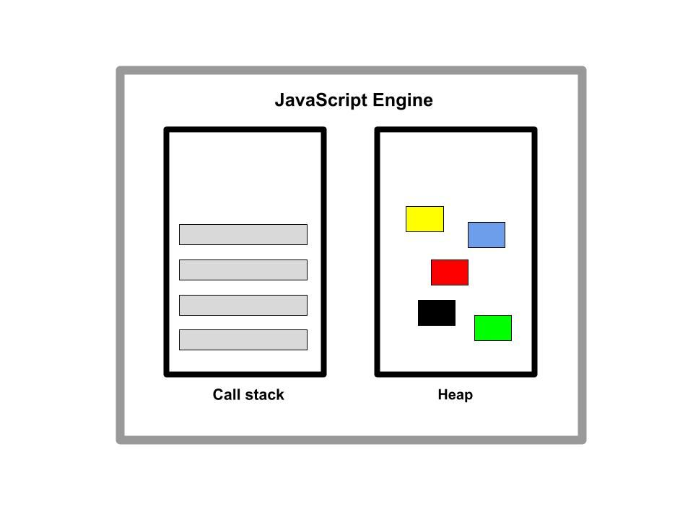

JavaScript Engine showing the Call stack and the Heap

The JavaScript engine is simply a computer program that interprets JavaScript code. The engine is responsible for executing the code.

Every major browser has a JavaScript engine that executes JavaScript code. The most popular one is the Google Chrome [V8](https://en.wikipedia.org/wiki/JavaScript_engine) engine. Google’s V8 powers Google Chrome and [Node.js](https://nodejs.org/en/docs), a back-end JavaScript runtime environment used to build server-side applications.

Other major browser engines include:

* SpiderMonkey developed by Mozilla for Firefox
* JavaScriptCore which powers the Safari browser
* Chakra which powers Internet Explorer

Any JavaScript engine typically contains a call stack and a heap. The call stack is where the code is executed. The heap is an unstructured memory pool that stores all the objects needed for the application.

Since the computer’s processor only understands binary, 0’s and 1’s, the code has to be translated to 0’s and 1’s.

When a code snippet passes into the engine, the code is initially parsed, that is read. The code is subsequently parsed to a data structure called the abstract syntax tree (AST). The resulting tree is then used to create machine codes.

Execution happens in the JavaScript engine call stack using the execution context. This is the environment where JavaScript code is executed.

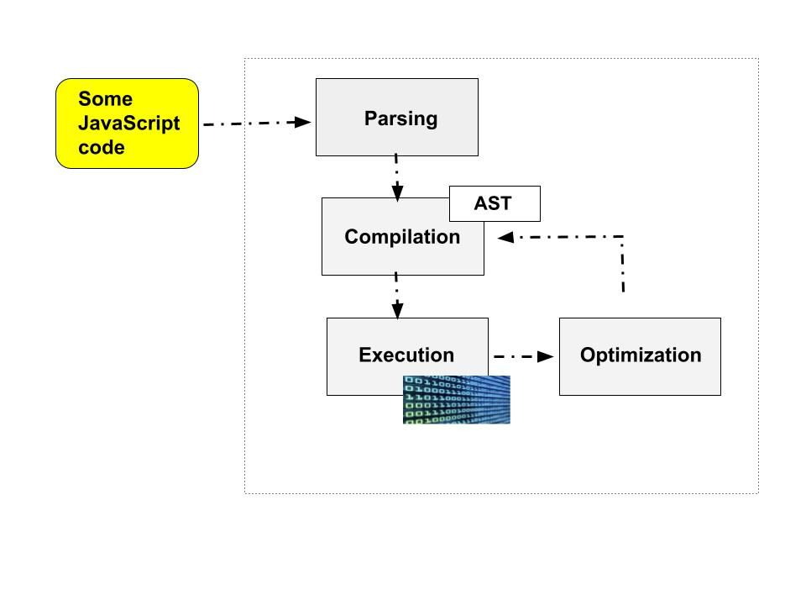A diagram illustration showing the JavaScript execution process

## **The JavaScript Runtime**

Think of the JavaScript runtime as the house that encompasses all the components needed to run JavaScript. This house comprises the JavaScript engine, Web APIs, and the callback queue.

Web APIs are functionalities that are provided to the engine but are not part of the JavaScript language. They are accessible to the engine through the browser and help access data or enhance browser functionality. Examples are the Document Object Model (DOM) and Fetch APIs.

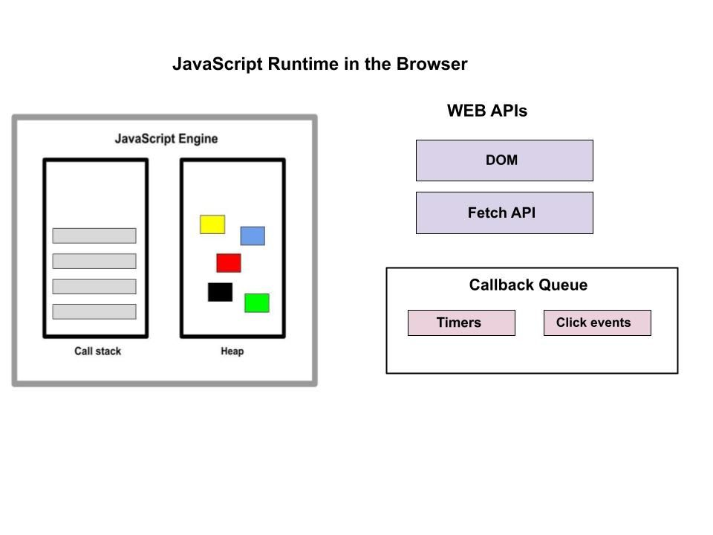

A diagram of JavaScript Runtime in the Browser containing the JavaScript Engine, WEB APIs, and the Callback Queue

The callback queue includes callback functions that are ready to be executed. The callback queue ensures that callbacks are executed in the First-In-First-Out (FIFO) method and they get passed into the stack when it’s empty.

The browser runtime and Node.js are examples of runtime environments.

When JavaScript executes within a web browser it is operating within the browser’s runtime environment. The browser runtime environment provides access to the DOM which enables interaction with web page elements, handling events, and manipulating the page structure.

Node.js provides a server-side runtime environment for executing JavaScript outside the browser. Because it executes JavaScript outside the browser, it does not have access to the web APIs. Instead, the Node.js runtime environment replaces it with something called C++ bindings and the thread pool.

## **JavaScript Optimization Strategies**

Modern JavaScript engines have some optimization strategies put in place to enhance the performance of code execution. These optimizations occur dynamically during the execution process. Let's look at some of these strategies.

### **Just-in-Time compilation**

The process that involves the translation of JavaScript code into machine code occurs using compilation and interpretation.

In compilation, the entire source code is converted into machine code at once and written into a binary file to be executed by the computer.

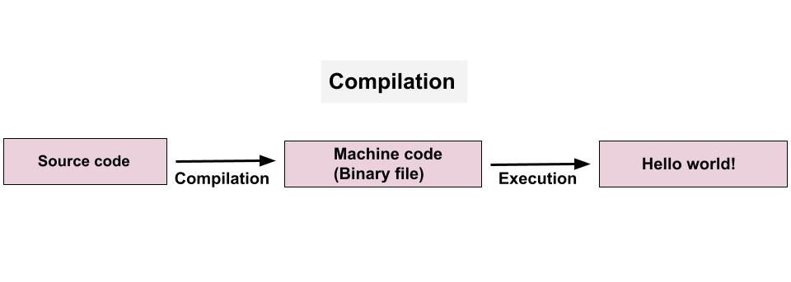

A diagram showing the code compilation process

In contrast, during interpretation, the interpreter goes through the source code and interprets it line by line, executing each line as it encounters it.

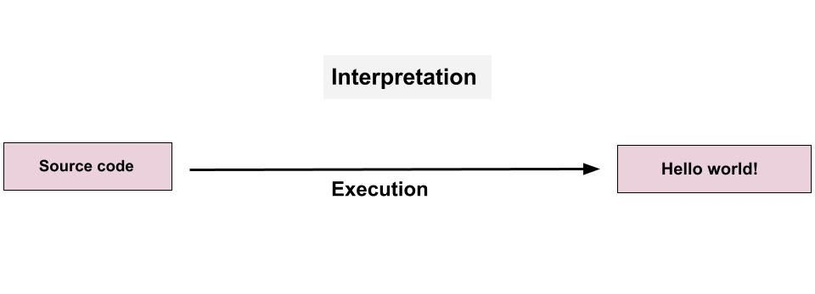

A diagram showing the code interpretation process

JavaScript used to be an interpreted language, but interpreted languages are slower compared to compiled languages.

In order to optimize the performance of web applications, JavaScript combines both compilation and interpretation. This is called Just-in-Time compilation. This method compiles the entire code into machine code all at once and executes it.

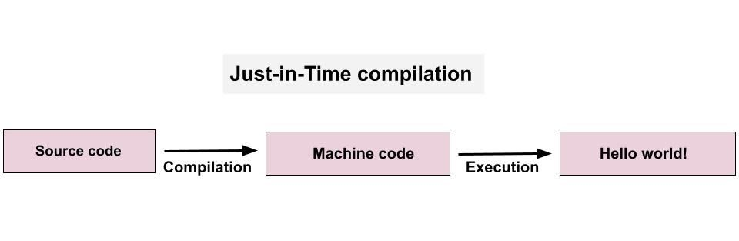

A diagram showing Just-in-Time compilation of code

Just-in-Time compilation involves the same two processes as regular compilation, but here the machine code isn’t written into a binary file. The code is also executed right away after compilation.

This has had a significant impact on the speed of code execution in JavaScript. So hopefully this helps dispel the notion that JavaScript is a purely interpreted language.

To fully optimize JavaScript code, the engine first creates an unoptimized version of the machine code so it can start executing immediately. While that is ongoing, the code is being re-optimized and recompiled in the background of the currently running program execution. This is done multiple times to produce the final, most optimized version.

The process of parsing, compilation, and execution happens in some special thread in the engine that can’t be accessed from the code.

# JavaScript Execution Context – How JS Works Behind the Scenes

Let's look at an example so we can learn more:

var n = 5;

function square(n) {

var ans = n * n;

return ans;

}

var square1 = square(n);

var square2 = square(8);

console.log(square1)

console.log(square2)

In the above code,

1. n is initialized and assigned a value of 5
2. We defined a function square() that accepts an argument n and returns the square of n.
3. We call the square() function and store the returned value in the square1 variable.
4. We call the square() function and store the returned value in the square2 variable.
5. Finally, it outputs both square1 and square2

Behind the scenes, JavaScript is doing so many things. Let's understand all of it.

## **What is the Execution Context?**

When the JavaScript engine scans a script file, it makes an environment called the **Execution Context**that handles the entire transformation and execution of the code.

During the context runtime, the parser parses the source code and allocates memory for the variables and functions. The source code is generated and gets executed.

There are two types of execution contexts: **global** and **function**. The global execution context is created when a JavaScript script first starts to run, and it represents the global scope in JavaScript. A function execution context is created whenever a function is called, representing the function's local scope.

### **Phases of the JavaScript Execution Context**

There are two phases of JavaScript execution context:

1. **Creation phase**: In this phase, the JavaScript engine creates the execution context and sets up the script's environment. It determines the values of variables and functions and sets up the scope chain for the execution context.
2. **Execution phase**: In this phase, the JavaScript engine executes the code in the execution context. It processes any statements or expressions in the script and evaluates any function calls.

Everything in JS happens inside this execution context. It is divided into two components. One is memory and the other is code. It is important to remember that these phases and components are applicable to both global and functional execution contexts.

### **Creation Phase**

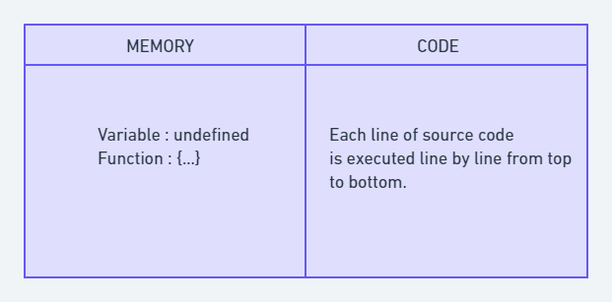

Execution Context

Let's take this simple example once again:

var n = 5;

function square(n) {

var ans = n * n;

return ans;

}

var square1 = square(n);

var square2 = square(8);

console.log(square1)

console.log(square2)

At the very beginning, the JavaScript engine executes the entire source code, creates a global execution context, and then does the following things:

1. Creates a global object that is**window** in the browser and **global** in NodeJs.
2. Sets up a memory for storing variables and functions.
3. Stores the variables with values as undefined and function references.

This is called the creation phase. Here's a diagram to help explain it:

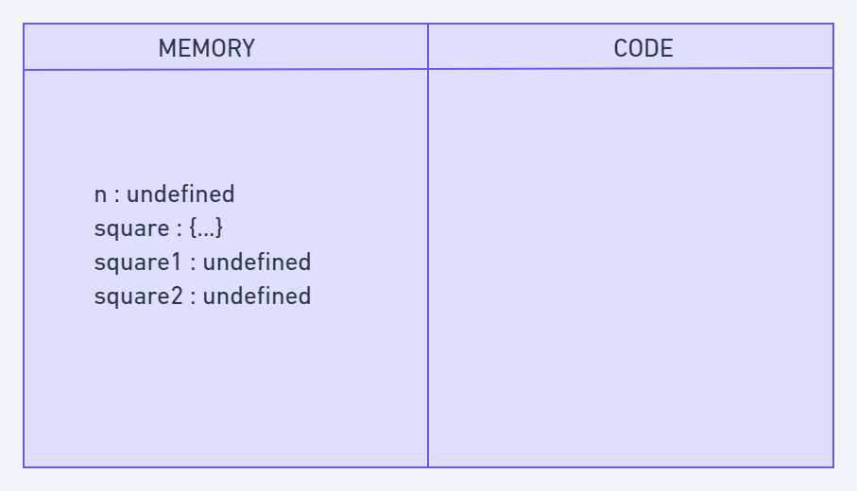

Creation Phase in Execution Context

After this creation phase, the execution context will move to the code execution phase.

### **Execution Phase**

Now, in this phase, it starts going through the entire code line by line from top to bottom. As soon as it encounters **n = 5**, it assigns the value 5 to 'n' in memory. Until now, the value of 'n' was undefined by default.

Then we get to the 'square' function. As the function has been allocated in memory, it directly jumps into the line **var square1 = square(n);**. square() will be invoked and JavaScript once again will create a new function execution context.

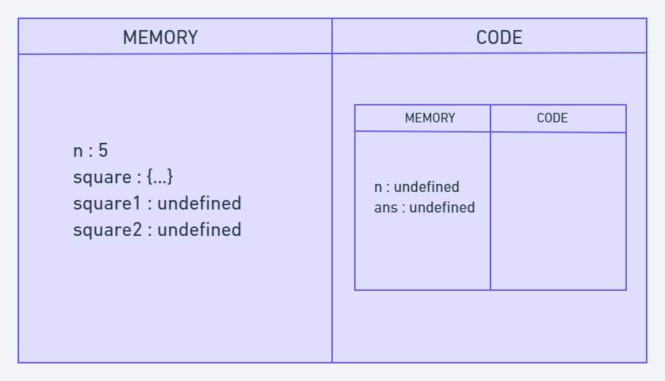

Code Execution Phase

Once the calculation is done, it assigns the value of square in the 'ans' variable that was undefined before. The function will return the value, and the function execution context will be destroyed.

The returned value from square() will be assigned on square1. This happens for square2 also. Once the entire code execution is done completely, the global context will look like this and it will be destroyed also.

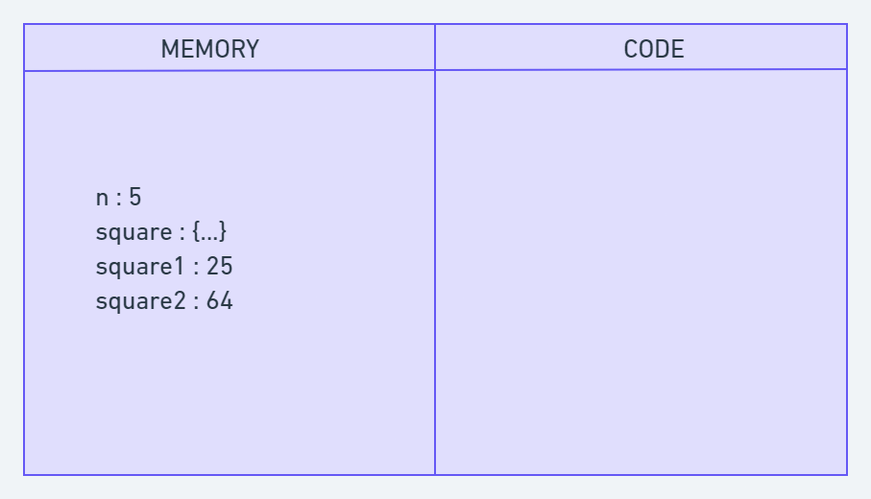

## **What is the Call Stack?**

To keep the track of all the contexts, including global and functional, the JavaScript engine uses a **call stack**. A call stack is also known as an 'Execution Context Stack', 'Runtime Stack', or 'Machine Stack'.

It uses the LIFO principle (Last-In-First-Out). When the engine first starts executing the script, it creates a global context and pushes it on the stack. Whenever a function is invoked, similarly, the JS engine creates a function stack context for the function and pushes it to the top of the call stack and starts executing it.

When execution of the current function is complete, then the JavaScript engine will automatically remove the context from the call stack and it goes back to its parent.

Let's see the following example:

function funcA(m,n) {

return m * n;

}

function funcB(m,n) {

return funcA(m,n);

}

function getResult(num1, num2) {

return funcB(num1, num2)

}

var res = getResult(5,6);

console.log(res); // 30

In this example, the JS engine creates a global execution context that enters the creation phase.

First it allocates memory for funcA, funcB, the getResult function, and the res variable. Then it invokes getResult(), which will be pushed on the call stack.

Then getResult() will call funcB(). At this point, funcB's context will be stored on the top of the stack. Then it will start executing and call another function funcA(). Similarly, funcA's context will be pushed.

Once execution of each function is done, it will be removed from the call stack. The following picture depicts the entire process of the execution:

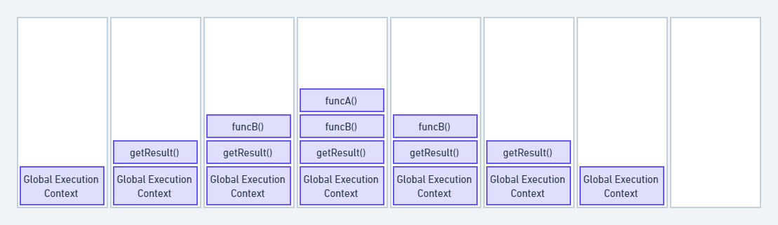

Call Stack

The call stack has its own fixed size depending on the system or browser. If the number of contexts exceeds the limit, then a stack overflow error will occur. This happens with a recursive function that has no base condition.

function display() {

display();

}

display(); //

Output :- RangeError: Maximum call stack size exceeded

## **Conclusion**

In conclusion, JavaScript execution context is a crucial part of understanding how JavaScript works behind the scenes. It determines the environment in which code is executed and what variables and functions are available to use.

The creation phase includes creating the global and function execution contexts, creating the scope chain, and allocating memories for the variables and functions. During the execution phase, the JavaScript engine executes the code line by line. This includes evaluating and executing statements.

# Scope Chains

# Before we get to closures, we have to have an understanding of scope.

# What is **scope** and why does it matter?

# Scope is the context environment (also known as lexical environment) created when a function is written. This context defines what other data it has access to.

Put another way, scope is about access. Does the function have the ability to look up a variable for execution or manipulation, which variables are visible?

There are two types of scope: local and global. Scope resolution, or finding what variables belong where, starts at the innermost context and proceeds outward until the identifier is found. Let’s start small…

var firstNum = 1;

function number() { var secondNum = 2; return firstNum + secondNum;}

number();

The scope chain is similar to the prototype chain. If a variable or property is not found, it continues up the chain until it is either found or a error is thrown. The function creates a hidden [[scope]] property. This property links innermost scopes to outermost scopes. In this case, number’s scope chain is linked to the global window object (the containing context that holds function number). This is what allows the engine to look outside of function number to find firstNum and secondNum.

For example, let’s take the same function number and change one thing:

*// global scope  - includes firstNum, secondNum, and the function number*

*var* firstNum = 1;

*function* number() {

*// local scope for number - only thirdNum is local to number()*

*// because it was explicitly declared. secondNum is implicitly declared in the global scope.*

  secondNum = 2;

*var* thirdNum = 3;

  return firstNum + secondNum;

} *// what do we have access to in the global scope?number(); // 3firstNum; // 1secondNum; // 2thirdNum; // Reference Error: thirdNum is not defined*

When speaking of global scope, variable declarations, non-nested function

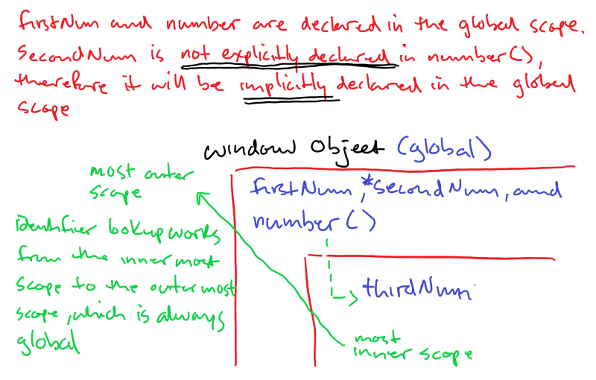When speaking of global scope, variable declarations, non-nested function declarations, and function expressions (still considered a variable definition) are considered in the scope of the global window object in the browser. So as we see above, the window object has a properties firstNum, secondNum, and number added to it. If we proceed along the scope chain looking for it, we keep looking until we reach the global context’s variable object. If it’s not in there, then we get the Reference Error.

In a new tab, type "about:blank" in the search bar. A blank page will open and hit cmd-option-i to open dev tools.

Type the code above and remember, shift-enter for a new line!

Now type "window" and explore all the properties on the window object.

Look closely and you will see the properties firstNum, secondNum, and number are all available on the window object.

When we try to access thirdNum outside of where it was declared, we get a Reference Error. The engine that compiles the code failed to find an identifier in the window global scope object.

ThirdNum is only available inside of the function where it was declared. It is encapsulated or private to function number

The question you may have is “Does the global scope has access to everything inside of number?” Again, scope only works from the inside out, the innermost context, local, to the outermost context, global.

Starting with local scope, we can say that data and variables that are wrapped in a function are only accessible to members of that function. The scope chain is what links firstNum to number().

**When number() is invoked, the non-technical conversation goes like this…**

***Engine:****“Number, I’m giving you a new execution context. Let me find what you need to run”*

***Engine****: “Ok, I see that thirdNum is explicitly declared. I’m setting space aside for you, go to the top of number’s function block and wait till I call you…*

***Engine****: “Number, I see secondNum, does he belong to you?”*

***Number****: “Nope.”*

***Engine****: “Ok, I see you’re linked to the global window object, let me look outside of you.”*

***Engine****: “Window, I have an identifier named secondNum, does he belong to you?”*

***Window****: “He didn’t declare himself explicitly in Number with a var, let, or*  
*const, so I’ll take him and set space aside.”*

***Engine****: “Cool. Number, I see firstNum in your function block, does he belong to you?”*

***Number****: “Nope.”*

***Engine****: “Window, I see firstNum being used inside of Number, he needs him, does he belong to you?”*

***Window****: “Yes, he was declared.”*

***Engine****: “Everyone is accounted for, Now I’m assigning values to variables.”*

***Engine****: Number, I’m executing you, ready, go!”*

That’s pretty much it for understanding scope, The key takeaways are:

1. Identifier lookup works from the inside out and stops at the first match.
2. There are two types of scope, global and local
3. The scope chain is created at function invocation and is based on where variables and/or blocks of code are written (lexical environment). Are variables or functions nested?
4. In JavaScript, if an identifier is not proceeded with a var, let, or const, it is implicitly declared in the global scope.
5. Scope does not go 1 for 1 with a function, it goes 1 to 1 with function invocation. Execute a function 3 times, get 3 different scopes. Why? Because if the execution of a function is finished, it is popped off the execution stack and with it, its access to other variables via its scope chain. Thus, a new scope is created each time a function is executed. Closures work a little differently!

# What is Hoisting in JavaScript?

In JavaScript, hoisting allows you to use functions and variables before they're declared. In this we learn what hoisting is and how it works.

## **What is hoisting?**

Take a look at the code below and guess what happens when it runs:

console.log(foo);

var foo = 'foo';

It might surprise you that this code outputs**undefined** and doesn't fail or throw an **error** – even though foo gets assigned after we console.log it!

This is because the JavaScript interpreter splits the declaration and assignment of functions and variables: it "hoists" your declarations to the top of their containing scope before execution.

This process is called hoisting, and it allows us to use foo before its declaration in our example above.

Let's take a deeper look at functions and variable hoisting to understand what this means and how it works.

### **Variable hoisting with var**

When the interpreter hoists a variable declared with var, it initializes its value to undefined. The first line of code below will output undefined:

console.log(foo); // undefined

var foo = 'bar';

console.log(foo); // "bar"

As we defined earlier, hoisting comes from the interpreter splitting variable declaration and assignment. We can achieve this same behavior manually by splitting the declaration and assignment into two steps:

var foo;

console.log(foo); // undefined

foo = 'foo';

console.log(foo); // "foo"

Remember that the first console.log(foo) outputs undefined because foo is hoisted and given a default value (not because the variable is never declared). Using an undeclared variable will throw a ReferenceError instead:

console.log(foo); // Uncaught ReferenceError: foo is not defined

Using an undeclared variable before its assignment will also throw a ReferenceError because no declaration was hoisted:

console.log(foo); // Uncaught ReferenceError: foo is not defined

foo = 'foo'; // Assigning a variable that's not declared is valid

By now, you may be thinking, "Huh, it's kind of weird that JavaScript lets us access variables before they're declared." This behavior is an unusual part of JavaScript and can lead to errors. Using a variable before its declaration is usually not desirable.

Thankfully the let and const variables, introduced in ECMAScript 2015, behave differently.

### **Variable hoisting with let and const**

Variables declared with let and const are hoisted but not initialized with a default value. Accessing a let or const variable before it's declared will result in a ReferenceError:

console.log(foo); // Uncaught ReferenceError: Cannot access 'foo' before initialization

let foo = 'bar'; // Same behavior for variables declared with const

Notice that the interpreter still hoists foo: the error message tells us the variable is initialized somewhere.

### **The temporal dead zone**

The reason that we get a reference error when we try to access a let or const variable before its declaration is because of the temporal dead zone (TDZ).

The TDZ starts at the beginning of the variable's enclosing scope and ends when it is declared. Accessing the variable in this TDZ throws a ReferenceError.

Here's an example with an explicit [block](https://developer.mozilla.org/en-US/docs/Web/JavaScript/Reference/Statements/block) that shows the start and end of foo's TDZ:

{

// Start of foo's TDZ

let bar = 'bar';

console.log(bar); // "bar"

console.log(foo); // ReferenceError because we're in the TDZ

let foo = 'foo'; // End of foo's TDZ

}

The TDZ is also present in default function parameters, which are evaluated left-to-right. In the following example, bar is in the TDZ until its default value is set:

function foobar(foo = bar, bar = 'bar') {

console.log(foo);

}

foobar(); // Uncaught ReferenceError: Cannot access 'bar' before initialization

But this code works because we can access foo outside of its TDZ:

function foobar(foo = 'foo', bar = foo) {

console.log(bar);

}

foobar(); // "foo"

### **typeof** in the temporal dead zone

Using a let or const variable as an operand of the typeof operator in the TDZ will throw an error:

console.log(typeof foo); // Uncaught ReferenceError: Cannot access 'foo' before initialization

let foo = 'foo';

This behavior is consistent with the other cases of let and const in the TDZ that we've seen. The reason that we get a ReferenceError here is that foo is declared but not initialized – we should be aware that we're using it before initialization ([source: Axel Rauschmayer](https://2ality.com/2015/10/why-tdz.html)).

However, this isn't the case when using a var variable before declaration because it is initialized with undefined when it is hoisted:

console.log(typeof foo); // "undefined"

var foo = 'foo';

Furthermore, this is surprising because we can check the type of a variable that doesn't exist without an error. typeof safely returns a string:

console.log(typeof foo); // "undefined"

In fact, the introduction of let and const broke typeof's guarantee of always returning a string value for any operand.

## **Function hoisting in JavaScript**

Function declarations are hoisted, too. Function hoisting allows us to call a function before it is defined. For example, the following code runs successfully and outputs "foo":

foo(); // "foo"

function foo() {

console.log('foo');

}

Note that only function declarations are hoisted, not function expressions. This should make sense: as we just learned, variable assignments aren't hoisted.

If we try to call the variable that the function expression was assigned to, we will get a TypeError or ReferenceError, depending on the variable's scope:

foo(); // Uncaught TypeError: foo is not a function

var foo = function () { }

bar(); // Uncaught ReferenceError: Cannot access 'bar' before initialization

let bar = function () { }

baz(); // Uncaught ReferenceError: Cannot access 'baz' before initialization

const baz = function () { }

This differs from calling a function that is never declared, which throws a different ReferenceError:

foo(); // Uncaught ReferenceError: baz is not defined

### **Temporal Dead Zone**

So, if the let and const are also hoisted, why is it that they cannot be accessed before their declaration? The answer to this lies within the concept of the Temporal Dead Zone (TDZ).

Variables declared using let and the constants declared using const are hoisted but are in a TDZ. This prevents them from being accessed before their declaration has actually been executed during the step-by-step execution of the code.

**Temporal Dead Zone** is the period of time during which the let and const declarations cannot be accessed.

Temporal Dead Zone starts when the code execution enters the block which contains the let or const declaration and continues until the declaration has executed.

In our code example above, Temporal Dead Zone starts after the opening parenthesis of the printAge function and continues until after the declaration of the age variable.

Consider the following code example that illustrates an interesting point about the Temporal Dead Zone.

  function print() {

    function log() {

      console.log(age);

    }

    const age = 20;

    log();

  }

  print(); *// 20*