DEFECT REPORT
Proton Mail Web Application – Compose Window After Draft Deletion
Title | Compose email window remains open after the draft is permanently deleted
Module | Drafts / Compose Email
Severity | Medium (suggested)
Priority | P2 – Normal (suggested)
Status | New / Open
Environment | Proton Mail web application on desktop; browser/version not recorded

1. Description
When a user opens a saved draft and permanently deletes it, the application confirms that the draft was deleted, but the compose email window remains open. Reloading the page closes the compose window. The main defect is that the compose window does not close automatically after successful draft deletion.

2. Preconditions
- The user is signed in to Proton Mail.
- At least one saved draft is available in the Drafts folder.

3. Steps to Reproduce
- Open Proton Mail and navigate to Drafts.
- Open a saved draft email (the observed draft subject/ID ended in 4480).
- Click the permanent-delete control for the draft.
- In the confirmation dialog, click Delete.
- Wait for the “Draft deleted” confirmation message.
- Observe that the compose window is still open. Do not reload the page yet.
- Reload the page and observe that the compose window closes.

4. Actual Result
- The application displays a “Draft deleted” confirmation.
- The compose email window remains open after the draft has been permanently deleted.
- Reloading the page closes the compose window.
- The Drafts list may also show stale information until refreshed; this is secondary to the main defect.

5. Expected Result
- After successful deletion of a draft, the compose email window should close automatically without requiring a page reload.
- The UI should immediately reflect that the deleted draft is no longer open.

6. Workaround in Automation
A page reload was added to the Playwright automation because the compose window does not close after deletion. Reloading closes the window, allowing the test to continue. This is a workaround in the test, not a fix for the application defect.

7. Evidence
The screenshots document the draft being opened, the permanent-delete action, the deletion confirmation, the compose window remaining open after deletion, and the window closing after a page reload.
Screenshot 1 – Open the saved draft (subject/ID ending in 4480).
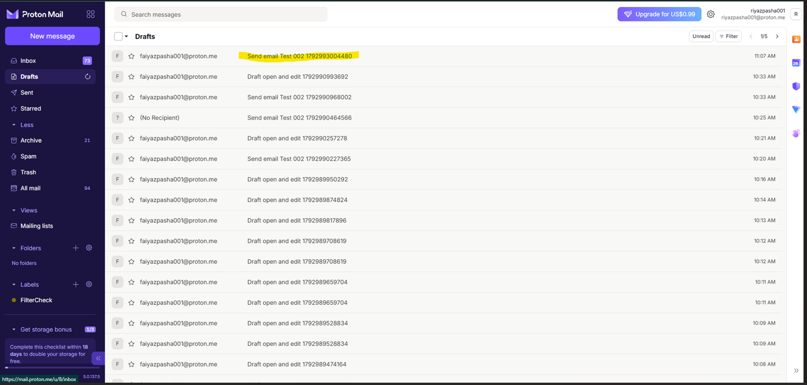
Screenshot 2 – Select the permanent-delete control.
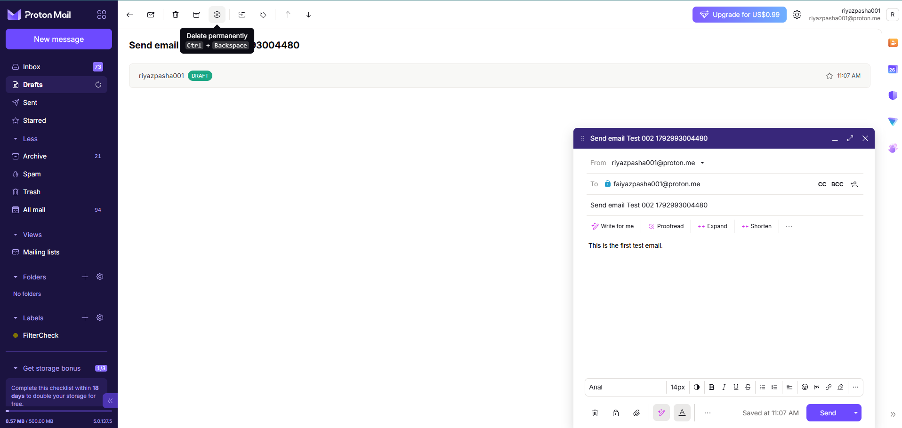
Screenshot 3 – Confirm deletion by clicking Delete.
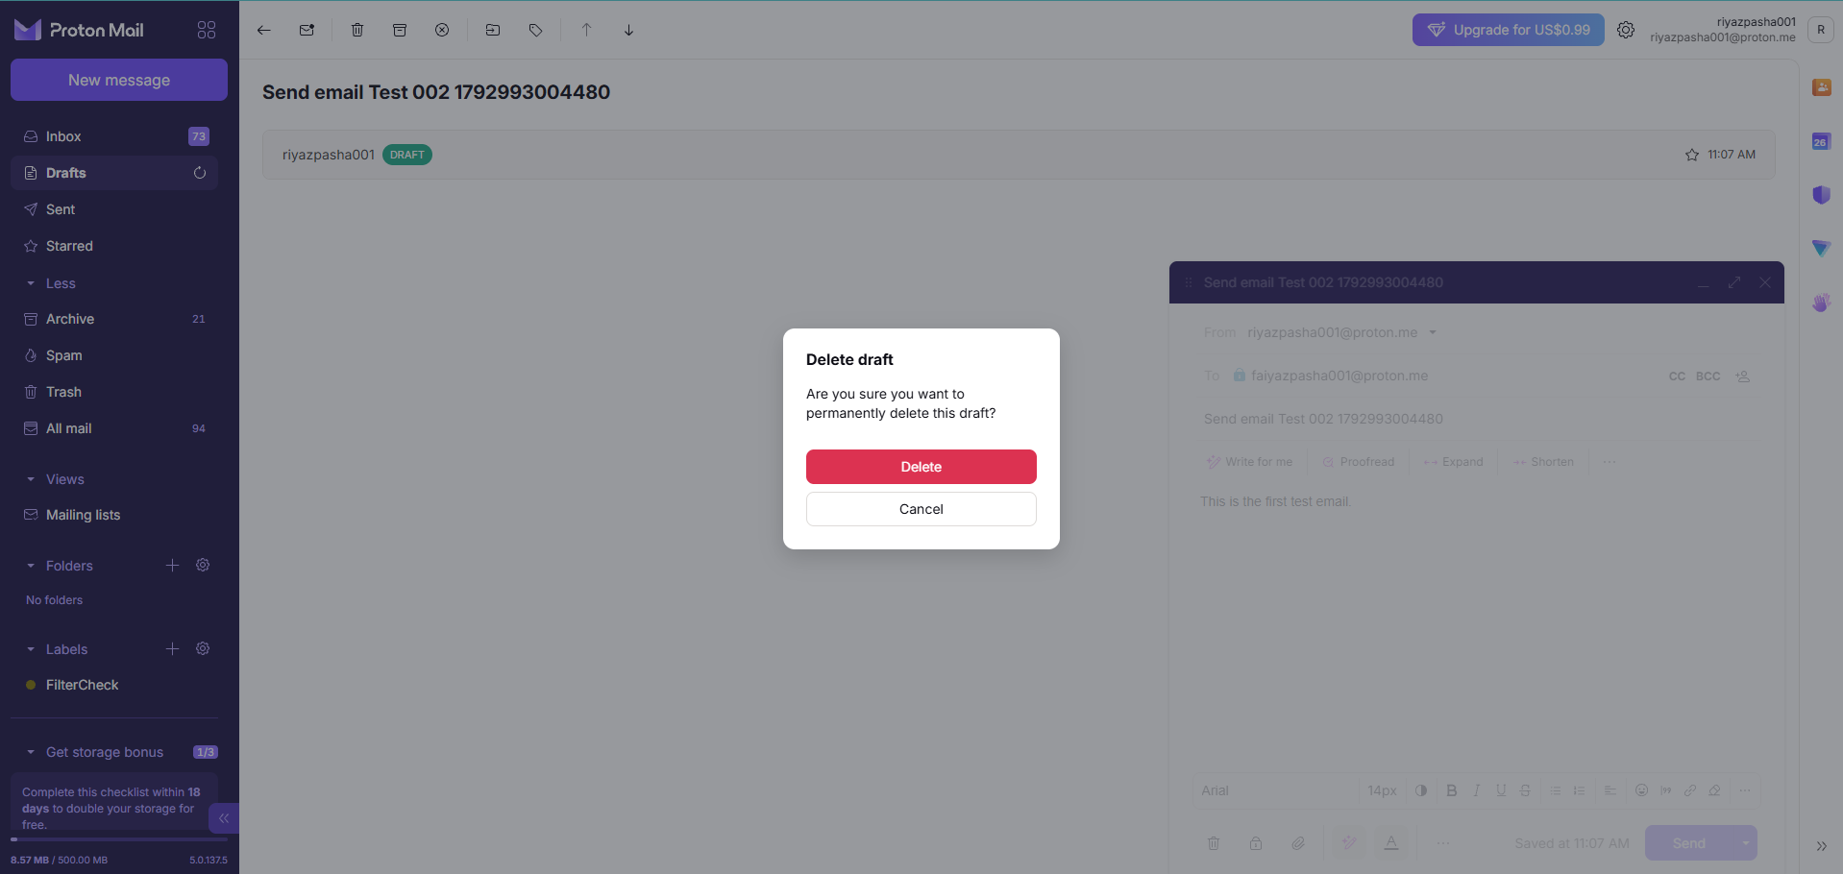
Screenshot 4 – The deletion confirmation appears, but the compose window remains open.
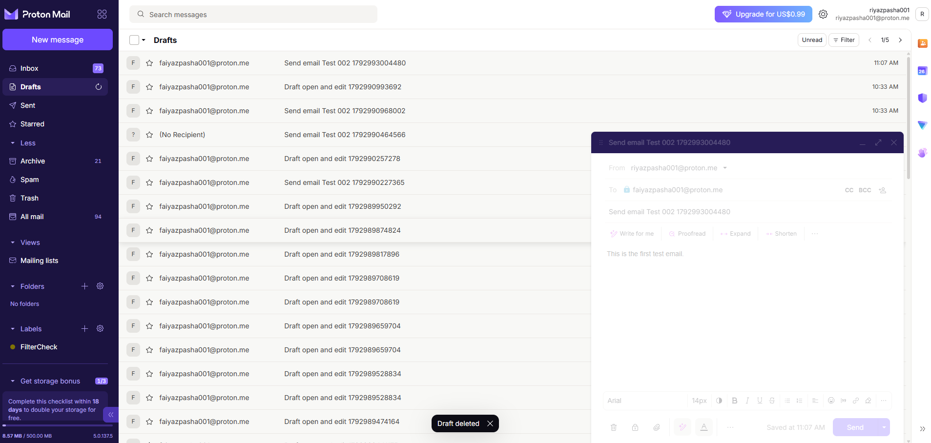

Screenshot 5 – The compose window remains open after deletion; the Drafts list may be stale.

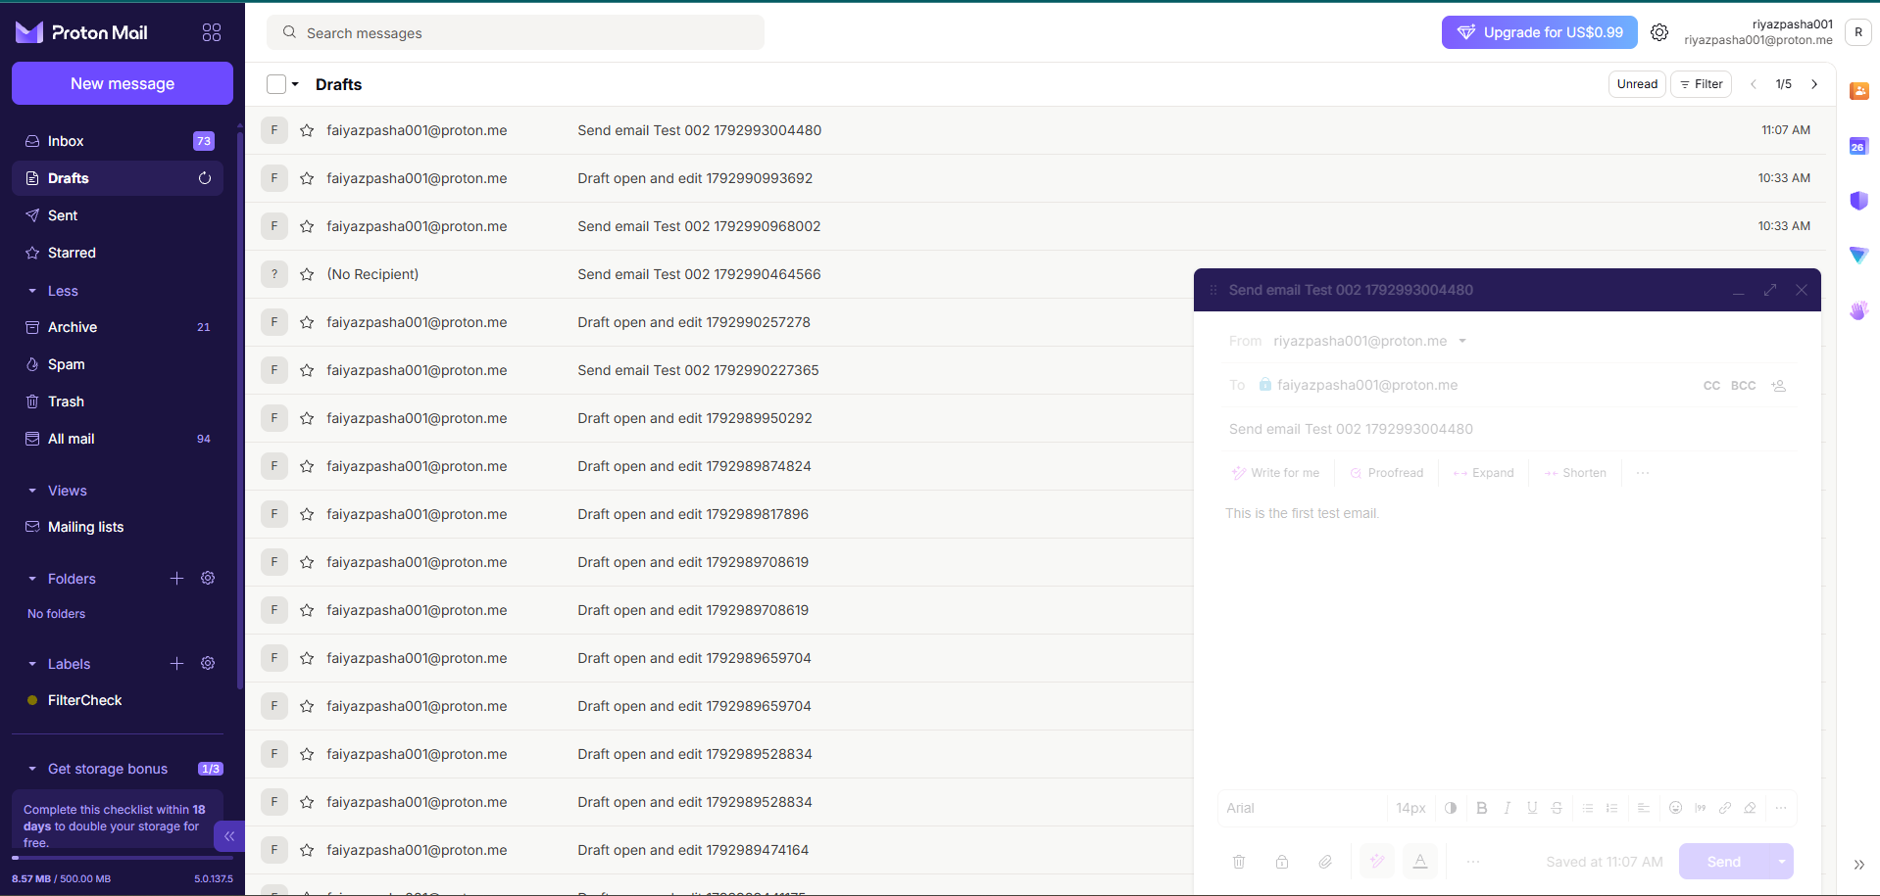

Screenshot 6 – After reloading the page, the compose window closes.

