

LAB Manual

**Mobile Application Development Subject Code - 702AI0E002**

# School of Technology Management & Engineering SVKM'S-NMIMS, Navi Mumbai

**[2023-24]**

* 1. **Aim:**

LAB Manual PART A

(PART A: TO BE REFFERED BY STUDENTS)

# Experiment No.02

To understand General UI Design/ Development of Interactive application.

* + 1. Development of an android application for a basic calculator.
    2. Development of an android application "Know your number" which provides an opening screen that introduces the problem and allows the user to provide the number as an input. It should also allow the user to choose among the various options that are
       1. Factorial of the number (ii) Is the number Even/Odd. Depending on the user's choice the answer is to be displayed. The application should display pleasing styles.

## Prerequisite:

Java Basics

## Outcome:

After successful completion of this experiment students will be able to understand

* Activity creation (Layout and MainActivity)
* Working of primary widgets like TextView, EditText, Button
* Input collection from User
* Adding Behavior to Button
* Displaying Result on Activity Screen

## Theory:

### Views:

* Views and ViewGroups are important in designing the UI of an android application.
* View is the basic building block of UI (User Interface) in android. View refers to the android.view.View class, which is the super class for all the GUI components like TextView, ImageView, Button etc.
* View can be considered as a rectangle on the screen that shows some type of content. It can be an image, a piece of text, a button or anything that an android application can display. The rectangle here is invisible, but every view occupies a rectangle shape.
* The size of the rectangle can be set manually, by specifying the exact size (with proper units) or by using some predefined values. These predefined values are match_parent (it will occupy the complete space available on the display of the device) and wrap_content (it will occupy only that much space as required for its content to display)
* A View is also known as Widget in Android. Any visual (that we can see on screen) and interactive (with which user can interact with) is called a Widget.
* There are two attributes that are necessary for every View. These are: android: layout_height and android:layout_width. These attributes define the size of the invisible rectangle that a view makes. Using these attributes, we can easily control the size for every view in our android application.

### Android View classes:

* + Some of the most used android View classes:
  + TextView
  + EditText
  + Button
  + ImageView
  + ImageButton
  + CheckBox
  + RadioButton
  + ListView
  + GridView
  + DatePicker
  + Spinner, etc.

PART B

(PART B: TO BE COMPLETED BY STUDENTS)

***(Students must submit the soft copy as per following segments as per the submission instructions. The soft copy must be uploaded on MS Teams)***

|  |  |
| --- | --- |
| Roll No.: B217 | Name: Riya Vengurlekar |
| Class: Btech CE | Batch: A1 |
| Experiment Number: 02 | |
| Date of Experiment: | Date of Submission: |
| Grade: |  |

* 1. **Answers of Task to be written by student:**

**Task 1.**

**Calci.java**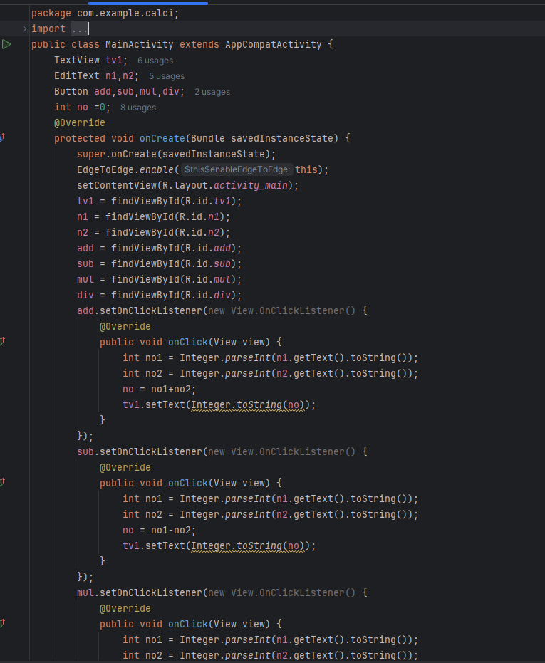

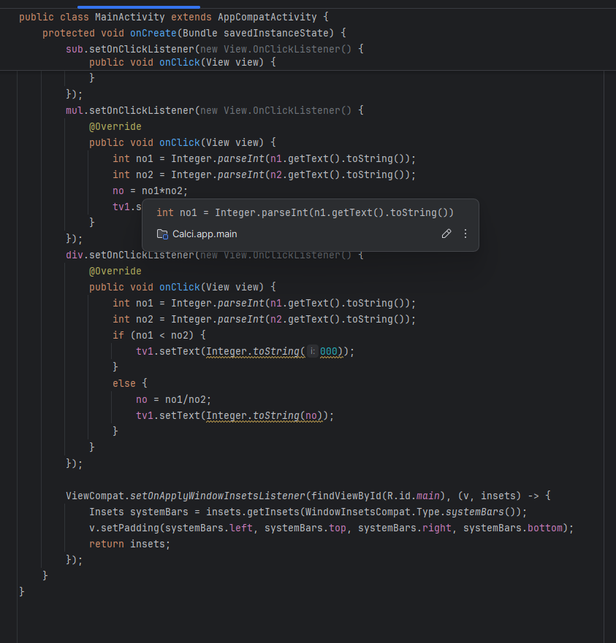

**Activity.xml**

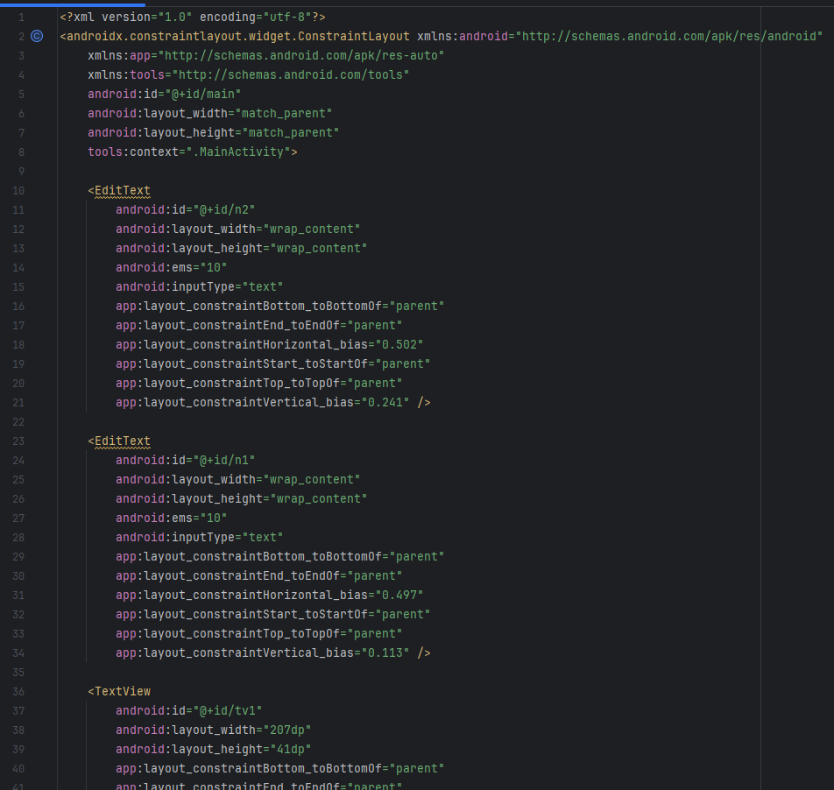

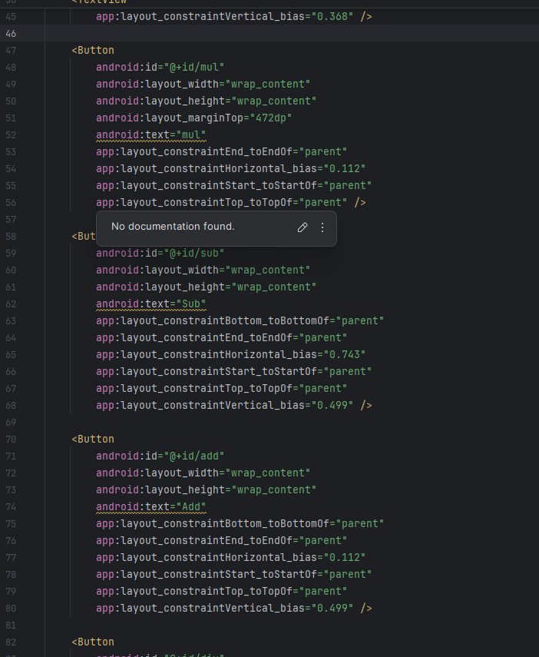

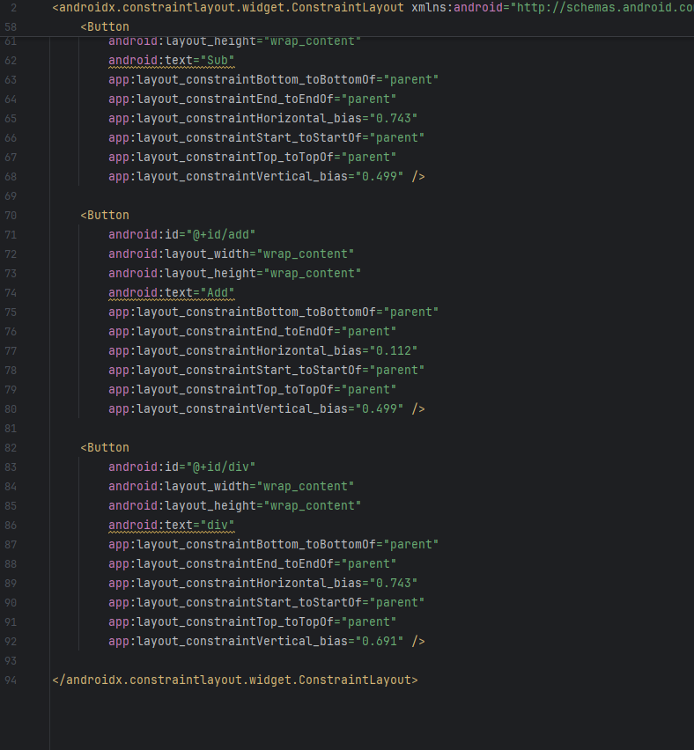

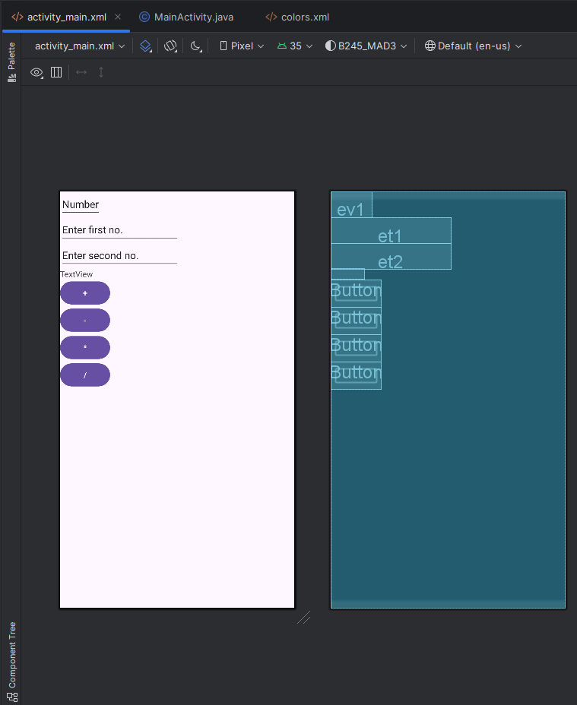

**Color.xml**

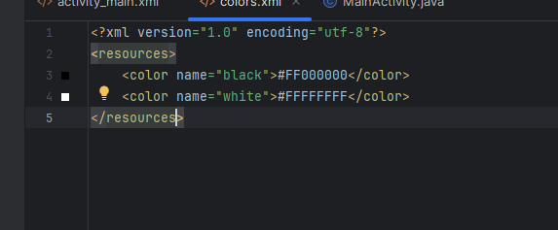

**Output**

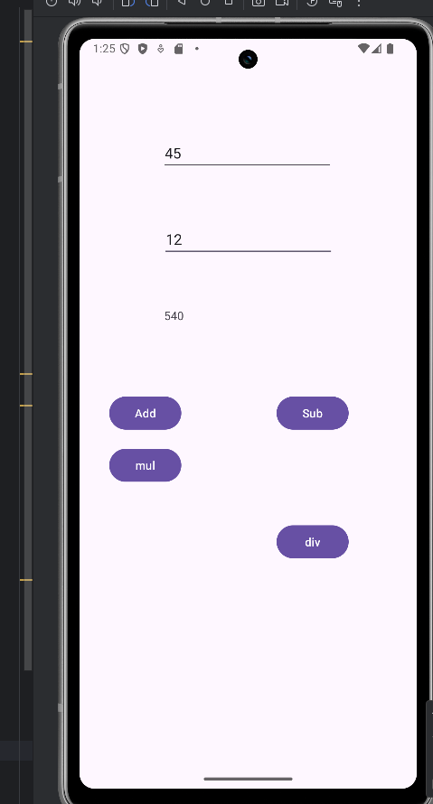

Task 2.

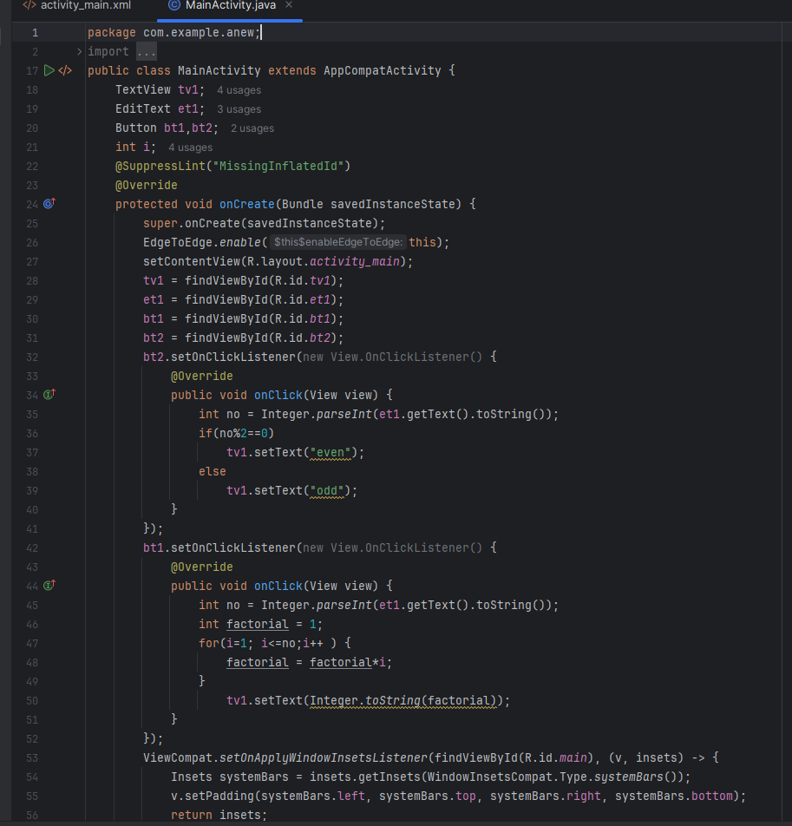

**Activity.xml**

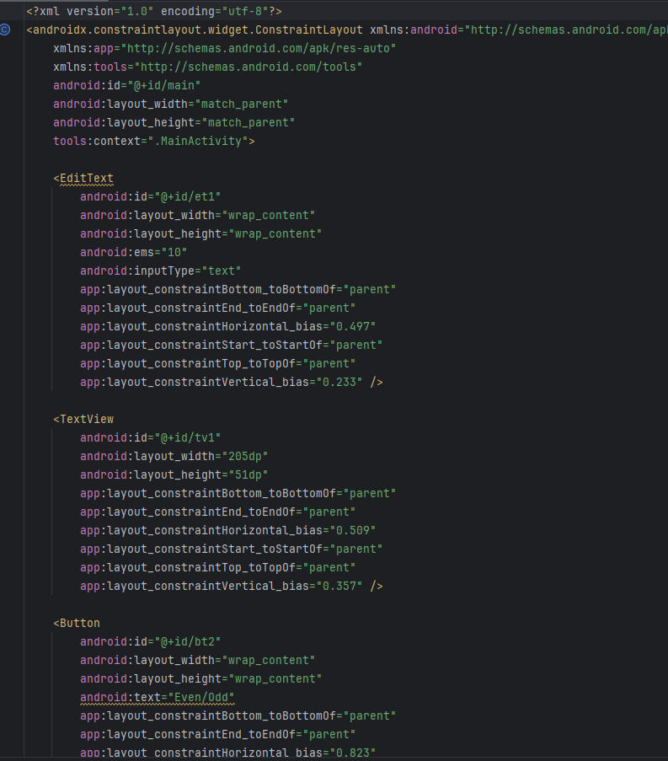

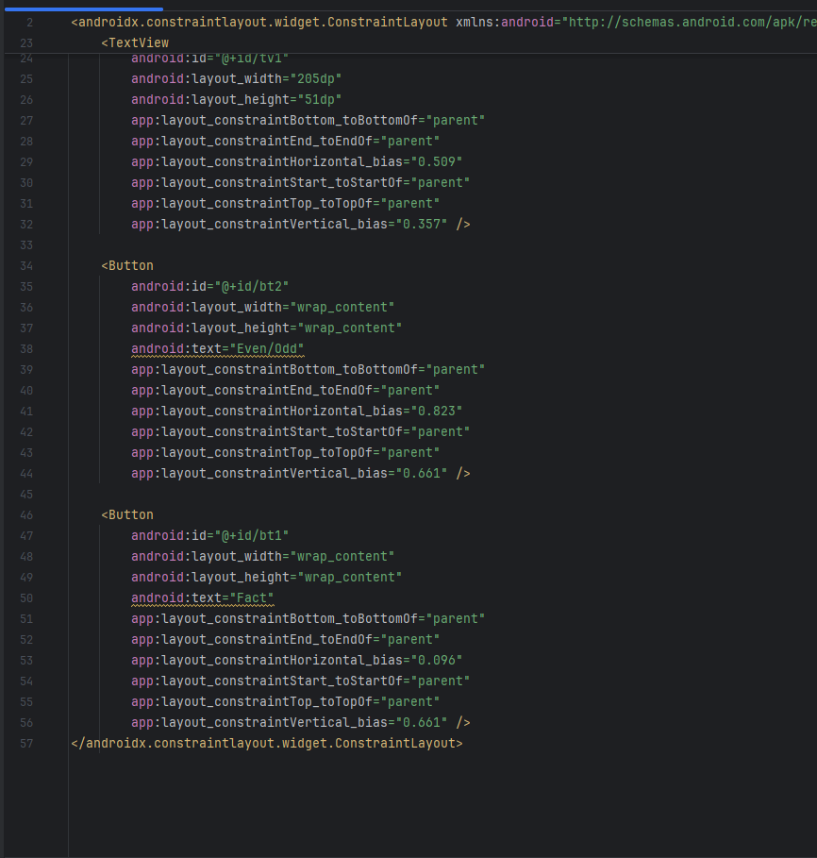

**Color.xml**

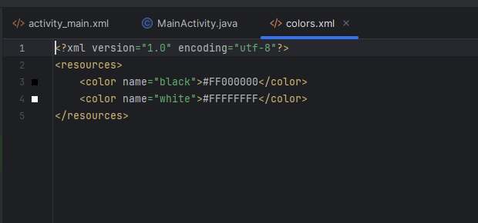

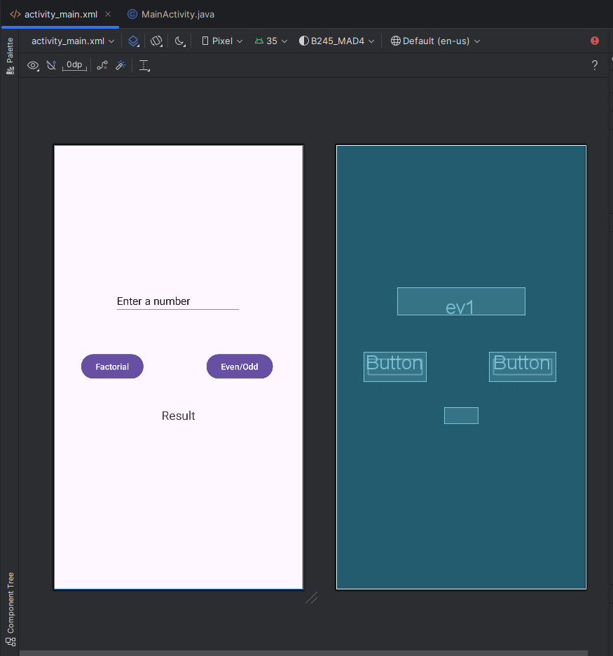

**Output**

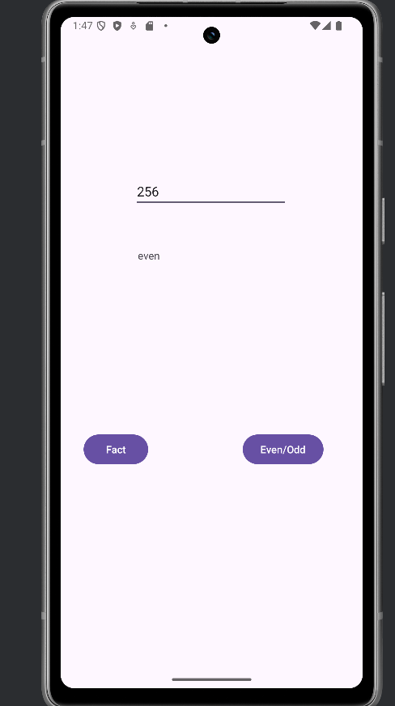

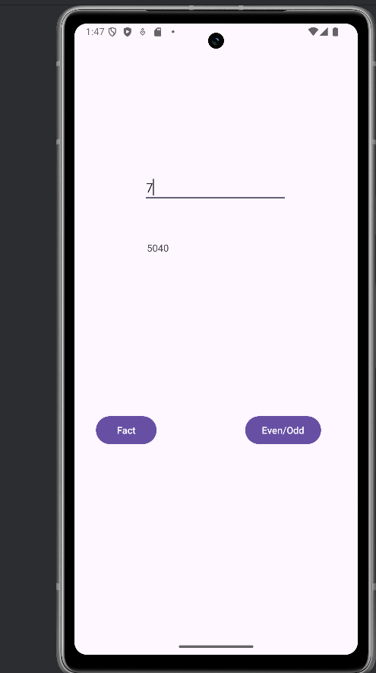

### Task 1:

* + 1. Develop an android application for a basic calculator (exhibiting 4 operations, Addition, Subtraction, Multiplication, Division)
    2. Development of an android application "Know your number" which provides an opening screen that introduces the problem and allows the user to provide the number as an input. It should also allow the user to choose among the various options that are
       1. Factorial of the number (ii) Is the number Even/Odd. Depending on the user's choice the answer is to be displayed. The application should display pleasing styles.
  1. **Conclusion (Learning Outcomes):** Reflect on the questions answered by you and write down your learnings about the topic given:
  2. **Assignment Questions**

### Q1. Answer the following.

1. Explain how can android:onClick attribute be used to add behavior to Button. Supplement your answer with an appropriate code snippet.

Ans: It helps us to create our own function that will execute on a click event.



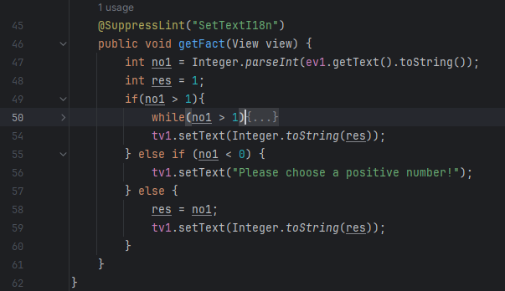

1. What are the various methods in a Toast class in Android Programming? How can you position your toast? With an example code, display a toast “Toast Testing” on click of a button through an application.

Ans: The Toast class in Android is used to display brief messages to the user. Here are some of the key methods in the Toast class:

makeText(Context context, CharSequence text, int duration): Creates a Toast object with the specified text and duration.

show(): Displays the Toast message.

setMargin(float horizontalMargin, float verticalMargin): Sets the horizontal and vertical margins of the Toast.

setGravity(int gravity, int xOffset, int yOffset): Positions the Toast at a specified location on the screen.

To position your Toast, you can use the setGravity method. This method takes three parameters:

gravity: A constant from the Gravity class (e.g., Gravity.TOP, Gravity.BOTTOM, Gravity.CENTER).

xOffset: The x-axis offset from the specified gravity position.

yOffset: The y-axis offset from the specified gravity position.

1. There are some predefined colors in Android Studio that are stored

under color.xml file. Answer the following questions in the context of color.xml.

* 1. Where is the file found.

Ans: res/values/colors.xml

* 1. How can these colors be accessed?

Ans: With the help of their name.

* 1. How can new colors be defined using color.xml

Ans: create a new color tag like this in colors.xml file.

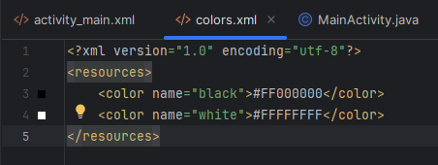

* 1. Why is it good practice to do so?

Ans: Because it will easier to make any changes in it. Also, we won’t have to hard-code any color if we do it like this.