<FlyShare -> AirForShare Clone>

Submitted By
Muhammad Riyyan Siddiqui
Project Leader 22k-4452

Student-1 Muhammad Fasih
Student-1 22k-4486

Department of Computer Science
National University of Computer & Emerging Sciences

- Motivation
The motivation behind this project stems from the frequent usage of "AirForShare" in our daily lives for quick and easy file and text sharing. As a computer science student, I was intrigued by the underlying networking principles and implementation of such a tool. I believed that with our academic and technical background, we could design and build a similar yet enhanced web application. This curiosity drove the development of FlyShare — a refined, efficient, and user-aware alternative to AirForShare.
.
- Overview
  - Significance of the Project
This project is highly significant due to its real-world applications and usability across various domains such as offices, schools, and colleges. It simplifies the process of sharing messages and files by eliminating the limitations of traditional methods like email or Bluetooth, which can be time-consuming, require authentication, or may not work across different platforms effectively.
  - Description of the Project
FlyShare is a web-based application designed for file and text sharing over the same internet network. It logically segregates users based on their local IP addresses. The application utilizes WebSockets for real-time text communication and FTP (File Transfer Protocol) for reliable file transfers.
  - Background of the Project
FlyShare is inspired by the functionality and concept of the AirForShare platform. However, the entire application was developed from scratch without relying on pre-built GitHub repositories. Development was guided by official documentation and online resources, including WebSocket APIs, FTP server libraries, tunneling tools like Ngrok, and cloud deployment platforms like Vercel. These resources provided foundational insights into integrating networking and web technologies seamlessly.
References (APA Style):
- Mozilla. (n.d.). WebSockets API. MDN Web Docs. Retrieved from https://developer.mozilla.org/en-US/docs/Web/API/WebSockets_API
- npm. (n.d.). basic-ftp. Retrieved from https://www.npmjs.com/package/basic-ftp
- Ngrok. (n.d.). Ngrok documentation. Retrieved from https://ngrok.com/docs
- Vercel. (n.d.). Vercel documentation. Retrieved from https://vercel.com/docs

  - Project Category
This project falls under the Software as a Service (SaaS) category. It delivers a cloud-based solution accessible through the browser without the need for installations or configurations on the client side.
- Features / Scope / Modules
Following are the features of FlyShare webapp in the order of most significant:
The main features of the FlyShare web application are listed below in order of significance:
- File and Text Sharing on the Same Network
The core functionality allows users on the same local network to share files and messages. WebSockets enable instant text communication, while FTP servers handle file transfers efficiently.
- User Tracking and Monitoring
Unlike AirForShare, FlyShare includes a user-tracking module that displays active users, their identities (or IP-based identifiers), and connection status. This functionality is particularly beneficial in environments like classrooms where it’s essential to know who is sending or receiving information, helping reduce misuse or anonymous disruptions.
- Project Planning
Week 1-2 | Set up Next.js project, WebSocket server, and basic UI layout.
Week 2-3 | Implement local network detection and text-sharing functionality.
Week 3-4 | Set up FTP server and file upload/download integration.
Week 4-5 | Add real-time notifications, auto-expire logic, and finalize UI.
Week 5-6 | Testing, bug fixes, and deployment on a VPS with Vercel frontend.

- Project Feasibility
- Technical Feasibility
FlyShare uses modern technologies such as WebSockets, FTP, and serverless deployment tools, making it feasible with current infrastructure. The primary technical limitation lies in its scalability due to hosting on free-tier platforms like Vercel, which may not support high traffic or large files.
- Economic Feasibility
To support high traffic and persistent file storage, transitioning to a Virtual Private Server (VPS) or cloud infrastructure (e.g., AWS, DigitalOcean) would be required. This would entail a recurring operational cost, estimated around PKR 50,000 per year.
- Schedule Feasibility
The project has been completed within the proposed timeline. However, several enhancements — such as room-based sharing using unique codes instead of relying solely on IP — have been identified as future improvements.
- Hardware and Software Requirements
Software Stack:
- Frontend:
  - Next.js (React Framework)
  - WebSockets (for real-time communication)
  - Deployed on Vercel
- Backend:
  - Node.js
  - WebSockets & FTP Server
  - Ngrok (for secure local tunneling and public IP allocation)
Hardware Requirements:
Standard development machines Windows with Node.js installed and a stable internet connection. No special hardware is required for client use.
- Diagrammatic Representation of the Overall System
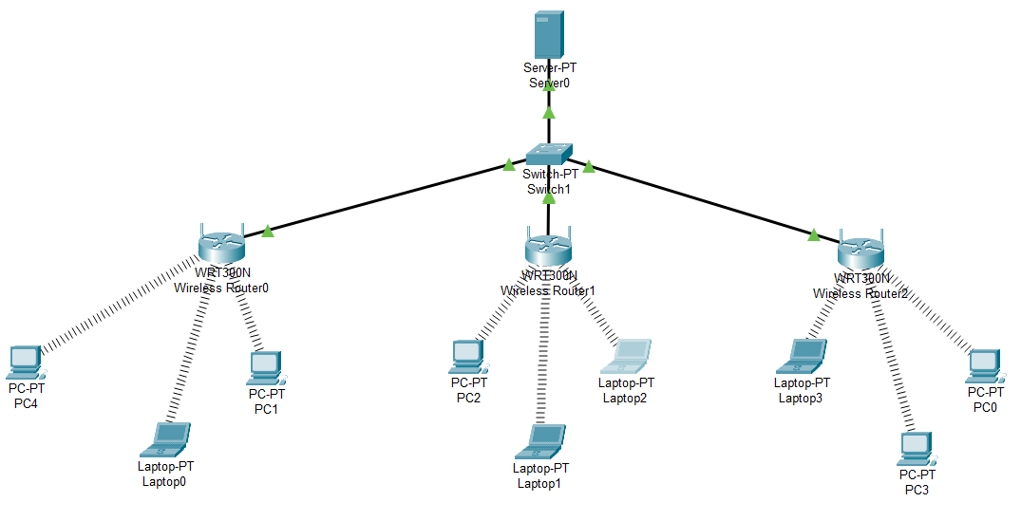
- References
[1]Mozilla, WebSockets API, Mozilla Developer Network, https://developer.mozilla.org/en-US/docs/Web/API/WebSockets_API, Accessed April 4, 2025.
[2]npm, basic-ftp, npmjs.com, https://www.npmjs.com/package/basic-ftp, Accessed April 14, 2025.
[3]Ngrok, Ngrok Documentation, Ngrok Inc., https://ngrok.com/docs, Accessed May 1, 2025.
[4]Vercel, Vercel Documentation, Vercel Inc., https://vercel.com/docs, Accessed May 2, 2025.

