Create VPC

Create a private subnet

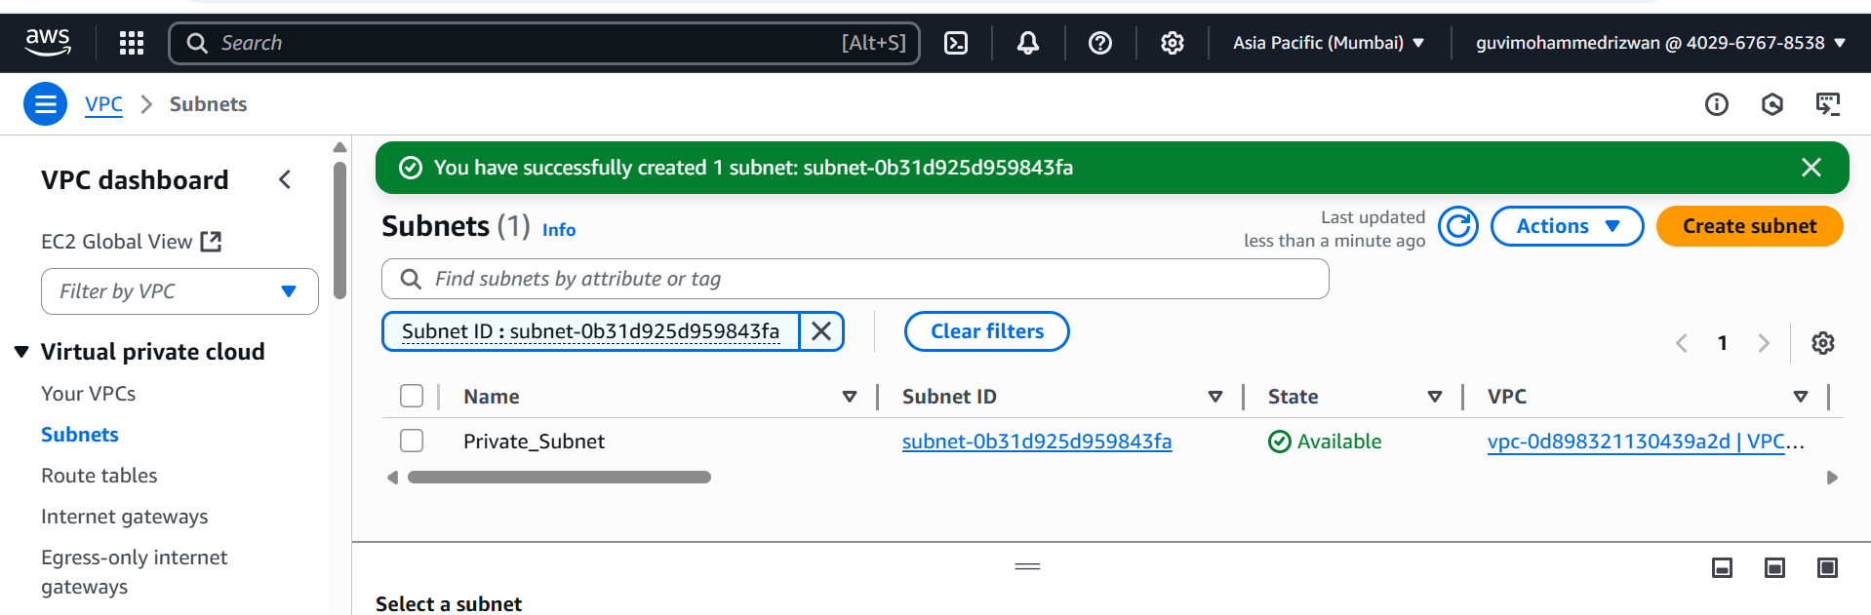

Create a Public Subnet

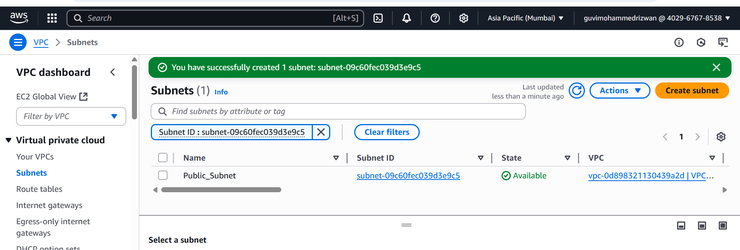

Create Private Routable and associate subnet

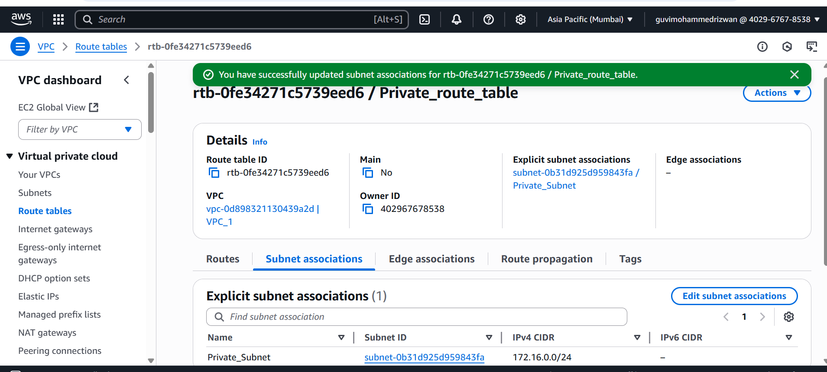

Create Public Routable and associate subnet

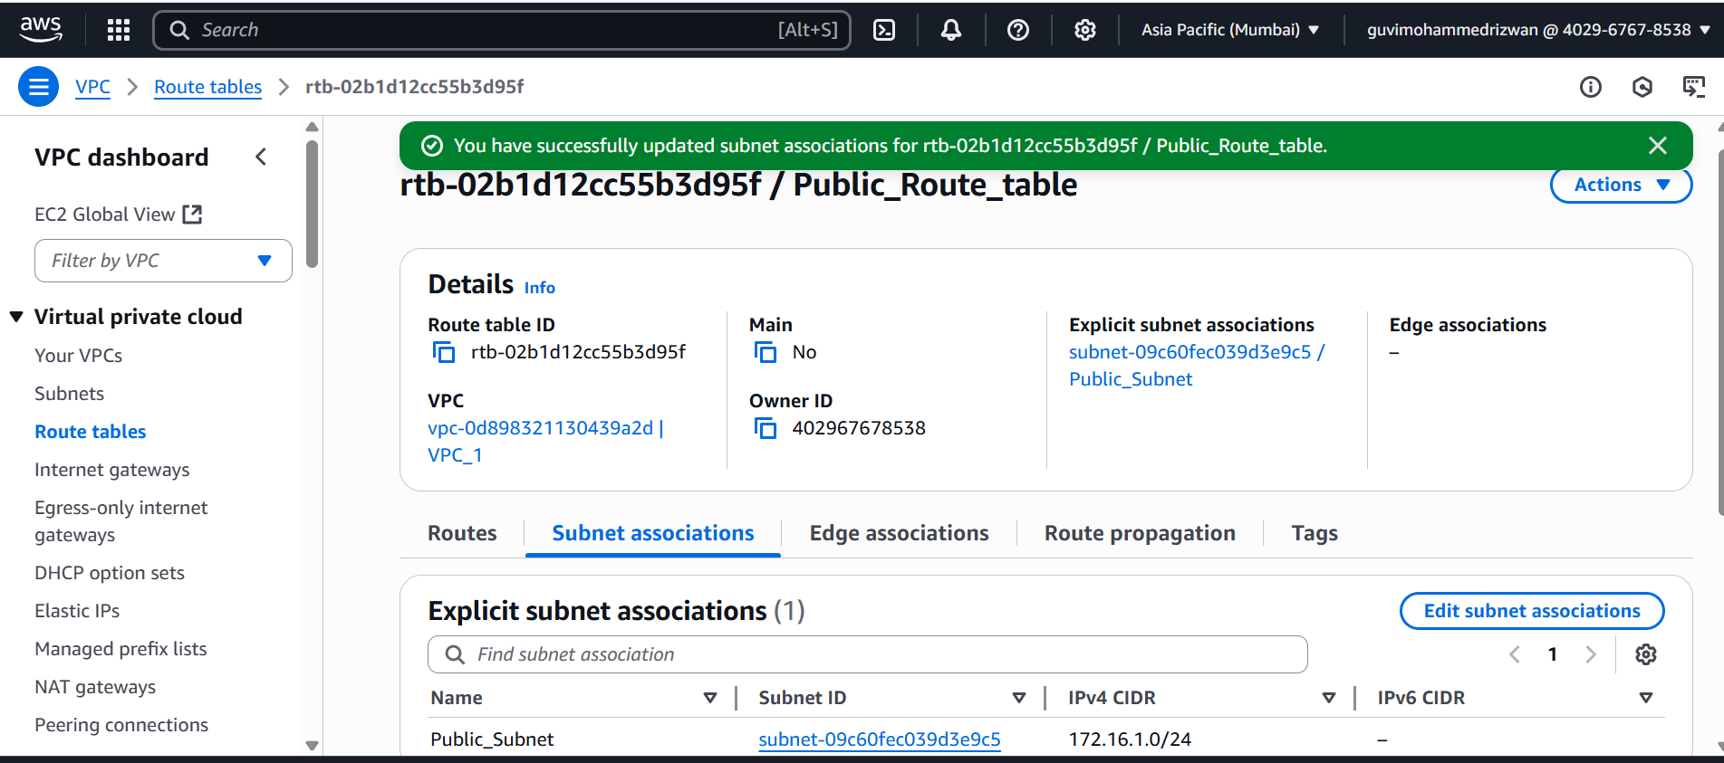

Create a Internet Gateway and attach to a VPC

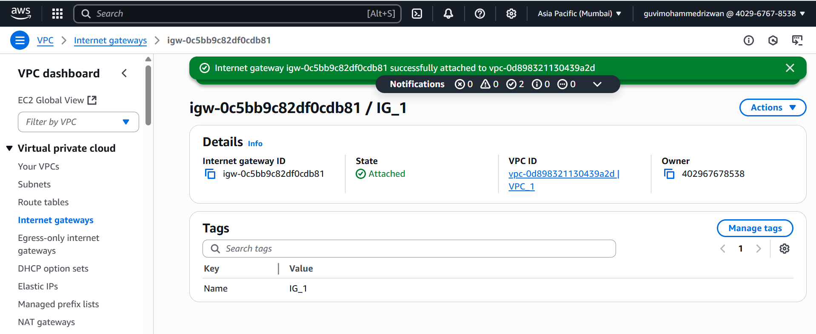

Associate IGW to Public Route table

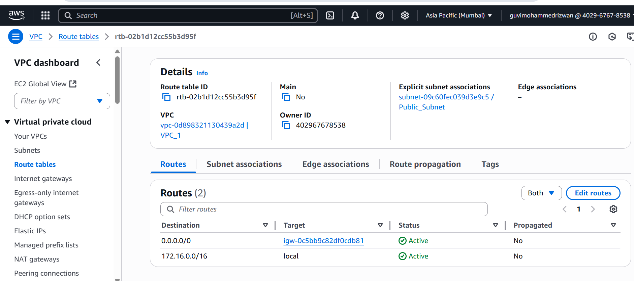

Create EC2 instance using VPC and Public Subnet

Login to the Public VM

