2. Launch two ec2-instances and connect it to a application load balancer, where the output traffic from the server must be an load balancer IP address.

EC2 instances

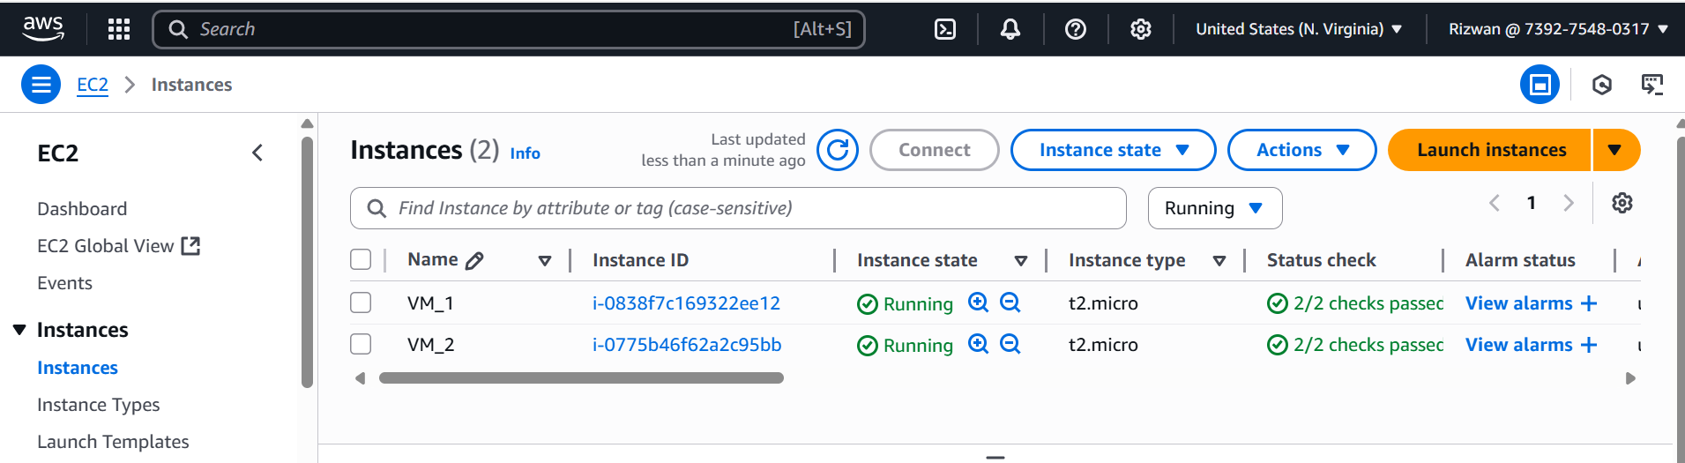

Target groups

Application Load Balancer

Listener Rules

Path based routing to first VM where nginx webserver is installed

Path based routing to second VM where apache2 webserver is installed.

Default Listener rule where If no other rule applies return fixed response.

