1.Create a S3 bucket, with no public access and upload files to the bucket & view the logs using cloudwatch for the uploaded files.

S3 Bucket

Create a Cloud Trail for S3 bucket

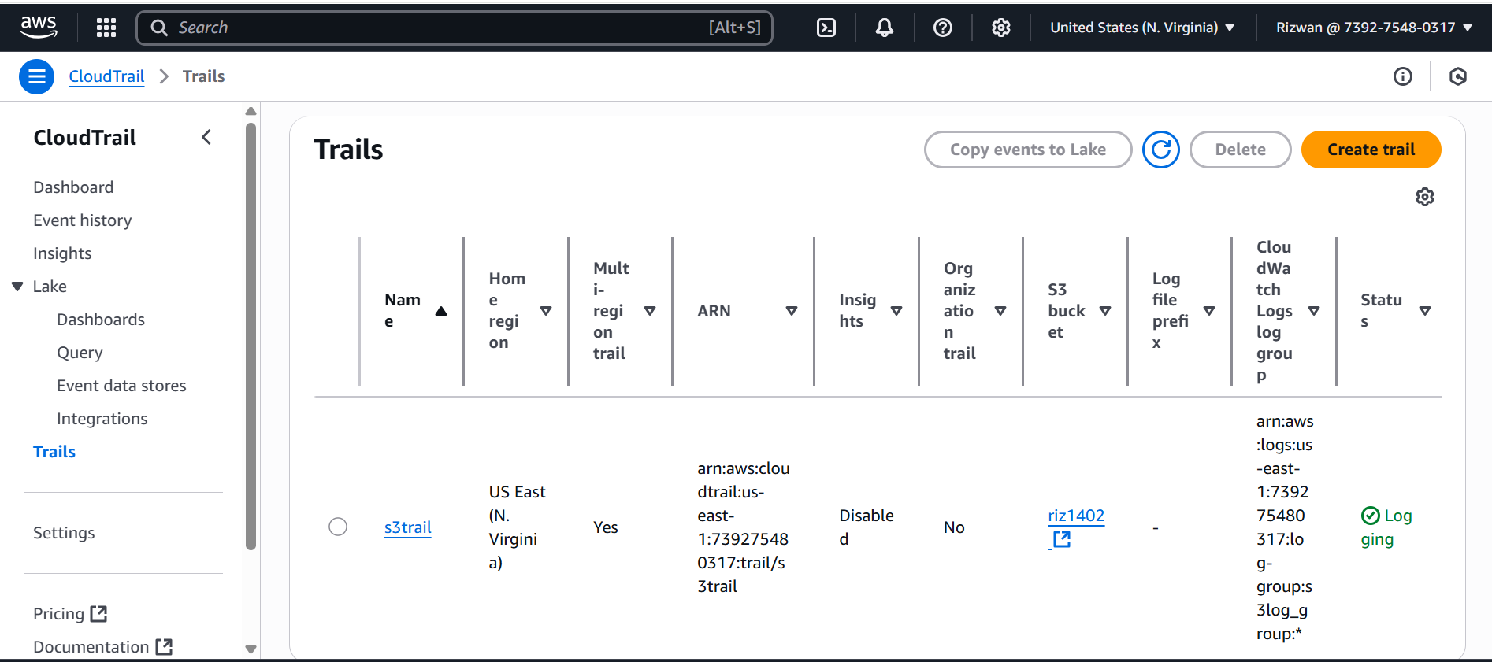

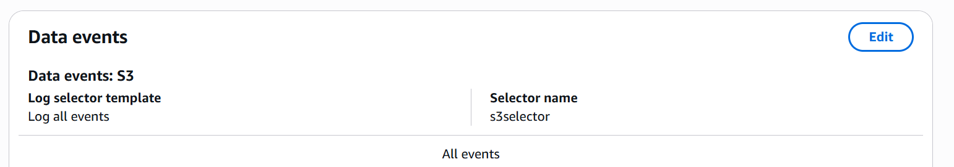

Integrated cloud trail logs to cloud watch logs for S3

Log Streams in cloud watch for S3 bucket

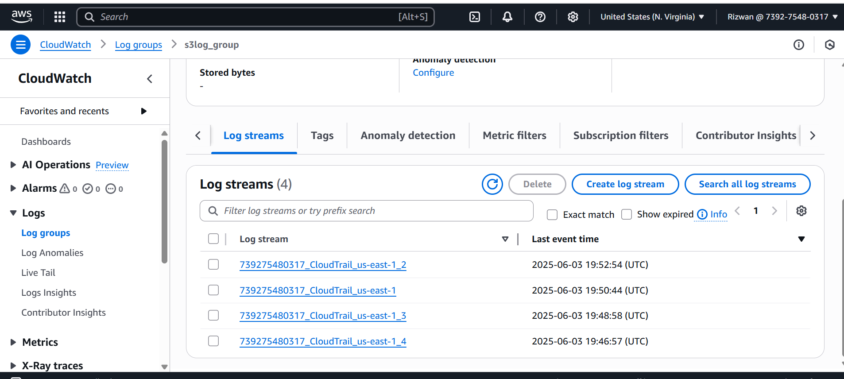

Cloud watch log events for S3 bucket.

