Launch an EC2 instance (Linux and Windows) along with a web server. Then, create an EBS volume of 5 GB, attach it to an EC2 machine (Linux and Windows), and take a snapshot. Finally, create an EBS volume using the taken snapshot.

1.Launch a Ec2 instance with a web server.

2. create an EBS volume of 5 GB.

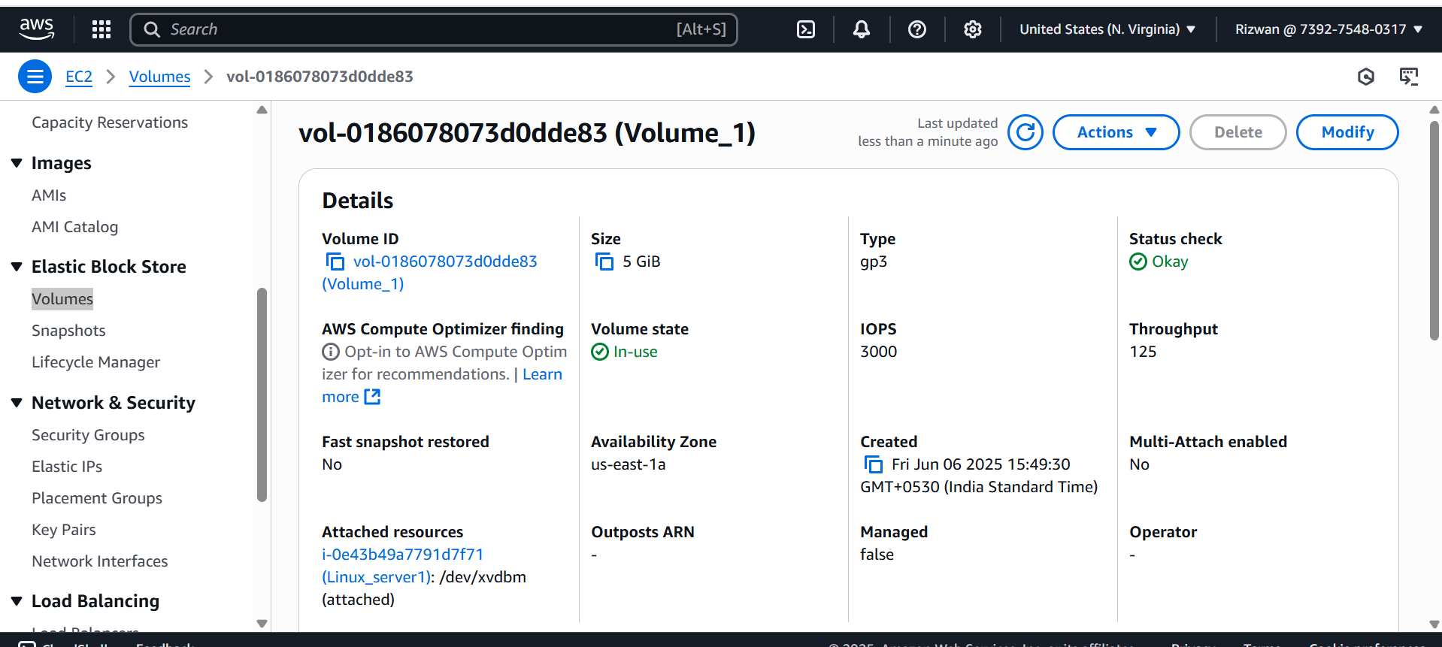

3. Attach it to an EC2 machine.

4. Take a Snapshot

5. Create an EBS volume using the taken snapshot.

