Install docker on EC2 instance

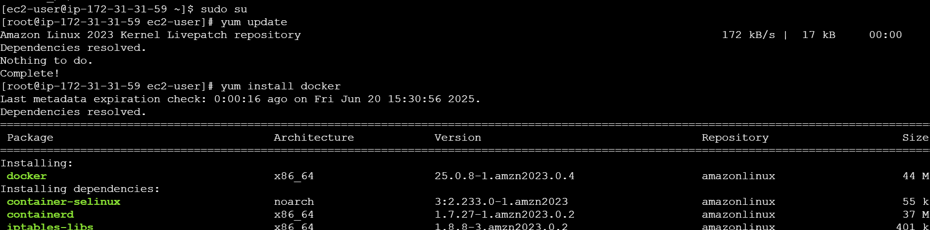

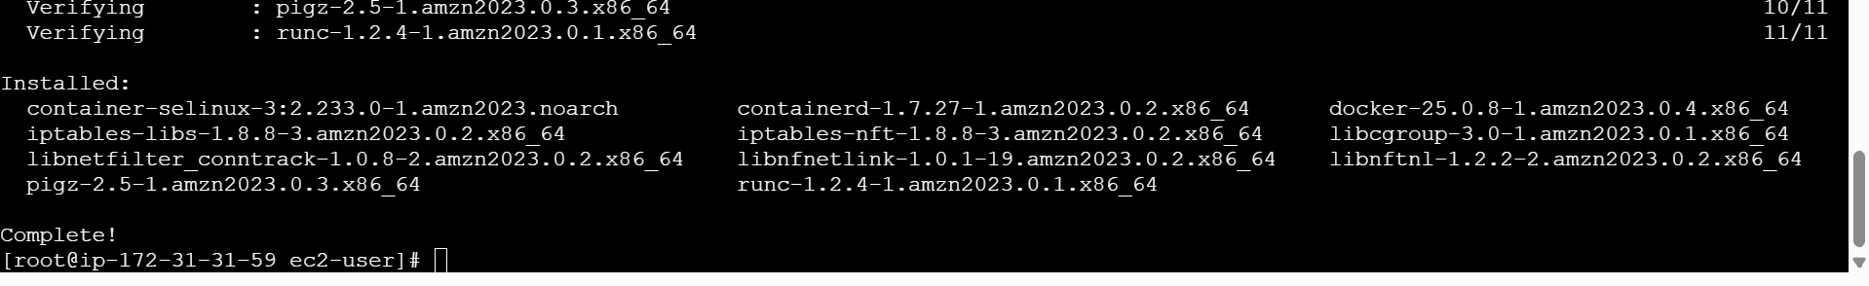

Start Docker

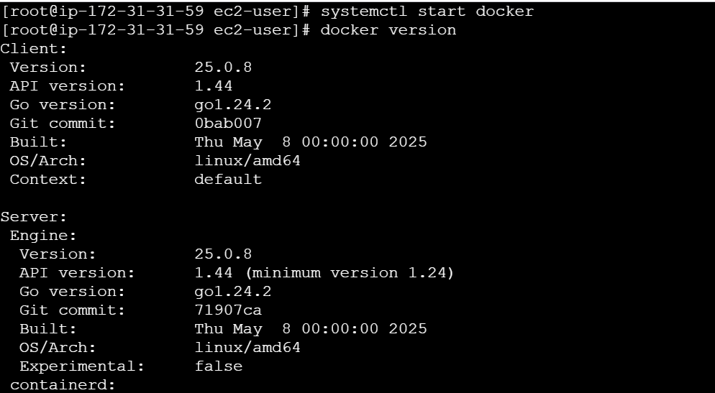

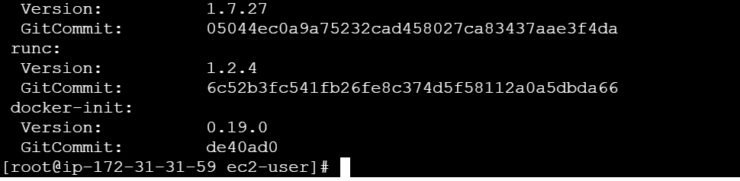

 explore the docker commands (docker images, containers, volumes, network)

docker pull

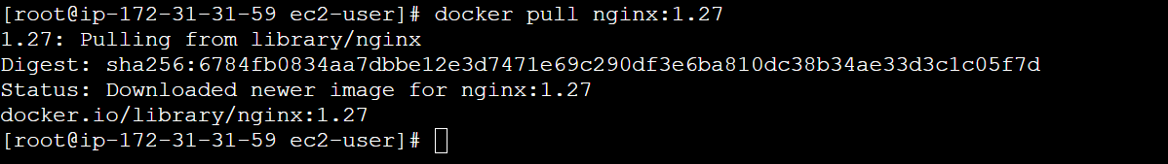

Docker images

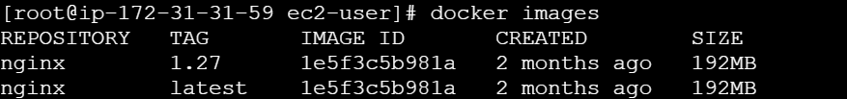

Docker rmi



Created a nginx container from an image



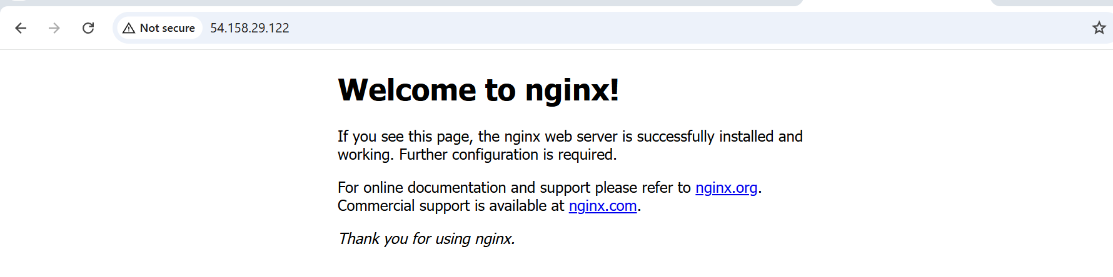

Docker network

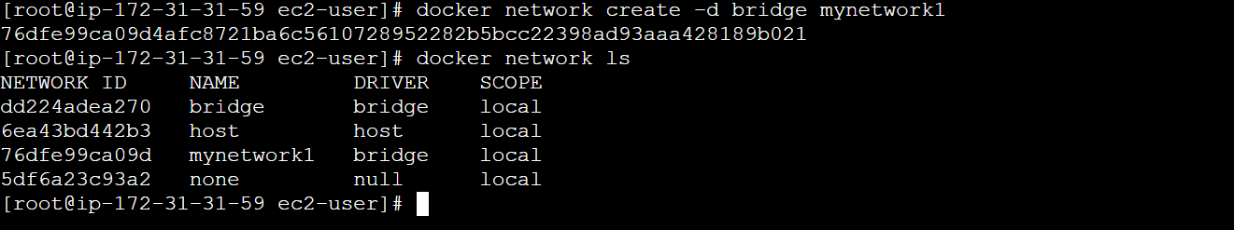

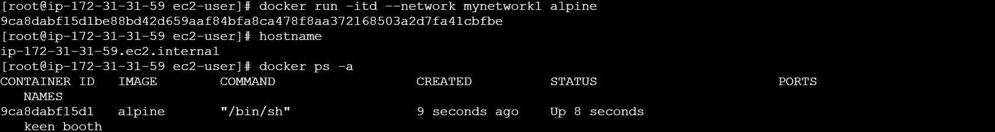

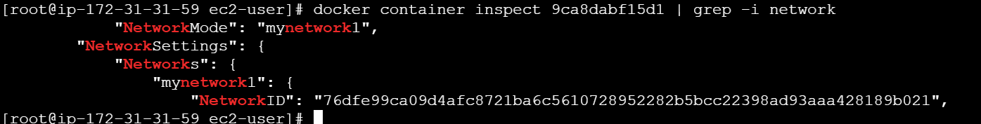

Docker Volume

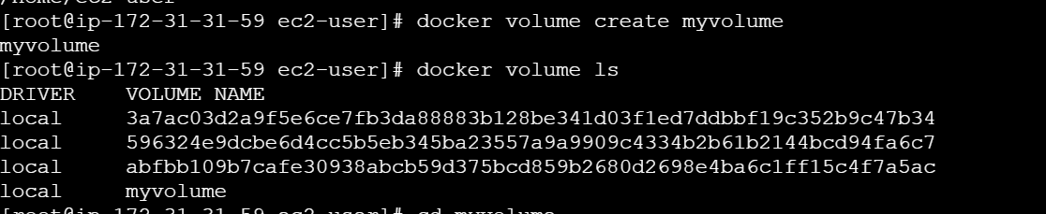



Volume location in container

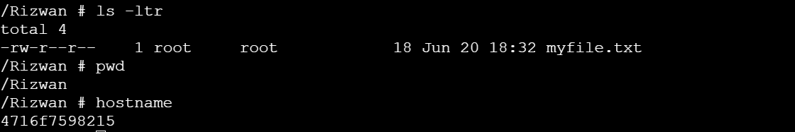

Volume location in host VM

