1.Create a dockerfile which when executed must display your basic details in the website.

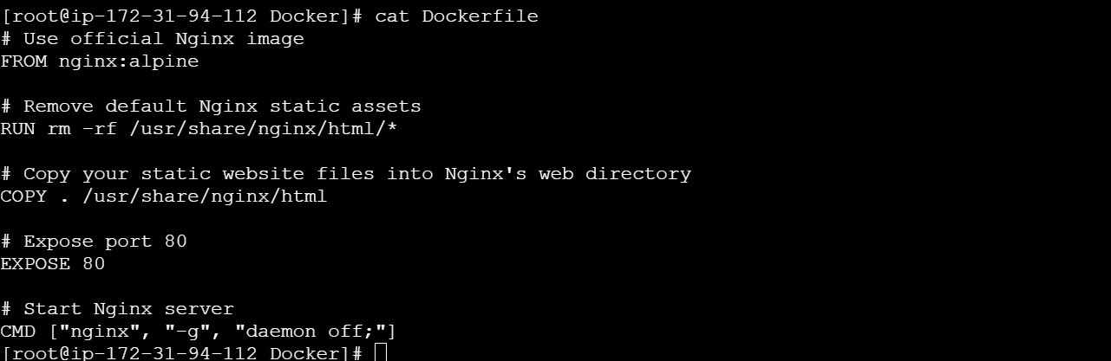

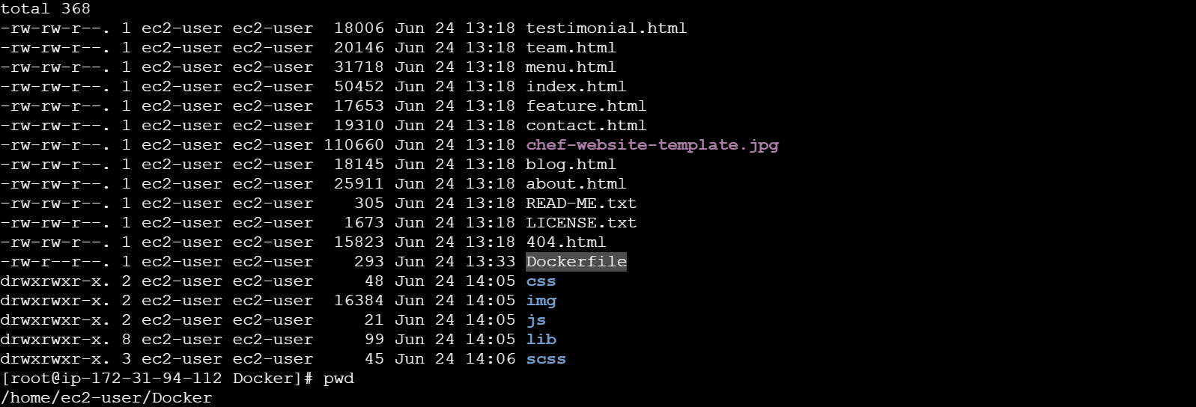

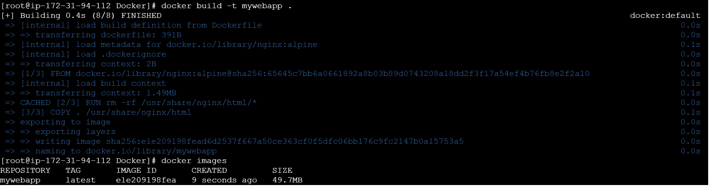



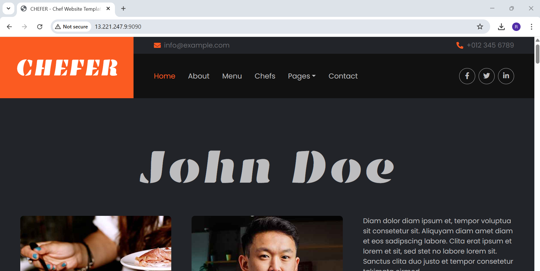

2. Create a docker-compose file which when executed must display your basic details in the website.

Docker- compose.yml

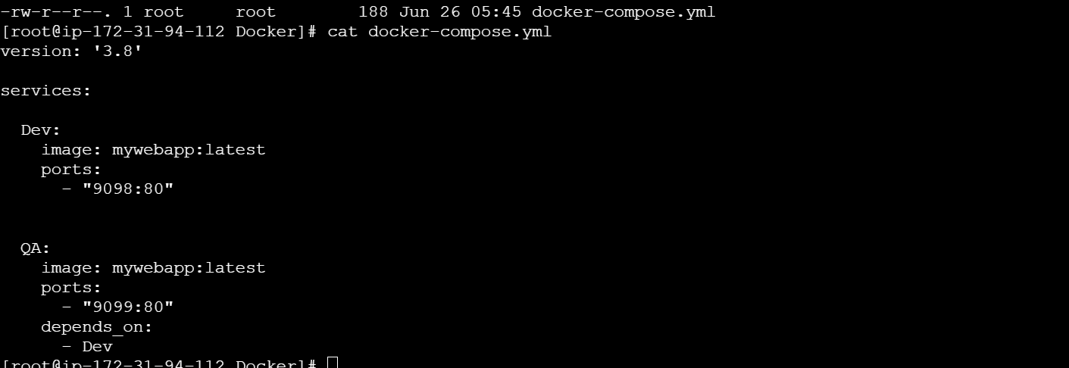

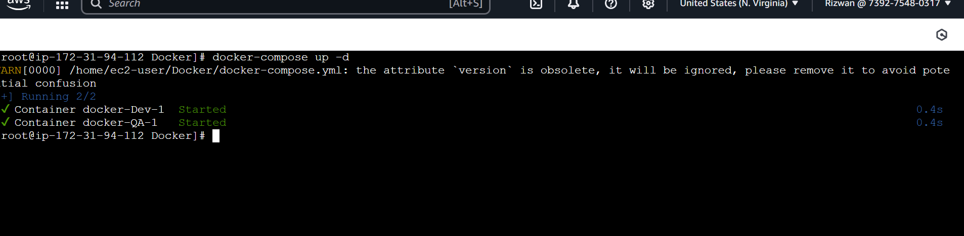



http://52.91.1.216:9098/

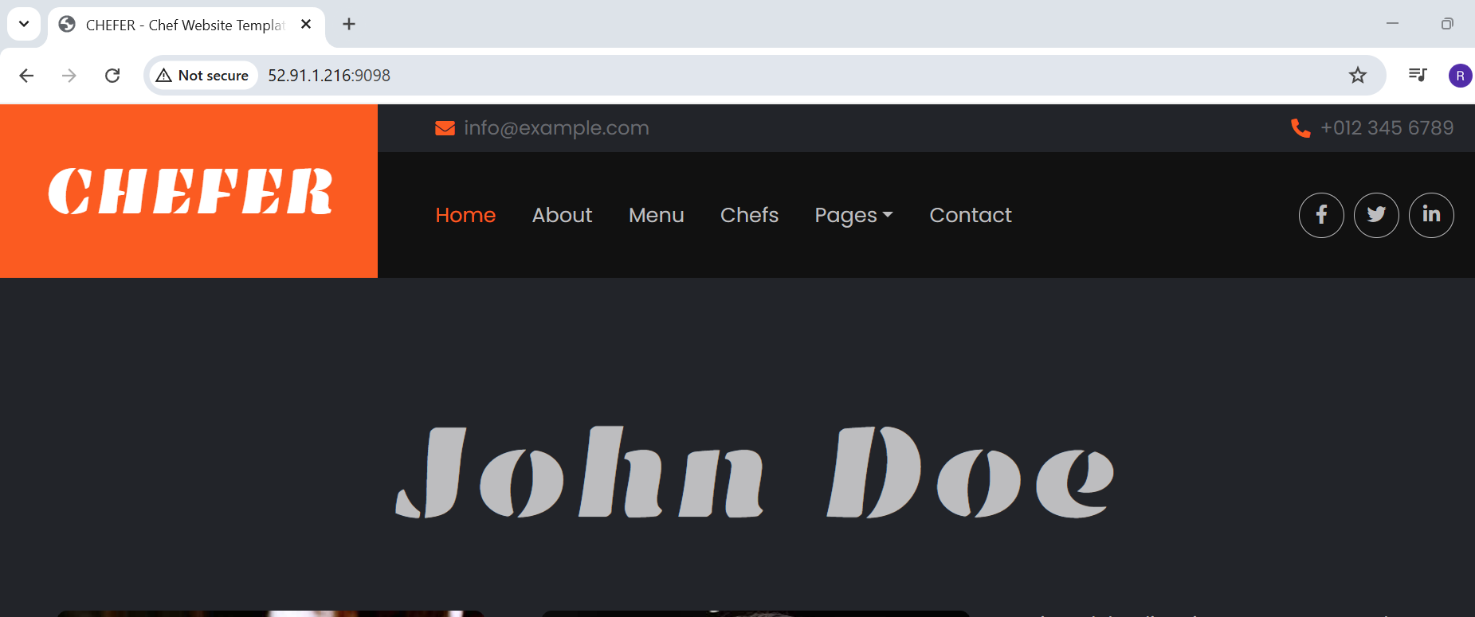

http://52.91.1.216:9099/

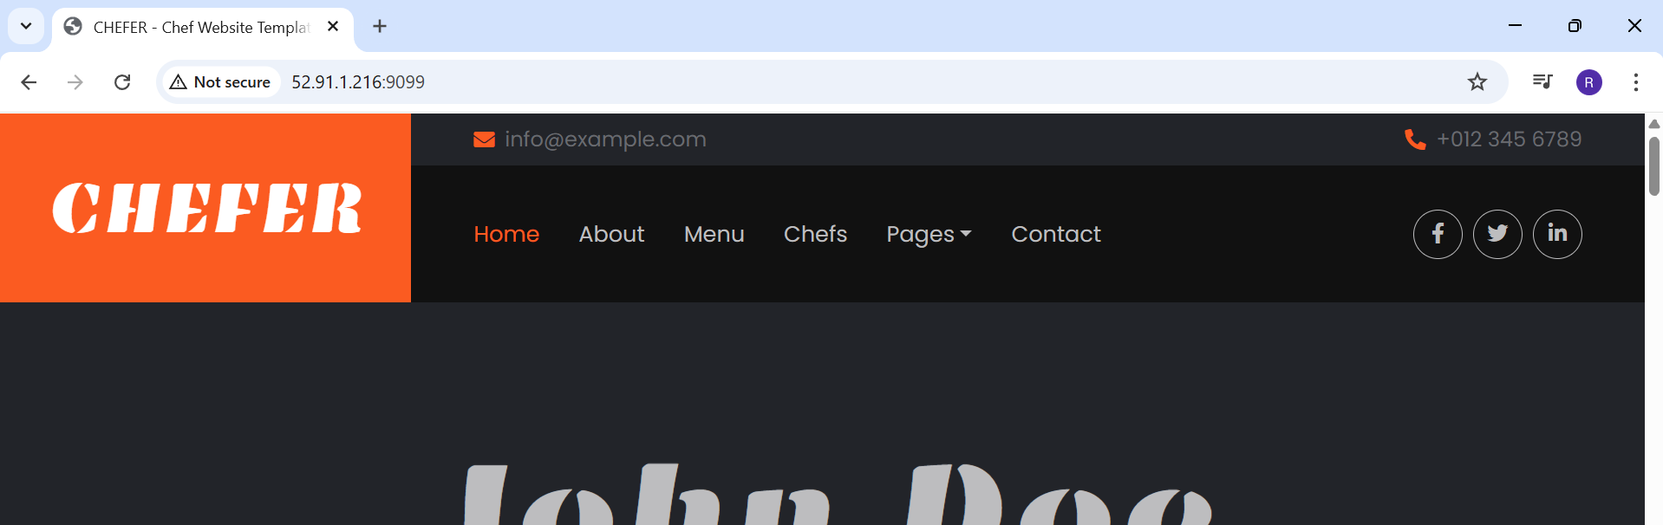

docker-compose down

