Get the IP address of a particular domain (guvi.in)

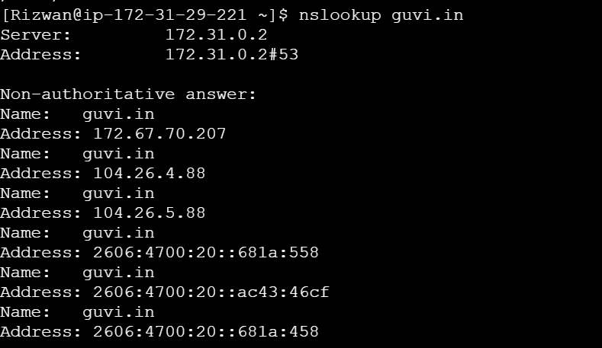

How do I find my CPU/memory usage of my server

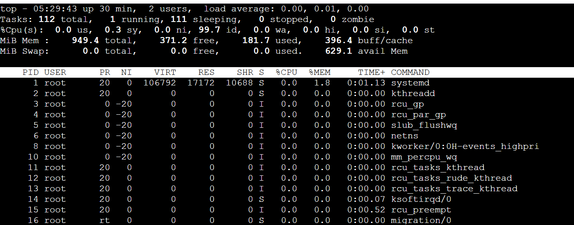

Test the connectivity between 2 nodes

I have deployed an application in guvi.com:9000, and logs show my app is running, but I’m unable to view the page. Check whether my port is open or not

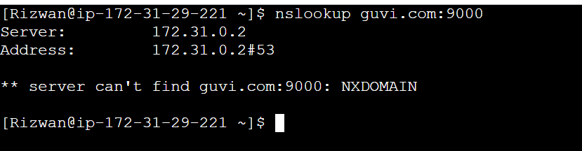

Unable to connect. Port 9000 is not open