1. Create a shell script to print the HTTP error code of guvi.in & print, the success/failure message based on the error code response

#!/bin/bash

status_code=$(curl -o /dev/null -s -w "%{http_code}\n" https://www.guvi.in)

if [ $status_code -eq 200 ]; then

echo "The request was successful."

else

echo "The request failed."

fi

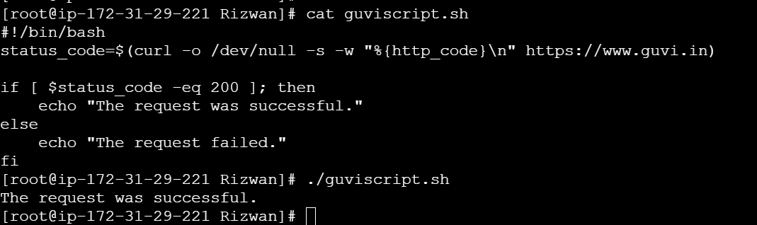

1. Given a file, replace all occurrence of the word "give" with "learning" from 5th line till the end in only those lines that contain the word "welcome"

sed '5,${/welcome/ s/give/learn/g}' sedcommandtest.txt

