Establish a new directory (git_task), populate it with script files(newfile.txt)



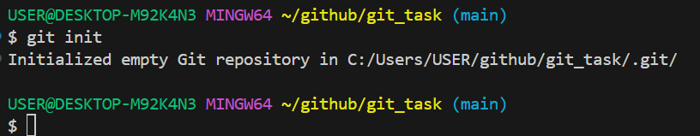

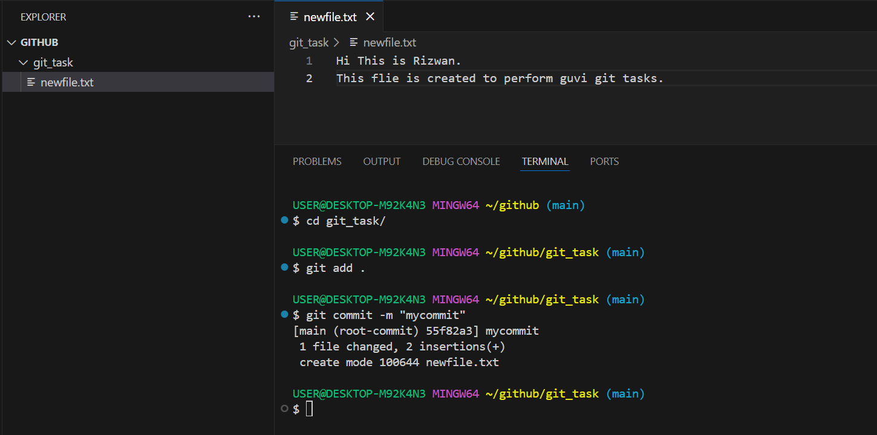

Initiate an empty repository on GitHub

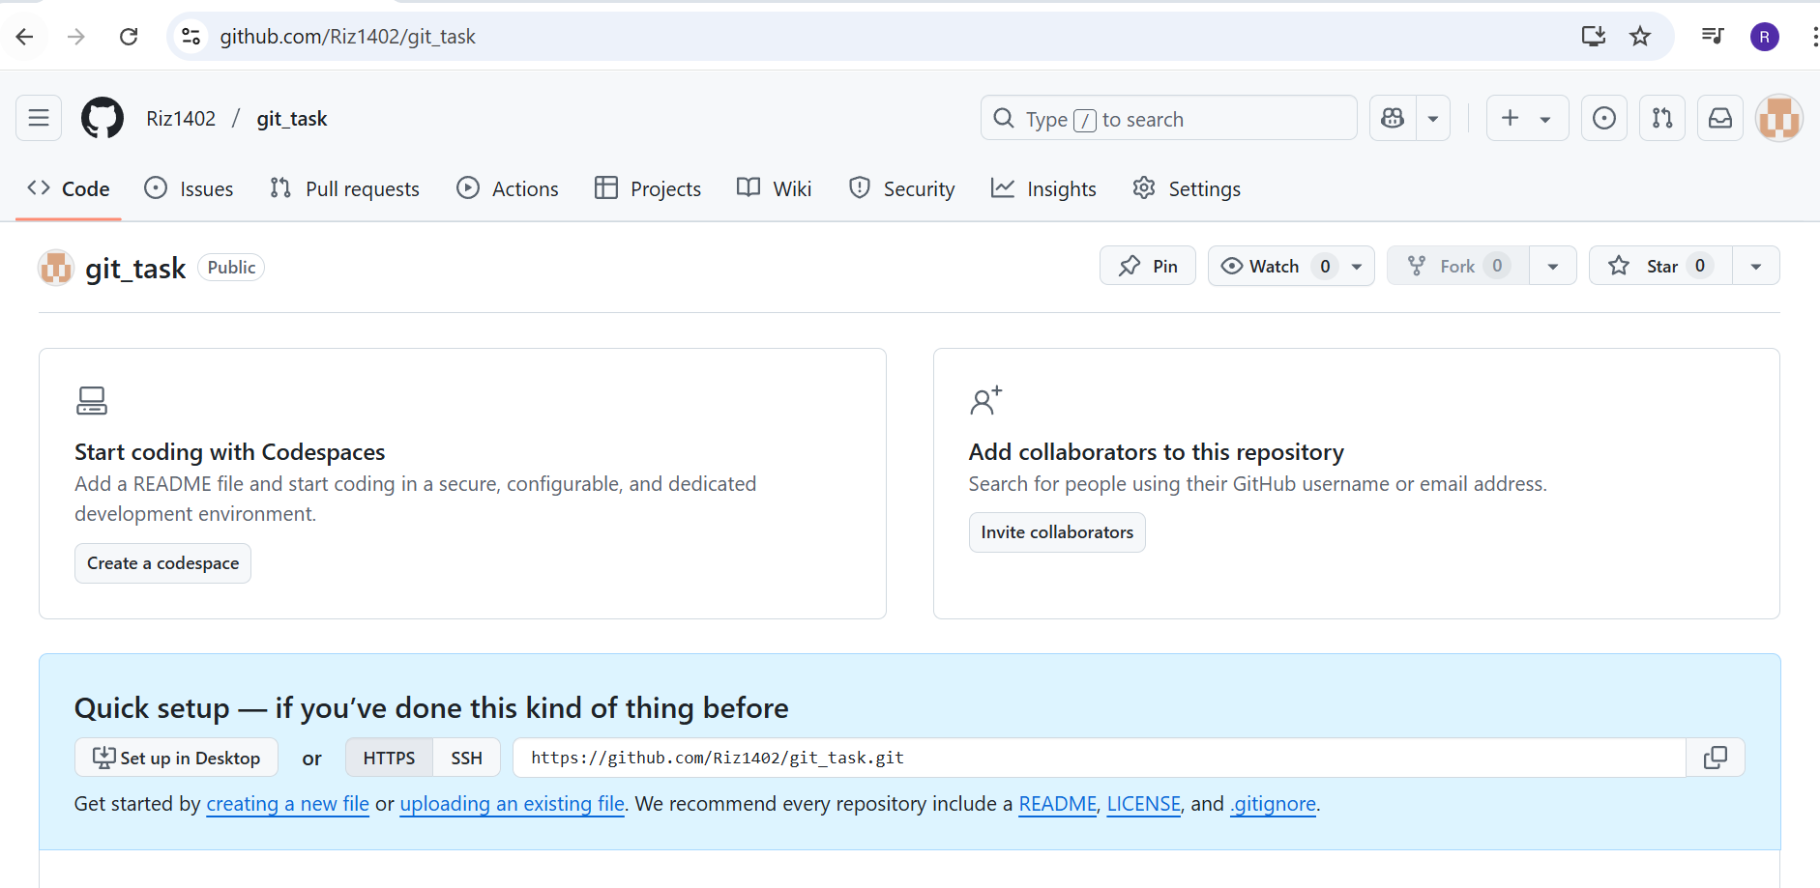

convert the local directory into a Git repository, and link it to GitHub for pushing the code into the repository.

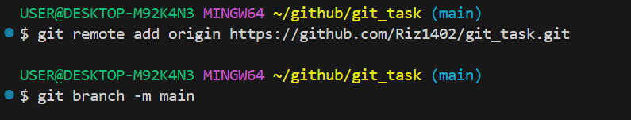

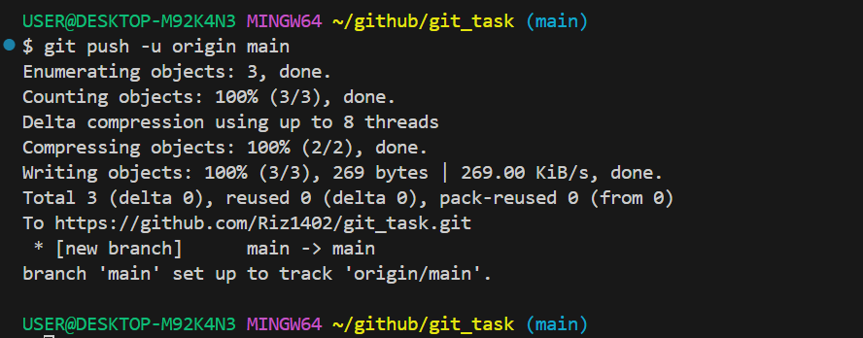

Perform merge

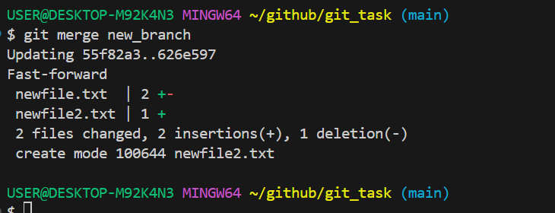

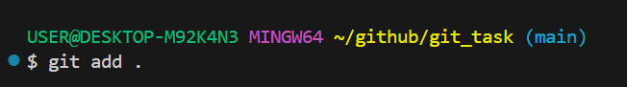

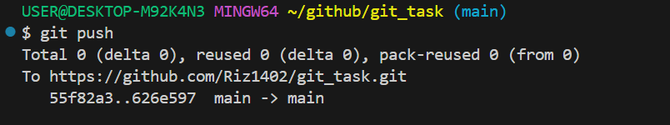

Git rebase

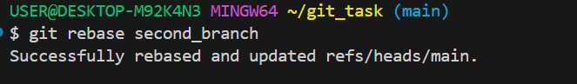

Git stash



