MOVEit Transfer – Azure Load Balancer Architecture
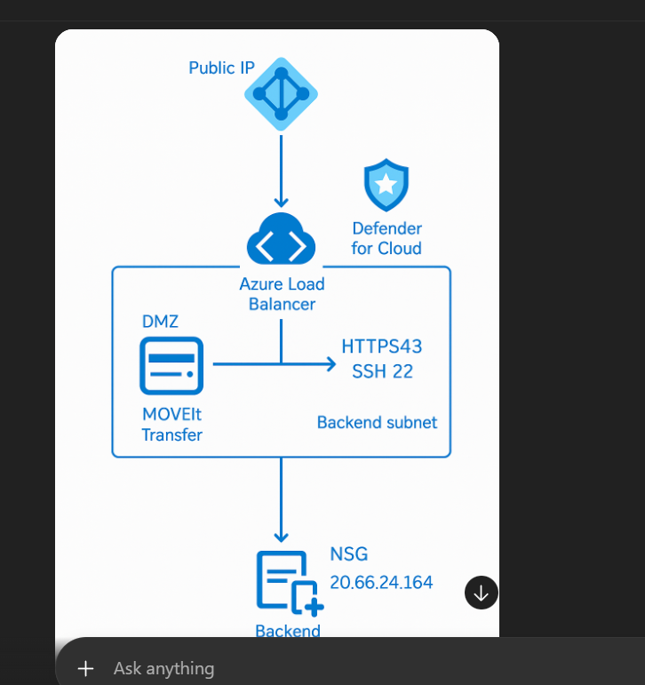

Overview
This architecture delivers a secure, scalable, Azure‑native deployment of MOVEit Transfer using:
• Azure Load Balancer (Inbound + NAT)
• DMZ-hosted MOVEit Transfer server
• Backend subnet protected by NSG
• Microsoft Defender for Cloud
• Private-only workload access
Architecture Components (Explained)
1. Public IP
Acts as the single secure entry point into the environment. Provides FTPS/HTTPS/SSH ingress based on NSG and LB rules.
2. Azure Load Balancer (Standard SKU)
Distributes inbound traffic to the MOVEit node while maintaining:
• High availability
• Health probes for 443 and 22
• NAT rules for SSH admin access
• Lower cost vs Application Gateway
• Supports Layer 4 FTPS/SFTP traffic (AG cannot handle this)
3. DMZ Subnet
Network-isolated perimeter hosting MOVEit Transfer. Zero trust aligned:
• No direct internet exposure
• Only LB traffic allowed
• NSG restricts east-west and inbound
4. MOVEit Transfer Server
Core secure file transfer application supporting HTTPS, SFTP/SSH.
Configured with hardened OS baseline, TLS enforcement, strong cipher suites.
5. Backend Subnet
Isolated network tier with additional internal services (DB/AV/Logging if needed).
NSG restricts inbound traffic to ONLY:
• HTTPS 443
• SSH/SFTP 22
6. Microsoft Defender for Cloud
Provides unified threat detection and continuous assessment:
• Just-In-Time access
• Secure configuration scoring
• Malware scanning
• File integrity monitoring
• Vulnerability assessments
7. Network Security Group (NSG)
Applies strict allow/deny policies to the backend subnet:
• Allows traffic only from Load Balancer
• Blocks internet
• Restricts SSH to admin IPs
• Enforces segmentation
Why Load Balancer (LB) Instead of Application Gateway?
✓ LB supports FTPS/SFTP/SSH – AG does NOT support FTPS or SSH
✓ Lower cost compared to AG/WAF
✓ Perfect for MOVEit protocols (L4)
✓ Supports NAT for admin SSH
✓ Simpler, faster deployment and smaller footprint

