MOVEit Transfer – Azure Architecture Business Case
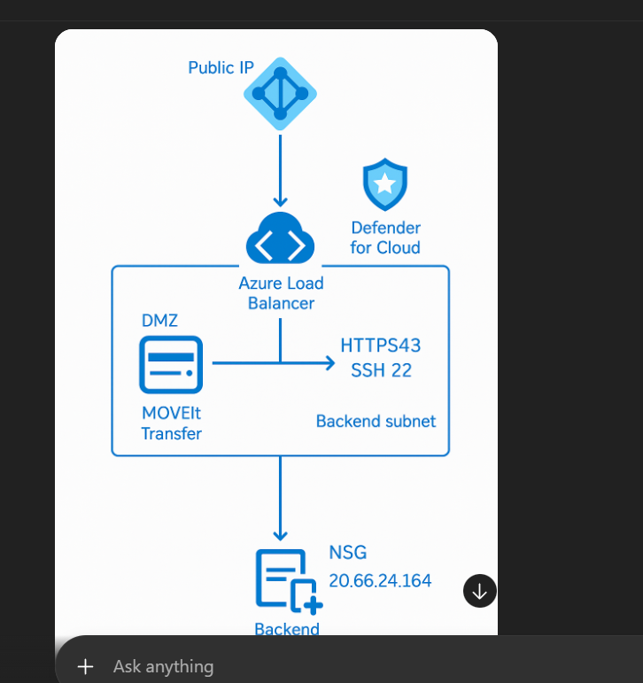

Executive Summary
This business case outlines why Azure Load Balancer + DMZ-hosted MOVEit Transfer + Microsoft Defender for Cloud is the optimal design for secure enterprise file transfer. It balances cost, security, scalability, and compliance requirements.
Key Benefits
1. Security Hardening
• Zero public IP on MOVEit servers
• DMZ isolation
• NSG segmentation
• Defender for Cloud threat protection
• TLS hardening + SSH security
• JIT and regulatory compliance alignment
2. Cost Optimization
Compared to Application Gateway:
• ~65% cheaper monthly
• No WAF needed (Layer 7 features not required)
• LB handles SFTP/FTPS which AG cannot
• Minimal operational overhead
3. Performance & Protocol Support
MOVEit requires protocols such as:
• FTPS
• SFTP / SSH
• HTTPS
Azure Application Gateway does NOT support FTPS or SFTP.
Azure Load Balancer supports all required Layer 4 protocols natively.
4. Operational Excellence
• Easy to deploy and maintain
• Azure-native monitoring and logging
• Blue/Green or HA options available
• Supports enterprise scaling
5. Compliance & Governance
• HIPAA
• PCI-DSS
• SOC2
• ISO 27001
• GDPR
With Defender for Cloud + NSG + private subnets, all required controls can be enforced.
Why This Architecture Fits Enterprise MOVEit Deployments
• Supports all MOVEit protocols
• Uses least privilege and zero trust networking
• Provides low cost + high security
• Ensures predictable traffic flow
• Aligned with Azure Landing Zone principles

