Azure Virtual Desktop (AVD) – Architecture Guide
Clean, secure, and repeatable design for production
Date: November 05, 2025
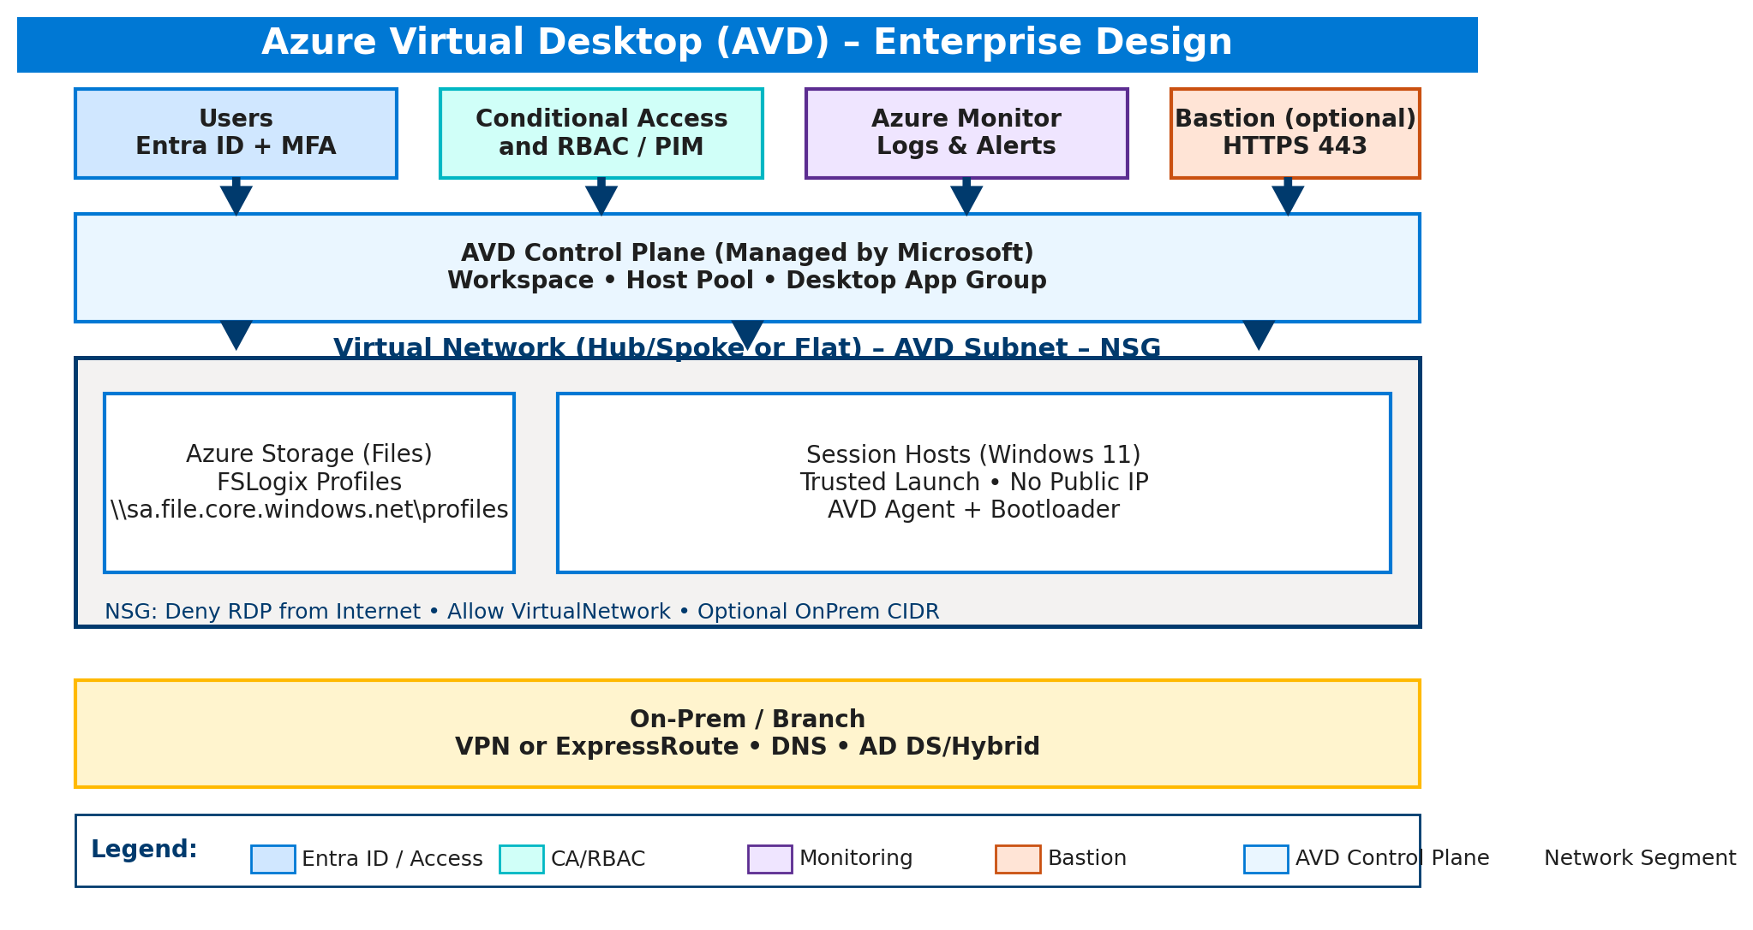

What we are building
- Identity is Entra ID with MFA. Access is controlled by Conditional Access and RBAC.
- AVD objects: one Workspace, a pooled Host Pool, and a Desktop App Group linked to the workspace.
- Session hosts are Windows 11. We use Trusted Launch, no public IPs, and the AVD agent/bootloader to join.
- Profiles go to Azure Files with FSLogix. We enforce TLS 1.2 and use storage keys at build time.
- Networking is a dedicated VNet and subnet with an NSG: block Internet RDP, allow VNet, and optionally allow a specific on‑prem CIDR.
- Optional: Azure Bastion for just‑in‑time admin (HTTPS only).

Security stance
- Zero Trust posture: no inbound RDP from the Internet, brokered access only.
- Strong identity: MFA + Conditional Access + least‑privilege RBAC.
- Trusted Launch (Secure Boot + vTPM) on the VMs.
- All profile traffic is encrypted; storage access is bootstrapped securely.
- Everything is observable: integrate with Azure Monitor for logs and alerts.

How the run works
- Load Az modules and connect.
- Pick subscriptions, host count (1–10), VM size.
- Resolve region + image and check quota for the VM family.
- Create or reuse RG, VNet/Subnet, and NSG rules.
- Provision Azure Files share for FSLogix (profiles).
- Create Host Pool, Desktop App Group, and Workspace; link DAG to the workspace.
- Generate the registration token and deploy session hosts (no public IP, Trusted Launch).
- Install AVD agent/bootloader, configure FSLogix, and optionally assign RBAC for users.

Network ports
Direction | Source | Destination | Port | Why
Inbound | Users | AVD Broker | 443 | User connections over HTTPS
Inbound | Azure control | Control plane | 443 | Azure platform operations
Outbound | Session hosts | Azure Files | 445 / 443 | FSLogix profile access
Outbound | Session hosts | Microsoft services | 443 | Windows/agent updates
Optional | Bastion | Session hosts | 3389 | RDP inside VNet only

