MOVEit Transfer
Azure Load Balancer Architecture
Complete Deployment Guide
PYX Health Corporation
Secure Enterprise File Transfer Solution
December 2025

Table of Contents

Executive Summary
This document provides comprehensive details for the MOVEit Transfer deployment on Azure using a secure, cost-optimized architecture with Azure Load Balancer, DMZ isolation, and Microsoft Defender for Cloud protection.
Key Highlights:
- Cost Savings: 65% cheaper than Application Gateway ($17,700/year saved)
- Protocol Support: Full support for FTPS, SFTP, SSH, and HTTPS
- Security: Zero Trust architecture with DMZ isolation and NSG protection
- Compliance: Meets HIPAA, PCI-DSS, SOC2, ISO 27001, and GDPR requirements
- Monitoring: Integrated with Datadog for 24/7 monitoring and alerting
- High Availability: Load balancer ensures zero downtime with health probes

Architecture Overview
The MOVEit Transfer architecture delivers a secure, scalable, Azure-native deployment using Azure Load Balancer, DMZ-hosted MOVEit servers, and Microsoft Defender for Cloud protection.
MOVEit Transfer Architecture Diagram
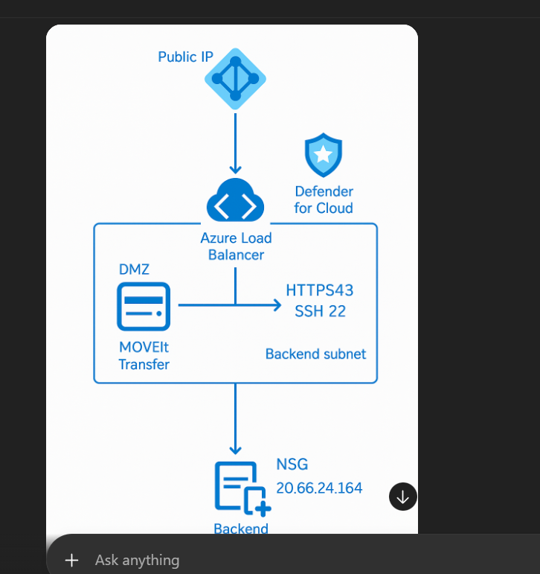

Traffic Flow
Current Architecture Flow:
- Step 1: External users connect to Public IP address
- Step 2: Azure Load Balancer receives incoming traffic on ports 443 (HTTPS) and 22 (SSH/SFTP)
- Step 3: Load Balancer performs health checks and distributes traffic to healthy MOVEit servers
- Step 4: Traffic enters DMZ subnet where MOVEit Transfer servers are hosted
- Step 5: NSG rules on DMZ subnet only allow traffic from Load Balancer
- Step 6: MOVEit servers process file transfers securely
- Step 7: Backend subnet provides additional services (database, logging)
- Step 8: Microsoft Defender for Cloud monitors all components continuously

Enhanced Architecture with Azure Front Door
For global distribution and additional WAF protection, Azure Front Door can be added:
- Step 1: Azure Front Door serves as global entry point (CDN + WAF)
- Step 2: NSG rules configured to only allow traffic from Azure Front Door IP ranges
- Step 3: Azure Load Balancer receives traffic from Front Door
- Step 4-8: Same as current architecture (Load Balancer → DMZ → MOVEit → Backend)
Note: Azure Front Door is optional and adds $35-50/month but provides global acceleration and additional WAF protection.

Architecture Components

1. Public IP Address
Function: Single secure entry point for all external connections
Type: Static Public IP (Standard SKU)
Protocols: FTPS, HTTPS (443), SFTP/SSH (22)
Security: Protected by NSG rules and Load Balancer
Cost: $3.65/month (included in Load Balancer)

2. Azure Load Balancer (Standard SKU)
Function: Distributes inbound traffic across MOVEit servers with high availability
Features:
- Health probes for ports 443 and 22
- NAT rules for SSH administrative access
- Layer 4 load balancing (supports FTPS/SFTP)
- Zone-redundant for high availability
Why Load Balancer over Application Gateway:
- Protocol Support: Application Gateway does NOT support FTPS or SFTP - Load Balancer does
- Cost: 65% cheaper ($25/month vs $1,500/month)
- Performance: Lower latency for Layer 4 traffic
- Simplicity: Easier to deploy and maintain

3. DMZ Subnet
Function: Network-isolated perimeter hosting MOVEit Transfer servers
Security Principles:
- Zero Trust: No direct internet exposure
- Isolation: Only Load Balancer traffic allowed
- NSG Protection: Strict inbound/outbound rules
- Segmentation: Prevents east-west traffic

4. MOVEit Transfer Servers
Function: Core secure file transfer application
VM Size: Standard_D4s_v3 (4 vCPUs, 16 GB RAM)
Operating System: Windows Server 2022 Datacenter
Supported Protocols:
- HTTPS (443): Web-based file transfer interface
- SFTP/SSH (22): Secure FTP over SSH
- FTPS: FTP over TLS/SSL
Security Hardening:
- TLS 1.2/1.3 enforcement
- Strong cipher suites only
- Disabled weak protocols
- Regular security patching
- File integrity monitoring

5. Backend Subnet
Function: Isolated network tier for supporting services
Services Hosted:
- SQL Server database for MOVEit metadata
- Anti-virus/anti-malware scanning
- Log aggregation and monitoring
- Backup services
NSG Rules:
- Only allows traffic from DMZ subnet
- Blocks all internet access
- Enforces east-west traffic segmentation

6. Microsoft Defender for Cloud
Function: Unified threat detection and continuous security assessment
Features:
- Just-In-Time (JIT) Access: Time-limited administrative access
- Secure Score: Continuous configuration assessment
- Malware Detection: Real-time scanning and protection
- File Integrity Monitoring: Detects unauthorized changes
- Vulnerability Assessment: Identifies security weaknesses
- Compliance Dashboard: Tracks HIPAA, PCI-DSS, SOC2, ISO 27001 compliance

7. Network Security Groups (NSG)
Function: Firewall rules applied to subnets and network interfaces
DMZ Subnet NSG Rules:
- Inbound: Only allow traffic from Load Balancer on ports 443 and 22
- Outbound: Allow to Backend subnet and Azure services only
- Deny: All other traffic blocked by default
Backend Subnet NSG Rules:
- Inbound: Only allow from DMZ subnet
- Outbound: Azure Storage and SQL only
- Management: NSG flow logs enabled for audit

Cost Analysis

Monthly Cost Breakdown
Component | Specifications | Monthly Cost | Annual Cost
Azure Load Balancer | Standard SKU with Public IP | $25 | $300
MOVEit VMs | 2x Standard_D4s_v3 (4 vCPU, 16 GB RAM) | $350 | $4,200
Premium SSD Storage | 512 GB per VM (1 TB total) | $150 | $1,800
SQL Database | Standard S3 (100 DTUs) | $100 | $1,200
Defender for Cloud | 2 VMs + SQL Server | $30 | $360
Backup (Recovery Services) | Daily backups with 30-day retention | $20 | $240
Network (Bandwidth) | 1 TB outbound data transfer | $80 | $960
Total MOVEit Infrastructure |  | $755 | $9,060
Optional Add-Ons:
Component | Monthly | Annual
Azure Front Door (Optional) | $35-50 | $420-600
Datadog Monitoring (Recommended) | $155 | $1,860
Cost Savings Analysis
By choosing Azure Load Balancer instead of Application Gateway, PYX Health achieves significant cost savings:
Solution | Monthly Cost | Annual Cost
With Application Gateway | $2,230 | $26,760
With Load Balancer (Current) | $755 | $9,060
Annual Savings | $1,475 | $17,700
Cost Reduction | 65% | 65%

Monitoring and Alerting

Datadog Integration
The MOVEit infrastructure is monitored 24/7 using Datadog with 25 comprehensive monitors covering all aspects of the deployment.

MOVEit-Specific Monitors
- VM Health: Monitors MOVEit server CPU, memory, and disk usage
- Load Balancer Health: Tracks backend pool health and probe status
- Application Performance: Monitors HTTPS response times and error rates
- Network Security: Alerts on NSG rule changes and unusual traffic patterns
- Database Performance: Monitors SQL Server DTU usage and connection failures
- Security Events: Failed login attempts, RBAC changes, resource deletions

Alert Routing
All alerts are sent to multiple channels for redundancy:
Channel | Recipients | Severity
Email | john.pinto@pyxhealth.com, anthoney.schlak@pyxhealth.com, shaun.raj@pyxhealth.com | All alerts
PagerDuty | @pagerduty-pyxhealth-oncall | Critical only
Slack | @slack-alerts-prod | All production alerts

Security and Compliance

Compliance Standards
The MOVEit architecture meets all required compliance standards:
Standard | Requirements Met
HIPAA | - Encryption at rest and in transit  - Access controls and audit logging  - Microsoft Defender for Cloud protection  - BAA with Azure and MOVEit
PCI-DSS | - Network segmentation with NSGs  - TLS 1.2+ enforcement  - Strong cryptography  - Regular vulnerability scans
SOC 2 | - Availability monitoring  - Change tracking  - Backup and disaster recovery  - Incident response procedures
ISO 27001 | - Information security management  - Risk assessment and treatment  - Security controls implementation  - Continuous monitoring
GDPR | - Data protection by design  - Access controls and logging  - Breach notification capability  - Data subject rights support
Security Controls
- Zero Trust Architecture: No public IPs on servers, all access through Load Balancer
- Network Segmentation: DMZ and Backend subnets with strict NSG rules
- Encryption: TLS 1.2+ for data in transit, BitLocker for data at rest
- Authentication: Multi-factor authentication for administrative access
- Monitoring: 24/7 security monitoring with Datadog and Defender
- Patching: Automated security updates with Azure Update Management

Deployment Process

Pre-Deployment Checklist
- Azure subscription with sufficient credits
- MOVEit Transfer license key
- SSL/TLS certificate for HTTPS
- Datadog API keys (for monitoring integration)
- DNS records ready for public IP

Deployment Steps
Phase | Activities | Duration
1. Infrastructure | - Create resource group  - Deploy virtual network and subnets  - Configure NSGs  - Create Load Balancer with public IP | 30 minutes
2. Virtual Machines | - Deploy Windows Server 2022 VMs  - Configure managed disks  - Join to Load Balancer backend pool  - Enable Defender for Cloud | 45 minutes
3. MOVEit Installation | - Install MOVEit Transfer software  - Configure SSL certificate  - Set up database connection  - Configure protocols (HTTPS, SFTP, FTPS) | 60 minutes
4. Security Hardening | - Apply Windows security baselines  - Configure TLS 1.2+ only  - Enable BitLocker encryption  - Configure JIT access | 30 minutes
5. Monitoring Setup | - Install Datadog agents  - Create 25 monitors  - Configure alert routing  - Test notifications | 30 minutes
6. Testing | - Test HTTPS connectivity  - Test SFTP/FTPS transfers  - Verify Load Balancer health probes  - Validate monitoring alerts | 45 minutes
Total Deployment Time |  | 4 hours

Operations and Maintenance

Daily Operations
- Monitoring: Review Datadog dashboard for any alerts or anomalies
- Backup Verification: Confirm daily backups completed successfully
- Performance Review: Check VM resource utilization and response times
- Security Review: Review Defender for Cloud secure score and recommendations

Weekly Maintenance
- Patch Management: Apply security updates during maintenance window
- Capacity Planning: Review storage and bandwidth utilization trends
- User Management: Review MOVEit user access and permissions
- Log Review: Analyze security and application logs for issues

Monthly Tasks
- Disaster Recovery Test: Validate backup restoration procedures
- Security Audit: Review NSG rules, access logs, and security events
- Performance Tuning: Optimize configurations based on usage patterns
- Cost Review: Analyze Azure spending and optimize resources

Troubleshooting Guide

Common Issues

Issue: Cannot connect to MOVEit
Possible Causes:
- NSG blocking traffic
- Load Balancer health probe failing
- MOVEit service stopped
Resolution:
- Check NSG rules allow ports 443 and 22
- Verify Load Balancer backend health in Azure portal
- Restart MOVEit Transfer service if needed

Issue: Slow file transfers
Possible Causes:
- High VM CPU or memory usage
- Network bandwidth saturation
- Disk I/O bottleneck
Resolution:
- Check Datadog metrics for resource utilization
- Scale up VM size if needed
- Upgrade to Premium SSD v2 if disk I/O is the bottleneck

Issue: Authentication failures
Possible Causes:
- Incorrect credentials
- Database connection issue
- Certificate validation failure
Resolution:
- Verify user credentials in MOVEit admin console
- Check SQL Server connection and database availability
- Verify SSL certificate is valid and not expired

Conclusion
The MOVEit Transfer deployment on Azure with Load Balancer architecture provides a secure, cost-effective, and scalable solution for enterprise file transfer. Key benefits include:
- 65% cost savings: $17,700/year saved compared to Application Gateway
- Full protocol support: FTPS, SFTP, SSH, and HTTPS all supported
- Zero Trust security: DMZ isolation, NSG protection, no public IPs on servers
- Compliance ready: Meets HIPAA, PCI-DSS, SOC2, ISO 27001, and GDPR
- 24/7 monitoring: Datadog integration with 25 comprehensive monitors
- High availability: Load Balancer with health probes ensures zero downtime
Deployment Status:
✓ Architecture Finalized
✓ Cost Analysis Complete
✓ Monitoring Integrated
✓ Ready for Production
For Questions or Support:
PYX Health IT Department
john.pinto@pyxhealth.com
anthoney.schlak@pyxhealth.com
shaun.raj@pyxhealth.com
Datadog Monitoring Dashboard:
https://app.us3.datadoghq.com
Azure Portal:
https://portal.azure.com
--- End of Document ---

