Real-Time Monitoring, Time-Series Analysis and Stream Intelligence for API Traffic
Endterm Project Technical Report
Item | Value
Domain | server and API request traffic
Stream volume | 270,925 events over 4,320 one-minute windows
Simulated span | 3 days, replayed at 1800 times real time
Processing topology | 9 concurrent processes over 4 hash partitions
Stack | Python 3.12, pandas, NumPy, scikit-learn, statsmodels, matplotlib

Every number in this report is produced by the code in this repository and written to the results directory by scripts/run_offline.py and scripts/run_stream.py. The seed is fixed in config.yaml, so a rerun reproduces the same dataset, the same models and the same metrics.

1. Introduction and objectives
This project extends a streaming application into an intelligent analytics system. The stream carries API request records from a web service. Each record holds a timestamp, an endpoint, a region, the measured latency, the HTTP status code, the response size and a user identifier. The system turns that raw event flow into operational intelligence in five layers: continuously updated visualization, time-series analysis, anomaly detection, machine learning that predicts the next minute, and a distributed processing topology that carries all of it.
The objectives follow the project requirements: continuously updated visualization with more than one view, temporal analysis with rolling windows, resampling, trend and seasonality, anomaly detection evaluated against ground truth, machine learning that predicts in real time from information available at prediction time, and a distributed topology with measured operational characteristics.
The dataset holds 4,320 minute windows with 468 anomalous minutes, a rate of 10.8%. Mean traffic is 62.7 requests per minute, mean p95 latency is 333 ms and the mean error rate is 2.03%.

2. System architecture
The system is a staged pipeline. Each stage is a separate operating-system process and the stages communicate only over authenticated TCP connections on the loopback interface. No stage shares memory with any other, so moving a stage to another machine is a change of host name and nothing else. This is the same shape as a Kafka or Flink deployment with the broker replaced by direct connections between operators.
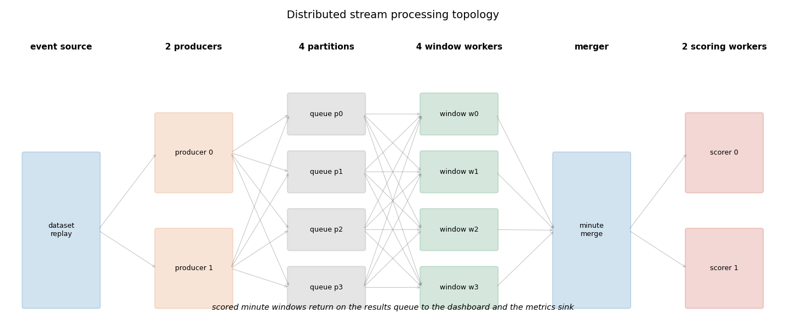
Figure 1. Stream topology: producers, hash partitions, window workers, merger and scorers.
Stage | Processes | Responsibility
Producers | 2 | replay the dataset in timestamp order, each owning a disjoint set of endpoints
Partitions | 4 | one inbox per partition, keyed by CRC32 of the endpoint name
Window workers | 4 | one-minute tumbling aggregation per partition behind an event-time watermark
Merger | 1 | joins the partial aggregates of one minute into a complete window
Scoring workers | 2 | one runs anomaly detection, one runs the machine-learning models
Sink | 1 | joins both result streams, drives the dashboard, records operational metrics

Two forms of parallelism are present. Producers and window workers are data parallel: the stream is split by key and the same code runs on each shard. The scoring stage is task parallel: both workers consume the same merged window stream but apply different models, so the machine-learning cost never delays the anomaly alarm. In total 9 processes run concurrently. Every stage owns an inbox, which is a listening socket, one reader thread per upstream connection and a local queue whose depth is the consumer lag of that stage. Each message carries the inbox depth of the stage that produced it, so the sink reconstructs the backlog of the whole topology without polling anything.

3. Data stream and generator
The generator in src/generator.py produces the event stream. Request volume per endpoint is drawn from a Poisson distribution whose rate follows a daily shape built from two sine components, a weekday factor that lowers weekend traffic, a slow upward drift across the three days and multiplicative noise. Latency is lognormal around an endpoint-specific base, status codes are drawn from an endpoint-specific error rate, and server errors carry extra latency.
Endpoint | Base rate (req/min) | Base latency (ms) | Base error rate
/api/v1/login | 12.0 | 140.0 | 1.5%
/api/v1/search | 22.0 | 95.0 | 1.0%
/api/v1/cart | 9.0 | 80.0 | 1.2%
/api/v1/checkout | 5.0 | 210.0 | 2.0%
/api/v1/recommend | 8.0 | 160.0 | 0.8%
/api/v1/health | 4.0 | 15.0 | 0.1%

Incident type | Labelled minutes | Injected effect
latency_spike | 114 | p95 latency multiplied by 4.5
error_burst | 105 | error rate raised to 38%, mostly 5xx
traffic_drop | 175 | request rate cut to 12% of normal
traffic_surge | 74 | request rate multiplied by 2.8

30 incidents are placed at random positions with a minimum gap of 40 minutes and a duration between 6 and 24 minutes. Every minute carries a ground-truth label, which is what makes the anomaly and classification results measurable rather than anecdotal.

4. Real-time visualization
The dashboard in src/dashboard.py is driven by the sink process and redraws as scored windows arrive. It shows four views at once, which satisfies the requirement for at least two meaningful views, and each view answers a different operational question. It keeps a sliding window of recent minutes, so the redraw cost stays constant as the run gets longer.
Panel | Content
Stream volume | requests per minute against its 15-minute rolling mean
Tail latency and alarms | p95 latency with anomaly alarms marked as they fire
Errors and risk | error rate on the left axis, predicted incident probability on the right
Operational metrics | throughput in events per second and total backlog

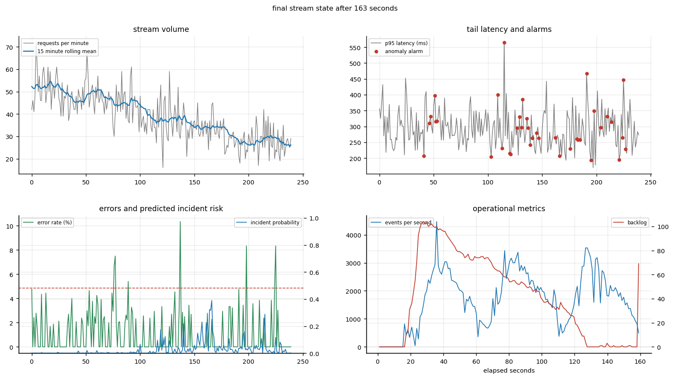
Figure 2. The live dashboard at the end of a run, with the running counters in the header.
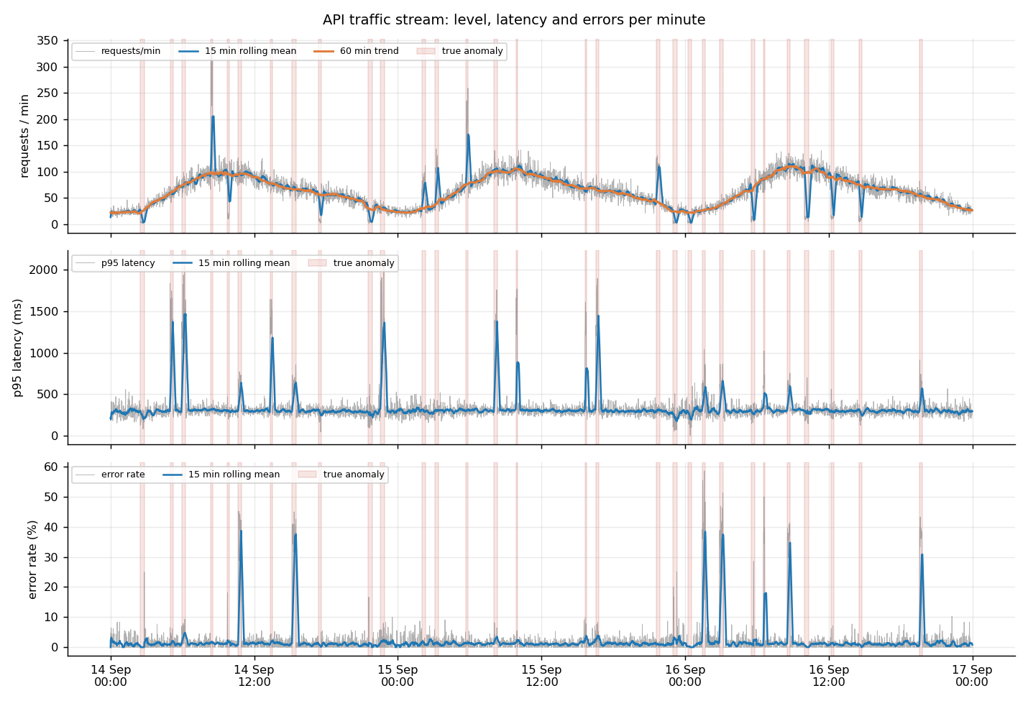
Figure 3. The complete three-day stream. Shaded bands are the injected incidents.

5. Time-series analysis
Events are resampled into one-minute tumbling windows indexed by timestamp. Each window carries the request count, the error rate, the server error rate, three latency quantiles, the bytes per request and the number of distinct users. This turns an irregular event stream into a regular series of 4,320 points, which is the input for every later layer. Three temporal methods are applied: rolling windows of 15 and 60 minutes for the local level and trend, resampling to hourly and to hour-of-day and weekday profiles for the daily cycle, and STL decomposition with a period of 1440 minutes into trend, seasonal and residual parts.
Property | Value
Mean requests per minute | 62.71
Linear trend per day | 0.17 requests per minute
Augmented Dickey-Fuller p-value | 0.0019
Autocorrelation at lag 1 | 0.878
Autocorrelation at lag 1440 | 0.377
Seasonal strength | 0.901
Trend strength | 0.137
Busiest and quietest hour | 8:00 and 0:00

The autocorrelation at lag 1440 confirms the daily cycle: the series is strongly related to its value exactly one day earlier. Seasonal strength of 0.90 says the daily component explains most of the structured variation, so any detector that ignores the time of day will raise alarms every morning and every night. That is the reason the detector works on deviation from a local baseline rather than on the raw level.
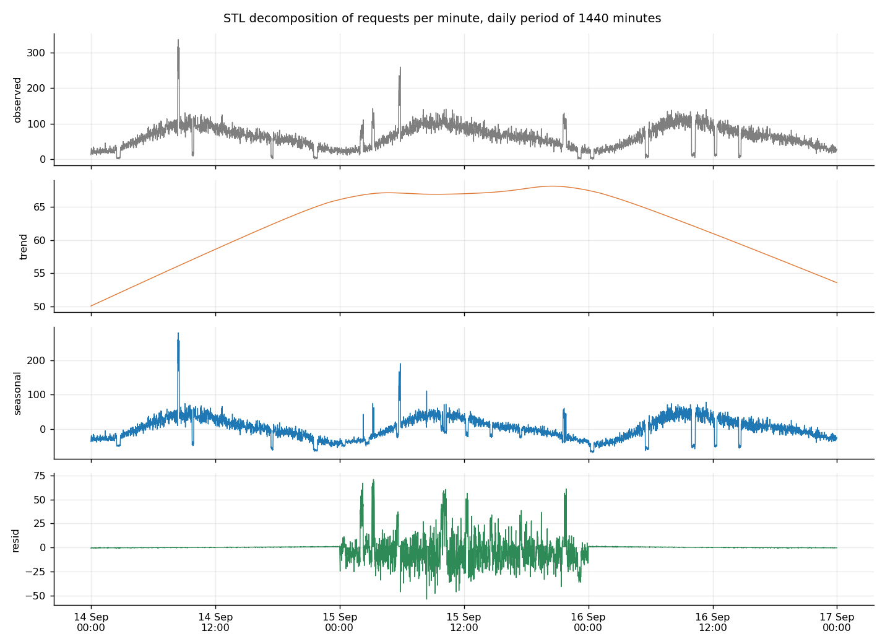
Figure 4. STL decomposition of requests per minute into trend, seasonal and residual parts.

6. Anomaly detection
Two detectors are implemented and compared on the same held-out window, the last 30 percent of the series, so that neither method benefits from data it was tuned on.

6.1 Rolling robust z-score
For the request count, the p95 latency and the error rate the detector keeps a trailing window of 180 minutes, takes the median as the baseline and the median absolute deviation scaled by 1.4826 as the spread, then reports the largest absolute deviation across the three signals. The current value is excluded from its own baseline, so a long incident cannot silently become the new normal inside the window. A minute is flagged when the score exceeds 3.5. The method is online by construction, so the streaming implementation keeps the same trailing buffer and needs no retraining.

6.2 Isolation forest
The second detector is an isolation forest with 200 trees fitted on the first 70 percent of the windows. It sees eight features per minute, including the ratio of the current volume and latency to their recent rolling means, so it judges the shape of a minute rather than its absolute level. Contamination is set to 4%, close to the true incident rate.
Method | Precision | Recall | F1 | ROC AUC | PR AUC | Incidents caught
rolling robust z score | 0.53 | 0.86 | 0.65 | 0.93 | 0.57 | 8/8
isolation forest | 1.00 | 0.44 | 0.61 | 0.95 | 0.77 | 5/8
streaming robust z score, live run | 0.38 | 0.86 | 0.52 | 0.86 | 0.40 | 29/30

Per-minute recall understates the operational value of a detector, because catching one minute of an incident is enough to page an engineer. The last column reports incident-level recall, the share of injected incidents with at least one flagged minute. The last row is the same detector running inside the live pipeline over the whole replay rather than the held-out window, which is why its precision is lower and its incident count is 30: it confirms that the streaming implementation reproduces the offline behaviour.
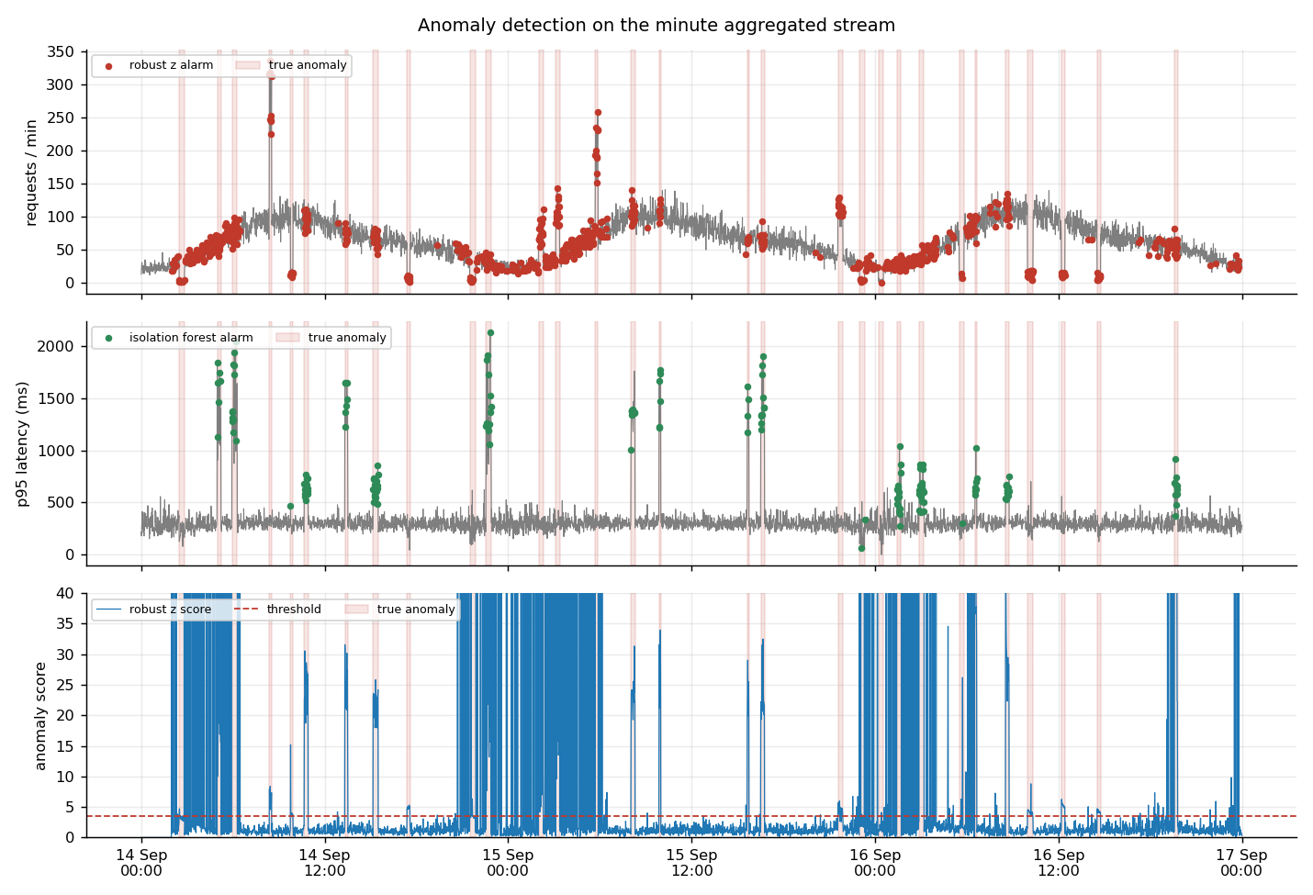
Figure 5. Alarms from both detectors against the injected incidents.
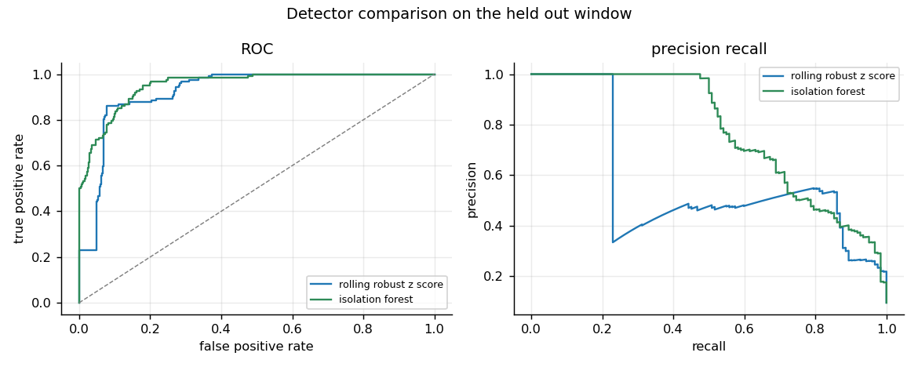
Figure 6. ROC and precision-recall curves for the two detectors on the held-out window.

7. Real-time machine learning
The prediction problem is classification: will the next minute be an incident. It is evaluated on a time-ordered split, 2,970 training windows followed by 1,274 test windows, with the test period starting at 2026-09-16 02:45:00. A random split would leak the future into the past and is never used.

7.1 Features available at prediction time
The feature builder in src/features.py produces 68 features for a prediction made at the end of minute t about minute t plus 1. Every feature is a function of windows that have already closed.
Group | Content
Lagged levels | request count, error rate, p95 and p50 latency, server error rate at lags 1, 2, 3, 5, 10, 15
Rolling statistics | mean, standard deviation and maximum over trailing windows of 5, 15, 60 minutes
Ratio and difference | volume over its 15-minute mean, p95 over its 60-minute mean, one-step changes
Calendar | sine and cosine of the time of day, weekday, weekend flag

Leakage is controlled in three places. Rolling statistics are computed on closed windows only. The targets are shifted backwards by one minute, so the label always lies strictly in the future of its features. The calendar features describe the target minute, which is legitimate because a clock is known in advance. The first 75 windows are dropped because their rolling features are not yet filled.

7.2 Incident classification
The classifier is a histogram gradient boosting model with balanced class weights, because only 9.6% of the test minutes are positive. It is reported at the default threshold and at a threshold tuned for F1, and the current output of the unsupervised detector is included as a baseline, because a model that cannot beat forwarding the detector is not worth its complexity.
Model | Precision | Recall | F1 | ROC AUC | PR AUC
gradient boosting, default threshold | 0.94 | 0.78 | 0.85 | 0.95 | 0.83
gradient boosting, tuned threshold | 0.94 | 0.78 | 0.85 | 0.95 | 0.83
current detector forwarded as prediction | 0.53 | 0.82 | 0.64 | 0.91 | 0.57

The headline F1 flatters the model, so it is worth splitting. An incident minute is either the first minute of an incident, where the evidence is still in the future, or a later minute of an incident that is already visible in the features.
Model | Onset minutes in test | Recall at onset | Recall while ongoing
gradient boosting, tuned threshold | 8 | 0.00 | 0.83
current detector forwarded as prediction | 8 | 0.25 | 0.86

The gradient boosting model recalls 83% of the minutes of incidents that are already under way and none of the onsets. That is the honest reading of the result: it is an excellent persistence detector and not an early warning system. It is also the expected result, because the generator places incidents at random times, so nothing in the traffic before an incident carries information about when it will start. The baseline catches 25% of the onsets, but only by firing on 190 of the 1,274 test minutes at a precision of 0.53, so its alarms are cheap and mostly wrong.
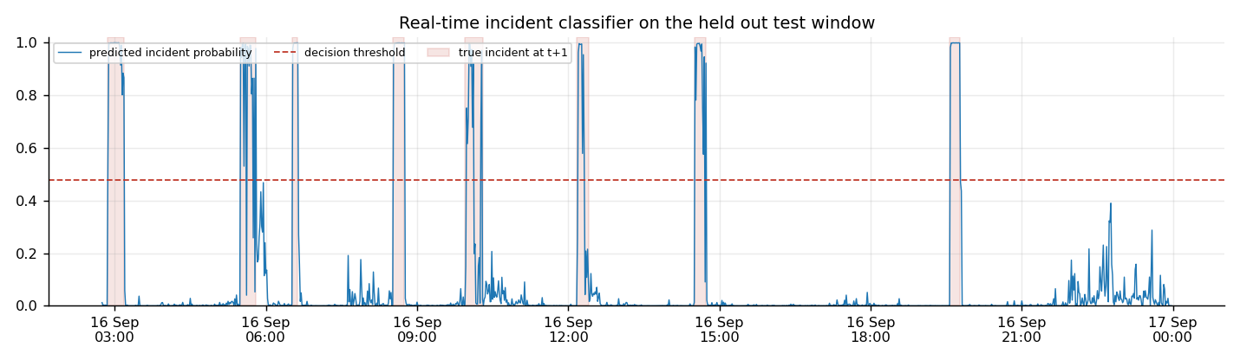
Figure 7. Predicted incident probability against the true incidents in the test window.
Permutation importance on the test window ranks the features by how much the ROC AUC falls when the feature is shuffled. The strongest are requests_lag1, latency_p50_lag1, requests_ratio_15, requests_lag2, latency_p95_mean60. The full ranking is in results/feature_importance.csv.

8. Distributed stream processing
The pipeline in src/pipeline.py demonstrates the distributed concepts on one machine with real operating-system processes and no shared state. Partitioning by a stable CRC32 hash of the endpoint guarantees that all events of one key reach the same window worker, which is what makes per-key aggregation correct under parallelism. A watermark of 20 event-time minutes closes a window once the stream has moved far enough past it, which bounds memory and tolerates producers that are not perfectly in step. Records that arrive for a window that is already closed are counted as late and dropped rather than silently reopening the window. End-of-stream sentinels are counted per upstream connection, so every stage shuts down only after all of its inputs are done.
Operational characteristic | Measured value
Wall-clock duration | 162.8 s
Simulated time | 72.0 h at 1800 times real time
Events processed | 270,925
Windows completed | 4,319
Throughput | 1,706 events per second mean, 4,472 peak
Window completion rate | 26.5 windows per second
End-to-end latency | 2233 ms mean, 4042 ms p95
Stage latency | aggregation 672 ms, merge 1.3 ms, scoring 1552 ms
Backlog | 41.8 mean, 104 peak at the anomaly stage
Late records dropped | 0 with a watermark of 20 event-time minutes

Five operational characteristics are measured, above the two the project requires: throughput, end-to-end and per-stage processing latency, completed event and window counts, per-stage backlog and dropped late records. The sink samples them once per second into results/ops_metrics.csv. The aggregation stage includes the wait for the window to close, so it carries the bulk of the end-to-end figure: at 1800 times real time a watermark of 20 event-time minutes is 667 ms of wall time, which matches the measured aggregation stage almost exactly. Backlog is the early warning signal, it stays near zero while the consumers keep up and grows as soon as a stage becomes the bottleneck, which is the signal a production consumer group exposes as consumer lag.
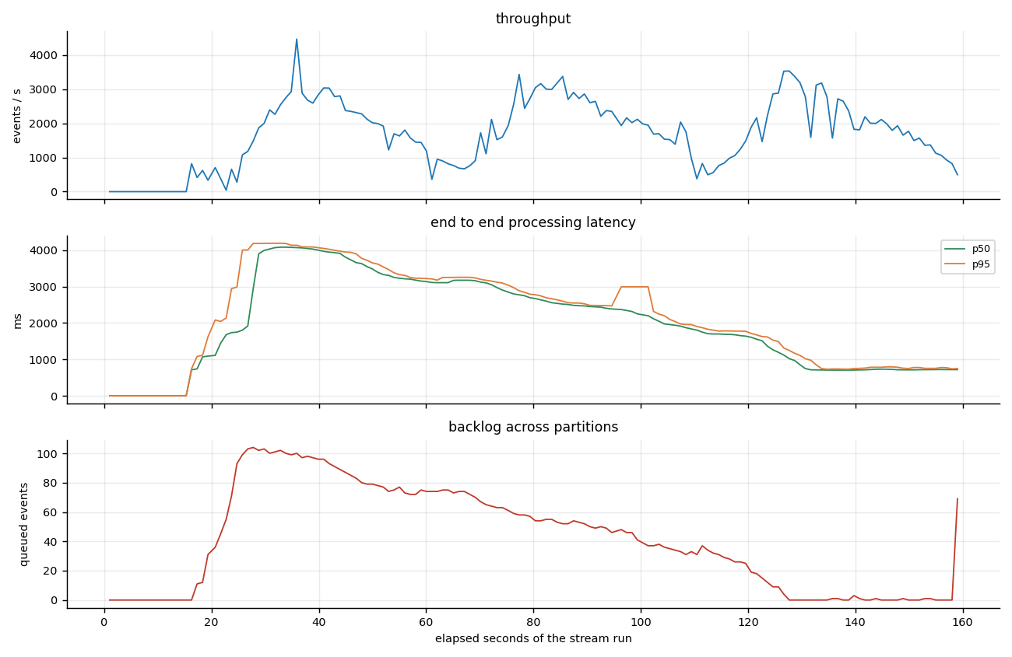
Figure 8. Throughput, end-to-end latency and backlog during the run.

8.1 Finding and removing the bottleneck
The first working version of the pipeline could not keep up. The per-stage traces showed why: the machine-learning worker needed about thirty milliseconds for every window, and almost all of it was the pandas feature build, which recomputed sixty rolling and lag expressions over the whole trailing buffer in order to obtain a single row. Its inbox grew without bound while the other stages sat idle, which is what a bottleneck looks like in the backlog series.
The fix was to compute the same feature row directly with NumPy on the trailing buffers, which is roughly fifty times faster than rebuilding the pandas frame for a single row. After the change the scoring stage is no longer the slowest link: the peak backlog of the run sits at the anomaly stage instead, and the average backlog across the whole topology is 41.8 messages.
A second defect surfaced in the same traces. The two producers drift by a few milliseconds, which at an accelerated replay is several minutes of event time, so batches from the slower producer arrived after their window had already been closed by the faster one. The window worker reopened the window and the same minute was scored twice. The fix has two parts: the producers are released by a shared start time, and a closed window is never reopened, so late records are counted and dropped. With the current watermark the run drops 0 records out of 270,925.

9. Discussion and limitations
The best detector on the held-out window is the rolling robust z score with an F1 of 0.65 and a ROC AUC of 0.93. The best classifier is the gradient boosting, default threshold with an F1 of 0.85 and a ROC AUC of 0.95. Detection and prediction answer different questions: the detector reports that the current minute is abnormal, the classifier reports that the next minute is likely to be, and section 7.2 shows where that skill actually comes from.
Five limitations are worth stating plainly. The data is synthetic, so the incidents have known shapes and the detectors face a cleaner problem than production traffic with correlated failures and missing data. The held-out window contains only 8 incidents, which is a small sample for event-level claims. The distributed layer runs on one machine, so network partitions, broker failures and rebalancing are out of scope, although the socket transport means the code itself is not tied to one host. The models are trained once offline and then served in the stream, so no drift detection or scheduled retraining is implemented. Finally, the supervised labels come from the generator and would not exist at prediction time in production, where they would have to be recovered from incident tickets or from the unsupervised detector.
The natural extensions are a Kafka or Flink backend with the same operators, a drift monitor that compares the live feature distribution against the training distribution, per-endpoint models instead of one global model, and alert suppression so that one long incident produces one page rather than one page per minute.

10. Conclusion
The streaming application was extended into a full analytics system. The dashboard updates continuously with four views. The temporal layer uses timestamps, rolling windows, resampling and STL decomposition, and quantifies a daily cycle with a seasonal strength of 0.90. Two anomaly detectors are implemented and evaluated against ground truth, and the streaming detector catches 29 of 30 injected incidents. A real-time machine-learning layer predicts the next minute from features that exist at prediction time and is evaluated with F1, ROC AUC and PR AUC against a baseline. The distributed layer runs 9 processes over 4 hash partitions with watermarked windows and reports throughput, latency, event counts, backlog and late records measured during a live run of 270,925 events in 163 seconds.

Appendix. Reproducing the results
Install the dependencies with pip install -r requirements.txt, then run python run_all.py. The stages run in order: the generator writes data/events.csv.gz with its labels, the offline stage performs the time-series, anomaly and machine-learning analysis and saves the fitted models, the stream stage replays the events through the distributed pipeline with the live dashboard, and the last two stages regenerate this report and the slides. All parameters live in config.yaml and the seed is fixed. Metrics land in results/ as JSON and CSV, figures in figures/.

