 | Republic of the Philippines  TARLAC STATE UNIVERSITY  COLLEGE OF COMPUTER STUDIES | 

WMA4 – Advanced Web Development
PROJECT DOCUMENTATION REPORT
Midterm Phase

Rental POS / Sales Management System
Assigned System Type: Point-of-Sale (POS) / Sales Management System

Submitted by:
[Member 1 – Full Name]
[Member 2 – Full Name]
[Member 3 – Full Name]
[Member 4 – Full Name]
[Member 5 – Full Name]
Submitted to: [Instructor Name]
Date: [Month DD, 2026]
GitHub Repository: [https://github.com/<user>/WM4Mid]

Table of Contents
A. Title Page
B. Introduction and Project Overview
C. Objectives of the System
D. Scope and Limitations
E. Requirements Analysis (Midterm Features)
F. System Design and Architecture
G. Database Design (ERD and Data Dictionary)
H. Implementation Details
H.1 Technology Stack
H.2 Project Structure
H.3 Object-Oriented Design
H.4 Feature Implementation
H.5 Validation and Exception Handling
H.6 API Endpoints
H.7 Testing Summary
H.8 Disclosure of External and AI-Assisted Code
H.9 Setup Instructions
H.10 Known Limitations and Next Phase (Final Term)

B. Introduction and Project Overview
This document is the Midterm Documentation Report for the WMA4 – Advanced Web Development course project. Following the course milestone, the group was assigned the Point-of-Sale (POS) / Sales Management System and adapted it to the context of an equipment rental business: the shop rents out items (e.g., tools, bikes, gear) to registered customers for a daily rate, collects a deposit, tracks due dates, charges late fees on overdue returns, and reports on sales.
In the POS context, the "primary record" is the rental contract (a sale transaction made of one or more rented items), backed by the customer and inventory records. The system is built with native PHP 8 (object-oriented, PDO) and MySQL, and presents a single-page HTML/JavaScript interface that communicates with server-side JSON endpoints. This midterm output is the foundation that will be extended in the Final Term phase (authentication and security, REST API, and Laravel).

Problem Statement
Small rental shops commonly record rentals on paper or spreadsheets. This leads to double-booked items, forgotten due dates, unrecorded deposits, inconsistent late-fee computation, and no quick view of revenue. The system centralizes these records and automates availability tracking and late-fee computation.

C. Objectives of the System

General Objective
To design and implement a database-driven rental POS web application using native PHP and MySQL that manages customers, inventory, rental transactions, returns, and sales summaries.

Specific Objectives
- Provide server-validated forms for registering customers, adding inventory items, creating rental contracts, and processing returns.
- Model the core entities in a normalized relational database with at least three related tables, using primary, foreign, and unique keys.
- Implement full CRUD for customers and inventory using PDO prepared statements.
- Provide searchable, filterable, and sortable listings using WHERE, ORDER BY, and LIMIT.
- Apply object-oriented PHP (interface, abstract base class, inheritance, encapsulation, custom exceptions).
- Provide a dashboard summarizing stock, contracts, deposits, late-fee exposure, and sales.

D. Scope and Limitations

Scope (Midterm)
- Customer management (add, view, search, edit, delete).
- Inventory management with status tracking (Available, Rented, Maintenance).
- Rental contract creation with multiple items and deposit; automatic item status updates.
- Returns processing (full or partial) with automatic late-fee computation.
- Dashboard and sales report computed from live data.

Limitations (to be addressed in Final Term)
- No user login or roles yet – all pages are open (authentication, RBAC, and CSRF protection are Final Term requirements).
- The data-entry forms and API are not yet protected by tokens.
- The REST API is endpoint-based (*.php) rather than resource-routed; Final Term will formalize it and add Postman documentation.
- Reports are limited to the dashboard summary.

E. Requirements Analysis (Midterm Features)
The table maps each required Midterm feature to its implementation in the system.
# | Required feature | Implementation | Status
1 | Server-side data-entry/transaction form with validation and friendly errors | Customer, inventory, new-rental and return forms in index.html; processed by customers.php, inventory.php, process_new_rental.php, process_return.php; ValidationException returns HTTP 422 with a readable message | Done
2 | Normalized MySQL DB, ≥3 related tables | customers, inventory, rental_contracts, contract_items (4 tables, FKs, unique keys) | Done
3 | Full CRUD with prepared statements (PDO) | Customer, InventoryManager (all 4 operations); RentalContract create/read/update. Delete buttons with confirmation added to the UI | Done
4 | Searchable/filterable/sortable listing (WHERE, ORDER BY, LIMIT) | all() methods + BaseModel::build_sort_and_limit() (whitelisted sort columns, paging) | Done
5 | ≥3 related OOP classes, encapsulation, inheritance/interface, exception handling | CrudInterface → BaseModel → Customer, InventoryManager, RentalContract; ValidationException; DB transactions with rollback | Done
6 | Dashboard / summary view via PHP/SQL | DashboardService + dashboard.php | Done

F. System Design and Architecture
The system follows a simple layered structure: a browser-based front end, thin PHP endpoint scripts that handle HTTP concerns, domain classes that contain business logic, and a MySQL database accessed through a single PDO connection.
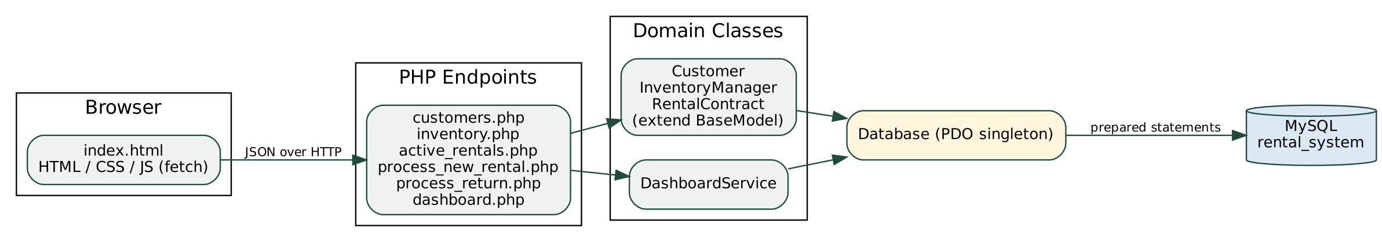
Figure 1. System architecture

Typical Request Flow – Create Rental
- The user fills in the New Rental form (customer, due date, deposit, items) and submits.
- JavaScript sends a JSON POST to process_new_rental.php.
- The endpoint calls RentalContract::create(), which validates input, then opens a database transaction.
- The contract row and each contract_items row are inserted (the current daily rate is snapshotted), and each item is marked Rented via InventoryManager.
- On success the transaction commits and the endpoint returns HTTP 201 with the contract; on any failure it rolls back and returns a 422/500 JSON error.

G. Database Design (ERD and Data Dictionary)
The database rental_system.sql contains four InnoDB tables in third normal form. Customer data and item data are stored once and referenced from contracts through foreign keys; the many-to-many relationship between contracts and inventory items is resolved by the associative table contract_items. The daily rate is copied into contract_items.daily_rate_at_checkout on purpose, so later price changes do not alter historical contracts or revenue.
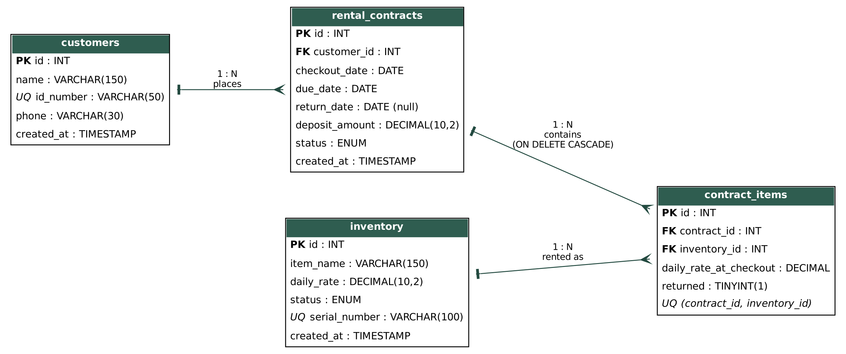
Figure 2. Entity Relationship Diagram

Relationships
- customers 1 — N rental_contracts (fk_contracts_customer, restrict: a customer with contracts cannot be deleted).
- rental_contracts 1 — N contract_items (fk_items_contract, ON DELETE CASCADE).
- inventory 1 — N contract_items (fk_items_inventory, restrict).

Data Dictionary
Table: customers
Column | Type | Constraints / Notes
id | INT | PK, AUTO_INCREMENT
name | VARCHAR(150) | NOT NULL
id_number | VARCHAR(50) | NOT NULL, UNIQUE (uq_customers_id_number)
phone | VARCHAR(30) | NOT NULL
created_at | TIMESTAMP | DEFAULT current_timestamp()

Table: inventory
Column | Type | Constraints / Notes
id | INT | PK, AUTO_INCREMENT
item_name | VARCHAR(150) | NOT NULL
daily_rate | DECIMAL(10,2) | NOT NULL
status | ENUM(Available, Rented, Maintenance) | DEFAULT Available; indexed
serial_number | VARCHAR(100) | NOT NULL, UNIQUE
created_at | TIMESTAMP | DEFAULT current_timestamp()

Table: rental_contracts
Column | Type | Constraints / Notes
id | INT | PK, AUTO_INCREMENT
customer_id | INT | FK → customers.id
checkout_date | DATE | NOT NULL
due_date | DATE | NOT NULL; indexed
return_date | DATE | NULL until fully returned
deposit_amount | DECIMAL(10,2) | DEFAULT 0.00
status | ENUM(Active, Returned, Overdue) | DEFAULT Active; indexed
created_at | TIMESTAMP | DEFAULT current_timestamp()

Table: contract_items
Column | Type | Constraints / Notes
id | INT | PK, AUTO_INCREMENT
contract_id | INT | FK → rental_contracts.id (CASCADE)
inventory_id | INT | FK → inventory.id
daily_rate_at_checkout | DECIMAL(10,2) | Price snapshot at rental time
returned | TINYINT(1) | DEFAULT 0; 1 when returned
(contract_id, inventory_id) | — | UNIQUE – an item appears once per contract

H. Implementation Details

H.1 Technology Stack
Layer | Technology
Back end | PHP 8 (declare(strict_types=1), OOP), PDO with prepared statements
Database | MySQL / MariaDB (InnoDB, utf8mb4)
Front end | HTML5, CSS3, vanilla JavaScript (fetch API)
Server | Apache (XAMPP) or PHP built-in server; hosted on InfinityFree for demo
Version control | Git / GitHub

H.2 Project Structure
WM4Mid-main/
├── index.html UI
├── customers.php Customer CRUD endpoint
├── inventory.php Inventory CRUD endpoint
├── active_rentals.php Contract listing (filter/search/sort)
├── process_new_rental.php Create rental contract
├── process_return.php Process return + late fee
├── dashboard.php Dashboard summary
├── CrudInterface.php Interface
├── BaseModel.php Abstract base class
├── Customer.php InventoryManager.php RentalContract.php
├── DashboardService.php Database.php ValidationException.php
├── rental_system.sql Schema + sample data
├── docs/ ERD, report
└── postman/ API collection

H.3 Object-Oriented Design
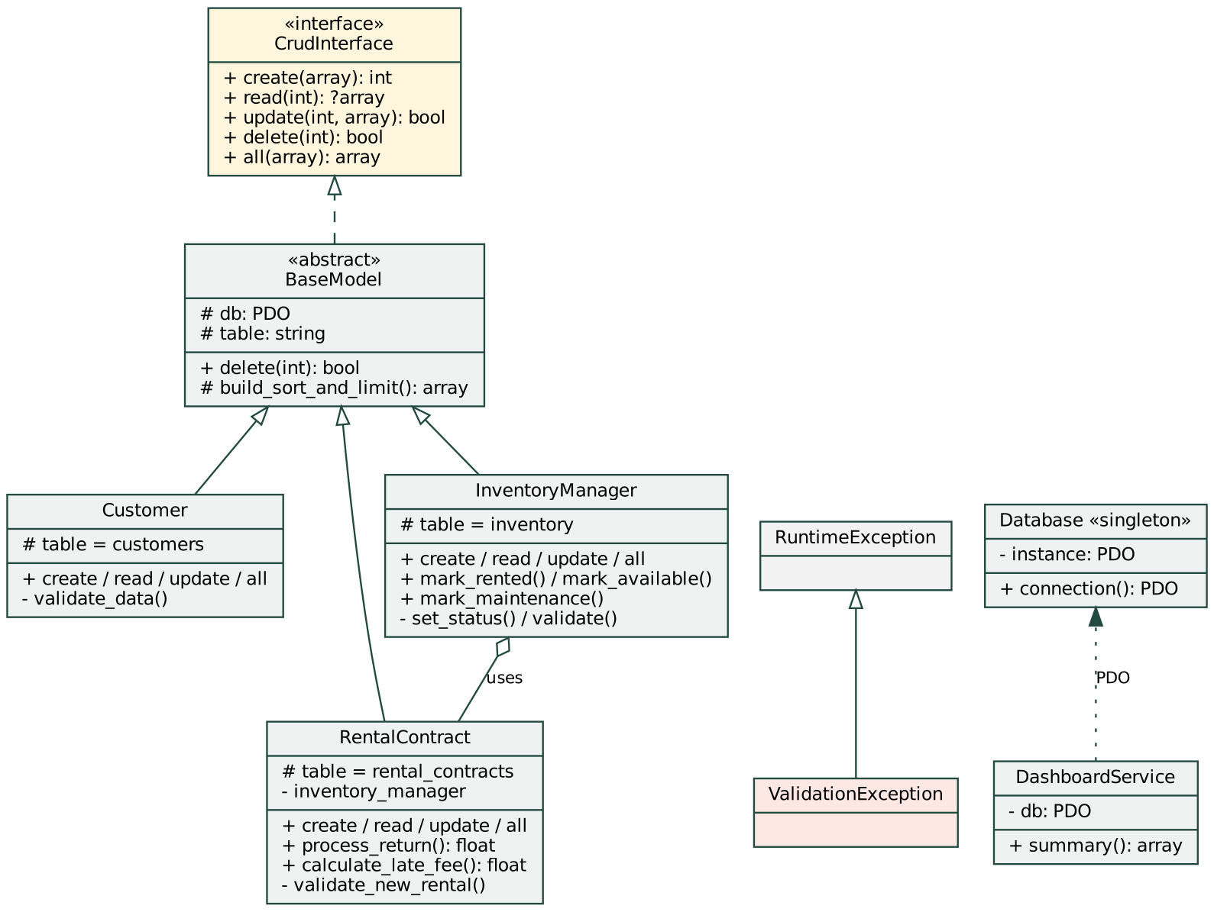
Figure 3. Class diagram
OOP concept | Where it is applied
Interface | CrudInterface defines create, read, update, delete, all
Abstraction / inheritance | BaseModel (abstract) implements CrudInterface, holds the PDO handle, a shared delete(), and build_sort_and_limit(); Customer, InventoryManager, RentalContract extend it
Encapsulation | protected PDO $db, protected string $table; private validators and set_status(); class constants for statuses; Database is a private-constructor singleton
Composition | RentalContract uses InventoryManager to update item status; DashboardService encapsulates reporting SQL
Exception handling | Custom ValidationException for user errors (HTTP 422); try/catch with beginTransaction/commit/rollBack around contract creation and returns; PDOException code 23000 mapped to HTTP 409

H.4 Feature Implementation

1. Customer and Inventory Management (CRUD)
Both modules expose Create (POST), Read (GET), Update (PUT/PATCH), and Delete (DELETE). All SQL uses named parameters. Updates only touch fields that are supplied. Deleting a record that is referenced by contracts is blocked by the foreign key and the user is shown a clear message (HTTP 409) rather than a generic error.
[Insert screenshot: Customers page – add/edit form and list with Edit/Delete buttons]

[Insert screenshot: Inventory page – add/edit form and list]

2. Search, Filter, Sort, Paging
Lists accept search, status, sort, direction, page, per_page. Search uses LIKE with bound parameters; the sort column is checked against a per-model whitelist and direction is forced to ASC/DESC, so these values cannot be used for SQL injection. per_page is clamped to 1–100 and translated to LIMIT/OFFSET.
GET customers.php?search=ant&sort=name&direction=ASC&page=1&per_page=25
GET inventory.php?status=Available&sort=daily_rate&direction=DESC
GET active_rentals.php?status=Active&sort=due_date

3. Rental Contract Creation
RentalContract::create() validates the customer, due date, deposit and item list; then, inside a transaction, inserts the contract and one contract_items row per item (snapshotting the daily rate) and marks each item as Rented. Any failure rolls everything back so the database never holds a contract with partially-rented items.
[Insert screenshot: New Rental form]

4. Returns and Late Fees
RentalContract::process_return() marks the chosen items (or all outstanding items) as returned and makes them Available again. When no items remain outstanding the contract is closed with today's date. The late fee is computed as the sum of each unreturned item's checkout daily rate multiplied by the number of days past the due date.
late_fee = Σ ( daily_rate_at_checkout × days_late ), days_late = max(0, return_date − due_date)
[Insert screenshot: Active Contracts page and Process Return panel]

5. Dashboard
DashboardService::summary() returns inventory counts by status, active/overdue/returned-today contracts, deposits held, estimated late-fee exposure, and a sales report (completed rentals, base revenue, late fees collected, total and average sale value, most-rented item), all computed with SQL aggregates (COUNT, SUM, GROUP BY, DATEDIFF).
[Insert screenshot: Dashboard]

H.5 Validation and Exception Handling
Rule | Where enforced | Response
Customer name, ID number, phone required | Customer::validate_data() | 422 + message
Item name and serial required; daily rate numeric ≥ 0; status in allowed list | InventoryManager::validate() | 422 + message
Rental needs valid customer, due date, ≥1 item, deposit ≥ 0 | RentalContract::validate_new_rental() | 422 + message
Duplicate ID number / serial number; deleting referenced records | Unique keys / foreign keys → PDOException 23000 | 409 + message
Wrong HTTP method | Endpoint scripts | 405
Unexpected errors | Generic catch (\Throwable) | 500 (no internal details leaked)

H.6 API Endpoints
Endpoint | Methods | Description
customers.php[?id=] | GET, POST, PUT/PATCH, DELETE | Customer CRUD, search/sort/paging
inventory.php[?id=] | GET, POST, PUT/PATCH, DELETE | Inventory CRUD, filter/search/sort/paging
active_rentals.php | GET | Contract list with status/search/sort
process_new_rental.php | POST | Create contract
process_return.php | POST | Return items, compute late fee
dashboard.php | GET | Summary metrics

Sample request/response:
POST /customers.php
{ "name": "Maria Santos", "id_number": "2026-0001", "phone": "09171234567" }
201 Created
{ "success": true, "id": 3, "customer": { "id": 3, "name": "Maria Santos", ... } }
POST /customers.php (missing phone)
422 Unprocessable Entity
{ "success": false, "error": "Field 'phone' is required." }

H.7 Testing Summary
Manual functional tests performed against the local/hosted setup. A Postman collection (postman/Rental_POS_API.postman_collection.json) covers every endpoint with status-code tests. [Group: confirm each "Result" after running your own tests and add screenshots.]
# | Test case | Expected result | Result
1 | Add customer with all fields | 201, appears in list | [Pass/Fail]
2 | Add customer with missing phone | 422 + message shown | [Pass/Fail]
3 | Add customer with duplicate ID number | 409 + message | [Pass/Fail]
4 | Edit customer phone | 200, list updates | [Pass/Fail]
5 | Delete customer with no contracts | 200, removed | [Pass/Fail]
6 | Delete customer that has contracts | 409, not deleted | [Pass/Fail]
7 | Add inventory item with negative rate | 422 | [Pass/Fail]
8 | Search/filter/sort inventory | Matching rows in order | [Pass/Fail]
9 | Create rental with 2 items | 201; items become Rented | [Pass/Fail]
10 | Create rental with no items | 422 | [Pass/Fail]
11 | Return overdue contract | Late fee > 0; items Available; contract Returned | [Pass/Fail]
12 | Dashboard reflects the changes above | Counts and totals update | [Pass/Fail]

H.8 Disclosure of External and AI-Assisted Code
In accordance with the project guidelines, the group discloses that AI assistance (Claude by Anthropic) was used to help draft this documentation report, the ERD and README, the Postman collection, and the small additions of the Delete buttons and the foreign-key-conflict error handling. No external templates or third-party libraries are used in the application. The group members can explain and modify all code presented. [Group: edit this paragraph if other AI tools, templates or code were used.]

H.9 Setup Instructions
- Copy the project folder to the web root (e.g., C:\xampp\htdocs\WM4Mid-main).
- Start Apache and MySQL, create a database (e.g., rental_system), and import rental_system.sql.
- Open Database.php and set HOST, DB, USER, PASS for your environment.
- Browse to http://localhost/WM4Mid-main/index.html.
Live demo URL: [https://your-site.example/]

H.10 Known Limitations and Next Phase (Final Term)
- Authentication & RBAC: add registration/login (password_hash/password_verify), Admin and Staff roles, CSRF tokens, secure logout.
- REST API: resource-style routes with correct status codes, documented in Postman.
- Laravel: rebuild or extend one module (e.g., Customers or Inventory) with migrations, seeders, and an Eloquent relationship.
- Reports: expand the dashboard into dedicated sales and overdue reports.
- Hardening: escape output in the UI to prevent XSS; move DB credentials out of source control; set the Overdue status automatically.

