ALL TEST 6.31 Analysis Results

Performance Summary

Bottom Line
This induction motor is operating normally, no action is required.
X This induction motor exhibits suspicious operation, trending of the induction motor is warranted.
This induction motor exhibits abnormal indications, action is warranted, NOW.

Power Factor Commentary
Power factor exceeds 0.85.
X Power factor is below 0.85, see detailed report.

Current Commentary
X Current variation is within normal limits.
Current variation is beyond normal limits, see detailed report.

Voltage Commentary
X Voltage variation is within normal limits.
Voltage variation is beyond normal limits, see detailed report.
RMS voltage differs from nameplate by more than 5%.

Load Commentary
X Load on the induction motor is consistent with nameplate values.
Load on the induction motor exceeds nameplate values, see detailed report.
Load on the induction motor is less than 25%.

Phase Connection Commentary
X Connections are normal.
Voltage ground reference is NOT neutral.
Loose connection.

Rotor Commentary
Rotor bar health is normal.
X Rotor bar health is questionable, see detailed report.
Load is insufficient to determine rotor bar health, at this time.

Stator Commentary
X Stator health is normal.
Stator mechanical health is questionable. .
Turn to turn short.

Rotor/Stator Air-gap Characteristics
X Dynamic or static eccentricity indications do not exist.
Indications of static eccentricity exist .
Indications of dynamic eccentricity exist.

Harmonic Distortion Commentary
X There is no evidence of harmonic distortion.
There is evidence of harmonic distortion, see detailed report.

Misalignment Indications
X There are no indications of mechanical problems like misalignment or unbalance.
There are indications of mechanical problems like misalignment / unbalance. Perform vibr. survey to identify and correct the cause.

Bearing Commentary
There is no evidence of bearing problem.
X Indications of potential bearing problems, perform vibration survey to verify.

INPUT SUMMARY

NAMEPLATE INFORMATION
 |  | Units
Model Number | YLKK355-6
Tested Equipment | Induction
Power | 422.25 | HP
RPM | 985.0 | Rpm
Poles | 6
Phases: | 3
Voltage | 6300.0 | Volt
Full Load Current | 41.90 | Amp
No Load Current | 3.00 | Amp
Number of rotor bars | -1
Number of stator slots | -1
Torque | 2250.6 | Ft.Lb
CT Ratio | 20.000
PT Ratio | 60.000
Duty Cycle | S1
Service Factor | 115
Insulation Type | F
Motor efficiency | -1.000
Power factor | -1.000

Description:
Belum ada data rotor bar dan stator slot

LEGENDS:
Impedance | = Complex Impedance = vi/ci
CF | = Crest Factor = (waveform peak)/(waveform rms)
VDF | = Transformer Harmonic De-rating Factor = sqrt(2)/CF, %

Slip % | = SRSS sum of slip and harmonic "levels" divided by RMS level of RMS DEMOD spectra between 0 and 65 Hz.
Upper sb | = dB level of upper slip sideband of power line peak
Lower sb | = dB level of lower slip sideband of power line peak
Se, fund | = Location of pole pass frequency fundamental, Hz
Se, harm | = Number of pole pass frequency harmonics
Rotor bar health | = Estimate of the percent of broken or cracked rotor bars
RB Hlt Index | = Rotor bar health index

THDF | = Voltage De-rating Factor = 100 - (voltage unbalance, %)^2, %
Level | = Sum of spectral amplitudes of pole pass frequency fundamentals and harmonics
Thd | = Total harmonic distortion
+Ve | = Positive sequence harmonic
-Ve | = Negative sequence harmonic
Zero | = Zero sequence harmonic

Detailed Calculations

Running Speed = 14.954 Hz [897 RPM]

Pole pass frequency = 10.406 Hz [624 RPM]

Load = 82.5 %
Time
 | RMS | Peak | CF
Current 1 | 30.600 | 45.735 | 1.495
Current 2 | 30.600 | 45.735 | 1.495
Current 3 | 31.000 | 46.333 | 1.495
Average | 30.733 | 45.935 | 1.495
% dev | 0.9 | 0.9 | 0.0

THDF = 94.6

Time
 | RMS | Peak | CF
Voltage 1 | 6228.000 | 8912.000 | 1.431
Voltage 2 | 6234.000 | 8920.600 | 1.431
Voltage 3 | 6246.000 | 8937.800 | 1.431
Average | 6236.000 | 8923.500 | 1.431
% dev | 0.2 | 0.2 | 0.0

VDF = 100.0
* Note-
Phase 2 and 3 CF and peak entries are assumed to be the same as phase-1.

 |  |  | App. Power | Real Power | Reac. Power
 | Power factor | Impedance | kVA | kW | kVARS
Phase 1 | 0.817 | 203.530 | 108.690 | 88.800 | 62.676
Phase 2 | 0.832 | 203.730 | 109.610 | 91.200 | 60.801
Phase 3 | 0.824 | 201.480 | 113.650 | 93.600 | 64.455
Avg/Total | 0.824 | 202.910 | 331.950 | 273.600 | 187.930
% dev | 1.0 | 0.7

Demand Pwr = 366.76 HP

Load:82.5 %

Motor Eff.:95.3 %

Loss due to THD:

Output Pow.:256.26 KW

Output Trq.:2010.00 Ft.Lb

Summary of Rotor Bar Health |  |  |  |  | Power line dB diff. |  | RB Hlt Index
 | Se, fund |  | Se, harm | Level % | Upper SB | Lower SB | RB Hlt Index
Measured | 10.406 |  | 2 | 0.3 | -51.041 | -50.415 | 0.421
Severity level |  | Rotor Condition Assessment |  |  | Recommended Corrective Action
3 |  | Slight indication of rotor problems |  |  | Continue surveys, trend only

Bearing condition
Location | Bearing No. | IR | OR | T/C | BS
Drive end | SKF 6228 | OK | OK | Bad | OK
Opposite end | SKF 7330B | OK | OK | Bad | OK

Harmonic Distortion Results:
Voltage input, from 50.018 Hz harmonics
 | THD Odd % | THD Even % | +ve% | -ve % | Zero % | THD All %
Current 1 | 0.978 | 0.180 | 0.286 | 0.949 | 0.085 | 0.994
Current 2 | *** | *** | *** | *** | *** | ***
Current 3 | *** | *** | *** | *** | *** | ***
Voltage 1 | 0.861 | 0.015 | 0.175 | 0.842 | 0.044 | 0.861
Voltage 2 | *** | *** | *** | *** | *** | ***
Voltage 3 | *** | *** | *** | *** | *** | ***

Harmonic distortion table – Peak values, voltage is phase to ground
Hz | Cur1 | Vlt1 | Cur2 | Vlt2 | Cur3 | Vlt3
50 | 43.5 | 5026 | *** | *** | *** | ***
100 | 0.0 | 0 | *** | *** | *** | ***
150 | 0.0 | 2 | *** | *** | *** | ***
200 | 0.0 | 1 | *** | *** | *** | ***
250 | 0.4 | 44 | *** | *** | *** | ***
300 | 0.0 | 1 | *** | *** | *** | ***
350 | 0.1 | 8 | *** | *** | *** | ***
400 | 0.1 | 0 | *** | *** | *** | ***
450 | 0.0 | 1 | *** | *** | *** | ***
500 | 0.0 | 1 | *** | *** | *** | ***
550 | 0.0 | 3 | *** | *** | *** | ***
600 | 0.0 | 1 | *** | *** | *** | ***

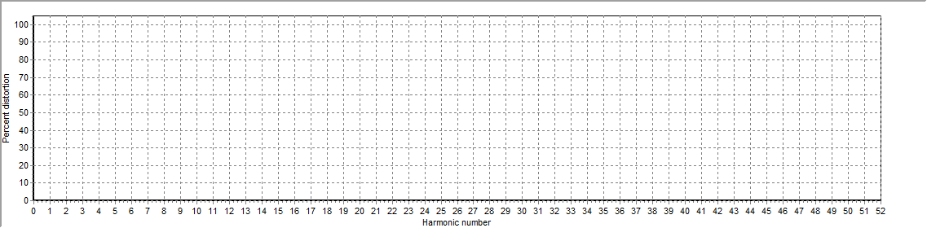
Figure 1: Current harmonic distortion plot

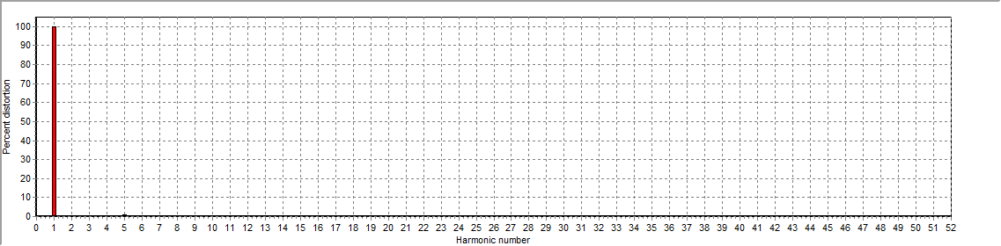
Figure 2: Voltage harmonic distortion plot

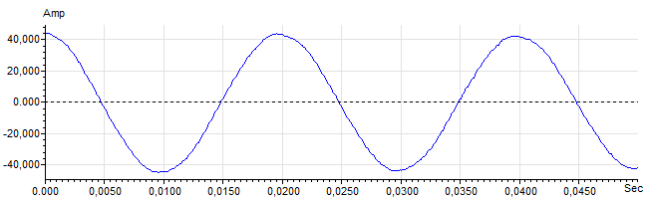
Figure 3: Raw Current

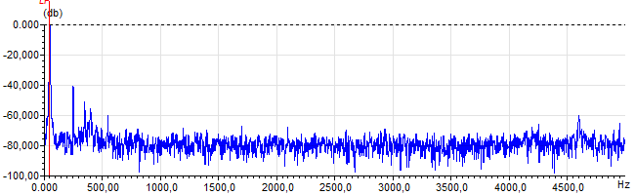
Figure 4: Raw Current Frequency spectrum

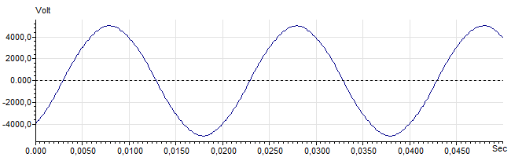
Figure 5: Raw Voltage

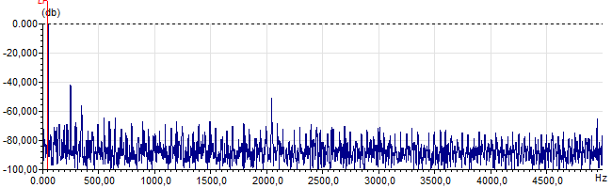
Figure 6: Raw Voltage Frequency spectrum

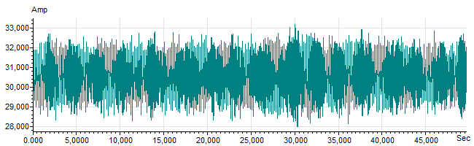
Figure 7: Demodulated current trace

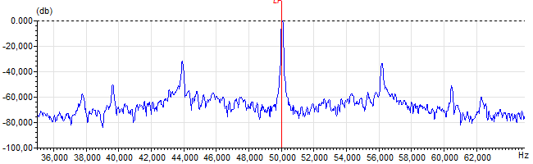
Figure 8: Raw current spectrum

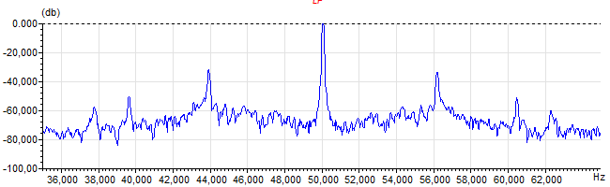
Figure 9: Demodulated current spectrum

