ALL TEST 6.31 Analysis Results

Performance Summary

Bottom Line
This induction motor is operating normally, no action is required.
X This induction motor exhibits suspicious operation, trending of the induction motor is warranted.
This induction motor exhibits abnormal indications, action is warranted, NOW.

Power Factor Commentary
X Power factor exceeds 0.85.
Power factor is below 0.85, see detailed report.

Current Commentary
X Current variation is within normal limits.
Current variation is beyond normal limits, see detailed report.

Voltage Commentary
X Voltage variation is within normal limits.
Voltage variation is beyond normal limits, see detailed report.
RMS voltage differs from nameplate by more than 5%.

Load Commentary
X Load on the induction motor is consistent with nameplate values.
Load on the induction motor exceeds nameplate values, see detailed report.
Load on the induction motor is less than 25%.

Phase Connection Commentary
X Connections are normal.
Voltage ground reference is NOT neutral.
Loose connection.

Rotor Commentary
X Rotor bar health is normal.
Rotor bar health is questionable, see detailed report.
Load is insufficient to determine rotor bar health, at this time.

Stator Commentary
X Stator health is normal.
Stator mechanical health is questionable. .
Turn to turn short.

Rotor/Stator Air-gap Characteristics
X Dynamic or static eccentricity indications do not exist.
Indications of static eccentricity exist .
Indications of dynamic eccentricity exist.

Harmonic Distortion Commentary
There is no evidence of harmonic distortion.
X There is evidence of harmonic distortion, see detailed report.

Misalignment Indications
X There are no indications of mechanical problems like misalignment or unbalance.
There are indications of mechanical problems like misalignment / unbalance. Perform vibr. survey to identify and correct the cause.

Bearing Commentary
X There is no evidence of bearing problem.
Indications of potential bearing problems, perform vibration survey to verify.

INPUT SUMMARY

NAMEPLATE INFORMATION
 |  | Units
Serial Number | G.912001
Model Number | YKK4504-6
Tested Equipment | Induction
Power | 603.22 | HP
RPM | 990.0 | Rpm
Poles | 6
Phases: | 3
Voltage | 6300.0 | Volt
Full Load Current | 52.80 | Amp
No Load Current | 3.00 | Amp
Number of rotor bars | -1
Number of stator slots | -1
Torque | 3198.9 | Ft.Lb
CT Ratio | 20.000
PT Ratio | 60.000
Duty Cycle | S1
Service Factor | 115
Insulation Type | F
Motor efficiency | -1.000
Power factor | -1.000

Description:
Belum ada data rotor bar dan stator slot

LEGENDS:
Impedance | = Complex Impedance = vi/ci
CF | = Crest Factor = (waveform peak)/(waveform rms)
VDF | = Transformer Harmonic De-rating Factor = sqrt(2)/CF, %

Slip % | = SRSS sum of slip and harmonic "levels" divided by RMS level of RMS DEMOD spectra between 0 and 65 Hz.
Upper sb | = dB level of upper slip sideband of power line peak
Lower sb | = dB level of lower slip sideband of power line peak
Se, fund | = Location of pole pass frequency fundamental, Hz
Se, harm | = Number of pole pass frequency harmonics
Rotor bar health | = Estimate of the percent of broken or cracked rotor bars
RB Hlt Index | = Rotor bar health index

THDF | = Voltage De-rating Factor = 100 - (voltage unbalance, %)^2, %
Level | = Sum of spectral amplitudes of pole pass frequency fundamentals and harmonics
Thd | = Total harmonic distortion
+Ve | = Positive sequence harmonic
-Ve | = Negative sequence harmonic
Zero | = Zero sequence harmonic

Detailed Calculations

Running Speed = 15.656 Hz [939 RPM]

Pole pass frequency = 6.195 Hz [372 RPM]

Load = 49.4 %
Time
 | RMS | Peak | CF
Current 1 | 29.400 | 41.329 | 1.406
Current 2 | 29.200 | 41.048 | 1.406
Current 3 | 29.800 | 41.891 | 1.406
Average | 29.467 | 41.422 | 1.406
% dev | 1.1 | 1.1 | 0.0

THDF = 100.0

Time
 | RMS | Peak | CF
Voltage 1 | 6234.000 | 9121.600 | 1.463
Voltage 2 | 6174.000 | 9033.800 | 1.463
Voltage 3 | 6240.000 | 9130.400 | 1.463
Average | 6216.000 | 9095.200 | 1.463
% dev | 0.7 | 0.7 | 0.0

VDF = 99.5
* Note-
Phase 2 and 3 CF and peak entries are assumed to be the same as phase-1.

 |  |  | App. Power | Real Power | Reac. Power
 | Power factor | Impedance | kVA | kW | kVARS
Phase 1 | 0.295 | 212.040 | 182.930 | 54.000 | 174.770
Phase 2 | 0.000 | 211.440 | 0.000 | 0.000 | 0.000
Phase 3 | 0.975 | 209.400 | 184.700 | 180.000 | 41.403
Avg/Total | 1.270 | 210.960 | 367.630 | 234.000 | 216.180
% dev | 0.0 | 0.7

Demand Pwr = 313.67 HP

Load:49.4 %

Motor Eff.:95.0 %

Loss due to THD:

Output Pow.:218.34 KW

Output Trq.:1635.80 Ft.Lb

Summary of Rotor Bar Health |  |  |  |  | Power line dB diff. |  | RB Hlt Index
 | Se, fund |  | Se, harm | Level % | Upper SB | Lower SB | RB Hlt Index
Measured | 6.195 |  | 1 | - | -65.005 | -62.037 | 0.143
Severity level |  | Rotor Condition Assessment |  |  | Recommended Corrective Action
1 |  | Excellent |  |  | None

Bearing condition
Location | Bearing No. | IR | OR | T/C | BS
Drive end | SKF NU228E | OK | OK | OK | OK
Opposite end | SKF 6226 | OK | OK | OK | OK

Harmonic Distortion Results:
Voltage input, from 50.049 Hz harmonics
 | THD Odd % | THD Even % | +ve% | -ve % | Zero % | THD All %
Current 1 | 1.474 | 0.113 | 0.373 | 1.426 | 0.113 | 1.478
Current 2 | *** | *** | *** | *** | *** | ***
Current 3 | *** | *** | *** | *** | *** | ***
Voltage 1 | 0.926 | 4.520 | 1.440 | 4.233 | 1.138 | 4.614
Voltage 2 | *** | *** | *** | *** | *** | ***
Voltage 3 | *** | *** | *** | *** | *** | ***

Harmonic distortion table – Peak values, voltage is phase to ground
Hz | Cur1 | Vlt1 | Cur2 | Vlt2 | Cur3 | Vlt3
50 | 42.0 | 8779 | *** | *** | *** | ***
100 | 0.0 | 364 | *** | *** | *** | ***
150 | 0.0 | 10 | *** | *** | *** | ***
200 | 0.0 | 121 | *** | *** | *** | ***
250 | 0.6 | 78 | *** | *** | *** | ***
300 | 0.0 | 67 | *** | *** | *** | ***
350 | 0.2 | 16 | *** | *** | *** | ***
400 | 0.0 | 94 | *** | *** | *** | ***
450 | 0.0 | 6 | *** | *** | *** | ***
500 | 0.0 | 10 | *** | *** | *** | ***
550 | 0.1 | 9 | *** | *** | *** | ***
600 | 0.0 | 57 | *** | *** | *** | ***

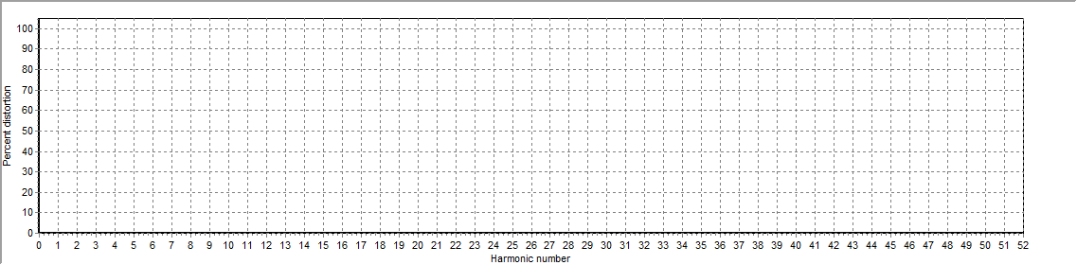
Figure 1: Current harmonic distortion plot

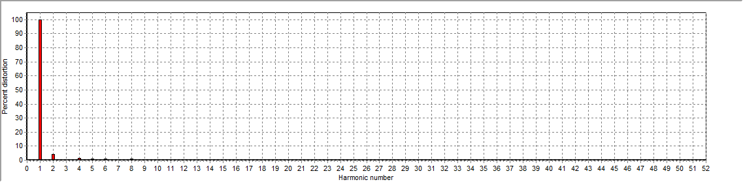
Figure 2: Voltage harmonic distortion plot

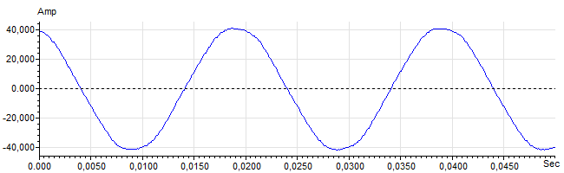
Figure 3: Raw Current

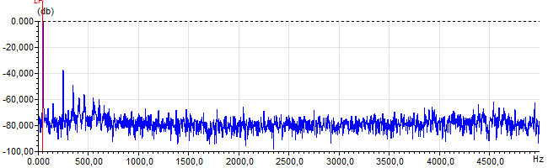
Figure 4: Raw Current Frequency spectrum

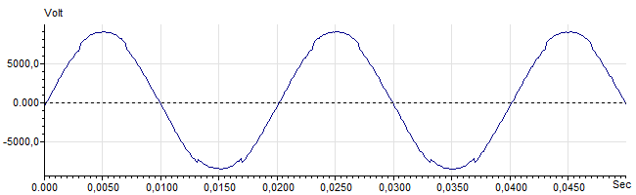
Figure 5: Raw Voltage

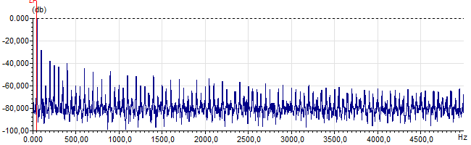
Figure 6: Raw Voltage Frequency spectrum

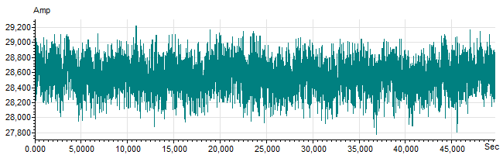
Figure 7: Demodulated current trace

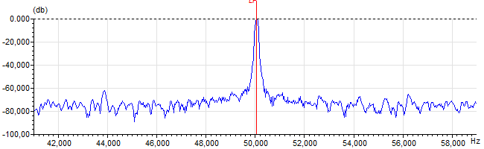
Figure 8: Raw current spectrum

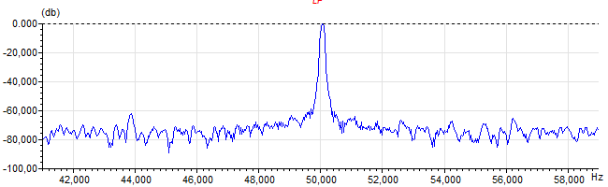
Figure 9: Demodulated current spectrum

