ALL TEST 6.31 Analysis Results

Performance Summary

Bottom Line
This induction motor is operating normally, no action is required.
X This induction motor exhibits suspicious operation, trending of the induction motor is warranted.
This induction motor exhibits abnormal indications, action is warranted, NOW.

Power Factor Commentary
X Power factor exceeds 0.85.
Power factor is below 0.85, see detailed report.

Current Commentary
X Current variation is within normal limits.
Current variation is beyond normal limits, see detailed report.

Voltage Commentary
X Voltage variation is within normal limits.
Voltage variation is beyond normal limits, see detailed report.
RMS voltage differs from nameplate by more than 5%.

Load Commentary
X Load on the induction motor is consistent with nameplate values.
Load on the induction motor exceeds nameplate values, see detailed report.
Load on the induction motor is less than 25%.

Phase Connection Commentary
X Connections are normal.
Voltage ground reference is NOT neutral.
Loose connection.

Rotor Commentary
X Rotor bar health is normal.
Rotor bar health is questionable, see detailed report.
Load is insufficient to determine rotor bar health, at this time.

Stator Commentary
X Stator health is normal.
Stator mechanical health is questionable. .
Turn to turn short.

Rotor/Stator Air-gap Characteristics
X Dynamic or static eccentricity indications do not exist.
Indications of static eccentricity exist .
Indications of dynamic eccentricity exist.

Harmonic Distortion Commentary
X There is no evidence of harmonic distortion.
There is evidence of harmonic distortion, see detailed report.

Misalignment Indications
X There are no indications of mechanical problems like misalignment or unbalance.
There are indications of mechanical problems like misalignment / unbalance. Perform vibr. survey to identify and correct the cause.

Bearing Commentary
There is no evidence of bearing problem.
X Indications of potential bearing problems, perform vibration survey to verify.

INPUT SUMMARY

NAMEPLATE INFORMATION
 |  | Units
Serial Number | G.912001
Model Number | YKK4504-6
Tested Equipment | Induction
Power | 603.22 | HP
RPM | 990.0 | Rpm
Poles | 6
Phases: | 3
Voltage | 6300.0 | Volt
Full Load Current | 52.80 | Amp
No Load Current | 3.00 | Amp
Number of rotor bars | 44
Number of stator slots | -1
Torque | 3198.9 | Ft.Lb
CT Ratio | 20.000
PT Ratio | 60.000
Duty Cycle | S1
Service Factor | 115
Insulation Type | F
Motor efficiency | -1.000
Power factor | -1.000

Description:
Belum ada data rotor bar dan stator slot

LEGENDS:
Impedance | = Complex Impedance = vi/ci
CF | = Crest Factor = (waveform peak)/(waveform rms)
VDF | = Transformer Harmonic De-rating Factor = sqrt(2)/CF, %

Slip % | = SRSS sum of slip and harmonic "levels" divided by RMS level of RMS DEMOD spectra between 0 and 65 Hz.
Upper sb | = dB level of upper slip sideband of power line peak
Lower sb | = dB level of lower slip sideband of power line peak
Se, fund | = Location of pole pass frequency fundamental, Hz
Se, harm | = Number of pole pass frequency harmonics
Rotor bar health | = Estimate of the percent of broken or cracked rotor bars
RB Hlt Index | = Rotor bar health index

THDF | = Voltage De-rating Factor = 100 - (voltage unbalance, %)^2, %
Level | = Sum of spectral amplitudes of pole pass frequency fundamentals and harmonics
Thd | = Total harmonic distortion
+Ve | = Positive sequence harmonic
-Ve | = Negative sequence harmonic
Zero | = Zero sequence harmonic

Detailed Calculations

Running Speed = 14.618 Hz [877 RPM]

Pole pass frequency = 12.512 Hz [751 RPM]

Load = 80.3 %
Time
 | RMS | Peak | CF
Current 1 | 44.200 | 62.292 | 1.409
Current 2 | 44.200 | 62.292 | 1.409
Current 3 | 44.400 | 62.574 | 1.409
Average | 44.267 | 62.386 | 1.409
% dev | 0.3 | 0.3 | 0.0

THDF = 100.0

Time
 | RMS | Peak | CF
Voltage 1 | 6240.000 | 8681.600 | 1.391
Voltage 2 | 6204.000 | 8631.500 | 1.391
Voltage 3 | 6246.000 | 8690.000 | 1.391
Average | 6230.000 | 8667.700 | 1.391
% dev | 0.4 | 0.4 | 0.0

VDF = 99.8
* Note-
Phase 2 and 3 CF and peak entries are assumed to be the same as phase-1.

 |  |  | App. Power | Real Power | Reac. Power
 | Power factor | Impedance | kVA | kW | kVARS
Phase 1 | 0.384 | 141.180 | 275.280 | 105.600 | 254.220
Phase 2 | 0.000 | 140.360 | 1.326 | 0.000 | 1.326
Phase 3 | 0.994 | 140.680 | 276.520 | 274.800 | 30.823
Avg/Total | 1.377 | 140.740 | 553.130 | 380.400 | 286.370
% dev | 0.0 | 0.3

Demand Pwr = 509.92 HP

Load:80.3 %

Motor Eff.:95.3 %

Loss due to THD:

Output Pow.:357.83 KW

Output Trq.:2871.20 Ft.Lb

Summary of Rotor Bar Health |  |  |  |  | Power line dB diff. |  | RB Hlt Index
 | Se, fund |  | Se, harm | Level % | Upper SB | Lower SB | RB Hlt Index
Measured | 12.512 |  | 1 | - | -69.455 | -67.472 | 0.029
Severity level |  | Rotor Condition Assessment |  |  | Recommended Corrective Action
1 |  | Excellent |  |  | None

Bearing condition
Location | Bearing No. | IR | OR | T/C | BS
Drive end | SKF NU228E | OK | OK | Bad | OK
Opposite end | SKF 6226 | OK | OK | OK | OK

Harmonic Distortion Results:
Voltage input, from 50.049 Hz harmonics
 | THD Odd % | THD Even % | +ve% | -ve % | Zero % | THD All %
Current 1 | 1.394 | 0.104 | 0.338 | 1.354 | 0.096 | 1.398
Current 2 | *** | *** | *** | *** | *** | ***
Current 3 | *** | *** | *** | *** | *** | ***
Voltage 1 | 0.789 | 1.102 | 0.391 | 1.263 | 0.297 | 1.355
Voltage 2 | *** | *** | *** | *** | *** | ***
Voltage 3 | *** | *** | *** | *** | *** | ***

Harmonic distortion table – Peak values, voltage is phase to ground
Hz | Cur1 | Vlt1 | Cur2 | Vlt2 | Cur3 | Vlt3
50 | 62.9 | 8800 | *** | *** | *** | ***
100 | 0.1 | 89 | *** | *** | *** | ***
150 | 0.1 | 7 | *** | *** | *** | ***
200 | 0.0 | 29 | *** | *** | *** | ***
250 | 0.9 | 69 | *** | *** | *** | ***
300 | 0.0 | 18 | *** | *** | *** | ***
350 | 0.2 | 15 | *** | *** | *** | ***
400 | 0.0 | 23 | *** | *** | *** | ***
450 | 0.0 | 3 | *** | *** | *** | ***
500 | 0.0 | 2 | *** | *** | *** | ***
550 | 0.1 | 5 | *** | *** | *** | ***
600 | 0.0 | 14 | *** | *** | *** | ***

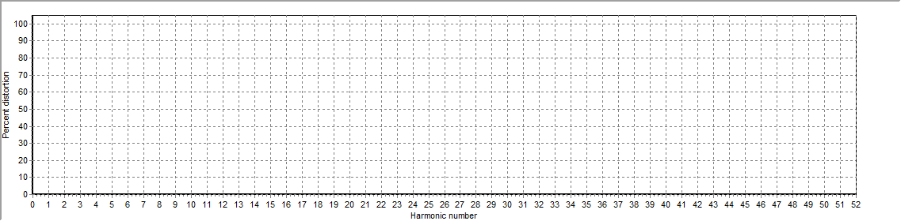
Figure 1: Current harmonic distortion plot

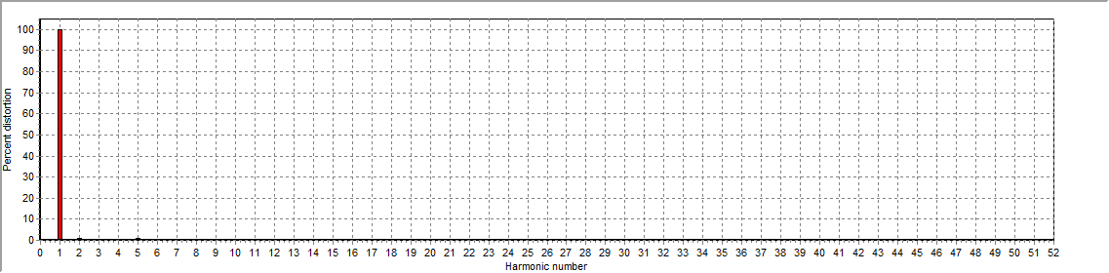
Figure 2: Voltage harmonic distortion plot

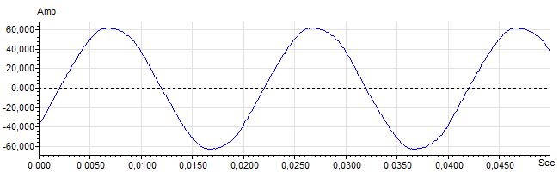
Figure 3: Raw Current

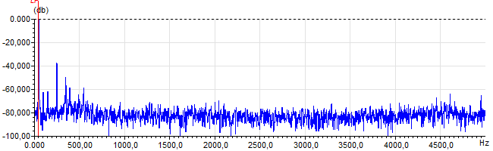
Figure 4: Raw Current Frequency spectrum

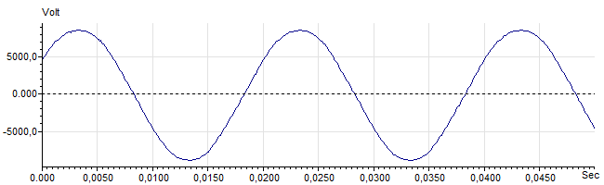
Figure 5: Raw Voltage

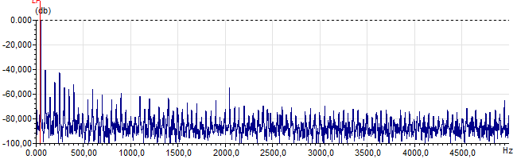
Figure 6: Raw Voltage Frequency spectrum

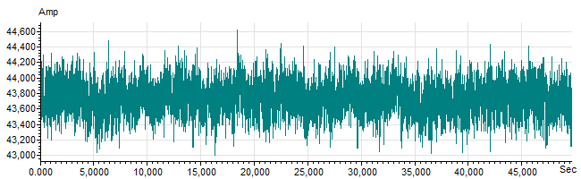
Figure 7: Demodulated current trace

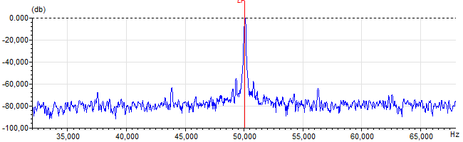
Figure 8: Raw current spectrum

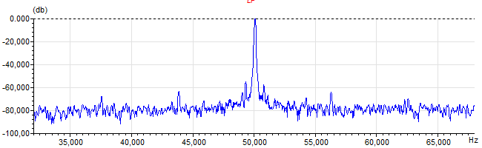
Figure 9: Demodulated current spectrum

