ALL TEST 6.31 Analysis Results

Performance Summary

Bottom Line
This induction motor is operating normally, no action is required.
X This induction motor exhibits suspicious operation, trending of the induction motor is warranted.
This induction motor exhibits abnormal indications, action is warranted, NOW.

Power Factor Commentary
X Power factor exceeds 0.85.
Power factor is below 0.85, see detailed report.

Current Commentary
X Current variation is within normal limits.
Current variation is beyond normal limits, see detailed report.

Voltage Commentary
X Voltage variation is within normal limits.
Voltage variation is beyond normal limits, see detailed report.
RMS voltage differs from nameplate by more than 5%.

Load Commentary
X Load on the induction motor is consistent with nameplate values.
Load on the induction motor exceeds nameplate values, see detailed report.
Load on the induction motor is less than 25%.

Phase Connection Commentary
X Connections are normal.
Voltage ground reference is NOT neutral.
Loose connection.

Rotor Commentary
X Rotor bar health is normal.
Rotor bar health is questionable, see detailed report.
Load is insufficient to determine rotor bar health, at this time.

Stator Commentary
X Stator health is normal.
Stator mechanical health is questionable. .
Turn to turn short.

Rotor/Stator Air-gap Characteristics
X Dynamic or static eccentricity indications do not exist.
Indications of static eccentricity exist .
Indications of dynamic eccentricity exist.

Harmonic Distortion Commentary
There is no evidence of harmonic distortion.
X There is evidence of harmonic distortion, see detailed report.

Bearing Commentary
X There is no evidence of bearing problem.
Indications of potential bearing problems, perform vibration survey to verify.

INPUT SUMMARY

NAMEPLATE INFORMATION
 |  | Units
Manufacturer | XIANGTAN ELECTR
Serial Number | YKK 5002-2
Model Number | 87684
Tested Equipment | Induction
Power | 1000.0 | KW
RPM | 2979.0 | Rpm
Poles | 2
Phases: | 3
Voltage | 6300.0 | Volt
Full Load Current | 109.20 | Amp
No Load Current | -1.00 | Amp
Number of rotor bars | -1
Number of stator slots | -1
Torque | 3203 | N.m
CT Ratio | 30.000
PT Ratio | 60.000
Service Factor | 115
Frame Size | 50HZ
Motor efficiency | 0.000
Power factor | 0.880

Description:
Belum ada data rotor bar dan stator slot

LEGENDS:
Impedance | = Complex Impedance = vi/ci
CF | = Crest Factor = (waveform peak)/(waveform rms)
VDF | = Transformer Harmonic De-rating Factor = sqrt(2)/CF, %

Slip % | = SRSS sum of slip and harmonic "levels" divided by RMS level of RMS DEMOD spectra between 0 and 65 Hz.
Upper sb | = dB level of upper slip sideband of power line peak
Lower sb | = dB level of lower slip sideband of power line peak
Se, fund | = Location of pole pass frequency fundamental, Hz
Se, harm | = Number of pole pass frequency harmonics
Rotor bar health | = Estimate of the percent of broken or cracked rotor bars
RB Hlt Index | = Rotor bar health index

THDF | = Voltage De-rating Factor = 100 - (voltage unbalance, %)^2, %
Level | = Sum of spectral amplitudes of pole pass frequency fundamentals and harmonics
Thd | = Total harmonic distortion
+Ve | = Positive sequence harmonic
-Ve | = Negative sequence harmonic
Zero | = Zero sequence harmonic

Detailed Calculations

Running Speed = 47.760 Hz [2866 RPM]

Pole pass frequency = 4.578 Hz [275 RPM]

Load = 72.5 %
Time
 | RMS | Peak | CF
Current 1 | 78.600 | 115.350 | 1.468
Current 2 | 77.400 | 113.590 | 1.468
Current 3 | 78.600 | 115.350 | 1.468
Average | 78.200 | 114.760 | 1.468
% dev | 1.0 | 1.0 | 0.0

THDF = 96.4

Time
 | RMS | Peak | CF
Voltage 1 | 6276.000 | 9061.600 | 1.444
Voltage 2 | 6222.000 | 8983.700 | 1.444
Voltage 3 | 6276.000 | 9061.600 | 1.444
Average | 6258.000 | 9035.600 | 1.444
% dev | 0.6 | 0.6 | 0.0

VDF = 99.7
* Note-
Phase 2 and 3 CF and peak entries are assumed to be the same as phase-1.

 |  |  | App. Power | Real Power | Reac. Power
 | Power factor | Impedance | kVA | kW | kVARS
Phase 1 | 0.542 | 79.847 | 491.880 | 266.400 | 413.490
Phase 2 | 0.000 | 80.388 | 3.251 | 0.000 | 3.251
Phase 3 | 0.998 | 79.847 | 490.460 | 489.600 | 29.100
Avg/Total | 1.540 | 80.027 | 985.590 | 756.000 | 445.840
% dev | 0.0 | 0.5

Demand Pwr = 756.0 KW

Load:72.5 %

Motor Eff.:95.7 %

Loss due to THD:

Output Pow.:713.26 KW

Output Trq.:2374.9 N.m

Summary of Rotor Bar Health |  |  |  |  | Power line dB diff. |  | RB Hlt Index
 | Se, fund |  | Se, harm | Level % | Upper SB | Lower SB | RB Hlt Index
Measured | 4.578 |  | 1 | - | -56.995 | -56.193 | 0.106
Severity level |  | Rotor Condition Assessment |  |  | Recommended Corrective Action
1 |  | Excellent |  |  | None

Bearing condition
Location | Bearing No. | IR | OR | T/C | BS
Drive end | SKF NU1022 | OK | OK | OK | OK
Opposite end | SKF NU1022 | OK | OK | OK | OK

Harmonic Distortion Results:
Voltage input, from 50.049 Hz harmonics
 | THD Odd % | THD Even % | +ve% | -ve % | Zero % | THD All %
Current 1 | 2.247 | 0.181 | 0.374 | 2.194 | 0.359 | 2.255
Current 2 | *** | *** | *** | *** | *** | ***
Current 3 | *** | *** | *** | *** | *** | ***
Voltage 1 | 1.073 | 2.931 | 0.916 | 2.882 | 0.774 | 3.122
Voltage 2 | *** | *** | *** | *** | *** | ***
Voltage 3 | *** | *** | *** | *** | *** | ***

Harmonic distortion table – Peak values, voltage is phase to ground
Hz | Cur1 | Vlt1 | Cur2 | Vlt2 | Cur3 | Vlt3
50 | 110.7 | 8853 | *** | *** | *** | ***
100 | 0.2 | 239 | *** | *** | *** | ***
150 | 0.4 | 4 | *** | *** | *** | ***
200 | 0.1 | 75 | *** | *** | *** | ***
250 | 2.5 | 95 | *** | *** | *** | ***
300 | 0.0 | 49 | *** | *** | *** | ***
350 | 0.4 | 16 | *** | *** | *** | ***
400 | 0.0 | 60 | *** | *** | *** | ***
450 | 0.0 | 6 | *** | *** | *** | ***
500 | 0.0 | 1 | *** | *** | *** | ***
550 | 0.2 | 6 | *** | *** | *** | ***
600 | 0.0 | 40 | *** | *** | *** | ***


Figure 1: Current harmonic distortion plot

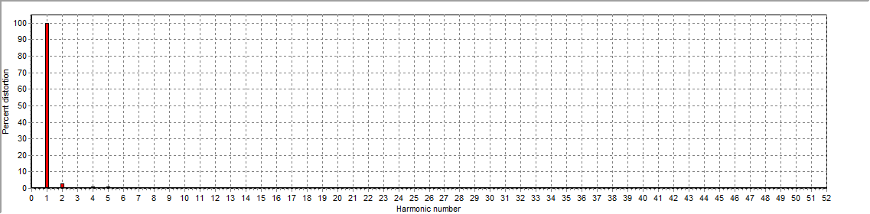
Figure 2: Voltage harmonic distortion plot

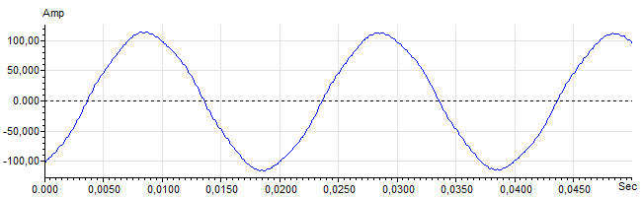
Figure 3: Raw Current

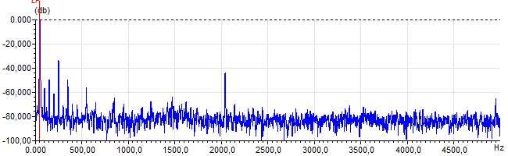
Figure 4: Raw Current Frequency spectrum

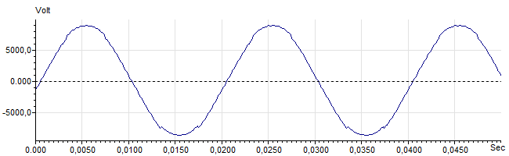
Figure 5: Raw Voltage

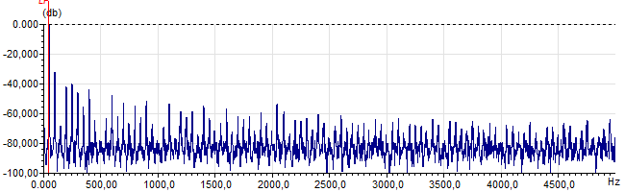
Figure 6: Raw Voltage Frequency spectrum

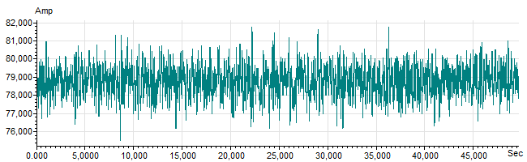
Figure 7: Demodulated current trace

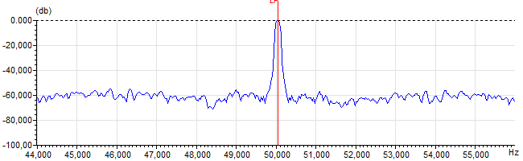
Figure 8: Raw current spectrum

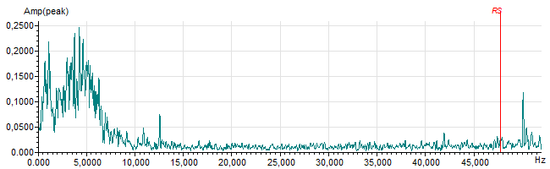
Figure 9: Demodulated current spectrum

