ALL TEST 6.31 Analysis Results

Performance Summary

Bottom Line
This induction motor is operating normally, no action is required.
X This induction motor exhibits suspicious operation, trending of the induction motor is warranted.
This induction motor exhibits abnormal indications, action is warranted, NOW.

Power Factor Commentary
X Power factor exceeds 0.85.
Power factor is below 0.85, see detailed report.

Current Commentary
X Current variation is within normal limits.
Current variation is beyond normal limits, see detailed report.

Voltage Commentary
X Voltage variation is within normal limits.
Voltage variation is beyond normal limits, see detailed report.
RMS voltage differs from nameplate by more than 5%.

Load Commentary
X Load on the induction motor is consistent with nameplate values.
Load on the induction motor exceeds nameplate values, see detailed report.
Load on the induction motor is less than 25%.

Phase Connection Commentary
X Connections are normal.
Voltage ground reference is NOT neutral.
Loose connection.

Rotor Commentary
Rotor bar health is normal.
X Rotor bar health is questionable, see detailed report.
Load is insufficient to determine rotor bar health, at this time.

Stator Commentary
X Stator health is normal.
Stator mechanical health is questionable. .
Turn to turn short.

Rotor/Stator Air-gap Characteristics
X Dynamic or static eccentricity indications do not exist.
Indications of static eccentricity exist .
Indications of dynamic eccentricity exist.

Harmonic Distortion Commentary
X There is no evidence of harmonic distortion.
There is evidence of harmonic distortion, see detailed report.

Misalignment Indications
X There are no indications of mechanical problems like misalignment or unbalance.
There are indications of mechanical problems like misalignment / unbalance. Perform vibr. survey to identify and correct the cause.

Bearing Commentary
X There is no evidence of bearing problem.
Indications of potential bearing problems, perform vibration survey to verify.

INPUT SUMMARY

NAMEPLATE INFORMATION
 |  | Units
Model Number | YLKK355-6
Tested Equipment | Induction
Power | 315.0 | KW
RPM | 985.0 | Rpm
Poles | 6
Phases: | 3
Voltage | 6300.0 | Volt
Full Load Current | 41.90 | Amp
No Load Current | -1.00 | Amp
Number of rotor bars | -1
Number of stator slots | -1
Torque | 3051 | N.m
CT Ratio | 20.000
PT Ratio | 60.000
Duty Cycle | S1
Service Factor | 115
Insulation Type | F
Motor efficiency | -1.000
Power factor | -1.000

Description:
Belum ada data rotor bar dan stator slot

LEGENDS:
Impedance | = Complex Impedance = vi/ci
CF | = Crest Factor = (waveform peak)/(waveform rms)
VDF | = Transformer Harmonic De-rating Factor = sqrt(2)/CF, %

Slip % | = SRSS sum of slip and harmonic "levels" divided by RMS level of RMS DEMOD spectra between 0 and 65 Hz.
Upper sb | = dB level of upper slip sideband of power line peak
Lower sb | = dB level of lower slip sideband of power line peak
Se, fund | = Location of pole pass frequency fundamental, Hz
Se, harm | = Number of pole pass frequency harmonics
Rotor bar health | = Estimate of the percent of broken or cracked rotor bars
RB Hlt Index | = Rotor bar health index

THDF | = Voltage De-rating Factor = 100 - (voltage unbalance, %)^2, %
Level | = Sum of spectral amplitudes of pole pass frequency fundamentals and harmonics
Thd | = Total harmonic distortion
+Ve | = Positive sequence harmonic
-Ve | = Negative sequence harmonic
Zero | = Zero sequence harmonic

Detailed Calculations

Running Speed = 15.747 Hz [945 RPM]

Pole pass frequency = 5.707 Hz [342 RPM]

Load = 52.8 %
Time
 | RMS | Peak | CF
Current 1 | 32.000 | 49.097 | 1.534
Current 2 | 31.600 | 48.483 | 1.534
Current 3 | 31.400 | 48.176 | 1.534
Average | 31.667 | 48.585 | 1.534
% dev | 1.1 | 1.1 | 0.0

THDF = 92.2

Time
 | RMS | Peak | CF
Voltage 1 | 6246.000 | 8623.300 | 1.381
Voltage 2 | 6240.000 | 8615.100 | 1.381
Voltage 3 | 6264.000 | 8648.200 | 1.381
Average | 6250.000 | 8628.900 | 1.381
% dev | 0.2 | 0.2 | 0.0

VDF = 99.9
* Note-
Phase 2 and 3 CF and peak entries are assumed to be the same as phase-1.

 |  |  | App. Power | Real Power | Reac. Power
 | Power factor | Impedance | kVA | kW | kVARS
Phase 1 | 0.438 | 195.190 | 199.870 | 87.600 | 179.650
Phase 2 | 0.000 | 197.470 | 0.000 | 0.000 | 0.000
Phase 3 | 0.447 | 199.490 | 195.940 | 87.600 | 175.260
Avg/Total | 0.885 | 197.380 | 395.810 | 175.200 | 354.920
% dev | 0.0 | 1.1

Demand Pwr = 175.2 KW

Load:52.8 %

Motor Eff.:95.0 %

Loss due to THD:

Output Pow.:163.02 KW

Output Trq.:1646.3 N.m

Summary of Rotor Bar Health |  |  |  |  | Power line dB diff. |  | RB Hlt Index
 | Se, fund |  | Se, harm | Level % | Upper SB | Lower SB | RB Hlt Index
Measured | 5.707 |  | 1 | - | -31.671 | -30.100 | 7.300
Severity level |  | Rotor Condition Assessment |  |  | Recommended Corrective Action
7 |  | Multiple broken rotor bars and end rings very likely. Severe problems throughout |  |  | Overhaul or replace ASAP

Bearing condition
Location | Bearing No. | IR | OR | T/C | BS
Drive end | SKF 6228 | OK | OK | OK | OK
Opposite end | SKF 7330B | OK | OK | OK | OK

Harmonic Distortion Results:
Voltage input, from 50.049 Hz harmonics
 | THD Odd % | THD Even % | +ve% | -ve % | Zero % | THD All %
Current 1 | 1.094 | 0.144 | 0.108 | 1.077 | 0.216 | 1.104
Current 2 | *** | *** | *** | *** | *** | ***
Current 3 | *** | *** | *** | *** | *** | ***
Voltage 1 | 0.982 | 2.084 | 0.641 | 2.142 | 0.554 | 2.304
Voltage 2 | *** | *** | *** | *** | *** | ***
Voltage 3 | *** | *** | *** | *** | *** | ***

Harmonic distortion table – Peak values, voltage is phase to ground
Hz | Cur1 | Vlt1 | Cur2 | Vlt2 | Cur3 | Vlt3
50 | 46.3 | 8798 | *** | *** | *** | ***
100 | 0.0 | 170 | *** | *** | *** | ***
150 | 0.1 | 2 | *** | *** | *** | ***
200 | 0.0 | 50 | *** | *** | *** | ***
250 | 0.5 | 87 | *** | *** | *** | ***
300 | 0.0 | 36 | *** | *** | *** | ***
350 | 0.0 | 15 | *** | *** | *** | ***
400 | 0.0 | 42 | *** | *** | *** | ***
450 | 0.0 | 3 | *** | *** | *** | ***
500 | 0.0 | 0 | *** | *** | *** | ***
550 | 0.0 | 1 | *** | *** | *** | ***
600 | 0.0 | 27 | *** | *** | *** | ***


Figure 1: Current harmonic distortion plot

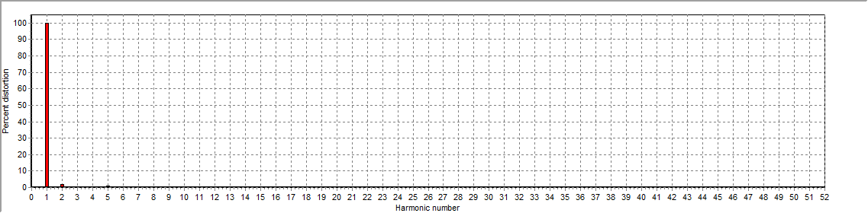
Figure 2: Voltage harmonic distortion plot

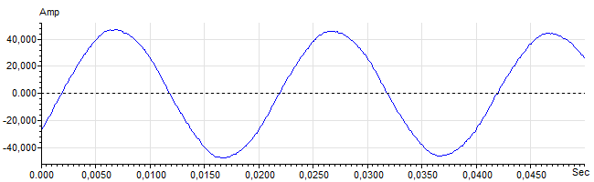
Figure 3: Raw Current

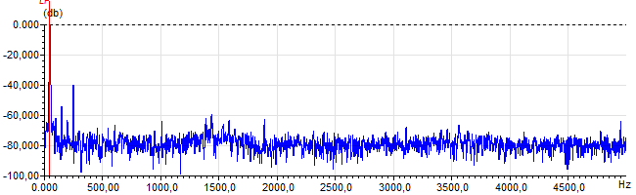
Figure 4: Raw Current Frequency spectrum

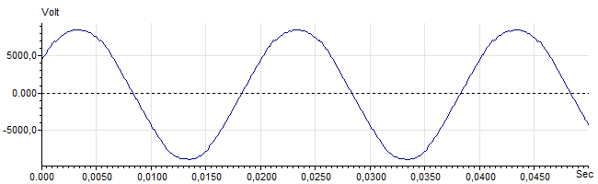
Figure 5: Raw Voltage

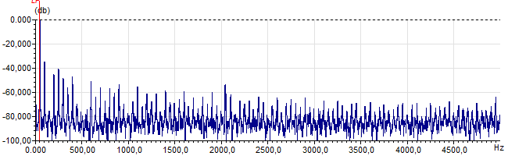
Figure 6: Raw Voltage Frequency spectrum

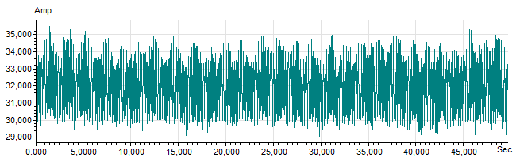
Figure 7: Demodulated current trace

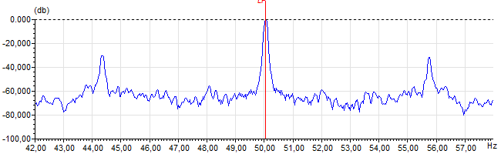
Figure 8: Raw current spectrum

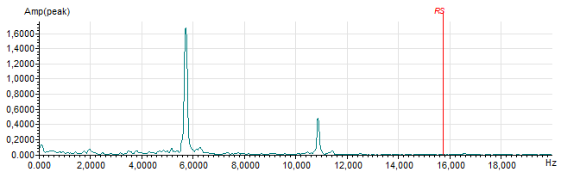
Figure 9: Demodulated current spectrum

