ALL TEST 6.31 Analysis Results

Performance Summary

Bottom Line
This induction motor is operating normally, no action is required.
X This induction motor exhibits suspicious operation, trending of the induction motor is warranted.
This induction motor exhibits abnormal indications, action is warranted, NOW.

Power Factor Commentary
Power factor exceeds 0.85.
X Power factor is below 0.85, see detailed report.

Current Commentary
X Current variation is within normal limits.
Current variation is beyond normal limits, see detailed report.

Voltage Commentary
X Voltage variation is within normal limits.
Voltage variation is beyond normal limits, see detailed report.
RMS voltage differs from nameplate by more than 5%.

Load Commentary
X Load on the induction motor is consistent with nameplate values.
Load on the induction motor exceeds nameplate values, see detailed report.
Load on the induction motor is less than 25%.

Phase Connection Commentary
X Connections are normal.
Voltage ground reference is NOT neutral.
Loose connection.

Rotor Commentary
Rotor bar health is normal.
X Rotor bar health is questionable, see detailed report.
Load is insufficient to determine rotor bar health, at this time.

Stator Commentary
X Stator health is normal.
Stator mechanical health is questionable. .
Turn to turn short.

Rotor/Stator Air-gap Characteristics
X Dynamic or static eccentricity indications do not exist.
Indications of static eccentricity exist .
Indications of dynamic eccentricity exist.

Harmonic Distortion Commentary
X There is no evidence of harmonic distortion.
There is evidence of harmonic distortion, see detailed report.

Misalignment Indications
X There are no indications of mechanical problems like misalignment or unbalance.
There are indications of mechanical problems like misalignment / unbalance. Perform vibr. survey to identify and correct the cause.

INPUT SUMMARY

NAMEPLATE INFORMATION
 |  | Units
Manufacturer | ABB
Model Number | 180M4
Tested Equipment | Induction
Power | 18.5 | KW
RPM | 1470.0 | Rpm
Poles | 4
Phases: | 3
Voltage | 380.0 | Volt
Full Load Current | 36.00 | Amp
No Load Current | -1.00 | Amp
Number of rotor bars | -1
Number of stator slots | -1
Torque | 120 | N.m
CT Ratio | 1.000
Service Factor | 115
Motor efficiency | -1.000
Power factor | 0.800

Description:
Belum ada data rotor bar dan stator slot

LEGENDS:
Impedance | = Complex Impedance = vi/ci
CF | = Crest Factor = (waveform peak)/(waveform rms)
VDF | = Transformer Harmonic De-rating Factor = sqrt(2)/CF, %

Slip % | = SRSS sum of slip and harmonic "levels" divided by RMS level of RMS DEMOD spectra between 0 and 65 Hz.
Upper sb | = dB level of upper slip sideband of power line peak
Lower sb | = dB level of lower slip sideband of power line peak
Se, fund | = Location of pole pass frequency fundamental, Hz
Se, harm | = Number of pole pass frequency harmonics
Rotor bar health | = Estimate of the percent of broken or cracked rotor bars
RB Hlt Index | = Rotor bar health index

THDF | = Voltage De-rating Factor = 100 - (voltage unbalance, %)^2, %
Level | = Sum of spectral amplitudes of pole pass frequency fundamentals and harmonics
Thd | = Total harmonic distortion
+Ve | = Positive sequence harmonic
-Ve | = Negative sequence harmonic
Zero | = Zero sequence harmonic

Detailed Calculations

Running Speed = 24.689 Hz [1481 RPM]

Pole pass frequency = 1.343 Hz [81 RPM]

Load = 39.9 %
Time
 | RMS | Peak | CF
Current 1 | 17.900 | 28.910 | 1.615
Current 2 | 18.180 | 29.362 | 1.615
Current 3 | 18.630 | 30.089 | 1.615
Average | 18.237 | 29.454 | 1.615
% dev | 2.2 | 2.2 | 0.0

THDF = 87.6

Time
 | RMS | Peak | CF
Voltage 1 | 389.400 | 547.760 | 1.407
Voltage 2 | 391.100 | 550.150 | 1.407
Voltage 3 | 391.000 | 550.010 | 1.407
Average | 390.500 | 549.300 | 1.407
% dev | 0.3 | 0.3 | 0.0

VDF = 99.9
* Note-
Phase 2 and 3 CF and peak entries are assumed to be the same as phase-1.

 |  |  | App. Power | Real Power | Reac. Power
 | Power factor | Impedance | kVA | kW | kVARS
Phase 1 | 0.647 | 21.754 | 4.024 | 2.602 | 3.069
Phase 2 | 0.691 | 21.513 | 4.090 | 2.825 | 2.958
Phase 3 | 0.655 | 20.988 | 4.218 | 2.761 | 3.189
Avg/Total | 0.664 | 21.418 | 12.332 | 8.188 | 9.216
% dev | 4.0 | 2.0

Demand Pwr = 8.2 KW

Load:39.9 %

Motor Eff.:87.1 %

Loss due to THD:

Output Pow.:6.92 KW

Output Trq.:44.6 N.m

Summary of Rotor Bar Health |  |  |  |  | Power line dB diff. |  | RB Hlt Index
 | Se, fund |  | Se, harm | Level % | Upper SB | Lower SB | RB Hlt Index
Measured | 1.343 |  | 1 | - | -34.027 | -32.803 | 3.016
Severity level |  | Rotor Condition Assessment |  |  | Recommended Corrective Action
7 |  | Multiple broken rotor bars and end rings very likely. Severe problems throughout |  |  | Overhaul or replace ASAP

Harmonic Distortion Results:
Voltage input, from 50.049 Hz harmonics
 | THD Odd % | THD Even % | +ve% | -ve % | Zero % | THD All %
Current 1 | 1.988 | 0.507 | 0.807 | 1.817 | 0.506 | 2.052
Current 2 | *** | *** | *** | *** | *** | ***
Current 3 | *** | *** | *** | *** | *** | ***
Voltage 1 | 1.274 | 0.071 | 0.508 | 1.140 | 0.263 | 1.276
Voltage 2 | *** | *** | *** | *** | *** | ***
Voltage 3 | *** | *** | *** | *** | *** | ***

Harmonic distortion table – Peak values, voltage is phase to ground
Hz | Cur1 | Vlt1 | Cur2 | Vlt2 | Cur3 | Vlt3
50 | 26.8 | 320 | *** | *** | *** | ***
100 | 0.1 | 0 | *** | *** | *** | ***
150 | 0.1 | 1 | *** | *** | *** | ***
200 | 0.0 | 0 | *** | *** | *** | ***
250 | 0.5 | 4 | *** | *** | *** | ***
300 | 0.0 | 0 | *** | *** | *** | ***
350 | 0.2 | 1 | *** | *** | *** | ***
400 | 0.0 | 0 | *** | *** | *** | ***
450 | 0.1 | 1 | *** | *** | *** | ***
500 | 0.0 | 0 | *** | *** | *** | ***
550 | 0.1 | 0 | *** | *** | *** | ***
600 | 0.0 | 0 | *** | *** | *** | ***

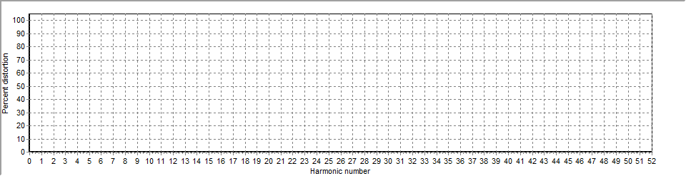
Figure 1: Current harmonic distortion plot

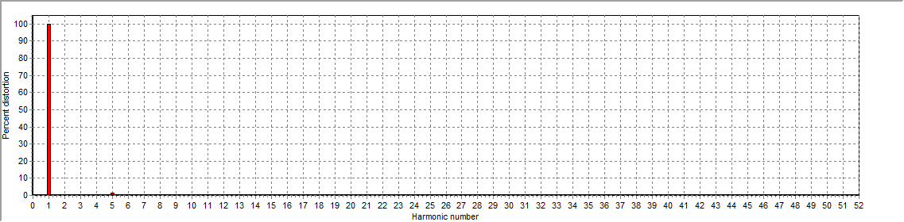
Figure 2: Voltage harmonic distortion plot

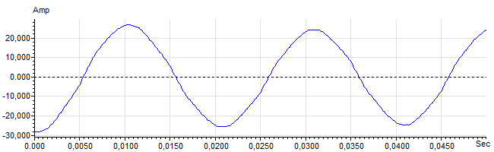
Figure 3: Raw Current

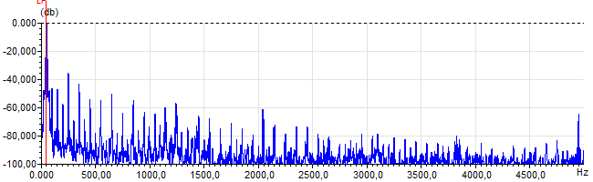
Figure 4: Raw Current Frequency spectrum

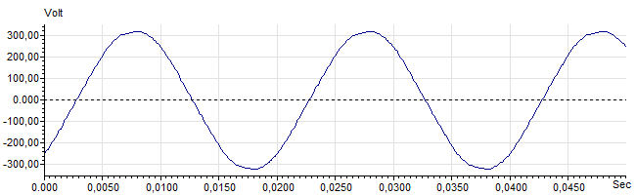
Figure 5: Raw Voltage

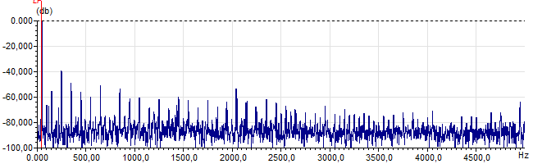
Figure 6: Raw Voltage Frequency spectrum

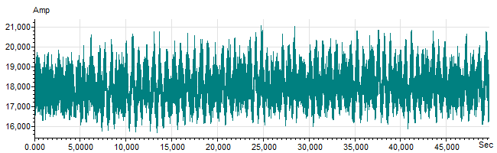
Figure 7: Demodulated current trace

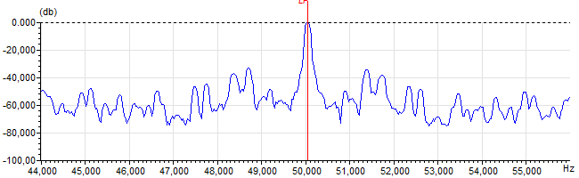
Figure 8: Raw current spectrum

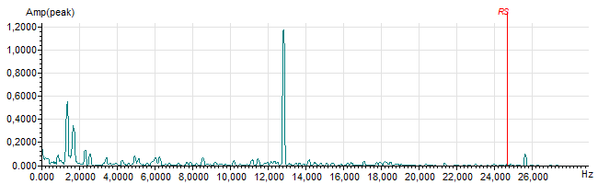
Figure 9: Demodulated current spectrum

