ALL TEST 6.31 Analysis Results

Performance Summary

Bottom Line
This induction motor is operating normally, no action is required.
X This induction motor exhibits suspicious operation, trending of the induction motor is warranted.
This induction motor exhibits abnormal indications, action is warranted, NOW.

Power Factor Commentary
Power factor exceeds 0.85.
X Power factor is below 0.85, see detailed report.

Current Commentary
X Current variation is within normal limits.
Current variation is beyond normal limits, see detailed report.

Voltage Commentary
X Voltage variation is within normal limits.
Voltage variation is beyond normal limits, see detailed report.
RMS voltage differs from nameplate by more than 5%.

Load Commentary
X Load on the induction motor is consistent with nameplate values.
Load on the induction motor exceeds nameplate values, see detailed report.
Load on the induction motor is less than 25%.

Phase Connection Commentary
X Connections are normal.
Voltage ground reference is NOT neutral.
Loose connection.

Rotor Commentary
Rotor bar health is normal.
X Rotor bar health is questionable, see detailed report.
Load is insufficient to determine rotor bar health, at this time.

Stator Commentary
X Stator health is normal.
Stator mechanical health is questionable. (Matching RB and SS peaks in high freq.spectrum).
Turn to turn short.

Rotor/Stator Air-gap Characteristics
Dynamic or static eccentricity indications do not exist.
X Indications of static eccentricity exist (Matching RB and SS peaks in high freq.spectrum).
Indications of dynamic eccentricity exist.

Harmonic Distortion Commentary
X There is no evidence of harmonic distortion.
There is evidence of harmonic distortion, see detailed report.

Misalignment Indications
X There are no indications of mechanical problems like misalignment or unbalance.
There are indications of mechanical problems like misalignment / unbalance. Perform vibr. survey to identify and correct the cause.

INPUT SUMMARY

NAMEPLATE INFORMATION
 |  | Units
Model Number | Y2-355L2-8
Tested Equipment | Induction
Power | 185.0 | KW
RPM | 740.0 | Rpm
Poles | 8
Phases: | 3
Voltage | 380.0 | Volt
Full Load Current | 358.00 | Amp
No Load Current | -1.00 | Amp
Number of rotor bars | 56
Number of stator slots | 72
Torque | 2385 | N.m
CT Ratio | 1.000
Service Factor | 115
Motor efficiency | -1.000
Power factor | 0.810

Description:
Belum ada data rotor bar dan stator slot

LEGENDS:
Impedance | = Complex Impedance = vi/ci
CF | = Crest Factor = (waveform peak)/(waveform rms)
VDF | = Transformer Harmonic De-rating Factor = sqrt(2)/CF, %

Slip % | = SRSS sum of slip and harmonic "levels" divided by RMS level of RMS DEMOD spectra between 0 and 65 Hz.
Upper sb | = dB level of upper slip sideband of power line peak
Lower sb | = dB level of lower slip sideband of power line peak
Se, fund | = Location of pole pass frequency fundamental, Hz
Se, harm | = Number of pole pass frequency harmonics
Rotor bar health | = Estimate of the percent of broken or cracked rotor bars
RB Hlt Index | = Rotor bar health index

THDF | = Voltage De-rating Factor = 100 - (voltage unbalance, %)^2, %
Level | = Sum of spectral amplitudes of pole pass frequency fundamentals and harmonics
Thd | = Total harmonic distortion
+Ve | = Positive sequence harmonic
-Ve | = Negative sequence harmonic
Zero | = Zero sequence harmonic

Detailed Calculations

Running Speed = 12.390 Hz [743 RPM]

Pole pass frequency = 0.885 Hz [53 RPM]

Load = 63.1 %
Time
 | RMS | Peak | CF
Current 1 | 268.600 | 403.460 | 1.502
Current 2 | 273.700 | 411.120 | 1.502
Current 3 | 266.000 | 399.550 | 1.502
Average | 269.430 | 404.710 | 1.502
% dev | 1.6 | 1.6 | 0.0

THDF = 94.2

Time
 | RMS | Peak | CF
Voltage 1 | 384.700 | 554.270 | 1.441
Voltage 2 | 385.300 | 555.140 | 1.441
Voltage 3 | 384.200 | 553.550 | 1.441
Average | 384.730 | 554.320 | 1.441
% dev | 0.1 | 0.1 | 0.0

VDF = 100.0
* Note-
Phase 2 and 3 CF and peak entries are assumed to be the same as phase-1.

 |  |  | App. Power | Real Power | Reac. Power
 | Power factor | Impedance | kVA | kW | kVARS
Phase 1 | 0.702 | 1.432 | 59.522 | 41.770 | 42.404
Phase 2 | 0.686 | 1.408 | 60.926 | 41.820 | 44.306
Phase 3 | 0.682 | 1.444 | 59.052 | 40.290 | 43.172
Avg/Total | 0.690 | 1.428 | 179.500 | 123.880 | 129.880
% dev | 1.7 | 1.4

Demand Pwr = 123.9 KW

Load:63.1 %

Motor Eff.:94.5 %

Loss due to THD:

Output Pow.:114.19 KW

Output Trq.:1465.5 N.m

Summary of Rotor Bar Health |  |  |  |  | Power line dB diff. |  | RB Hlt Index
 | Se, fund |  | Se, harm | Level % | Upper SB | Lower SB | RB Hlt Index
Measured | 0.885 |  | 0 | 2.4 | -33.681 | -29.574 | 2.447
Severity level |  | Rotor Condition Assessment |  |  | Recommended Corrective Action
6 |  | Multiple cracked or broken rotor bars and end rings indicated. Also joint and ring problems |  |  | Overhaul ASAP

Harmonic Distortion Results:
Voltage input, from 50.018 Hz harmonics
 | THD Odd % | THD Even % | +ve% | -ve % | Zero % | THD All %
Current 1 | 1.122 | 0.105 | 0.538 | 0.983 | 0.120 | 1.127
Current 2 | *** | *** | *** | *** | *** | ***
Current 3 | *** | *** | *** | *** | *** | ***
Voltage 1 | 1.318 | 0.030 | 0.543 | 1.185 | 0.201 | 1.318
Voltage 2 | *** | *** | *** | *** | *** | ***
Voltage 3 | *** | *** | *** | *** | *** | ***

Harmonic distortion table – Peak values, voltage is phase to ground
Hz | Cur1 | Vlt1 | Cur2 | Vlt2 | Cur3 | Vlt3
50 | 451.5 | 308 | *** | *** | *** | ***
100 | 0.5 | 0 | *** | *** | *** | ***
150 | 0.5 | 1 | *** | *** | *** | ***
200 | 0.1 | 0 | *** | *** | *** | ***
250 | 4.3 | 3 | *** | *** | *** | ***
300 | 0.1 | 0 | *** | *** | *** | ***
350 | 2.3 | 1 | *** | *** | *** | ***
400 | 0.0 | 0 | *** | *** | *** | ***
450 | 0.1 | 0 | *** | *** | *** | ***
500 | 0.1 | 0 | *** | *** | *** | ***
550 | 1.4 | 1 | *** | *** | *** | ***
600 | 0.0 | 0 | *** | *** | *** | ***


Figure 1: Current harmonic distortion plot


Figure 2: Voltage harmonic distortion plot

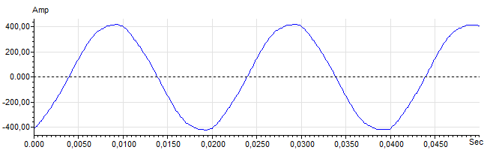
Figure 3: Raw Current

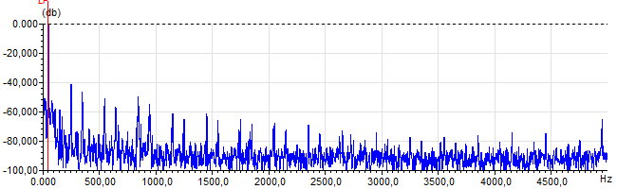
Figure 4: Raw Current Frequency spectrum

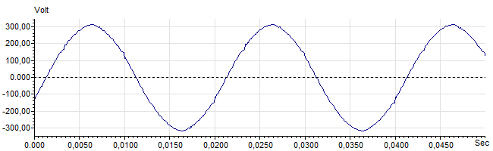
Figure 5: Raw Voltage

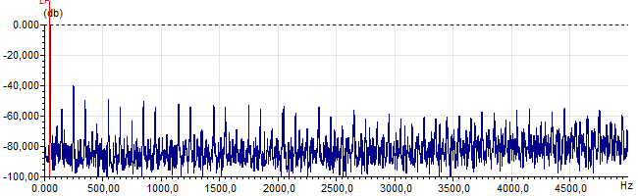
Figure 6: Raw Voltage Frequency spectrum

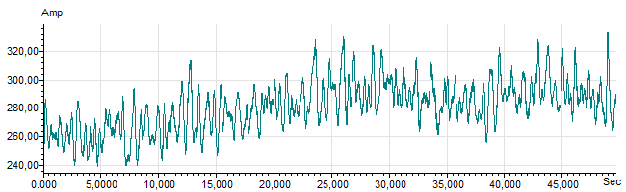
Figure 7: Demodulated current trace

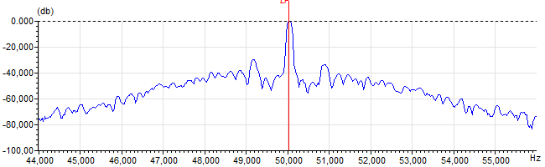
Figure 8: Raw current spectrum

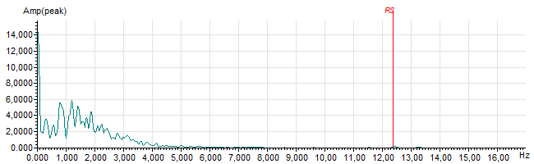
Figure 9: Demodulated current spectrum

