Bengali PL-BERT
Training Package — Full Documentation
Replacing the English-only prosody encoder in the bilingual StyleTTS2 fine-tune

StyleTTS2-Fork / PLBERT_BN_TRAINING
Prepared 22 October 2026
Target hardware: NVIDIA RTX 3060 Ti, 8 GB (Windows)

In one sentence
StyleTTS2 ships a PL-BERT pretrained on English Wikipedia only; it feeds both the duration predictor and the style diffusion, and across 25 epochs of a 90% Bengali run neither improved. This package trains a Bengali replacement on a home GPU and grafts it into the existing checkpoint without losing the 25 epochs already spent.

Contents
# | Section | What it covers
1 | Why this project exists | The flat duration MAE, and what it points at
2 | The pipeline, part by part | Four diagrams, each box explained
3 | Code reference | Every file in the package, what it does and why
4 | How to run the training | Step by step, from empty folder to resumed TTS run
5 | What was verified | The checks that were actually executed
6 | Known risks | What could still be wrong

1 Why this project exists

1.1 The symptom
The live fine-tune (Configs/config_bengali_dominant_40epoch.yaml) trains on a manifest that is 90.2% Bengali — 261,623 of 290,060 rows. Its own checkpoint ranking shows the model reaching most of its quality by epoch 6 and then flattening:
Stage | Epochs | Best epoch | Score A | Spectral loss | Duration MAE
stage_1 base | 1–10 | 6 | 0.35680 | 0.28284 | 0.52948
stage_2 diffusion | 11–20 | 18 | 0.34656 | 0.26878 | 0.52815
stage_3 joint SLM | 21–40 | 24 | 0.35403 | 0.27922 | 0.52868

Across roughly half a million steps Score A improved about 3%, and the duration MAE did not move at all. Stage 3 is worse than stage 2’s best.
Putting 0.529 in context
Measured from a 300-file sample of the manifest, a token lasts 3.45 aligner frames on average (p95 6.11, max 11.43). A mean absolute error of 0.53 frames is therefore roughly a 15% relative error on the length of every phoneme — and it is static across the entire run.

1.2 Where PL-BERT sits
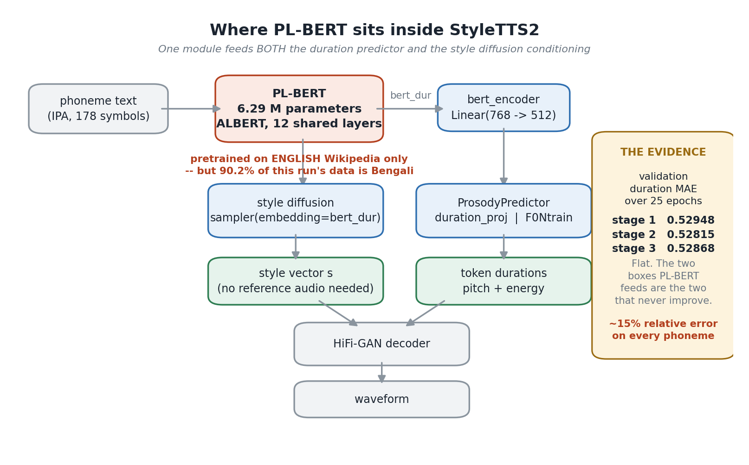
Figure 1 — PL-BERT is not a side branch. Its output is the conditioning signal for the two subsystems whose metrics are frozen.
PL-BERT reads the phoneme sequence and produces bert_dur, a contextual embedding. That one tensor is consumed twice:
- Duration and prosody — bert_encoder projects it to 512 and hands it to ProsodyPredictor, which emits per-token durations through duration_proj and pitch/energy through F0Ntrain.
- Style diffusion — the same tensor is the embedding argument to the diffusion sampler, so it determines the style vector the model invents when no reference audio is given.
Those are exactly the two things that are not improving. The module is fine-tuned during the run, but at bert_lr = 1e-5 starting from English weights — far too small a budget to move a 12-layer ALBERT into another language.

1.3 What was ruled out first
Each of these was checked before committing to the work:
Suspect | Verdict | Evidence
Ready-made multilingual PL-BERT | Unusable | papercup-ai/multilingual-pl-bert covers 16 subsets (en, en-xl, ca, de, es, el, fa, fi, fr, it, pl, pt, ru, sv, uk, zh). Bengali is not among them.
max_dur: 50 clipping durations | Not the cause | Measured p95 = 6.11 and max = 11.43 aligner frames per token. Nowhere near the cap.
ASR text aligner is English-only | Minor | Pretrained on English, Japanese and Chinese; upstream states it transfers to other languages without fine-tuning.
JDC pitch extractor is English-only | Not an issue | F0 is a physical property of the voice and is language-independent.

1.4 Why this is affordable
 | Value
PL-BERT encoder parameters | 6,292,480
Released checkpoint size | 25 MB
Architecture | ALBERT — 12 layers sharing a single weight group
StyleTTS2 checkpoint, for comparison | 2.26 GB
Ratio | PL-BERT is roughly 100× smaller than the TTS model

That size difference is what makes this practical: a consumer GPU can train the whole thing overnight, while the TTS model itself needs two datacentre-class cards for weeks.

2 The pipeline, part by part

2.1 End-to-end workflow
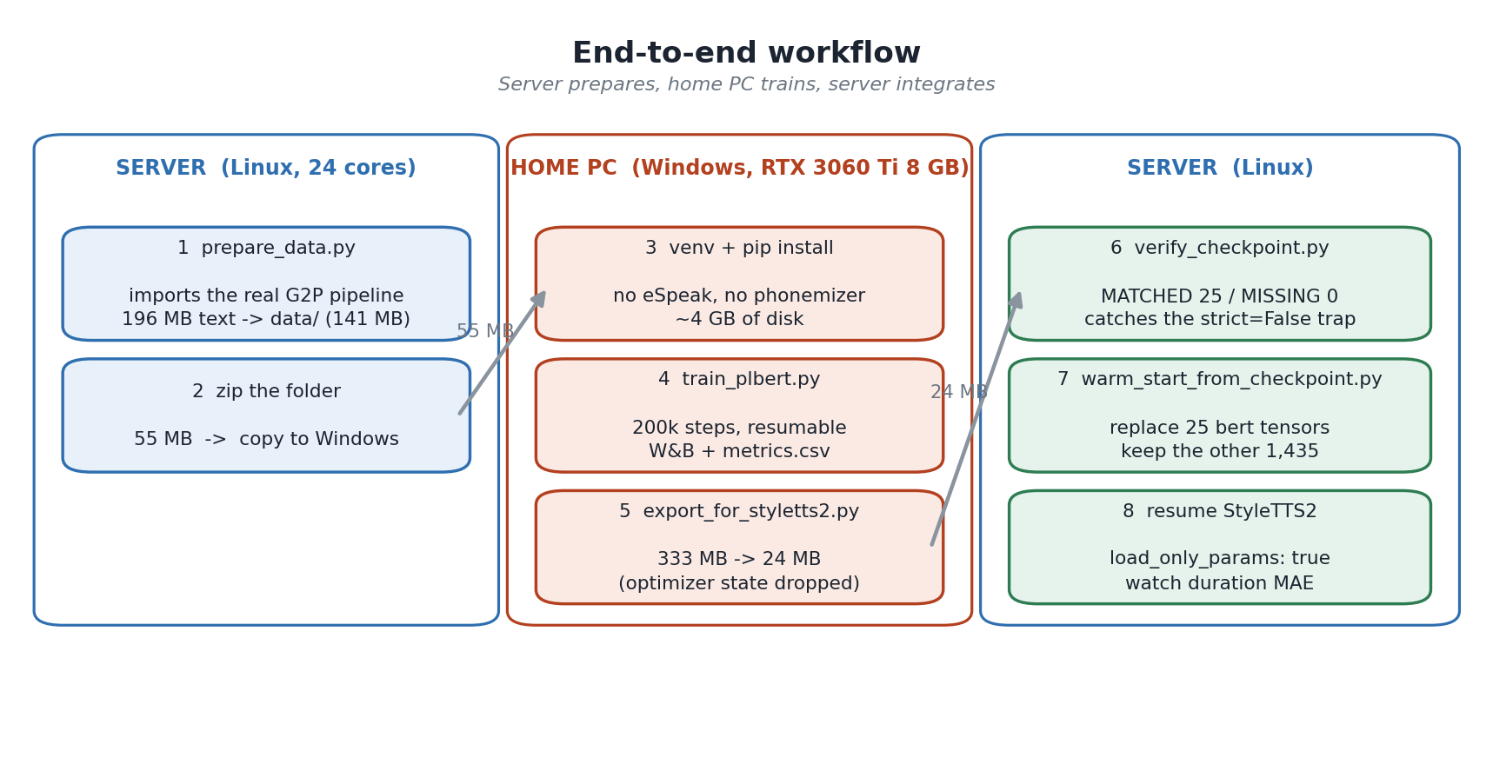
Figure 2 — Three phases. The heavy, language-specific work stays on the server; the home PC only needs PyTorch.
The split is deliberate. Installing eSpeak NG and phonemizer on Windows is fiddly — the library has to be found through PHONEMIZER_ESPEAK_LIBRARY, and a wrong build produces silently different phonemes. Doing all G2P on the server removes that entire class of problem: the Windows box receives phonemes, never text.
Step | Where | What it gives you
1 prepare_data.py | Server | Turns 196 MB of Bengali text into data/ using the project’s own G2P code, so the phonemes match the TTS manifests exactly.
2 zip and copy | Server → PC | 55 MB. No credentials, no model weights, no secrets.
3 venv + pip install | Windows | PyTorch CUDA, transformers, wandb. About 4 GB of disk, no compiler, no eSpeak.
4 train_plbert.py | Windows | 200k steps, resumable after a shutdown, losses in W&B and in a local CSV.
5 export_for_styletts2.py | Windows | Strips the optimizer state: 333 MB becomes 24 MB, which is what you upload.
6 verify_checkpoint.py | Server | Proves all 25 encoder tensors actually load. Catches the silent strict=False failure.
7 warm_start_from_checkpoint.py | Server | Swaps the 25 bert tensors inside the existing StyleTTS2 checkpoint, keeping 1,435 others.
8 resume StyleTTS2 | Server | Training continues with the decoder, style encoders and aligner intact.

2.2 Data preparation
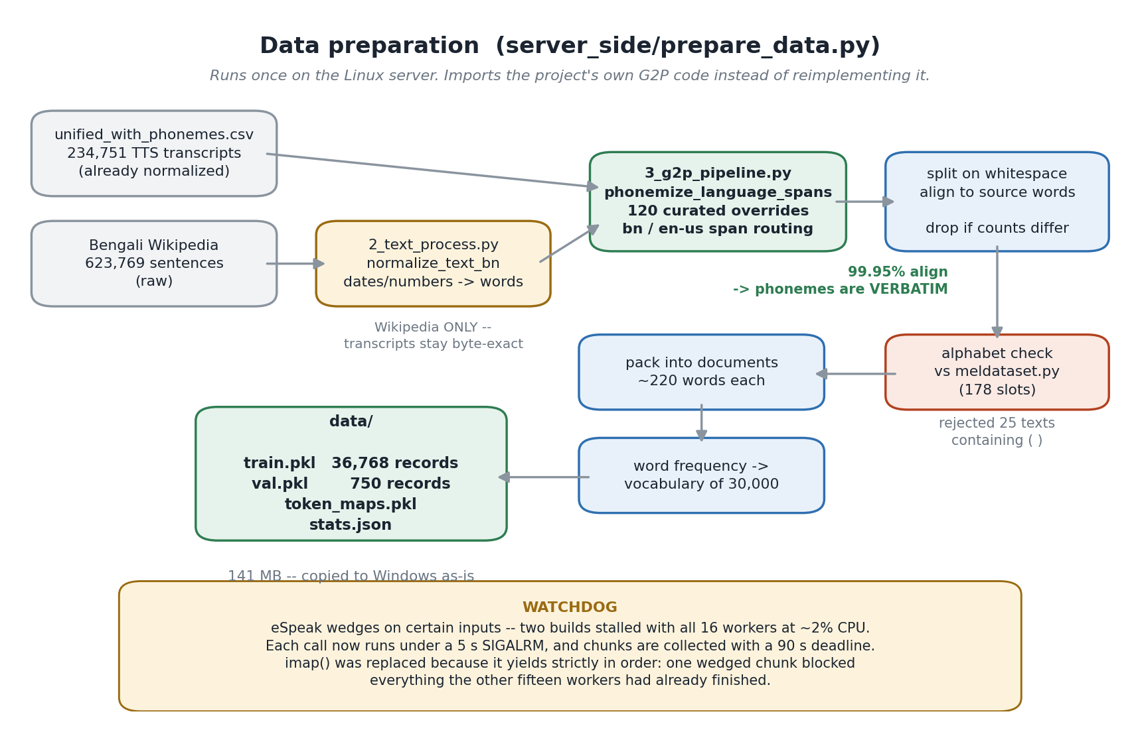
Figure 3 — Every box exists to protect one invariant: the phonemes PL-BERT learns must be the phonemes StyleTTS2 speaks.

2.2.1 Why each stage is there
Two text sources
TTS transcripts alone are 5.3 M characters. Upstream guidance is that "a text dataset of more than 30 MB is sufficient", so Bengali Wikipedia is added to reach 196 MB. Mixing them matters: transcripts are conversational and match what the model will actually say, Wikipedia supplies vocabulary breadth.
normalize_text_bn — Wikipedia only
At inference, Services/backend/text_preprocessing.py expands numbers, dates, currency and percentages into words before anything is phonemized. Raw Wikipedia still contains digits. Without this stage PL-BERT would learn pronunciations for "১৯৭১" that the serving stack never produces. Transcripts skip it because they are already normalized and are the ground truth the TTS model trained on.
phonemize_language_spans — imported, not reimplemented
This is the single most important decision in the package. The function brings 120 curated Bengali pronunciation overrides, 3 English ones, bn/en-us span routing, and sanitize_model_phonemes. Importing the real file means the two can never drift apart as the project evolves.
Split on whitespace and align
PL-BERT needs per-word phonemes; the pipeline emits one string per sentence. Phonemizing word by word loses eSpeak’s cross-word behaviour, so instead the sentence is phonemized whole and the result is split. Where the word count and the group count agree — 99.95% of manifest rows — the alignment is unambiguous and the phonemes are verbatim.
Alphabet check
Every phoneme character is compared against the 178-slot table copied from meldataset.py. In this build it rejected 25 texts containing round brackets picked up from Wikipedia — characters StyleTTS2 has no embedding for.
Pack, count, build vocabulary
Short transcripts are concatenated into ~220-word documents so the 512-character random crop has material to work with; a 4-word transcript would otherwise be almost all padding.

2.2.2 The fidelity measurements
The approach was not chosen on intuition. Three variants were measured against 400 rows of the real manifest, where the stored phonemized_transcription column is ground truth:
Approach | Exact sentence match | Character similarity
Reimplemented G2P (bn backend, word by word, no overrides) | 88.2% | 99.70%
Imported rules, still word by word | 95.5% | 99.97%
Shipped: phonemize the sentence, split on whitespace | 100% on aligned rows | 100%

The first version’s failures were concrete, not cosmetic: খুলনা came out as kʰˈulɔnˌa instead of the curated khulna; a space appeared before every comma; and Latin-script words were sent to the Bengali backend. The shipped version cannot have those problems because it calls the same function the manifests were built with.
Why dropping 11% of the corpus is the right trade
Across the full build 763,343 of 858,520 texts aligned (88.91%). Wikipedia prose carries many more hyphens and brackets than TTS transcripts, so the loss is concentrated there. Because the corpus is already six times the recommended size, discarding an ambiguous row costs nothing — whereas guessing an alignment would put wrong phonemes under a word with no way to detect it later.

2.2.3 The eSpeak watchdog
Two complete builds stalled at the same point in the Wikipedia stream: all sixteen workers at about 2% CPU, no progress for over ten minutes. Some particular input wedges eSpeak, and a hung call cannot be recovered from inside the process. Two defences were added:
- A 5-second SIGALRM around each call — the offending text is dropped and the worker continues.
- apply_async with a 90-second deadline instead of imap — imap yields results strictly in order, so a single wedged chunk blocked collection even after the other fifteen workers had finished everything else — which is exactly what happened. The final build abandoned 4 chunks, about 800 texts out of 858,520.

2.2.4 What came out
Measure | Value
TTS transcripts | 234,751
Bengali Wikipedia sentences | 623,769
Total source text | 65.3 M characters ≈ 196 MB UTF-8
Aligned texts | 763,343 (88.91%)
Rejected for out-of-alphabet characters | 25
Packed documents | 37,518
Training / validation records | 36,768 / 750
Phoneme characters | 65,919,381
Unique words seen | 481,002
Word vocabulary | 30,000 (87.62% token coverage)
data/ on disk | 141 MB

2.3 One training step
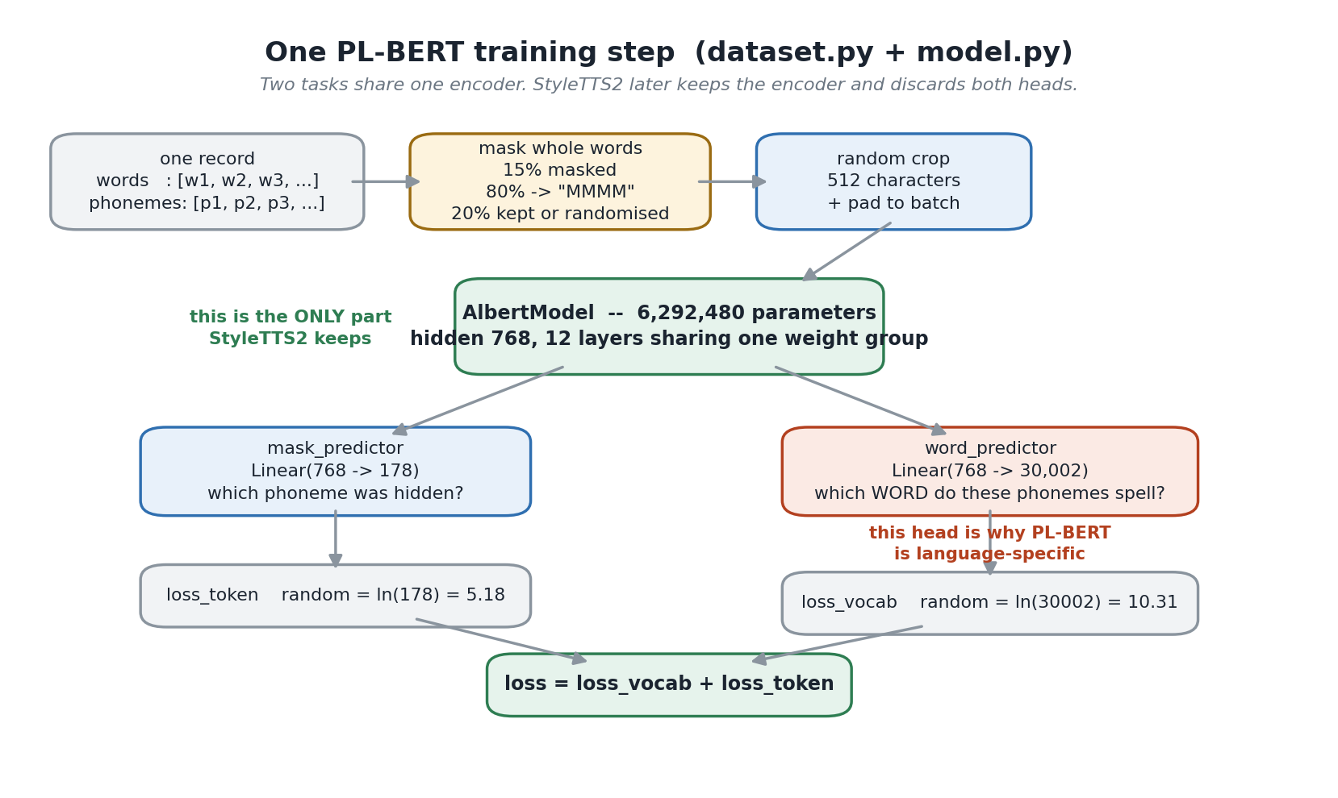
Figure 4 — Two tasks, one shared encoder. Only the green box survives into StyleTTS2.
PL-BERT is trained on two objectives at once. Neither is the goal in itself; both exist to force the encoder to build a representation that knows what the phonemes mean.
Masking whole words, not random characters
With probability 0.15 an entire word is masked. Masking single characters would let the model fill gaps from immediate neighbours; masking the whole word forces it to use sentence context. Of the masked words, 80% become "MMMM", and the rest are either left intact or replaced with random phonemes — the standard BERT recipe that stops the model from assuming an unmasked token is always correct.
The 512-character random crop
Each access to a record takes a different window with fresh masking, so 36,768 records yield far more than 36,768 distinct training examples.
mask_predictor — Linear(768 → 178)
Predicts the hidden phoneme. Random guessing scores ln(178) = 5.18, which is the number to compare the training log against.
word_predictor — Linear(768 → 30,002)
Predicts which word a phoneme span spells. This head is why PL-BERT is language-specific: it is the task that forces the encoder to learn that /bɾˈiʃʈiɾ/ is a Bengali word with a grammatical role, rather than an unfamiliar noise. Random scores ln(30002) = 10.31. StyleTTS2 discards this head entirely, which is why the vocabulary can be chosen freely.
loss = loss_vocab + loss_token
Unweighted sum, exactly as upstream. Both are plain cross-entropy, computed in fp32 even under fp16 autocast, because a softmax over 30,000 classes in half precision loses too much resolution.

2.3.1 Why the vocabulary is 30,000
The word head is Linear(768, num_vocab), so the vocabulary directly sets both the parameter count and the size of the logits tensor — which on an 8 GB card is the dominant activation. Coverage was measured on the real corpus:
Vocabulary size | Token coverage | Logits tensor (batch 16, seq 512, fp16)
10,000 | 78.65% | 164 MB
20,000 | 84.68% | 328 MB
30,000 (chosen) | 87.62% | 492 MB
40,000 | 89.45% | 656 MB
50,000 | 90.73% | 820 MB
80,000 | 93.06% | 1.3 GB

Going from 30,000 to 50,000 buys 3.1 percentage points of coverage for an extra 328 MB of activation before gradients. On a card with 8 GB that is not a trade worth making blind. Raise it later if the first run shows spare memory; nothing else in the package changes.

3 Code reference
Fourteen files, about 2,000 lines. Files under server_side/ run on the Linux box; everything else runs on Windows.
File | Lines | Runs on | Purpose
train_plbert.py | 523 | Windows | Training loop, resume, metrics, checkpointing
dataset.py | 151 | Windows | Masking, cropping, batching
model.py | 23 | Windows | MultiTaskModel: encoder plus two heads
text_utils.py | 41 | Windows | The 178-slot phoneme alphabet
config.yml | 56 | Windows | Every setting
export_for_styletts2.py | 77 | Windows | 333 MB → 24 MB before upload
run_training.bat | 17 | Windows | Double-click launcher
setup.bat | 60 | Windows | One-click venv, install and preflight check
check_setup.py | 381 | Windows | Preflight: packages, GPU, data, two real training steps
env_file.py | 36 | Windows | Loads WANDB_API_KEY from .env
server_side/prepare_data.py | 415 | Server | Builds data/ from the real G2P code
server_side/verify_checkpoint.py | 109 | Server | Proves all 25 tensors load
server_side/warm_start_from_checkpoint.py | 92 | Server | Swaps bert in a checkpoint
server_side/util.py | 42 | Server | Copy of StyleTTS2’s loader, for reference

3.1 train_plbert.py
Windows · 523 lines
The training entry point. A single-process, single-GPU rewrite of upstream’s train.ipynb.
- What it does — Loads the two pickles and token_maps, builds AlbertModel wrapped in MultiTaskModel, runs AdamW at 1e-4 under fp16 autocast, validates every val_interval steps, and writes a checkpoint every save_interval steps.
- Resume — On start it scans log_dir for the highest step_*.t7 and restores model, optimizer and GradScaler. This is not a nicety: the machine is a home PC that will be switched off.
- The stats.json cross-check — word_separator is produced by prepare_data.py and merely copied into config.yml. If the two ever disagree the dataloader maps the separator onto a real word and every sample is quietly mislabelled, so the script refuses to start instead.
- MetricsLogger — W&B when it is available, a local metrics.csv always. The CSV uses a fixed column set — an earlier version built the DictWriter fieldnames from each row, which wrote validation numbers underneath the training headers. Before wandb starts, the API key is read from .env (see section 3.11).
- save_checkpoint — Two details are load-bearing. Every key gets a module. prefix, because load_plbert strips exactly seven characters from each key. And embeddings.position_ids is re-inserted — see section 3.9.
- --device cpu — Runs the whole pipeline on CPU for a sanity check. Far too slow to train, but it proves the files load before you commit GPU hours.

3.2 dataset.py
Windows · 151 lines
Turns a record into a masked training sample. Contains no torch model code and no phonemizer import.
- Per-word expansion — Each word contributes its phoneme characters plus one separator space, and the parallel words array repeats that word’s id once per character. Phonemes, labels and word ids therefore always have identical length — asserted on every sample.
- Masking — word_mask_prob 0.15 selects a word; replace_prob 0.2 then decides between leaving it intact and substituting random phonemes drawn from the same record; otherwise the whole word becomes "M" repeated. "M" is a real entry in the 178-symbol table.
- Cropping — If the stream is longer than max_mel_length a random window is taken and the masked indices are rebased into it.
- Collater — Sorts by length, pads to the longest sample, returns input_lengths so the model can build an attention mask.

3.3 model.py
Windows · 23 lines
Structurally identical to upstream’s model.py.
- Why the attribute is named encoder — load_plbert() selects checkpoint keys by the encoder. prefix and discards everything else. Renaming this attribute would silently produce a checkpoint StyleTTS2 cannot read — and because of strict=False, would not error.
- The two heads — mask_predictor is Linear(768, 178), word_predictor is Linear(768, 30002). Together they are 23.2 M of the 29.5 M total parameters, and all of it is thrown away at handoff.

3.4 text_utils.py
Windows · 41 lines
The phoneme alphabet, and nothing else.
- Generated, not typed — The symbol block is copied verbatim out of StyleTTS2’s meldataset.py and the copy was asserted equal to the original — both the symbols list and the dicts mapping. If these two alphabets ever disagreed, PL-BERT’s embeddings would be indexed by different phonemes than the TTS model uses, and the transfer would produce noise with no error anywhere.
- 178 slots, 177 distinct characters — The apostrophe appears twice inside _letters_ipa, so one embedding row is unreachable. n_token: 178 refers to the slot count and must not be "corrected".
- A hard assert — The module refuses to import if the table is not 178 entries long.

3.5 config.yml
Windows · 56 lines
Every tunable in one file, split into blocks you may edit and one you may not.
- Safe to change — num_steps, batch_size, precision, learning_rate, save/val/log intervals, the wandb block.
- model_params — frozen — StyleTTS2 rebuilds the encoder from these exact numbers, and its bert_encoder and diffusion layers are shaped around hidden_size 768 and vocab_size 178. Changing any of them produces a checkpoint that cannot fit the TTS model.
- dataset_params.word_separator — Comes from data/stats.json. The trainer cross-checks it and refuses to start on a mismatch.

3.6 export_for_styletts2.py
Windows · 77 lines
Shrinks a training checkpoint to the part StyleTTS2 reads.
- What is removed — The AdamW moments, the GradScaler state and both prediction heads — about 309 MB of state that load_plbert() discards the moment it opens the file.
- What is kept — The 25 encoder tensors plus position_ids, which is 24 MB. For comparison, the English PL-BERT that ships with StyleTTS2 is 25 MB, because it is the same 25 tensors.
- Nothing is lost — The full checkpoint stays in checkpoints/ on the Windows machine. If you later want more steps, the same training command resumes from it with its optimizer state intact.
- It refuses bad input — If position_ids is missing or the tensor count is not 26, it exits rather than writing a file that would fail on the server.

3.7 server_side/prepare_data.py
Server · 415 lines
Builds data/. The only file that needs eSpeak, and it never leaves the server.
- It imports rather than reimplements — Both 2_text_process.py and 3_g2p_pipeline.py are loaded through importlib and called directly, so the override table, the span routing and the sanitiser are the project’s own, not a copy that can drift.
- Alignment, not guessing — Sentences whose word count and phoneme-group count disagree are dropped. The source is also split on hyphens, because sanitize_model_phonemes turns "-" into a space.
- Two timeouts — A 5 s SIGALRM per call and a 90 s per-chunk deadline. See section 2.2.3.
- It reports what it did — stats.json records the G2P source paths, the override counts, the alignment rate, the number of abandoned chunks and every corpus figure, so a later reader can tell how the data was made without re-running anything.

3.8 server_side/verify_checkpoint.py
Server · 109 lines
The gate between a trained file and the TTS run. Always run it.
- What it checks — model_params against the four values StyleTTS2 requires; that position_ids is present; that all 25 encoder tensors match by name; and that every matched tensor has the right shape.
- Why it has to exist — load_plbert() ends in load_state_dict(..., strict=False). If key names disagree the affected tensors stay randomly initialised and nothing is printed. Training would run to completion and produce a worse model with no error anywhere in the logs.
- Pass condition — MATCHED: 25, MISSING: 0, SHAPE MISMATCHES: 0.

3.9 server_side/warm_start_from_checkpoint.py
Server · 92 lines
Grafts the new encoder into the existing StyleTTS2 checkpoint.
- What it replaces — net['bert'] — 25 tensors.
- What it preserves — 1,435 tensors across 12 modules, including the decoder’s 678. None of that knowledge is invalidated by changing the text encoder’s prosody context, so there is no reason to restart from scratch.
- What it deliberately drops — The optimizer state. Those AdamW moments were accumulated against the English embeddings and would fight the new ones, which is why the resumed run must use load_only_params: true.
- It validates before writing — Key sets and tensor shapes are compared first; a mismatch aborts rather than producing a corrupt 2.2 GB file.

3.10 data/
Both · 141 MB
The prepared corpus. Copied to Windows unchanged.
- train.pkl / val.pkl — 36,768 and 750 records. Each record is {phonemes: [per-word strings], input_ids: [word ids]}.
- token_maps.pkl — Maps each word id to a compact index, in the {id: {token, word}} shape the dataloader expects. Includes the <unk> and <sep> entries.
- stats.json — The provenance record described in 3.7.

3.11 env_file.py and .env
Windows · 36 lines
Lets run_training.bat log in to Weights & Biases without a separate wandb login.
- What it does — Reads KEY=VALUE lines from the .env file next to the scripts and puts them in the environment. wandb reads WANDB_API_KEY from the environment, so the key is used automatically. Standard library only, so no python-dotenv dependency.
- Who calls it — train_plbert.py, just before wandb.init, and check_setup.py, which reports whether a key was found. A missing key is a warning, never a failure: losses still go to metrics.csv.
- Precedence — A WANDB_API_KEY already set in the real environment wins over .env, and an empty value is ignored, so the shipped placeholder WANDB_API_KEY= changes nothing.
- Keep it private — .env holds a personal credential. It is not part of export\ and must not be uploaded or included when the folder is shared.

4 How to run the training
From an empty Windows folder to a resumed StyleTTS2 run. Steps 1 and 2 are already done — data/ is in the package.

4.1 Prerequisites
Requirement | Detail
Python | 3.9 – 3.12, 64-bit. Not 3.13 — tokenizers and numpy have no Windows wheels for it and would try to build from source.
GPU | Any NVIDIA card with 8 GB or more; tuned for an RTX 3060 Ti
Disk | About 4 GB for the venv, 141 MB for data/, up to 1 GB for checkpoints
Download | About 2.5 GB the first time — the CUDA wheel is most of it
Internet | Needed once for pip. Optional afterwards — see 4.5
NOT needed | eSpeak NG, phonemizer, Bengali tooling, the StyleTTS2 repository, a C or Rust compiler

4.2 One-time setup
Double-click setup.bat. It checks the Python version, creates the virtual environment, installs every package and then runs the preflight check. If it finishes with "Ready." there is nothing else to do.
To do the same by hand, or to see why setup.bat failed:
cd path\to\PLBERT_BN_TRAINING

python -m venv .venv
.venv\Scripts\activate REM PowerShell: .venv\Scripts\Activate.ps1

python -m pip install --upgrade pip
pip install -r requirements.txt
python check_setup.py
Why one pip install is enough
On Windows, the "torch" on PyPI is the CPU-only build — installing it would leave you with a package that imports fine and then reports no GPU. requirements.txt therefore carries an --extra-index-url line pointing at PyTorch’s own wheel server and pins torch==2.5.1+cu121. No "+cu121" build exists on PyPI, so pip cannot fall back to the CPU wheel even if the extra index is unreachable: it fails loudly instead.

4.2.1 check_setup.py — run this before committing 14 hours
The preflight check verifies the interpreter version, every package, the GPU and its free memory, all ten package files, the 178-slot alphabet, and that config.yml and data/stats.json agree on the separator id and vocabulary size. It then runs two real training steps at the configured batch size:
--- two real training steps -----------------------------------
[ ok ] ran 2 steps at batch_size=8
loss 9.6749 on cuda
[ ok ] peak VRAM
4.12 GiB of 8.0 GiB (3.88 GiB headroom). Comfortable.
If the configured batch size does not fit, the check does not simply fail -- it steps down a ladder (16, 12, 8, 6, 4, 2), reports the largest value that works, and prints the exact line to put in config.yml:
[ warn ] batch_size=16 does not fit
retrying with a smaller batch
[ FAIL ] config.yml needs one change
batch_size: 16 does not fit this card. batch_size: 8 does,
using 4.12 GiB of 8.0 GiB. Edit config.yml:
batch_size: 8
So the number is measured on your card rather than estimated. The check exits with status 1 when anything fails, so setup.bat stops rather than telling you it is ready.
python check_setup.py --device cpu runs the same two steps without a GPU, which is useful before CUDA is working or while the card is busy.

4.3 Start training
.venv\Scripts\activate
python train_plbert.py --config config.yml
Or simply double-click run_training.bat, which does the same thing.
The header confirms what it is about to do:
[14:02:11] GPU : NVIDIA GeForce RTX 3060 Ti
[14:02:11] VRAM : 8.0 GiB
[14:02:11] precision : fp16
[14:02:12] data check : separator id 30001, vocab 30,002 -- consistent with stats.json
[14:02:12] train / val: 36,768 / 750 records
[14:02:12] parameters : 29,500,900 total, 6,292,480 in the encoder StyleTTS2 will keep
[14:02:13] metrics : W&B run bn-plbert-3060ti (a1b2c3d4) + CSV
[14:02:13] training to step 200,000 ...

4.4 Reading the training log
[14:22:07] step 12,400/200,000 | vocab 3.1482 | token 0.9140 | 4.21 steps/s
Field | Meaning | Random baseline | Healthy direction
vocab | Which word does this phoneme span spell? | ln(30002) = 10.31 | Falls steadily
token | Which phoneme was hidden? | ln(178) = 5.18 | Falls steadily
steps/s | Throughput | — | Stable

Divide 200,000 by the printed steps/s for the finish time. At 4 steps/s that is about 14 hours. If either loss is still near its baseline after a few thousand steps, something is wrong — stop and check that data/ was copied completely.

4.5 Watching the losses
- checkpoints\metrics.csv — written unconditionally, one row per log interval and per validation, with a fixed column set. Open it in Excel for a quick chart.
- Weights & Biases — enabled by default in config.yml. Open .env in the package folder and paste your API key (from https://wandb.ai/authorize) after WANDB_API_KEY=. train_plbert.py and check_setup.py load it automatically, so double-clicking run_training.bat needs nothing else. Running wandb login once also works. Keep .env private: never upload it or include it when sharing the folder.
If wandb is missing, unauthenticated or offline, the script says so and carries on with the CSV. It will never stop training because a dashboard is unreachable. For a machine with no internet, set mode: offline in config.yml and upload later:
wandb sync checkpoints\wandb\offline-run-*
The run id is stored in checkpoints\wandb_run_id.txt, so stopping and restarting continues the same W&B run instead of creating a new one every evening.

4.6 If you hit CUDA out of memory
check_setup.py already finds the answer -- run it first. To tune by hand, these are the levers in order:
Setting | Default | Try | Effect
batch_size | 8 | 12 or 16 with room, 4 without | Biggest lever, roughly linear
max_mel_length | 512 | 384, then 256 | Attention cost falls with the square
precision | fp16 | bf16 | Similar memory, sometimes more stable

Measured cost at sequence length 512, which is why 8 is the default on an 8 GB card:
Batch | Word logits | Attention | Hidden states | Weights | Total
16 | 2.29 GB | 2.25 GB | 2.06 GB | 0.46 GB | 7.06 GB - does not fit
12 | 1.72 GB | 1.69 GB | 1.55 GB | 0.46 GB | 5.41 GB
8 (default) | 1.14 GB | 1.12 GB | 1.03 GB | 0.46 GB | 3.76 GB
4 | 0.57 GB | 0.56 GB | 0.52 GB | 0.46 GB | 2.11 GB

The CUDA context, the display driver and allocator fragmentation sit on top of those figures, which is why 7.06 GB does not leave enough room on an 8 GB card. The word-logits column is the one that surprised the first estimate: the vocabulary head emits batch x 512 x 30,002 values, and autograd keeps an fp32 copy and its gradient as well as the fp16 tensor. compute_losses therefore upcasts each utterance slice individually rather than calling .float() on the whole batch, which alone saves about a gigabyte.

4.6.1 A bigger effective batch, for free
Extrapolating from a real measurement on an RTX 3060 Ti -- batch 8 peaked at 5.28 GiB, which is 0.605 GiB per sample on top of 0.44 GiB of weights and optimizer state:
Batch | Predicted peak | Margin | Verdict
8 | 5.28 GiB | 1.82 GiB | Measured, safe
10 | 6.49 GiB | 0.61 GiB | Probably fits, thin -- may OOM hours into a run
12 | 7.70 GiB | -0.60 GiB | Will not fit

The margin is measured against a realistic ceiling of about 7.1 GiB, because max_memory_allocated counts only PyTorch allocations -- the CUDA context and the Windows desktop take roughly 0.9 GiB more.
A bigger batch does not make training faster
Each step does proportionally more work, so samples per second barely changes. What a bigger batch buys is a less noisy gradient, and gradient accumulation gives exactly that at identical VRAM: two micro-batches of 8 are accumulated before each optimizer step, producing the gradient of a real batch of 16 at the peak memory of 8. Each optimizer step then takes twice as long, so halve num_steps to keep the same wall-clock and the same number of samples seen.
batch_size: 8
gradient_accumulation: 2 # effective batch 16, identical VRAM
num_steps: 100000 # halved because each step now costs twice as much
Do not touch model_params
Those seven numbers define the tensor shapes StyleTTS2 will rebuild. Lowering hidden_size to save memory would produce a checkpoint that cannot be loaded into the TTS model at all. Reduce batch_size and max_mel_length instead — they change only how much is processed at once, never what is produced.
Smaller batches need more steps for the same quality, so prefer shrinking max_mel_length second rather than dropping batch_size twice.

4.7 Stopping and resuming
Close the window, shut the machine down, come back tomorrow and run the same command. The script finds the newest checkpoint and continues, restoring the optimizer and the loss scaler as well as the weights:
[09:14:02] resumed from checkpoints\step_45000.t7 at step 45,000
Only the newest keep_last_checkpoints files are kept, so the folder does not grow without bound.

4.8 Export and upload
python export_for_styletts2.py --checkpoint checkpoints\step_200000.t7
checkpoints\step_200000.t7 333.1 MB
export\step_200000.t7 24.0 MB (26 tensors)
Upload the export folder. Keep checkpoints\ locally.
 | Size | Contents | Where it lives
data/ | 141 MB | The whole corpus | Untouched on both machines
checkpoints\step_N.t7 | 333 MB | Encoder + 2 heads + AdamW moments + scaler | Stays on your PC — needed to resume
export\step_N.t7 | 24 MB | The 25 tensors StyleTTS2 reads | The only upload

4.9 On the server
# 1. place the uploaded folder
mv export /mnt/newworkspace/rizoan/StyleTTS2-Fork/Utils/PLBERT_bn

# 2. prove it loads -- this catches the silent strict=False failure
cd /mnt/newworkspace/rizoan/StyleTTS2-Fork
python PLBERT_BN_TRAINING/server_side/verify_checkpoint.py \
--plbert-dir Utils/PLBERT_bn

# 3. graft it into the current run's checkpoint
python PLBERT_BN_TRAINING/server_side/warm_start_from_checkpoint.py \
--checkpoint Models/Bengali_dominant_schema_v2_40epoch/epoch_000NN.pth \
--plbert-dir Utils/PLBERT_bn \
--out Models/Bengali_dominant_schema_v2_40epoch/warmstart_bn_plbert.pth
Step 2 must print:
AlbertModel expects : 25 tensors
checkpoint provides : 25 tensors
MATCHED : 25
MISSING : 0
PASS - all 25 encoder tensors load cleanly.
Then edit the training config:
pretrained_model: /…/Models/<run>/warmstart_bn_plbert.pth
second_stage_load_pretrained: true
load_only_params: true # the optimizer state was deliberately dropped
PLBERT_dir: Utils/PLBERT_bn/
What to watch after restarting
eval/duration_alignment_mae is the metric this entire project exists to move. It sat at 0.529 for 25 epochs. If it does not start falling within a few epochs of the warm start, the bottleneck is somewhere other than PL-BERT and the hypothesis in section 1 was wrong.

5 What was verified
Scope of this table
Every row below was executed, not reasoned about. None of it ran on a GPU — both server cards were occupied by the 40-epoch TTS run — so all of it is CPU. That is why batch_size: 16 is an estimate rather than a measurement.
Check | Result
Reference G2P pipeline reproduces the manifest CSV | 400 / 400 = 100% (harness is valid)
Shipped alignment approach on manifest rows | 1,999 / 2,000 = 99.95% align
text_utils.symbols vs meldataset.symbols | Identical list and identical dict
Bengali phonemes outside the alphabet | 0 across 269,897 characters
Training loop learns | vocab 9.85 → 8.50, token 4.60 → 3.78
Encoder parameter count | 6,292,480 — matches the English PL-BERT exactly
Resume from checkpoint | Picked up at step 12, continued to 15
Checkpoint pruning | Kept the newest 2, removed the rest
stats.json consistency check | separator 30001 / vocab 30,002 accepted
metrics.csv column alignment | Train and validation rows line up
Export | 333 MB → 24.0 MB, 26 tensors, all identical to the source
verify_checkpoint.py | MATCHED 25, MISSING 0, SHAPE MISMATCHES 0
Stock, unpatched load_plbert() | Loads; weights equal the file, not random
build_model() with the new encoder | 13 modules, bert_encoder.in_features = 768
warm_start_from_checkpoint.py | 25 replaced, 1,435 preserved byte-identical

5.1 The two traps this guards against
Both would fail silently, which is why they were tested explicitly rather than assumed.
Trap 1 — strict=False
load_plbert() ends with bert.load_state_dict(new_state_dict, strict=False). If key names disagree, the affected tensors keep their random initialisation and nothing is printed. Training would run to completion and produce a worse model, with no error anywhere to explain it. verify_checkpoint.py exists for exactly this case.
Trap 2 — position_ids
Utils/PLBERT/util.py line 39 performs an unconditional del new_state_dict["embeddings.position_ids"]. transformers 4.31 and later no longer place that key in ALBERT’s state_dict, so a freshly trained checkpoint makes the stock loader raise KeyError. Rather than patching a file inside a live training tree, train_plbert.py re-inserts the tensor when saving. The stock loader then works unchanged — which was verified end to end before this package was built.

6 Known risks
Risk | Severity | Detail
No GPU run | Medium | batch_size: 16 was never executed on a real card. If it does not fit, section 4.6 lists the knobs in the order to turn them. Nothing about the resulting checkpoint changes.
The hypothesis is unproven | High impact | A Bengali PL-BERT is the best-supported explanation for the flat duration MAE, not a demonstrated one. The warm-start run is the experiment. If eval/duration_alignment_mae does not move within a few epochs, the bottleneck is elsewhere — the next suspects would be the effective batch size of 4 under DataParallel, and the LR schedulers that are built but never stepped.
87.62% vocabulary coverage | Low | Roughly one word position in eight trains against <unk>. Acceptable for an auxiliary task; raise the vocabulary if the card turns out to have spare memory.
11% of source texts dropped at alignment | Low | The loss is concentrated in hyphen- and bracket-heavy Wikipedia prose rather than being random. Judged acceptable because the corpus is six times the recommended size, but it is a known bias, not a neutral sample.
transformers pinned to 4.36.2 | Low | A newer release that renames ALBERT keys would break the handoff. verify_checkpoint.py would catch it before any training time is lost.
eSpeak wedging | Contained | Root cause unidentified — a specific input hangs the library. The timeout and the per-chunk deadline contain it; they do not fix it. Rebuilding the corpus with different settings may abandon a different handful of chunks.

6.1 If the warm start does not help
The next two candidates, both already identified in the trainer and both independent of PL-BERT:
- Effective batch size — batch_size: 4 split across two GPUs by DataParallel means two samples per card. Gradients are extremely noisy, which is consistent with a model that plateaus early and then wanders.
- The LR schedulers are never stepped — build_optimizer creates OneCycleLR objects but optimizer.scheduler() is never called in the training loop, so the learning rate is constant for all 40 epochs. This is upstream behaviour, not a fork regression, and is documented in the trainer’s own comments.

See also: README.md (operating manual) and DESIGN.md (decision record) in the package root.

