PDS-Pertemuan-6.R
r4057261
2026-10-05
#Tipe Data
#Numeric
print("Numeric")
## [1] "Numeric"
a <- 800.78
class(a)
## [1] "numeric"
print("Integer")
## [1] "Integer"
b <- -90L
class(b)
## [1] "integer"
print("Character")
## [1] "Character"
c <- "Hello saya Ciko"
class(c)
## [1] "character"
print("Complex")
## [1] "Complex"
d <- 9i + 3
class(d)
## [1] "complex"
print("Boolean")
## [1] "Boolean"
e <- TRUE
class(e)
## [1] "logical"
#Struktur Data
buah <- c("Pisang","Semangka","Persik")
buah #Vector
## [1] "Pisang" "Semangka" "Persik"
list_buah <- list("Durian","Mangga",10,20)
list_buah #Data List
## [[1]]
## [1] "Durian"
##
## [[2]]
## [1] "Mangga"
##
## [[3]]
## [1] 10
##
## [[4]]
## [1] 20
matrix_angka <- matrix(c(1,2,3,4,5,6),nrow = 3,ncol = 2)
matrix_angka
## [,1] [,2]
## [1,] 1 4
## [2,] 2 5
## [3,] 3 6
#Data Frame (DF)
statistik_Game_RPG <- data.frame(
Stat = c("Power","Mana","Exp"),
Marksmen = c(200,24,50),
Fighter = c(100,40,80)
)
statistik_Game_RPG
## Stat Marksmen Fighter
## 1 Power 200 100
## 2 Mana 24 40
## 3 Exp 50 80
#Vector Numeric
angka <- c(1,2,3)
angka
## [1] 1 2 3
urutan <- 1:50
urutan
## [1] 1 2 3 4 5 6 7 8 9 10 11 12 13 14 15 16 17 18 19 20 21 22 23 24 25
## [26] 26 27 28 29 30 31 32 33 34 35 36 37 38 39 40 41 42 43 44 45 46 47 48 49 50
urutan_desimal <- 1.5:10.5
urutan_desimal
## [1] 1.5 2.5 3.5 4.5 5.5 6.5 7.5 8.5 9.5 10.5
urutan_desimal <- 1.5:6.3
urutan_desimal
## [1] 1.5 2.5 3.5 4.5 5.5
#Panjang Vektor
length(urutan_desimal)
## [1] 5
length(buah)
## [1] 3
#Mengurutkan vektor
fruits <- c("banana","apple","lemon","mango")
sort(fruits)
## [1] "apple" "banana" "lemon" "mango"
#Mengakses vektor
fruits[1]
## [1] "banana"
fruits[-1]
## [1] "apple" "lemon" "mango"
#Mengganti item
fruits[1] <- "peach"
fruits
## [1] "peach" "apple" "lemon" "mango"
#Data Frame
statistik_Game_RPG
## Stat Marksmen Fighter
## 1 Power 200 100
## 2 Mana 24 40
## 3 Exp 50 80
summary(statistik_Game_RPG)
## Stat Marksmen Fighter
## Length :3 Min. : 24.00 Min. : 40.00
## N.unique :3 1st Qu.: 37.00 1st Qu.: 60.00
## N.blank :0 Median : 50.00 Median : 80.00
## Min.nchar:3 Mean : 91.33 Mean : 73.33
## Max.nchar:5 3rd Qu.:125.00 3rd Qu.: 90.00
## Max. :200.00 Max. :100.00
#Mengakses Data Frame
statistik_Game_RPG[1]
## Stat
## 1 Power
## 2 Mana
## 3 Exp
statistik_Game_RPG$Marksmen
## [1] 200 24 50
#Menambahkan baris di dataframe
statistik_Game_RPG
## Stat Marksmen Fighter
## 1 Power 200 100
## 2 Mana 24 40
## 3 Exp 50 80
statistik_Game_RPG <- rbind(statistik_Game_RPG, c("Gold", 70, 50))
statistik_Game_RPG
## Stat Marksmen Fighter
## 1 Power 200 100
## 2 Mana 24 40
## 3 Exp 50 80
## 4 Gold 70 50
ML <- statistik_Game_RPG
ML_baru <- ML[-c(5,6,7),]
ML <- ML_baru
ML
## Stat Marksmen Fighter
## 1 Power 200 100
## 2 Mana 24 40
## 3 Exp 50 80
## 4 Gold 70 50
#Memambahkan kolom di dataframe
ML <- cbind(ML, Assassin = c(220,25,60,50))
ML
## Stat Marksmen Fighter Assassin
## 1 Power 200 100 220
## 2 Mana 24 40 25
## 3 Exp 50 80 60
## 4 Gold 70 50 50
#Menghapus Baris dan Kolom di Dataframe
ML_HapusBarisKolom <- ML[-c(1),-c(1)]
ML_HapusBarisKolom
## Marksmen Fighter Assassin
## 2 24 40 25
## 3 50 80 60
## 4 70 50 50
#Melihat dimensi data frame
dim(ML)
## [1] 4 4
dim(ML_HapusBarisKolom)
## [1] 3 3
#Melihat data frame
#View(ML)
#View(ML_HapusBarisKolom)
#Menggabungkan Dua Data Frame
Data_Frame1 <- data.frame(
senjata <- c("M4","AK47","uzi"),
skin <- c("Dragon","Alok","38"),
Damage <- c(100,200,300)
)
Data_Frame2 <- data.frame(
senjata <- c("Glock","Shotgun","Riffle"),
skin <- c("Neymar","Jokowi","Ahok"),
Damage <- c(400,250,100)
)
#FF <- rbind(Data_Frame1,Data_Frame2)
#View(FF) #ERROR
#Grafik plot
plot(1,3)
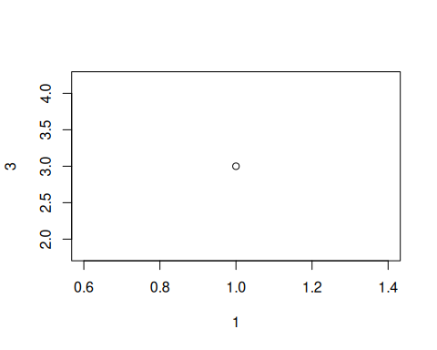
plot(c(1,8),c(7,9))
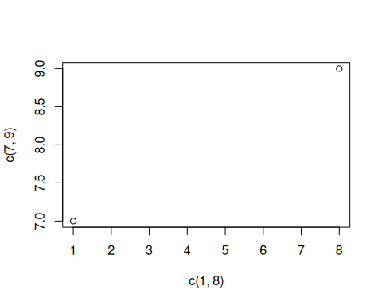
x <- c(1,2,3,4,13)
y <- c(5,7,9,11,13)
plot(x,y)
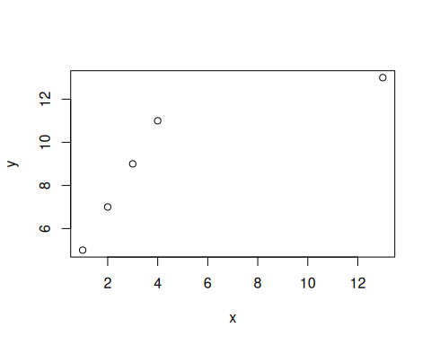
plot(3:10)
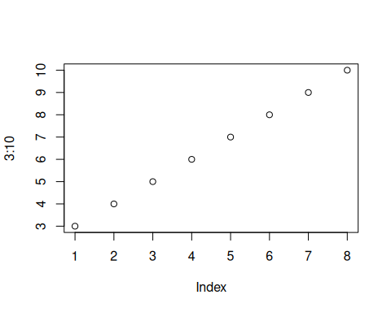
plot(3:10, type = "l")
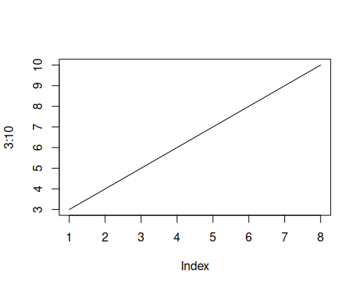
plot(3:10, main = "Grafik Lurus", xlab = "Ini adalah sb X", ylab = "Ini adalah sb Y", type = "l", col = "blue")
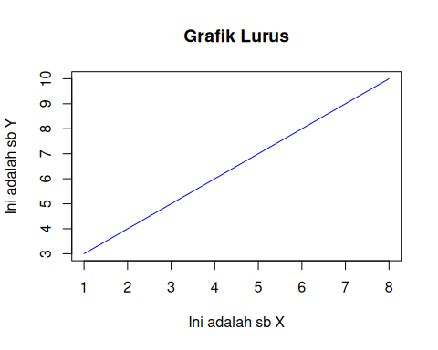
plot(1:10)
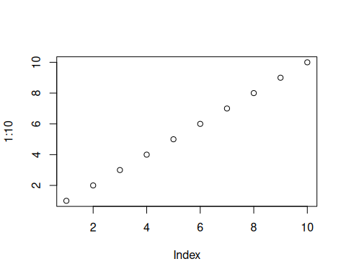
plot(1:10, pch = 25)
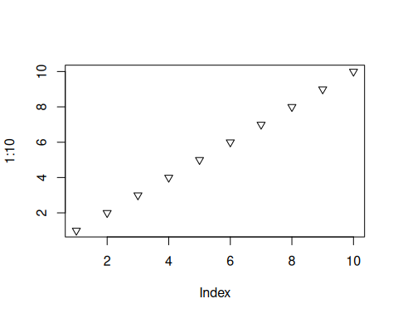
plot(1:10, pch = 25, type ="l")
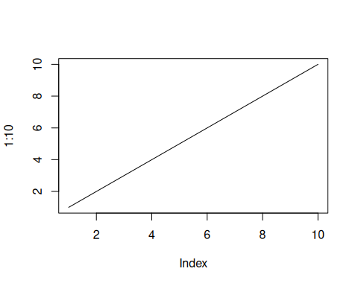
plot(1:10, pch = 25, type ="l", lwd = 10)
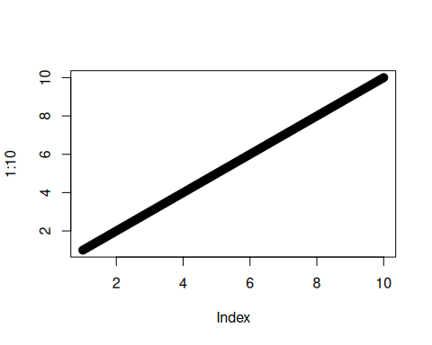
plot(x, type="l", col = "blue")
lines(y,type="l", col = 'green')
