**Meenakshi Sundararajan Engineering College : Department of Computer Science and Engineering**

**NM1009 - Generative AI for Engineering**

**LSUN(LARGE SCALE SCENE UNDERSTANDING CHALLENGE)**

**MOHAMED RIZWAN ROSHAN R (311521104028)**

**NM Id : au311521104028**

**ARCHITECTURE :**

**INTERNAL GUIDE:**

Dr.S.AARTHI

**Head of The Department, CSE**

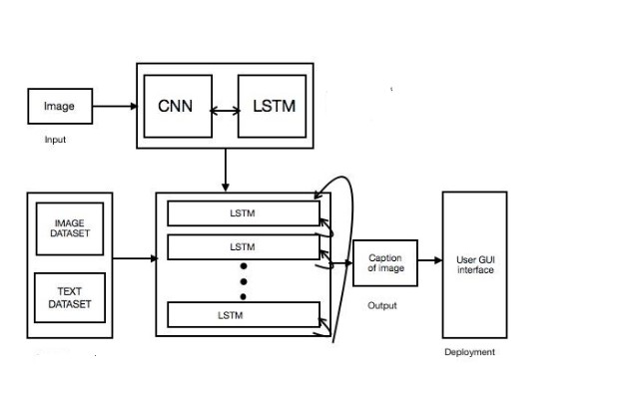

**FEATURES:**

* **Generate textual descriptions and captions for scenes from the LSUN dataset.**
* **Optimize model parameters and explore hyperparameters.**
* **Evaluate generated outputs for contextual fidelity and relevance.**