Name : [Muhammad Rizwan Azhar](mailto:231451216@formanite.fccollege.edu.pk)  
Roll number: 231451216

Assignment 1

Information Security

I used sqlmap for conducting the attack on the website [www.vulnweb.com](http://www.vulnweb.com).

First I used sqlmap command to look for databases running on this website. Here is how I performed it.

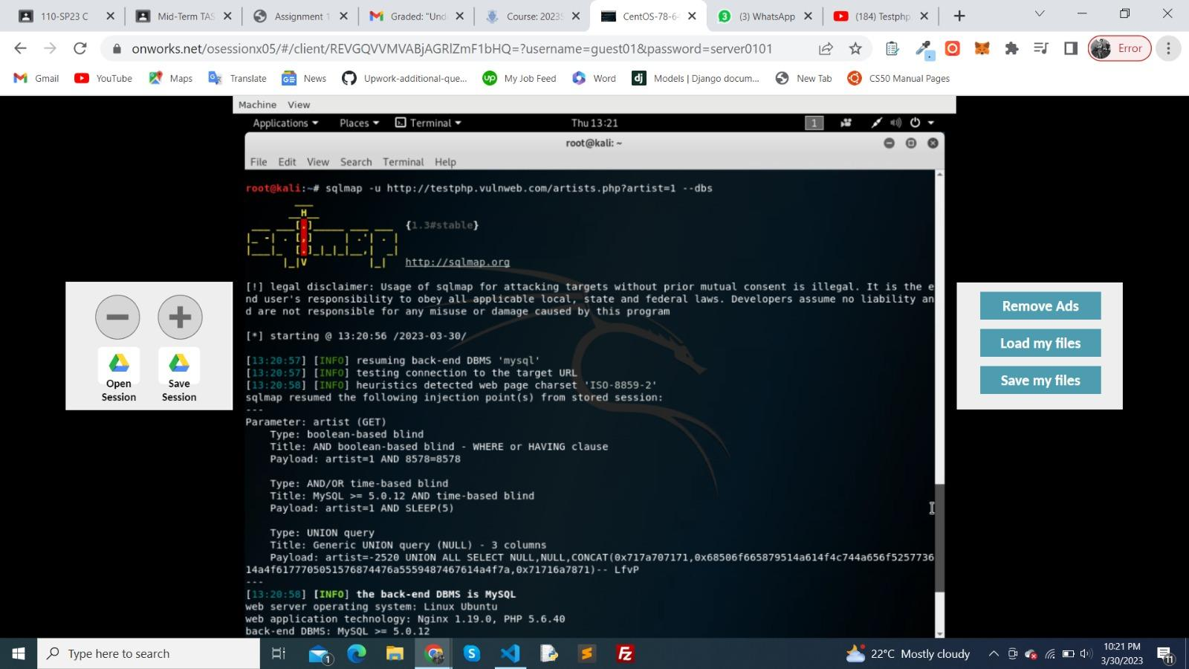

Then I used the same command on the category page. Like this

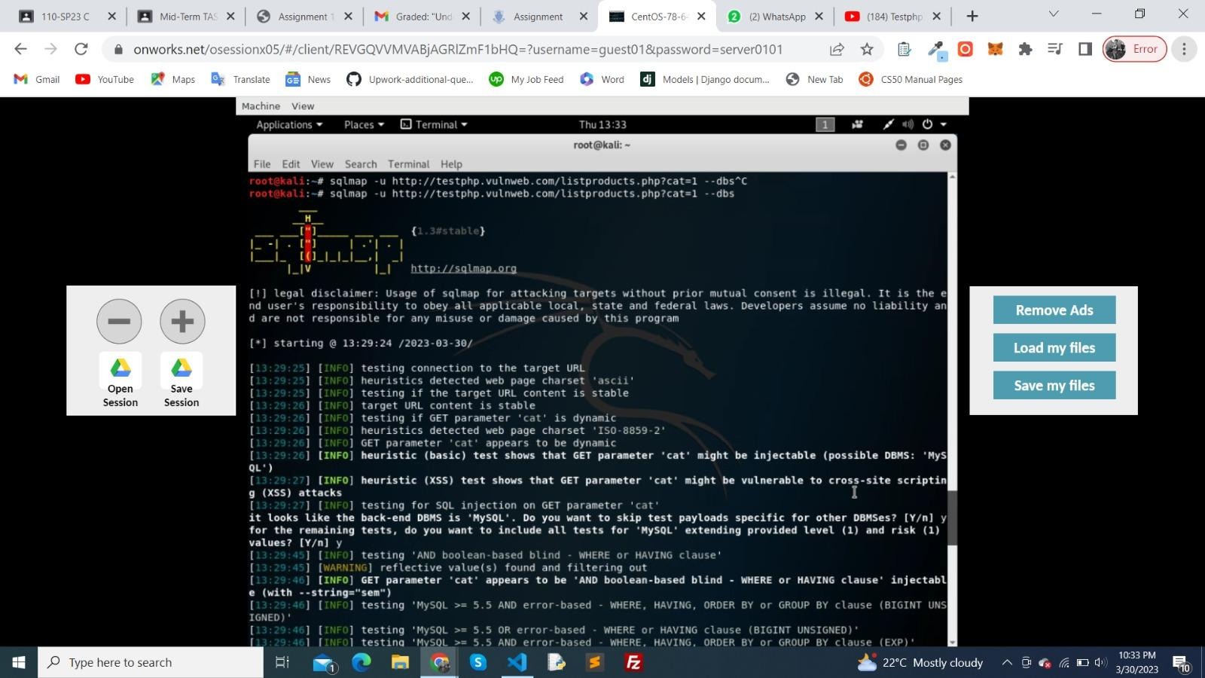

Here I found 2 databases. Acuart and information_schema

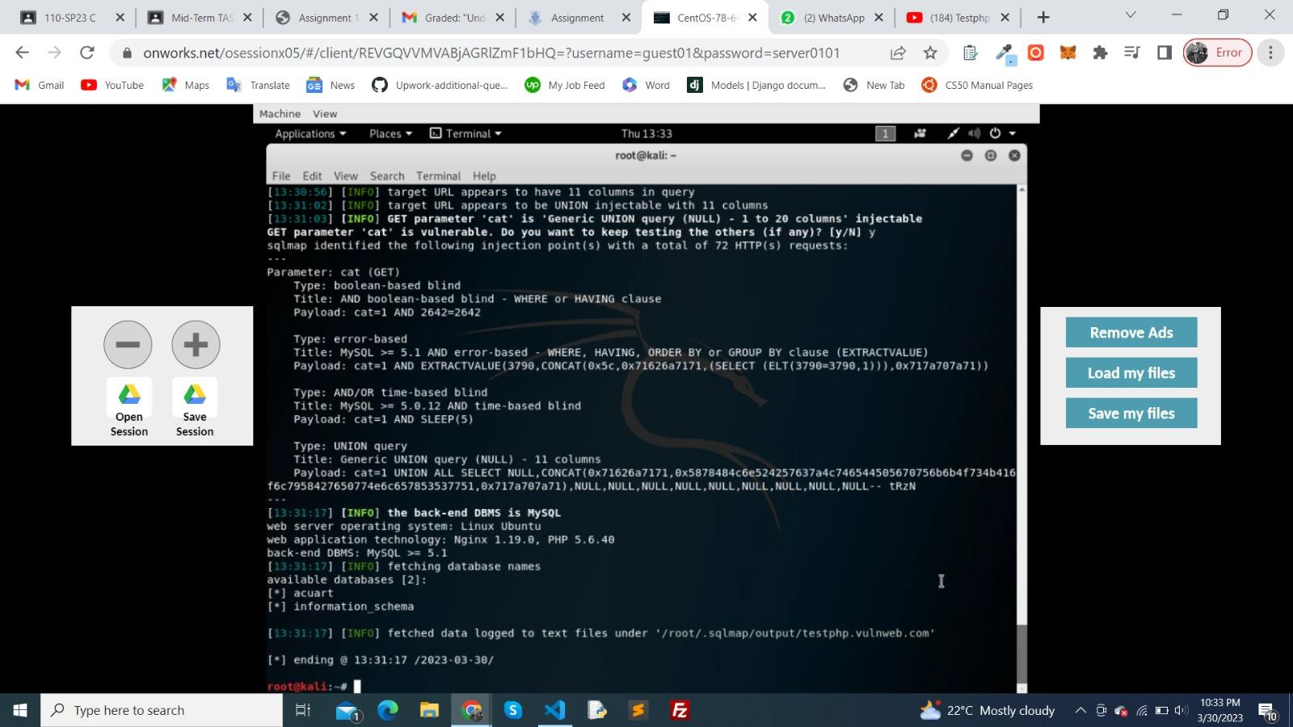

I used the acuart database and then by running this command I git access to the tables in the database.

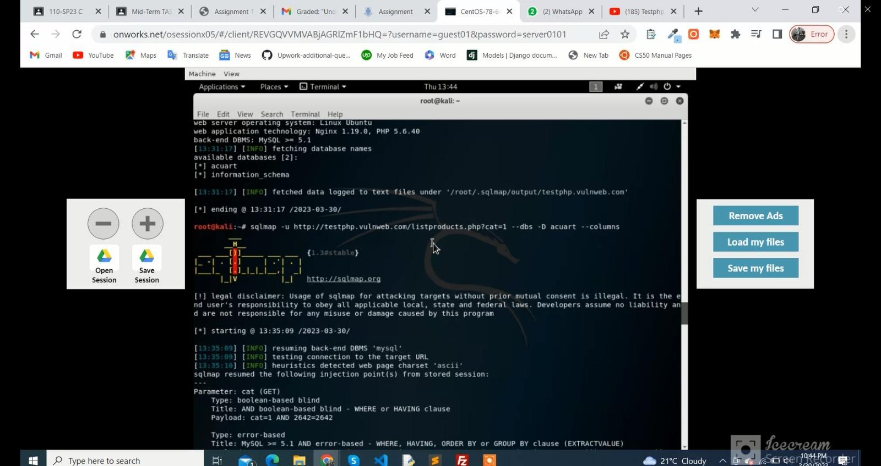

Here are the tables I found

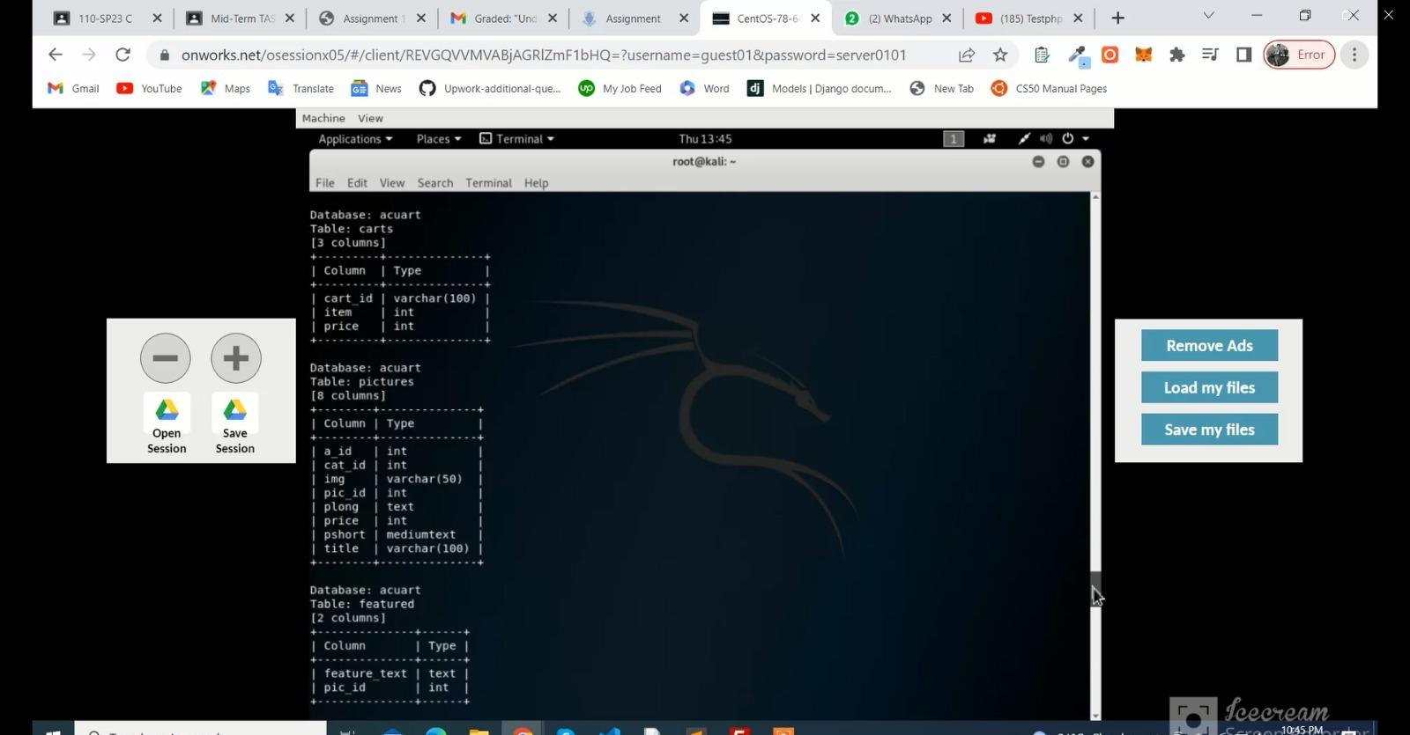

Then I used this command to inject. Injected a table users which have a column of phones.

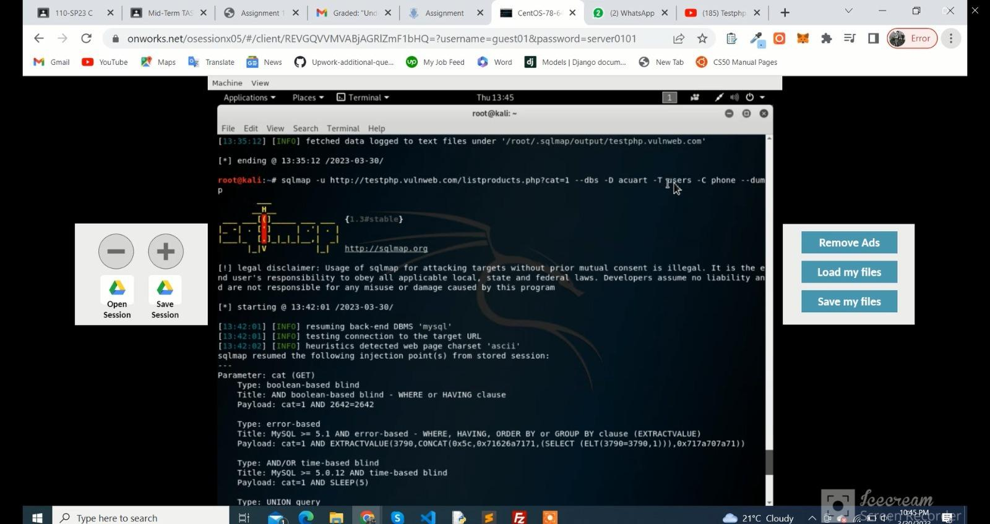

Here is the output

