
Name: Muhammad Rizwan Riaz
Pnumber: p2901284

Fashion-MNIST Classification Using ANN and CNN with Swish & Mish Activations
1.Introduction:
This project explores how different neural network architectures perform on the Fashion-MNIST image classification task. The goal was to design and compare two models — a Multi-Layer Perceptron (ANN) and a Convolutional Neural Network (CNN) — while integrating modern activation functions and regularization techniques to improve accuracy. The experiment is relevant to the broader field of computer vision, where understanding how models interpret, visual data can lead to better systems in areas like retail automation, medical imaging, and robotics.
The motivation behind this work was to see how architectural choices and activation functions affect learning outcomes. By comparing a basic ANN with a deeper CNN, I aimed to understand which approach is more effective for classifying grayscale clothing images and how techniques like dropout, batch normalization, and data augmentation contribute to performance.
2.Experimental Methodology:
The dataset used was Fashion-MNIST, which contains 70,000 grayscale images (28×28 pixels) across 10 clothing categories. Each image is labelled with one of ten classes, such as T-shirt, trouser, dress, coat, and sneaker. To prepare the data, I normalized pixel values and applied data augmentation — specifically random horizontal flips and cropping — to improve generalization and reduce overfitting.
The dataset was split into 50,000 training samples, 10,000 validation samples, and 10,000 test samples. All models were implemented in PyTorch and trained for 10 epochs using the Adam optimizer and CrossEntropyLoss. While 10 epochs was enough to observe meaningful results, I believe extending training would further improve accuracy and stability.
Two models were developed:
- SwishMish MLP (ANN): This model flattens each image into a 784-dimensional vector and passes it through two hidden layers with 512 and 256 neurons. The first layer uses the Swish activation function, and the second uses Mish. Dropout was applied after each layer to reduce overfitting. The final layer outputs logits for the 10 classes.
- Deep SwishMish CNN: This model uses three convolutional blocks with increasing filter sizes (64, 128, and 256). Each block includes convolutional layers followed by batch normalization, Swish activation, max pooling, and dropout. After the final block, the output is flattened and passed through a fully connected layer with Mish activation and another dropout layer before classification.
Both models were trained using the same optimizer and loss function. Performance was tracked using accuracy, loss, confusion matrices, and softmax confidence visualizations.
3.Results:
The CNN significantly outperformed the ANN:
Model | Test Accuracy | Test Loss
SwishMish MLP | 81.37% | 0.4935
Deep SwishMish CNN | 91.22% | 0.2530
The CNN showed strong classification across all categories, with only minor confusion between visually similar items like shirts and coats. The ANN, while simpler and faster to train, struggled to capture spatial features, which limited its accuracy. Training curves showed that both models converged steadily, but the CNN maintained lower loss and higher accuracy throughout.
Softmax confidence plots revealed that the CNN made more confident predictions, often assigning high probabilities to the correct class. The confusion matrix for the CNN showed balanced performance across all categories, with only a few misclassifications. These results were visualized using Matplotlib and Seaborn and are included in the appendix.
4.Notable Innovations:
Several innovations were introduced to improve model performance:
- Activation Functions: I used Swish and Mish instead of traditional ReLU. Swish is smooth and non-monotonic, which helps with gradient flow. Mish has self-regularizing properties that improve generalization.
- Regularization: Dropout was applied throughout both models to prevent overfitting. In the CNN, batch normalization was also used to stabilize training and accelerate convergence.
- Optimizer Selection: The Adam optimizer was chosen for its adaptive learning rate and efficient handling of sparse gradients. It helped both models converge quickly within the limited training window.
- Visualization Techniques: I used training curves, confusion matrices, and softmax confidence plots to interpret model behavior and validate performance. These visual tools provided deeper insights into how each model learned and where it struggled.
5.Conclusion:
This experiment shows that CNNs are more effective than ANNs for image classification tasks, especially when dealing with spatial data. The Deep SwishMish CNN achieved over 91% test accuracy, outperforming the SwishMish MLP by nearly 10%. The use of advanced activation functions, regularization techniques, and data augmentation contributed significantly to this success.
It’s worth noting that both models were trained for only 10 epochs. With more training time, learning rate scheduling, or early stopping, performance could likely improve further. Future work could include experimenting with ensemble models, attention mechanisms, or more aggressive augmentation strategies like cutout or mixup.
Overall, this project highlights the importance of thoughtful architecture design, activation function selection, and regularization in building high-performing neural networks. The results are promising and provide a strong foundation for further exploration in deep learning and image classification.
6.References:
- Kumar, R. (2022). APTx: Better Activation Function than Mish, Swish, and ReLU Variants in Deep Learning. arXiv. Highlights how Mish and Swish outperform traditional functions like ReLU in terms of learning stability and generalization.
- GeeksforGeeks. (2025). Understanding the Swish Activation Function in Deep Learning. Explains the mathematical behavior of Swish and why it’s preferred in deeper networks.
- Wang, X., Ren, H., & Wang, A. (2022). Smish: A Novel Activation Function for Deep Learning. Electronics, 11(4), 540. Compares Mish and Swish, showing Mish’s advantages in regularization and performance.
- Kingma, D. P., & Ba, J. (2015). Adam: A Method for Stochastic Optimization. arXiv. Introduces the Adam optimizer, known for its adaptive learning rate and fast .
Appendix:
Visulization:
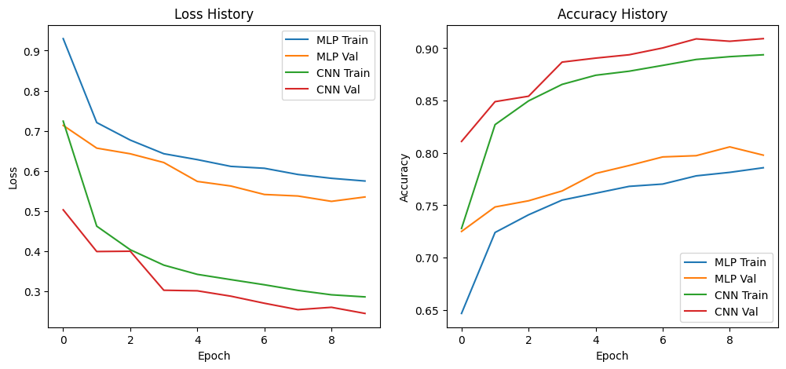
Confusion Matrix of CNN:
