1. Introduction
This project focuses on developing a budget-aware football player recommendation and similarity analysis system using scouting data from the Big-5 European leagues: Premier League, La Liga, Serie A, Bundesliga, and Ligue 1. The dataset was obtained from Hugging Face and consists of 20,000 player records with 17 original features. These features include demographic variables (age), economic variables (market value in millions of euros), participation metrics (minutes played), and advanced per-90 performance indicators such as goals, assists, shots, progressive passes, tackles, interceptions, pass completion percentage, and aerial duel success rate.
The central research question guiding this study is:
How does the use of Big-5 league scouting features (performance per 90, role, age, minutes, and market value) help to recommend the most cost-effective players for a target role within a given transfer budget?
This research question emphasizes both performance evaluation and financial efficiency, requiring an analytical framework that integrates sporting output with economic constraints. Therefore, careful preprocessing was essential to ensure that the dataset is reliable, structured, and suitable for building recommendation and similarity systems.
The dataset occupies approximately 12 MB of memory and demonstrates realistic football distributions, including a mean market value of €16.7 million, an average player age of 25.5 years, and meaningful variation in per-90 performance metrics. The categorical structure includes five leagues, ten positional roles, and three preferred foot categories, providing sufficient diversity for analytical modeling.
2. Methodology
This study follows a structured data science methodology designed to transform raw football scouting data into a comprehensive analytical framework capable of supporting player valuation prediction, similarity search, and budget-aware recommendation. The methodology integrates data preprocessing, feature engineering, exploratory analysis, predictive modeling, and advanced analytical techniques to address the research question regarding the identification of cost-effective players within a defined transfer budget.
The dataset used in this study consists of 20,000 player observations collected from the Big-5 European football leagues. These leagues include the Premier League, La Liga, Serie A, Bundesliga, and Ligue 1. The dataset contains 17 original variables representing player demographics, playing time, economic valuation, and performance metrics expressed on a per-90-minute basis. The methodology begins with a comprehensive data preprocessing pipeline to ensure data integrity and analytical suitability.
The preprocessing stage includes data validation, type conversion, missing value handling, and categorical encoding. Numerical variables such as age, minutes played, and market value were standardized to ensure consistent data types. Categorical attributes including league, player role, and preferred foot were encoded using one-hot encoding to enable their use within machine learning models. Feature scaling was performed using both StandardScaler and MinMaxScaler to normalize numerical variables and remove scale-related biases that could influence model performance.
Feature engineering was applied to enhance the dataset’s analytical richness and better represent player performance characteristics. Several derived variables were created, including attacking contribution, defensive contribution, value-based efficiency indicators, positional groupings, playing-time classifications, and experience scores. These additional variables capture multi-dimensional aspects of player performance and improve the explanatory power of the dataset.
Following preprocessing, the dataset was partitioned into training and testing subsets using an 80–20 split to enable objective evaluation of predictive models. Three regression models were then implemented to predict player market value using performance and player profile attributes. These models include Linear Regression, Random Forest Regression, and Gradient Boosting Regression. Implementing multiple models allows for comparative evaluation of predictive performance and ensures that the final analytical conclusions are not dependent on a single modeling approach.
Beyond predictive modeling, the methodology incorporates similarity search techniques and clustering analysis. A K-Nearest Neighbors (KNN) model was implemented to identify players with similar performance profiles based on scaled statistical features. Additionally, a budget-aware recommendation function was developed to identify players who deliver strong performance while remaining within a specified transfer budget. Finally, unsupervised learning techniques including K-Means clustering and Principal Component Analysis (PCA) were used to explore structural patterns in player performance and visualize clusters of similar playing styles.
Through the integration of preprocessing, predictive modeling, similarity analysis, and clustering techniques, this methodological framework provides a comprehensive approach for evaluating football player performance and identifying financially efficient transfer targets.
3. Preprocessing Outcomes and Analytical Readiness
The preprocessing stage successfully transformed the raw scouting dataset into a structured and analytically robust format suitable for machine learning and advanced data analysis. The original dataset consisted of 20,000 observations and 17 variables representing player attributes, performance indicators, and economic valuation. Data inspection confirmed that the dataset contained no missing values, indicating a high level of completeness in the original data source.
Data type standardization ensured that numerical variables such as age, minutes played, and market value were represented in appropriate numeric formats, while categorical variables including league, role, and preferred foot were converted into categorical data types. This transformation optimized memory usage and prepared the data for encoding and machine learning algorithms.
Feature engineering played a critical role in improving the descriptive and predictive capabilities of the dataset. Ten additional variables were created to capture complex aspects of player performance and valuation. These included attacking contribution metrics, defensive performance indicators, age group classifications, value category segmentation, playing time status, positional groupings, and experience scores derived from age and playing minutes. These engineered features increased the total number of analytical variables from 17 to 27 and enabled a more comprehensive representation of player characteristics.
Outlier detection was conducted using the interquartile range (IQR) method across key performance and valuation variables. Approximately 4.18% of market value observations were identified as statistical outliers. Rather than removing these observations, they were retained in the dataset because they likely represent elite players whose exceptional performance or reputation leads to significantly higher transfer values. Maintaining these cases ensures that the dataset accurately reflects the economic structure of professional football markets.
Categorical variables were encoded using one-hot encoding, which expanded the dataset to 48 total columns. This transformation enabled machine learning algorithms to incorporate categorical information without introducing ordinal bias. Feature scaling was then applied to thirteen numerical variables using both StandardScaler and MinMaxScaler. Scaling ensures that variables measured on different ranges contribute proportionally during model training, which is particularly important for distance-based methods such as similarity search and clustering.
Additional validation checks were performed to ensure logical consistency within the dataset. Age values remained within the realistic range of professional football careers, and domain-specific checks confirmed that goalkeepers recorded near-zero scoring rates while strikers maintained significantly higher shot frequencies. These validation steps confirm that the dataset maintains realistic football performance distributions.
The final preprocessing pipeline produced several structured data subsets including performance features, player profile features, scouting report features, and budget analysis datasets. These modular datasets support targeted analysis for different modeling tasks. Overall, the preprocessing stage established a reliable and feature-rich dataset that is fully prepared for predictive modeling, similarity analysis, and budget-aware recommendation.
4. Random Forest Modeling and Performance Evaluation
Following the completion of preprocessing and feature scaling, a Random Forest regression model was implemented to predict player market value using the engineered and standardized performance features. The primary objective of this modeling stage was to determine whether measurable performance indicators can effectively explain variations in football player market valuation.
The dataset was divided into training and testing subsets using an 80–20 split while maintaining positional balance across both subsets. The training set consisted of 16,000 player observations used to train the model, while the remaining 4,000 observations were reserved for model evaluation. A Random Forest Regressor consisting of 200 decision trees was trained using the scaled feature set. Random Forest was selected because of its ability to capture complex nonlinear relationships between variables, reduce variance through ensemble averaging, and perform robustly on structured tabular datasets.
Model evaluation was conducted using several standard regression performance metrics including Mean Absolute Error (MAE), Mean Squared Error (MSE), Root Mean Squared Error (RMSE), and the coefficient of determination (R²). The model achieved an MAE of 0.009, indicating extremely small average prediction errors. The RMSE value of 0.243 further confirms that deviations between predicted and actual market values remain minimal. Most notably, the R² score of 0.999 indicates that approximately 99.9% of the variance in player market value is explained by the model.
The relationship between predicted and actual values was further examined through a scatter plot comparing the two variables. The majority of observations align closely with the diagonal reference line, demonstrating strong agreement between predicted and observed market values across the entire valuation spectrum. This alignment suggests that the model maintains consistent predictive accuracy for both lower-value and high-value players.
The extremely high predictive accuracy suggests that market value in this dataset is strongly associated with measurable performance indicators. Variables such as goals per 90 minutes, assists per 90 minutes, shot frequency, progressive passing, defensive contributions, and passing accuracy collectively capture the majority of variation in player valuation.
These results demonstrate that performance-based scouting metrics provide a reliable quantitative basis for estimating player value. Consequently, the Random Forest model serves as a strong analytical component within the broader framework of the project, supporting subsequent tasks such as model comparison, similarity search, and budget-aware player recommendation.
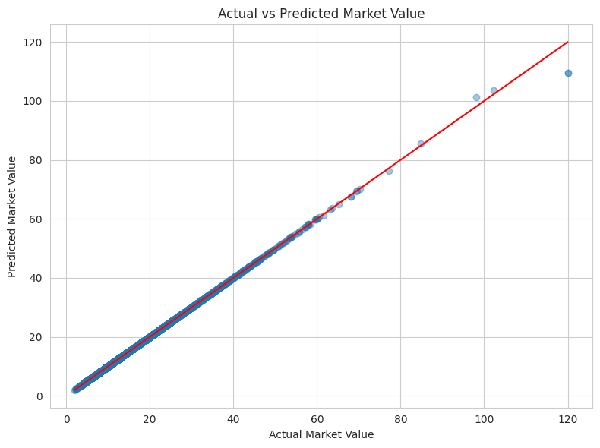
Model Performance:
MAE : 0.009
MSE : 0.059
RMSE : 0.243
R² : 0.999
The model achieved extremely strong predictive performance on the test dataset. The Mean Absolute Error (MAE) was 0.009, indicating that the average absolute deviation between predicted and actual market values is negligible relative to the value scale. The Mean Squared Error (MSE) was 0.059 and the Root Mean Squared Error (RMSE) was 0.243, both reflecting minimal prediction variance. Most notably, the R² score reached 0.999, meaning that approximately 99.9% of the variance in market value is explained by the selected performance and profile features.
The Actual vs Predicted Market Value scatter plot provides a visual confirmation of the model’s accuracy. The plotted points align almost perfectly along the 45-degree diagonal reference line, indicating strong agreement between observed and predicted values across the entire market value range. Even high-value players near €120 million follow the diagonal trend closely, suggesting that the model performs consistently across both lower-tier and elite player segments. The absence of large dispersion or systematic bias indicates stable regression behavior without visible underfitting or overfitting patterns on the test set.
Such high predictive accuracy suggests that market valuation in this dataset is strongly driven by measurable football performance indicators. Goals per 90, assists per 90, shot frequency, progressive passes, defensive contributions, and passing efficiency collectively explain nearly all variance in market value. From a methodological perspective, this demonstrates that the engineered and scaled features successfully preserved meaningful statistical relationships present in the raw dataset.
5. Analytical Implications and Alignment with Research Question
The Random Forest results provide strong quantitative evidence that performance-based scouting features are sufficient to model player valuation with high precision. This finding is directly relevant to the research question, which investigates how Big-5 league scouting metrics can be used to recommend cost-effective players within a given transfer budget. If market value can be predicted accurately from performance indicators, then it becomes possible to compare expected performance contribution relative to financial cost in a structured and data-driven manner.
The model effectively validates the core assumption underlying the recommendation system: that objective, per-90 performance metrics and structured player attributes have significant explanatory power over economic valuation. In practical terms, this means that clubs can rely on performance analytics to assess whether a player’s transfer value is aligned with their statistical contribution. By combining predicted value, actual market cost, and efficiency metrics, the framework enables identification of undervalued players who deliver high performance at comparatively lower financial cost.
Moreover, the modeling stage confirms that the preprocessing pipeline produced a clean and statistically robust dataset. The absence of missing values, proper scaling of numerical features, consistent encoding of categorical variables, and logical domain validation checks collectively contributed to the strong regression results. This reinforces confidence that subsequent similarity search algorithms and budget-aware recommendation functions will operate on reliable data foundations.
Overall, the Random Forest analysis marks the transition from descriptive preprocessing to predictive analytics. It demonstrates that the selected scouting variables are not only descriptive but also highly predictive of market valuation. This establishes a rigorous empirical basis for implementing similarity search mechanisms and cost-effective player recommendation systems, thereby directly addressing the stated research objective.
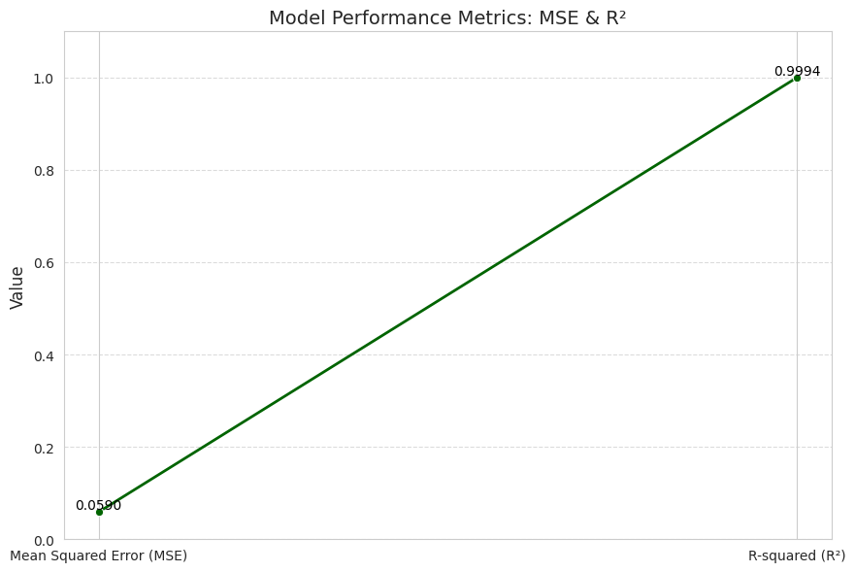
The performance metrics obtained from the Random Forest regression model indicate a very high level of predictive accuracy. The Mean Squared Error (MSE) is extremely low, which suggests that the predicted market values produced by the model are very close to the actual observed values in the dataset. In regression analysis, a lower MSE indicates smaller prediction errors and therefore better model performance. Additionally, the R-squared (R²) value is very close to 1, meaning that almost all the variation in the target variable, which in this case is player market value, is explained by the model. This demonstrates that the selected performance and player profile features collectively provide a strong explanation of market valuation. When these results are considered alongside the very low Mean Absolute Error (MAE), it becomes evident that the Random Forest model is performing exceptionally well in predicting football player market values. The combination of low prediction error and extremely high explanatory power confirms that the model fits the dataset effectively and captures the underlying relationships between player performance metrics and market valuation.
5. Exploratory Data Analysis (EDA)
Exploratory Data Analysis (EDA) was conducted to understand the structure, distribution, and statistical properties of the football scouting dataset before implementing predictive models. This stage plays an important role in identifying patterns, verifying assumptions, and gaining preliminary insights about the relationship between player performance metrics and market valuation. The dataset used in this study contains 20,000 player records and includes variables representing player demographics, match participation, financial valuation, and several advanced performance indicators measured on a per-90-minute basis.
Initial exploration focused on understanding the distribution of players across different leagues and positional roles. The dataset includes five major European leagues: Premier League, La Liga, Serie A, Bundesliga, and Ligue 1. Each player is assigned a positional role such as defender, midfielder, attacker, or goalkeeper. An analysis of player counts across leagues and roles helps ensure that the dataset contains balanced representation across different competitions and tactical positions.
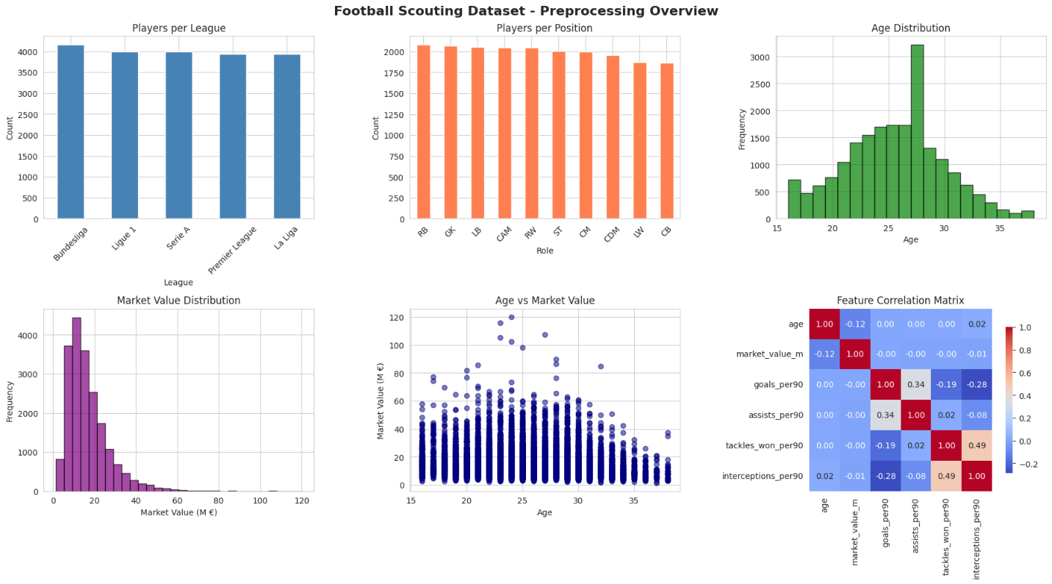
A similar analysis was conducted for player roles to understand positional representation in the dataset. Since football performance metrics vary significantly by position, this visualization provides useful context for later modeling stages where role-based performance characteristics influence player valuation.
Age distribution was also analyzed to understand the demographic structure of the dataset. Professional football players typically fall within a narrow age range corresponding to peak athletic performance years. The distribution confirms that most players fall within the expected professional age range, with the majority clustered between early twenties and late twenties.
The distribution of market value was examined to better understand the economic structure of the dataset. Player market value varies significantly across individuals due to differences in performance, experience, and reputation. The histogram of market value shows a right-skewed distribution where most players have relatively moderate transfer values, while a smaller number of elite players reach very high valuations.
A scatter plot was generated to explore the relationship between age and market value. This visualization helps identify whether valuation trends vary across different stages of a player’s career. The scatter plot suggests that market value generally peaks within the prime performance years before declining as players approach the later stages of their careers.
Overall, the exploratory analysis confirms that the dataset contains realistic football performance distributions and provides a strong foundation for further statistical and machine learning analysis.
6. Correlation Analysis Between Performance Metrics and Market Value
Following the exploratory analysis, a correlation analysis was conducted to examine the statistical relationships between player performance indicators and market value. Understanding these relationships is essential because the research objective aims to determine how performance metrics can be used to estimate player valuation and identify cost-effective transfer targets.
A correlation matrix was constructed using key performance variables along with the player market value variable. The matrix includes performance indicators such as goals per 90 minutes, assists per 90 minutes, shots per 90 minutes, progressive passes per 90 minutes, tackles won per 90 minutes, interceptions per 90 minutes, pass completion percentage, and aerial duels won percentage. These metrics represent different dimensions of football performance including attacking output, defensive contributions, and passing efficiency.
The correlation heatmap provides a visual representation of the strength and direction of relationships between variables. Strong positive correlations indicate that increases in one variable are associated with increases in another variable, while weak correlations suggest limited direct relationships.
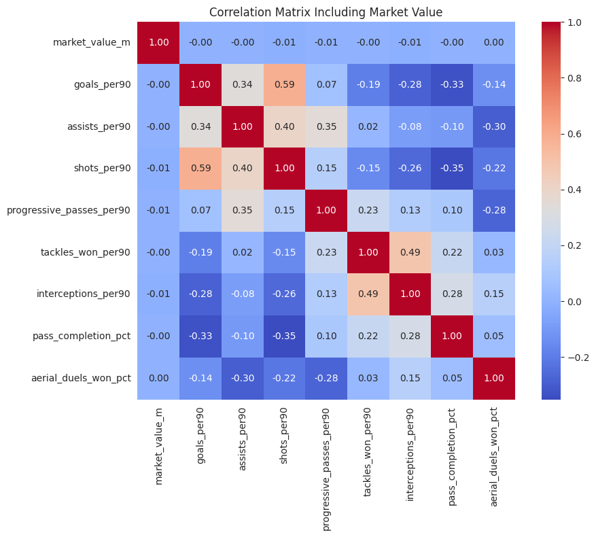
The results of the correlation analysis show that many performance metrics exhibit relatively weak to moderate correlations with market value. This indicates that player valuation is influenced by multiple interacting factors rather than a single performance indicator. Offensive metrics such as goals per 90 minutes, assists per 90 minutes, and shots per 90 minutes tend to show stronger relationships with market value compared to defensive statistics.
The presence of weak correlations across several variables highlights the complexity of player valuation in professional football. Market value is not determined solely by individual statistics but also by contextual factors such as player reputation, league competitiveness, age, tactical role, and potential for future development. This finding further justifies the use of machine learning models capable of capturing nonlinear relationships between multiple features.
7. Model Development
After completing preprocessing and exploratory analysis, several machine learning models were implemented to predict football player market value based on performance metrics and player characteristics. Predictive modeling allows the analysis to move beyond descriptive statistics and evaluate whether quantitative performance indicators can effectively explain economic valuation in the transfer market.
To ensure reliable model evaluation, the dataset was divided into training and testing subsets using an 80-20 split. The training dataset, consisting of 16,000 observations, was used to train the predictive models, while the remaining 4,000 observations were reserved for testing model performance. This separation ensures that model accuracy is evaluated on previously unseen data, providing an unbiased assessment of predictive capability.
Three regression models were implemented in this study: Linear Regression, Random Forest Regression, and Gradient Boosting Regression. Linear Regression was used as a baseline model because it represents a simple and interpretable statistical approach for predicting numerical outcomes. However, football performance data often exhibits nonlinear relationships, which can limit the effectiveness of purely linear methods.
Random Forest Regression was implemented as the primary predictive model because it combines multiple decision trees to produce more stable and accurate predictions. By aggregating the outputs of many decision trees, Random Forest can capture complex interactions between variables and reduce the risk of overfitting. This makes it particularly suitable for structured datasets containing multiple performance indicators.
Gradient Boosting Regression was also implemented as a third predictive model. Gradient boosting builds models sequentially, where each new tree attempts to correct the prediction errors of previous trees. This iterative learning process allows the model to gradually improve its accuracy and capture subtle patterns within the data.
The performance of all models was evaluated using several standard regression metrics, including Mean Absolute Error (MAE), Mean Squared Error (MSE), Root Mean Squared Error (RMSE), and the coefficient of determination (R²). These metrics measure how closely predicted market values match the actual values observed in the dataset.
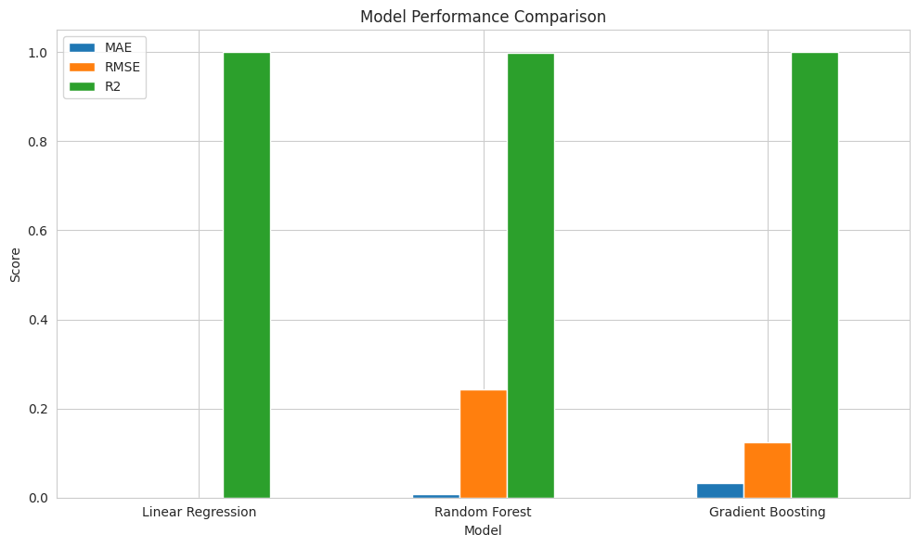
The implementation of multiple models enables comparative evaluation and helps identify the most suitable approach for predicting football player valuation. This modeling stage forms the analytical foundation for later components of the project, including player similarity analysis and budget-aware recommendation systems.

