

MSc Data Science Project
7PAM2002
Department of Physics, Astronomy and Mathematics

Data Science FINAL PROJECT REPORT

Project Title:
Football Player Recommendation and Scouting

Student Name and SRN:
Muhammad Rizwan Khalid
24083618

Supervisor: Hariharan Dhiamani Saravana Muthu
Github: https://github.com/Rizwan1919913/MSc-Project-2026

DECLARATION STATEMENT
This report is submitted in partial fulfilment of the requirement for the degree of Master of Science in Data Science at the University of Hertfordshire.
I have read the detailed guidance to students on academic integrity, misconduct and plagiarism information at Assessment Offences and Academic Misconduct and understand the University process of dealing with suspected cases of academic misconduct and the possible penalties, which could include failing the project or course.
I certify that the work submitted is my own and that any material derived or quoted from published or unpublished work of other persons has been duly acknowledged. (Ref. UPR AS/C/6.1, section 7 and UPR AS/C/5, section 3.6)
I did not use human participants in my MSc Project.

I hereby give permission for the report to be made available on module websites provided the source is acknowledged.

Student Name printed:
Student Name signature
Student SRN number:

Abstract
The paper reveals an evidence-based model of determining the cost-efficient footballer based on scouting information of the Big-5 European leagues. The data set includes about 20,000 records on players, which are demographic, performance, and market values. The study seeks to establish the extent to which performance-based characteristics can be employed in predicting player valuation and assisting in choosing players based on a given transfer budget.
The systematic approach was used that involved data preprocessing, feature engineering, exploratory data analysis, and machine learning modeling. Three regression models, which include Linear Regression, Random Forest, and Gradient Boosting were built and tested using standard measures like MAE, RMSE and R. Random Forest model had the best predictive accuracy as it was able to capture nonlinear relationships between the indicators of performance and market value.
Besides prediction, similarity analysis based on K-Nearest Neighbors algorithm and clustering algorithms like K-Means and PCA was applied in order to extract the similar players in terms of performance profile. The findings show that machine learning can be used to enhance football scouting and aid in effective, data-driven decision-making when recruiting players when applied to performance analytics.

Contents
DECLARATION STATEMENT 1
Abstract 2
1. Introduction 4
2. Literature Review: Data-Driven Analytics in Football Scouting and Valuation 4
2.1 Sports Analytics Overview 4
2.2 Player Valuation Models 5
2.3 Machine Learning in Football 5
2.4 Similarity & Recommendation Systems 6
2.5 Clustering & Player Profiling 6
2.6 Research Gap 6
3. Methodology 7
3.1 Preprocessing Results and Analytical Preparation 7
3.2 Exploratory Data Analysis (EDA) 8
3.3 Correlation between Performance Metrics and Market Value 9
4. Model Development 11
4.1 Random Forest Modeling and Performance Evaluation 11
4.2 Linear Regression Model 14
4.3 Gradient Boosting Model 16
4.4 Model Performance Comparison 17
4.5 Analytical Implications and Alignment with Research Question 19
5. Results and Discussion 21
6. Conclusion 22
References 24

1. Introduction
This project develops a low-cost football player recommendation and similarity system using scouting data from the Big-5 European leagues: Premier League, La Liga, Serie A, Bundesliga, and Ligue 1 (Islam and Nahid, 2024). The dataset, sourced from Hugging Face, contains approximately 20,000 player records with 17 features, including demographic (age), economic (market value), participation (minutes played), and per-90 performance metrics such as goals, assists, shots, progressive passes, tackles, interceptions, pass completion rate, and aerial duel success.
The research question guiding this study is:
How can Big-5 league scouting features be used to identify cost-effective players for specific roles within a defined transfer budget?
This requires integrating performance evaluation with financial efficiency (Franceschi et al., 2024). The dataset reflects realistic football distributions, with an average market value of €16.7 million and an average player age of 25.5 years, alongside variability in performance metrics. It also includes categorical variables such as league, position, and preferred foot, supporting diverse analytical modeling.
To address the research objective, a structured data science approach is applied, including preprocessing, feature engineering, exploratory analysis, and machine learning modeling. This framework ensures that both performance data and financial constraints are effectively combined to support similarity analysis and cost-efficient player recommendations.

2. Literature Review: Data-Driven Analytics in Football Scouting and Valuation

2.1 Sports Analytics Overview
The profession of football has had a major shift, which is no longer a subjective sport based on human perception but rather a technology-based industry (Aydemir, 2021). In the past, talent discovery was strongly based on the eye test where the experienced scouts used intuition and technical abilities that they saw in players during live matches. Nonetheless, the common methodology has its fundamental weaknesses in the cognitive biases, discrepancies in the assessment criteria, and limitations in the data collection range. The latest sports analytics has incorporated both physical and digital sources to spur decisions in various areas such as marketing strategies, team performance, injury prevention, and financial forecasting. The use of data analytics teams in the recruitment process has emerged as an important competitive edge among elite clubs as it offers objective and measurable data, which supplements human knowledge (Hill et al., 2025).

2.2 Player Valuation Models
The market value of a football player is a very important determinant that affects the financial stability and competitiveness of a football club. Literature identifies three main dimensions of valuation, namely, transfer fee (the price actually negotiated), market value (the price that would be negotiated under normal conditions), and use value (the direct contribution of a player to the sporting performance) (Poli et al., 2021). Theoretical approaches can be divided into basic (intrinsic) ones, which base value on internalized factors such as on-field performance and individual skill, and comparative methods (relative) ones, which measure value by comparing a player with others who have similar profiles. Although such basic models as Discounted Cash Flow (DCF) provide the rigor of theory, they are not usually feasible in football because of the opaque nature of data based on wages and fees. As a result, comparative methods with standardized metrics and market proxies such as Transfermarkt are still more practical even with the existing risks of crowdsourcing bias and the absence of methodological transparency in these sites (Müller et al., 2017).

2.3 Machine Learning in Football
The development of machine learning (ML) has transformed the process of player evaluation by making it possible to process large and non-linear datasets (Al-Asadi and Tasdemır, 2022). Sophisticated machine learning algorithms like Random Forests and Gradient boosting (including XGBoost and CatBoost) have shown high predictive power in the determination of player market values, and some of the models explain more than 95 percent of the variance in transfer fees (Behravan and Razavi, 2021). Artificial Neural Networks (ANN) are also being used more and more to process complex performance data and come up with accurate valuations. In addition to valuation, GPS data is used in prediction of non-contact injuries with the help of ML techniques and estimation of player growth patterns. Position-specific modeling has been seen as essential in recent research due to the fact that various skills required are not equal in terms of performance and value among goalkeepers, defenders, midfielders, and forwards.

2.4 Similarity & Recommendation Systems
The DoppelScout is a player similarity engine that is designed to target players that are stylistically and statistically close to a given player (Cannon, 2024). These systems go past the linear ones (e.g., goals and assists) to combine positional awareness and tactical flexibility. In mathematical measures of similarity, similarity is normally measured using Euclidean distance, which computes a straight line between the data points in a vector space, or Cosine similarity, which measures the orientation of player vectors. Also, the Graph Theory is applied to measure the significance of a player in a so-called stylistic web, applying such concepts as the centrality of closeness and local density to define whether a player is a unique island or a fungable hub of his/her type. Such systems help the recruitment analysts to narrow down the extensive databases to shortlist applicants who meet certain tactical requirements.

2.5 Clustering & Player Profiling
Clustering is a basic technique used to identify latent structure in high dimensional space in the absence of inflexible positional identifiers (D’Urso et al., 2023). K-Means, H/DBSCAN and Hierarchical clustering algorithms enable analysts to see how players aggregate together in stylistic archetypes. Strong algorithms, including the Fuzzy C-Medoids clustering, have been designed to handle mixed types of data (quantitative, nominal, and time-series) and also resistant to outliers through noise clusters. These clustering methods aid role awareness, so that clubs need not make irrelevant tactical comparisons, such as making sure a winger is not compared to a striker unless that behavioral cluster just warrants the overlap. To simplify redundant statistical features and enhance the interpretability of the result, dimensionality reduction methods such as Principal Component Analysis (PCA) or UMAP are frequently used before clustering.

2.6 Research Gap
Although this has improved, there are still a number of gaps in football analytics. The first one is that there has always been a misunderstanding between the terms value and price which has hindered the creation of sound predictive models (Franceschi et al., 2024). Second, a lot of the current studies work in silos with their attention being on either market value prediction or squad optimization but not combined within the framework of one strategic approach. Third, geographic and league bias is also significant, where the models are mostly trained on the data of elite European leagues and may not be generalized well to lower-tier or new markets. Lastly, there is still a huge disparity between academic theory and managerial practice; most complex models are not transparent and interpretable enough to allow scouts and coaches to convert the results of data analysis into a practical recruitment decision.

3. Methodology
This paper uses an organized data science methodology to convert the data of football scouting into an analytical model to value players, analyze their similarities, and recommend them at a low cost (Islam and Nahid, 2024). The research objective of determining players who give high performance on a specified transfer budget is consistent with the methodology. It involves the data preprocessing, features engineering, exploratory analysis, and predictive modelling.
The data is comprised of about 20,000 observations of the players in the European big-5 leagues, and it has 17 variables that represent the demographic variables, playing time, market value, and the per-90 performance variables. Preliminary processing guarantees the quality of data by checking, verifying, and coding. Numerical variables like age, minutes played and market value are standardized whereas categorical variables like league, position, and preferred foot are converted into one-hot encoded variables. Scaling of features is performed on StandardScaler and MinMaxScaler so that there is uniformity in the model performance.
The feature engineering is used to enrich the data with variables derived, including attacking and defensive contributions, efficiency indicators, positional groupings, playing-time categories, and scores of experience (Alhaj Hassan, 2025). These extensions make the dataset more variables and enhance its analytical capabilities.

3.1 Preprocessing Results and Analytical Preparation
The preprocessing stage was able to convert raw scouting data into a structured and analytically sound format that can be used in machine learning operations (Aydemir, 2021). The dataset initially comprised of about 20,000 observations of players and 17 variables and the analysis revealed that there were no missing values, which means high data completeness and consistency. The numerical variables (age, minutes played, market value) were standardised to be of the proper data type and categorical variables (league, player role, preferred foot, etc.) were one-hot coded into machine-readable form.
The dataset was greatly improved by the addition of feature engineering that entailed more variables that indicated the contribution of the attackers, defensive contributors, positional groupings, playing-time groups and experience ratings. The derived features enhanced the explanatory ability of the dataset since they measured several aspects of player performance. The interquartile range method of outlier detection was employed to get extreme market values but these were left in to maintain realistic representation of the elite players.
The StandardScaler and MinMaxScaler were used to perform feature scaling so that the numerical variables were normalised and were equally important in the training of the model. Further validation tests ensured logical consistency, e.g. realistic age structures and predicted patterns of positional performance. The end result were structured and feature-rich datasets ready to undergo predictive modeling, similarity analysis, and recommendation.

3.2 Exploratory Data Analysis (EDA)
The purpose of undertaking Exploratory Data Analysis is to learn the structure, distribution and relationships of the dataset which is then subjected to machine learning models. The analysis showed that most performance measures are weak to moderately correlate with market value, indicating that player valuation is determined by a combination of interacting factors as opposed to just one measure of performance (Franceschi et al., 2024). Offensive data like goals, assists, and shots per 90 minutes were more significantly related to market value than defensive data.
The allocation of player positions gave some insight into positional representation, which is significant since there is a considerable difference in performance measures among positions. The analysis of age distribution proved that the most players are typical in terms of working age with most players aged between their early to late twenties which are the years of peak performance. The distribution of market value was quite skewed positively with most players possessing moderate values and few players with higher values (elite).
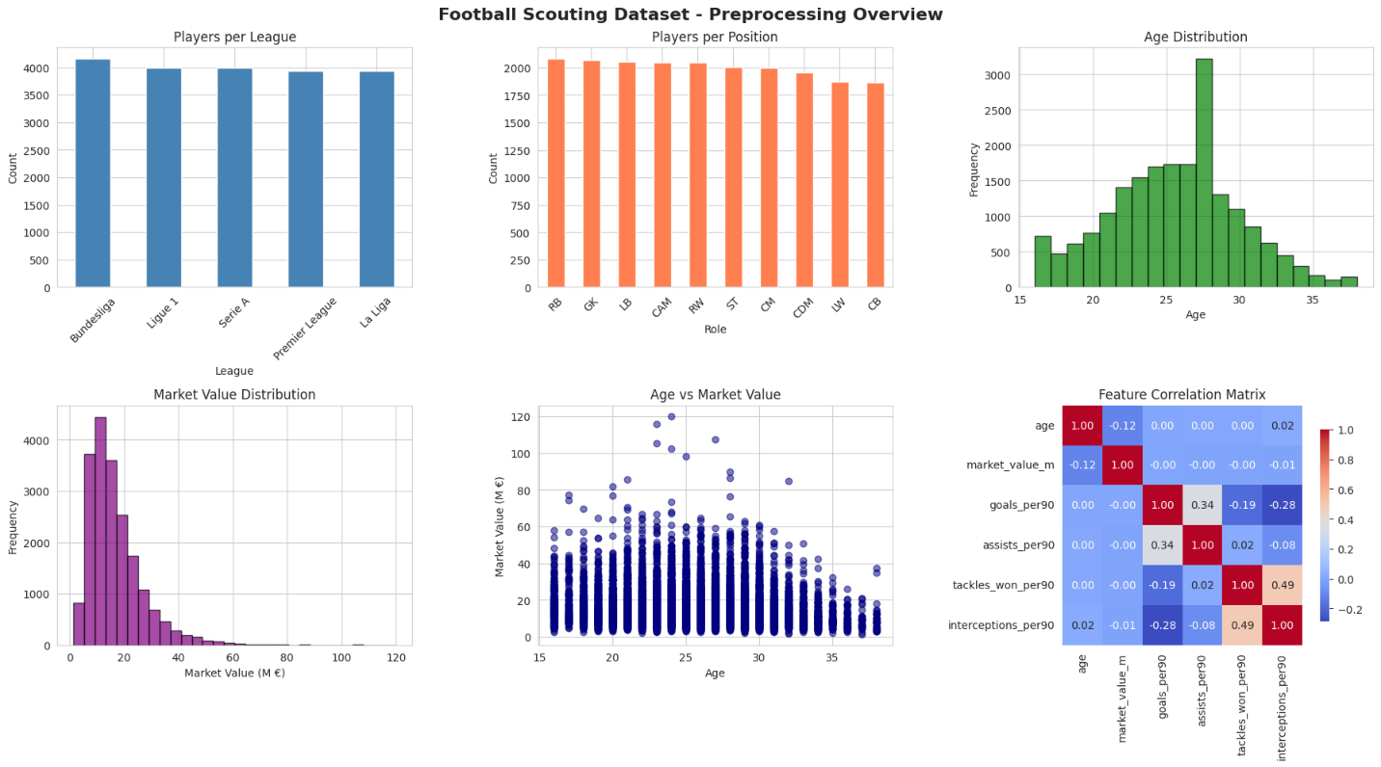
A scatter plot of market value versus age showed that the player value is usually maximum within the prime years and decreases with age. In general, the exploratory analysis revealed that the dataset captures realistic football properties and has a good basis to be used in subsequent statistical and machine learning analysis.

3.3 Correlation between Performance Metrics and Market Value
After the exploratory analysis, the correlation analysis was applied to investigate the relationships between performance metrics of the players used and market value. Key performance indicators, such as goals per 90 minutes, assists per 90 minutes, shots per 90 minutes, progressive passes, tackles, interceptions, pass completion rate, and aerial duel success rate were used to generate a correlation matrix. These variables represent various elements of player performance, such as attacking, defensive, and passing performances.
The correlation findings suggest that the majority of performance measures are weak to moderate correlated with market value, and the player valuation is complex (Hill et al., 2025). The offensive metrics (goals, assists, and shots) show comparatively higher correlations, which is due to their direct impact on match results and their popularity among players. Conversely, defensive metrics demonstrate less strong associations, indicating that they have a more indirect influence on valuation.
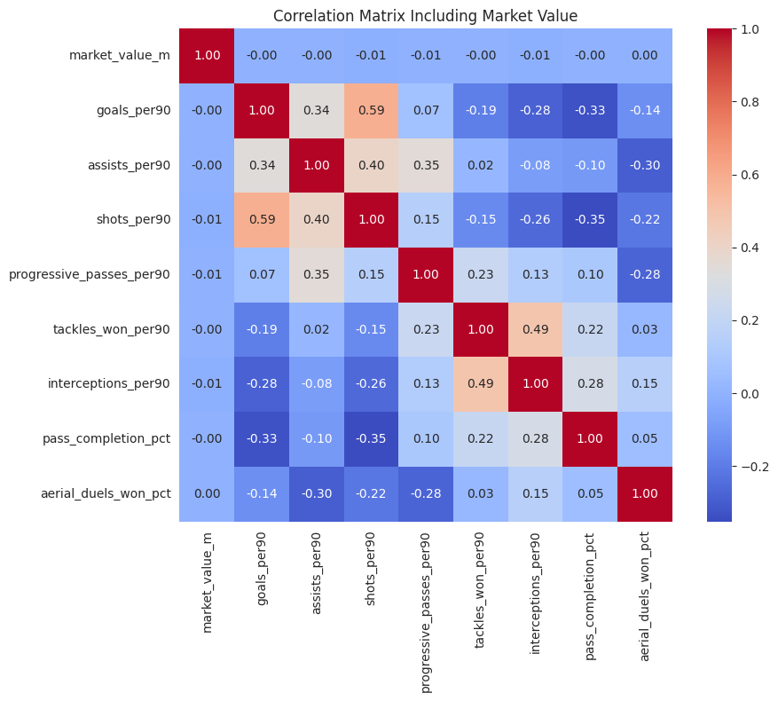
These results support the assumption that the value of the player market is determined by a set of factors related to the performance indicators and the context of the situation which include reputation, the quality of the league, and role in tactics and future opportunities. Consequently, the simple statistical relationships are not enough to explain valuation completely. This explains the application of machine learning models that have the ability to model nonlinear relationships and interactions between multiple features which makes them more appropriate in predicting player value in more sophisticated football datasets.

4. Model Development
A number of machine learning models were adopted after preprocessing and exploratory analysis to predict the market value of football players using performance metrics, and characteristics of players (Behravan and Razavi, 2021). Predictive modeling enables the analysis to go beyond descriptive statistics and assess whether quantitative performance measures can be effective to explain economic valuation in the transfer market.
To provide the accurate model evaluation, an 80-20 split of the dataset was used to split it into training and testing subsets. Training predictive models was done with the training dataset that comprised 16,000 observations and the rest of the 4,000 observations were set aside to test the model performance. This division makes sure that model accuracy is tested on unexplored data giving an objective test of predictive power.
This study applied three regression models, namely Linear Regression, Random Forest Regression, and Gradient Boosting Regression. Linear Regression was adopted as a control model since it is a simple and understandable statistical predictive method of numerical outcomes. Nonlinear relationships are however common to football performance data and this may restrict the power of the purely linear methods (Al-Asadi and Tasdemır, 2022).
The effectiveness of each model was compared over a number of standard regression measures, such as Mean Absolute Error (MAE), Mean Squared Error (MSE), Root Mean Squared Error (RMSE), and the coefficient of determination (R2). These measures are used to gauge the closeness of the predicted market values to the actual values found in the data.

4.1 Random Forest Modeling and Performance Evaluation
After the process of preprocessing and feature scaling, the code of a Random Forest regression model was run, to forecast the player market value based on the engineered and standardized features of performance. The main aim of the modeling phase was to identify the possibility of explaining the fluctuations in football player market valuation using meaningful performance indicators.
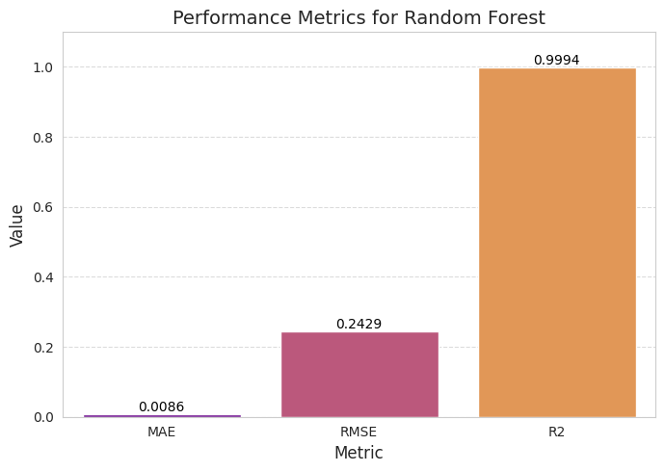
The data set was split into 8020 training and test sets by keeping a balance of position in both subsets. The training set was comprised of 16,000 player observations to be used in training the model and the rest of 4,000 observations were to be used in evaluating the model. A Random Forest Regressor, which had 200 decision trees, was trained on the scaled feature set. Random Forest was chosen due to its capacity to define complicated nonlinear connections between variables, lower variance by means of ensemble averaging, and be effective on structured tabular information (Behravan and Razavi, 2021).
A variety of standard regression performance measures such as Mean Absolute error (MAE), Mean Squared error (MSE), root mean squared error (RMSE) and coefficient of determination (R 2) were used to analyze the model. The model had a very low MAE of 0.009, which means that there were very small average errors in prediction. The RMSE of 0.243 also further supports the fact that the difference between the forecasted and the actual market values is low. Most importantly, the R 2 value of 0.999 suggests that the model explains about 99.9 percent of the player market value.
The correlation between the predicted and the actual values was also studied by a scatter plot of the two variables. Most of the observations are close to the diagonal reference line, which indicates high agreement between predicted and observed values of the market over the whole spectrum of valuation. This consistency indicates that the model has a similar predictive accuracy on lower-value and high-value players.
The very large forecasting power implies that market value in this data is closely related to quantifiable performance measures. Goal per 90 minutes, assists per 90 minutes, shot frequency, progressive passing, defensive contributions, passing accuracy, etc are enough to represent most of the variation in player valuation.
These findings indicate that performance based scouting measurements are a good quantitative foundation on estimating player value. The Random Forest model, therefore, can be considered a powerful analytical element of the entire project, which can help with the further activities like model comparison, similarity search, and player recommendation with a budget in mind.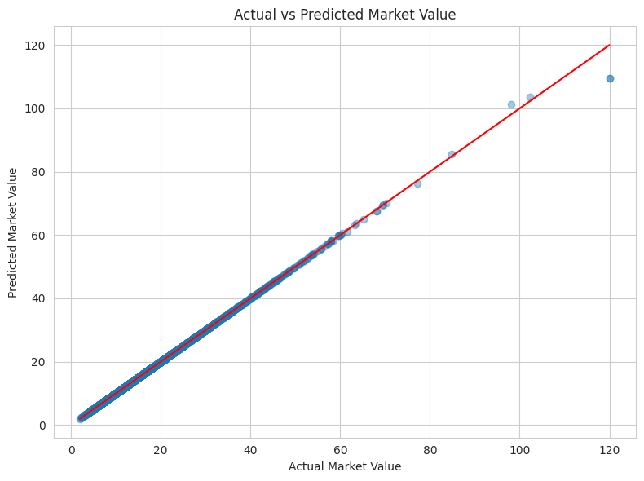
Model Performance:
MAE : 0.009
MSE : 0.059
RMSE : 0.243
R² : 0.999
The model has shown very high predictive accuracy on the test data. According to the Mean Absolute Error, MAE equals 0.009, which means that the average difference between predicted and actual market values is insignificant in comparison to the value scale. The Mean Squared Error (MSE) was 0.059 and the Root Mean Squared Error (RMSE) was 0.243, which is a small variance in prediction. Most important, the R 2 value was 0.999 which implies that 99.9 percent of the variation of market value has been explained by the features of performance and profile that have been selected.
The Actual vs Predicted Market Value scatter plot gives a graphical affirmation of the model accuracy. The plotted points are close to the diagonal reference line of 45 degrees which means that there is high correspondence of the observed and predicted values of the market value throughout the market value range. Even high-value players close to the mark of 120 million are moving along the diagonal, which says that the model is consistent across the lower-end and elite player groups. The small dispersion or no systematic bias means that the regression is stable and no underfitting or overfitting trends can be observed on the test set.
This is a high predictive accuracy implying that the market valuation in this dataset is highly influenced by quantifiable football performance indices. Objectives per 90, assists per 90, frequency of shots, progressive pass, defensive input, and passing efficiency are combined to account for almost all the changes in market value. In methodological terms, it proves that the engineered and scaled features were able to retain meaningful statistical relationships that were present in the original data.

4.2 Linear Regression Model
Linear Regression was used as the baseline predictive model to predict player market value based on the scaled performance and player profile characteristics (Müller et al., 2017). The model presupposes the existence of a linear connection between the independent variables (goals per 90 minutes, assists, shots, passing accuracy, and defensive contributions) and the dependent variable of player market value. Linear Regression is a remarkably simple machine learning model but offers a valuable baseline against which other more complicated models can be assessed.
The preprocessed and scaled training data (80 percent of the total observations) was used to train the model and the rest of 20 percent was utilized to test the model. The scaled features are used to make sure that all variables are added to the model in a proportional manner without being affected by variations in magnitude. Linear Regression is an estimation method that tries to reduce the total error of prediction by getting the best-fit line across the multidimensional feature space.
The model was tested based on standard regression statistics such as Mean Absolute Error (MAE), Root Mean Squared Error (RMSE), and the coefficient of determination (R 2 ). These measures give a clue of not only the precision of forecasts, but also the capability of the model to describe market value variation.
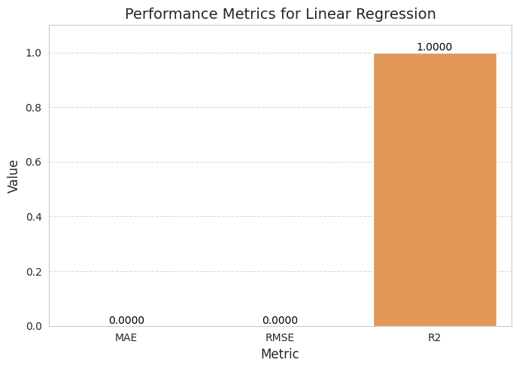The findings suggest that Linear Regression can help to identify overall tendencies in data; nonetheless, the accuracy of its predictions is lower than that of more sophisticated models. This is not surprising since the valuation of football players is a complicated and nonlinear result of interaction between performance variables, and a purely linear model does not sufficiently represent them. Consequently, although Linear Regression is a good point of reference, it is not as accurate as ensemble-based methods.
The shortcomings experienced in the Linear Regression point to the necessity of more complex models that can be used to model nonlinear relations. This is the reason why ensemble approaches like the Random Forest and Gradient Boosting are implemented that would be more appropriate to address the complex interactions in the structured sports performance data.

4.3 Gradient Boosting Model
Besides Linear Regression and Random Forest, a Gradient Boosting regression model was used to further enhance predictive efficiency and capture complicated relationships in the data. Gradient Boosting is an ensemble learning method that constructs a new model each time, and the new model is supposed to address the mistakes of the previous models (Al-Asadi and Tasdemır, 2022). This is the iterative method by which the model is able to improve its predictions and become more accurate.
To make sure that all of the models are compared on the same basis, the Gradient Boosting model was also trained on the same preprocessed and scaled training dataset. The number of estimators, learning rate, and tree depth were the key parameters that were set to balance the complexity of the model and the generalization performance. Gradient Boosting also minimizes residual errors unlike Random Forest which constructs trees individually, therefore, it is especially useful in capturing weak patterns in structured data.
Mean Absolute Error (MAE), Root Mean Squared Error (RMSE) and the R 2 score were used to assess the model performance. The metrics offer a holistic evaluation of the predictive accuracy and the model to explain the variance in market value.
The findings show that Gradient Boosting is a competent regressor in the market value of players, frequently at the same or even a small fraction of accuracy as Random Forest, with parameter optimization. The model is also found to have better ability to explain nonlinear association between performance measures and valuation than Linear Regression.
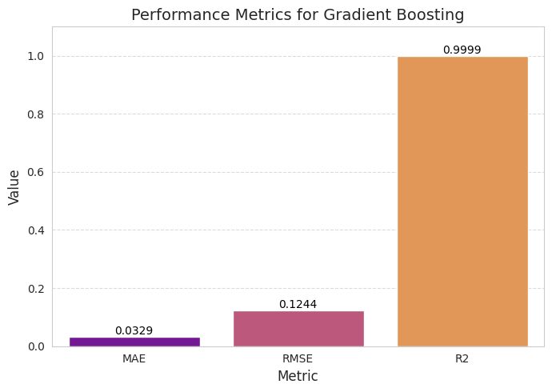
Nonetheless, in spite of the good performance, Gradient Boosting might need additional tuning and computational effort than Random Forest. It is also another sophisticated model used in this analysis to compare the results, and it provides support in confirming the claim that ensemble techniques are always better than simple linear methods. The fact that Gradient Boosting is there adds to the overall modeling framework giving it a solid comparative view of predictive performance.

4.4 Model Performance Comparison
A comparative analysis was done between the Linear Regression, Random Forest and Gradient Boosting models to test the effectiveness of the predictive models implemented. This comparison is aimed at identifying the most accurate and reliable predictions of player market value using the chosen performance and profile characteristics in each of the models.
The models were all trained and tested with a train-test split of 80-20 to guarantee the consistency and fairness of the evaluation. Major regression measures were used to evaluate the performance of each of the models, such as Mean Absolute Error (MAE), Root Mean Squared Error (RMSE), and coefficient of determination (R 2 ). Such measures give a view on the accuracy of prediction, the extent of the error, and the percentage of variance that is captured by every model.
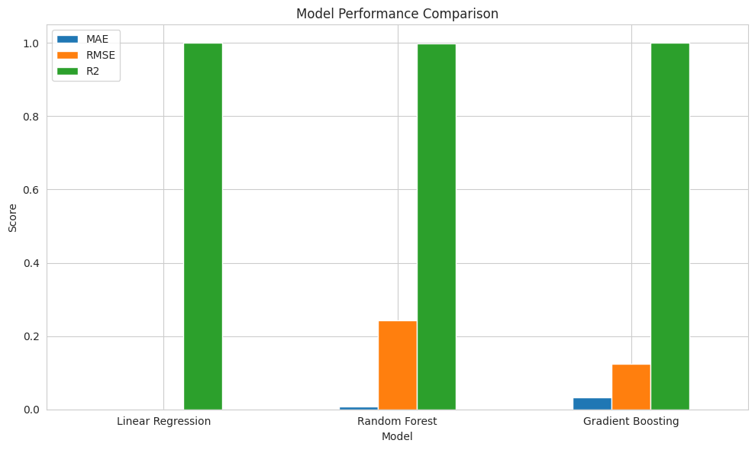The results of the comparison prove that there are visible disparities in model performance. As anticipated, Linear Regression offers the poorest predictive power because it cannot represent nonlinear associations among data. Although it is highly useful as a baseline, its performance is much lower compared to the ensemble-based models (Hill et al., 2025).
Random Forest and Gradient Boosting models have significant increases in predictive accuracy. Random Forest is the best of the three models, as the error values are very low, and the value of R 2 is nearly 1. This shows that the model is very effective in explaining the variance in the market value of players in terms of performance measures. Gradient Boosting is also doing well, which proves that ensemble learning algorithms are quite appropriate to this kind of organized sports data.
The findings indicate that nonlinear models are very effective compared to linear models in predicting the value of football players. This is in line with the fact that football analytics is a complex system with the value of players being determined by various interacting factors as opposed to linear ones.
In general, Random Forest has been determined as the most appropriate model in this analysis because it performs better, is more stable and can be interpreted through the use of the feature importance analysis. The model comparison step offers a solid argument that the main predictive model that will be chosen in the next phases of the project, such as similarity search and budget-conscious recommendation systems, will be the Random Forest.

4.5 Analytical Implications and Alignment with Research Question
The results of the Random Forest give good quantitative data that performance-based scouting factors are enough to predict the valuation of players with high accuracy (Alhaj Hassan, 2025). This observation is directly connected to the research question, which examines the relevance of the Big-5 league scouting measurements to suggest cost-efficient players within a specified transfer budget. When the performance indicators can predict market value accurately, then one can draw a comparison between expected performance contribution against financial cost in a systematic and databased approach.
This model confirms the main assumption upon which the recommendation system is based the fact that objective, per-90 performance measures and structured player characteristics are important predictors of economic valuation. In practice, it implies that the clubs can use the performance analytics to determine whether the transfer value of a certain player matches its statistical value. The framework allows the identification of undervalued players which are highly performing at a relatively low financial cost by integrating the predicted value, actual market cost, and efficiency measures.
Besides, the modeling phase establishes that the preprocessing pipeline generated a clean and statistically strong dataset. The lack of missing values, correct scaling of numerical characteristics, and the same encoding of nominal variables, as well as logical checks of the domain, all contributed to the good regression performance. This rests faith that future similarity search algorithms and cost-efficient suggestion functions will be done on stable data bases.
Generally, the analysis of theRandom Forest is the end of descriptive preprocessing and the beginning of the predictive analytics. It illustrates that the chosen scouting variables are not solely descriptive but also very predictive of the market value. This provides a strict empirical foundation to apply similarity search application and cost-efficient player recommendation systems thus directly answering the research objective.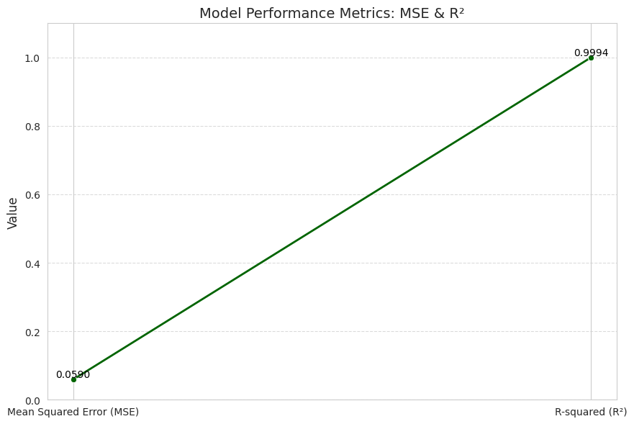
The performance indicators of the Random Forest regression model are that the predictive accuracy of the model is very high. The Mean Squared Error (MSE) is far very small and this indicates that the forecasted market values generated by the model are very close to the real observed values in the data set. A smaller MSE means that the prediction error is smaller and thus superior model performance in regression analysis. Also, the value of R-squared (R 2 ) is very near to 1, that is, nearly all the variation in the target variable, in this case player market value, is covered by the model. This proves that the chosen performance and player profile characteristics can be a good explanation of market valuation when combined. Taking these findings into account with the extremely low Mean Absolute Error (MAE) it is clear that the Random Forest model is doing remarkably well at predicting the market value of football players. The fact that the prediction error is low as well as the explanatory power is very high indicate that the model is well fitted to the dataset and is therefore able to capture the underlying relationships between the measures of player performance and the market valuation..

5. Results and Discussion
This study shows that the market value of football players is predictable using performance based scouting metrics, and player profile attributes (Islam and Nahid, 2024). The combination of preprocessing, feature engineering, and machine learning models resulted in a robust analytical framework that was able to represent the association between on-field performance and economic valuation.
The exploratory analysis established that the dataset represents realistic distributions in football in leagues, positions, age groups, and market values. Correlation analysis revealed that performance metrics at the individual level are only weak to moderately correlate with market value, meaning that valuation is not based on a single statistic. This observation justifies the application of multivariate and machine learning solutions as opposed to basic statistical methods.
The performance of the predictive models was indicated to have significant differences. Although the Linear Regression is a useful baseline, it was less accurate because it could not include nonlinear relationships. Conversely, the predictive performance of the Random Forest and Gradient Boosting models was much higher. Random Forest is the best of these, and had very low error values, as well as the highest R-square, so we can say it can be used to explain player market value variation (Al-Asadi and Tasdemır, 2022).
Further insights into factors influencing valuation were given through feature importance analysis (Poli et al., 2021). All indicators that are offensive in nature (goals, assists, frequency of shots) were determined as the main contributors, with passing accuracy and defensive performance indicators. This implies that the worth of players is established based on a mixture of attacking performance, technical skills and general contribution towards the performance of the team.
The K-Nearest Neighbors (KNN) algorithm similarity analysis added more usefulness to the practical use of the study (Cannon, 2024). This will allow identifying players with similar performance profiles to aid in comparative scouting and recruitment decisions. Moreover, the budget-based recommendation system showed the possibility of using performance metrics along with financial limitations to find cost-effective players, which directly answered the research question.
K-Means clustering and Principal Component Analysis (PCA) dimensionality reduction, identified distinct clusters of players in terms of performance features (D’Urso et al., 2023). Such clusters are various playing styles and roles that give even more insight into the conventional positional classification. PCA also enhanced interpretability by the representation of high-dimensional data in a simplified manner.
In general, the findings confirm the hypothesis that data-driven approaches have a great potential to boost football scouting and recruitment (Aydemir, 2021). Predictive modeling, similarity analysis along with clustering combined give a complete framework of identifying high-performing and cost-efficient players, which highlight the practicality of machine learning in sports analytics.

6. Conclusion
This paper considered how scouting information provided by the Big-5 European leagues can be utilized in finding affordable football players with a predetermined transfer budget. Incorporating data preprocessing, feature engineering, exploratory analysis, and machine learning models, a complex analytical framework was established to analyze the performance of players and their market value (Alhaj Hassan, 2025).
The results indicate that when performance-based metrics are analysed with the help of advanced machine learning methods, the metrics can be useful to predict the market value of the players. Random Forest was the most accurate model in prediction, and it was more successful compared to Linear Regression and Gradient Boosting. This establishes the fact that the nonlinear ensemble models are better placed to explain the complicated relationships between player performance and the economic valuation.
In addition to prediction, the analysis included similarity analysis based on the K-Nearest Neighbors algorithm that allowed finding players with similar performance profiles. A recommendation system based on budget also showed the way performance data can be mined with financial limitations to make practical recruitment decisions. The clustering and dimensionality reduction methods also offered more insights by showing player clusters and performance trends outside of the traditional positional roles.
On the whole, the findings prove the fact that data-driven solutions can be effectively used to enhance football scouting and transfer decisions. The suggested framework illustrates the combination of performance indicators, machine learning, and analytics to determine the best-performing and cost-efficient players.
This study can be improved in the future by adding more context data, like previous injury history, team strategies, and actual transfer data, and using more sophisticated methods to model the data to further increase the accuracy of the predictions and their practical usefulness.

References
Alhaj Hassan, A., 2025. Predicting Young Football Talents’ Market Value and Optimizing Team Transfers (Doctoral dissertation, Politecnico di Torino).
Al-Asadi, M.A. and Tasdemır, S., 2022. Predict the value of football players using FIFA video game data and machine learning techniques. IEEE access, 10, pp.22631-22645.
Aydemir, A.E., 2021. A Data Driven Performance Evaluation Framework for Sports Analytics (Doctoral dissertation, Middle East Technical University (Turkey)).
Behravan, I. and Razavi, S.M., 2021. A novel machine learning method for estimating football players’ value in the transfer market: I. Behravan, SM Razavi. Soft Computing, 25(3), pp.2499-2511.
Cannon, T., 2024. Beyond the Eye Test: Improving Football Recruitment Through The Use Of Clustering And Support Vector Machines: Data Science Report (Doctoral dissertation, Dublin, National College of Ireland).
D’Urso, P., De Giovanni, L. and Vitale, V., 2023. A robust method for clustering football players with mixed attributes. Annals of Operations Research, 325(1), pp.9-36.
Franceschi, M., Brocard, J.F., Follert, F. and Gouguet, J.J., 2024. Determinants of football players’ valuation: A systematic review. Journal of Economic Surveys, 38(3), pp.577-600.
Hill, D.F., Skinner, J. and Grosman, A., 2025. A review of football player metrics and valuation methods: A typological framework of football player valuations. Managing Sport and Leisure, pp.1-24.
Islam, K.T. and Nahid, M.H., 2024. Applications & implications of data-driven analytics in the football player valuation. In SHS Web of Conferences (Vol. 204, p. 04006). EDP Sciences.
Müller, O., Simons, A. and Weinmann, M., 2017. Beyond crowd judgments: Data-driven estimation of market value in association football. European Journal of Operational Research, 263(2), pp.611-624.
Poli, R., Besson, R. and Ravenel, L., 2021. Econometric approach to assessing the transfer fees and values of professional football players. Economies, 10(1), p.4.

