**CC-1 727721EUIT129 Rizwan MS**

**Qno – 1**

**Code :**

package pom.demo.demo;

import org.openqa.selenium.By;

import org.openqa.selenium.JavascriptExecutor;

import org.openqa.selenium.Keys;

//import org.openqa.selenium.By;

//import org.openqa.selenium.JavascriptExecutor;

import org.openqa.selenium.WebDriver;

import org.openqa.selenium.WebElement;

import org.openqa.selenium.WindowType;

import org.openqa.selenium.chrome.ChromeDriver;

import org.openqa.selenium.chrome.ChromeOptions;

import io.github.bonigarcia.wdm.WebDriverManager;

/**

* Hello world!

*

*/

public class App

{

public static void main( String[] args ) throws InterruptedException

{

ChromeOptions co=new ChromeOptions();

co.addArguments("--remote-allow-origins=*");

WebDriverManager.chromedriver().setup();

WebDriver driver=new ChromeDriver();

driver.get("https://www.saucedemo.com/");

driver.manage().window().maximize();

driver.findElement(By.xpath("//input[@id=\"user-name\"]")).sendKeys("standard_user");

driver.findElement(By.xpath("//input[@id=\"password\"]")).sendKeys("secret_sauce");

driver.findElement(By.xpath("//input[@id=\"login-button\"]")).click();

driver.findElement(By.xpath("//*[@id=\"item_4_title_link\"]/div")).click();

// JavascriptExecutor js=(JavascriptExecutor) driver;

// js.executeScript("window.scrollBy(0,500)", "");

// Thread.sleep(5000);

String currentURL=driver.getCurrentUrl();

String expectedURL="https://www.saucedemo.com/inventory-item.html?id=4";

if(currentURL.equals(expectedURL)) {

System.out.println("URL MACTHED");

}

else {

System.out.print("URL NOT MACTHED");

}

driver.findElement(By.xpath("//*[@id=\"add-to-cart-sauce-labs-backpack\"]")).click();

driver.findElement(By.xpath("//*[@id=\"shopping_cart_container\"]/a")).click();

//using getText method the retrieve the text of the element

Thread.sleep(5000);

String currentTitle=driver.getTitle();

String expectedTitle="Swag Labs";

if(currentTitle.equals(expectedTitle)) {

System.out.println("Title Matched");

}

else {

System.out.println("Title not Matched");

}

if(driver.getPageSource().contains("carry.allTheThings() with the sleek, streamlined Sly Pack that melds uncompromising style with unequaled laptop and tablet protection.")){

System.out.println("Added to cart");

System.out.println("Can view cart items");

}else{

System.out.println("Not added to cart ");

}

Output :

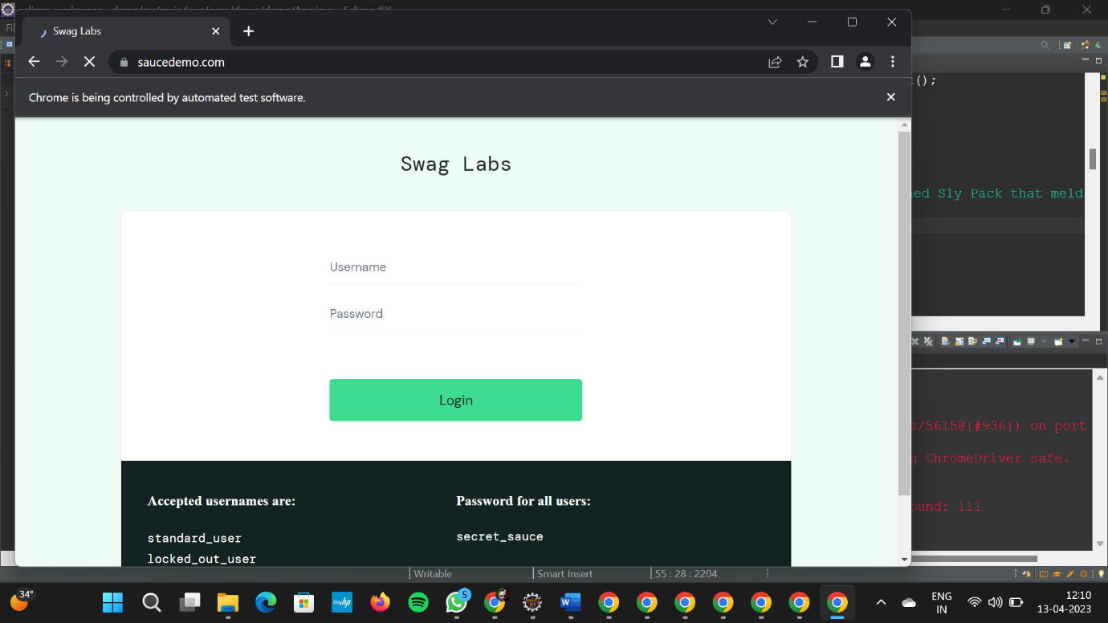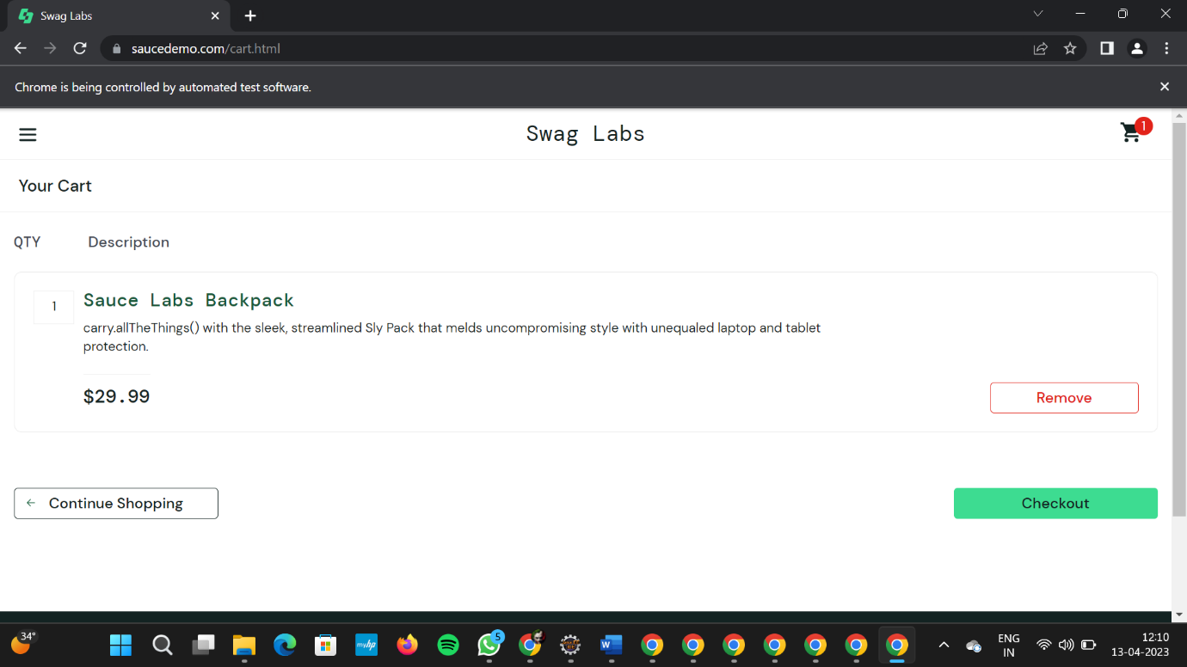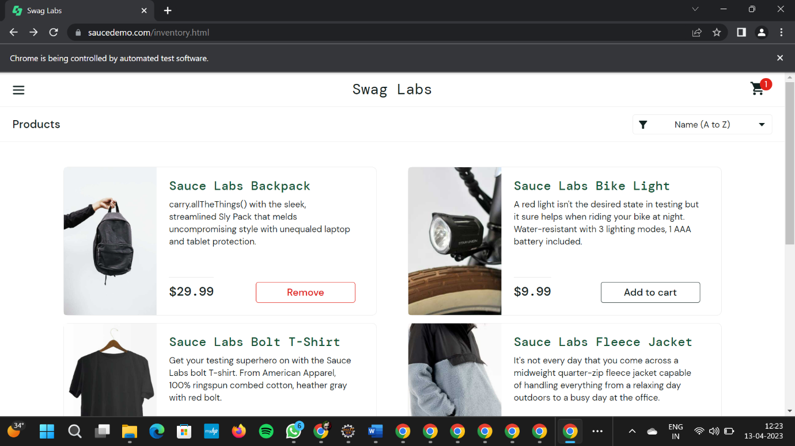

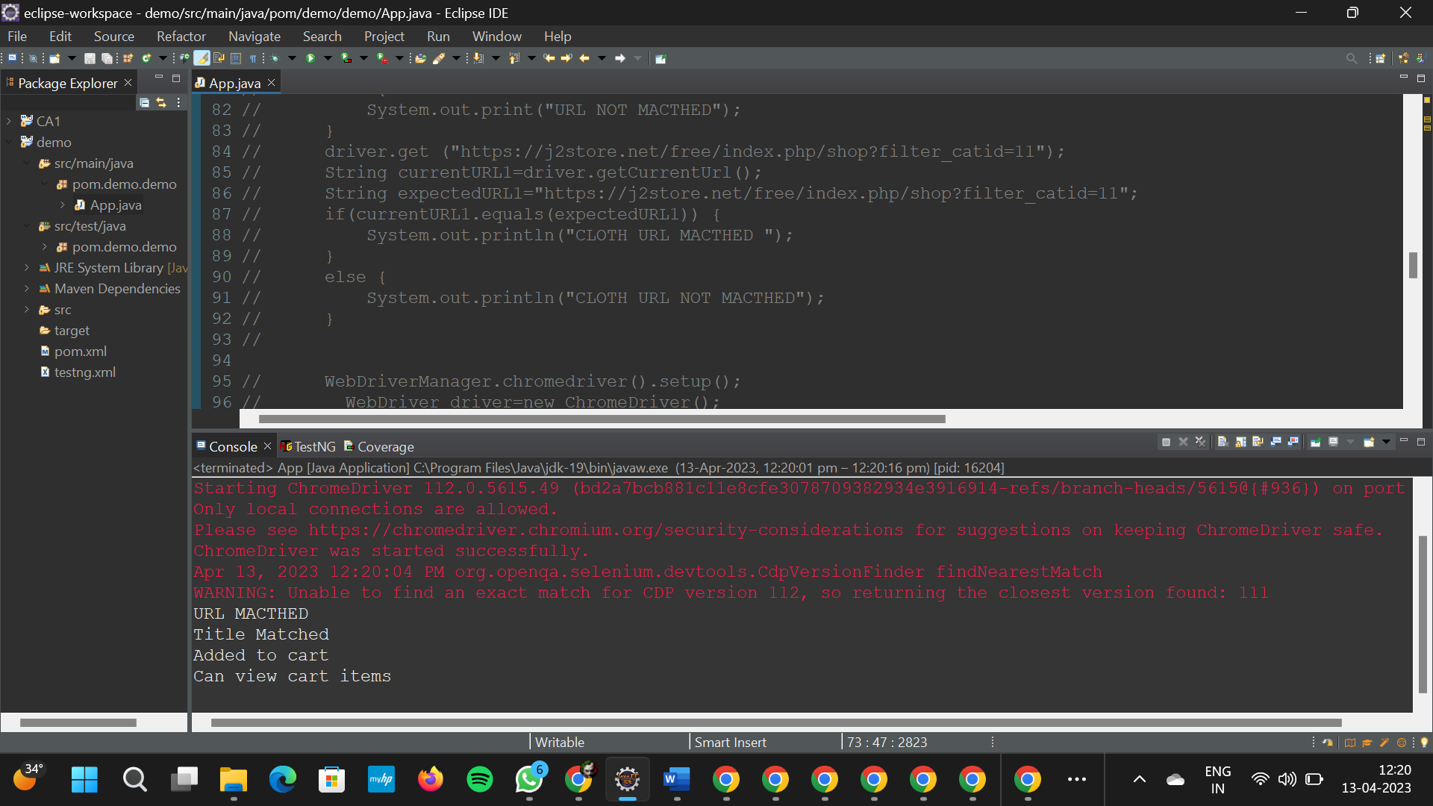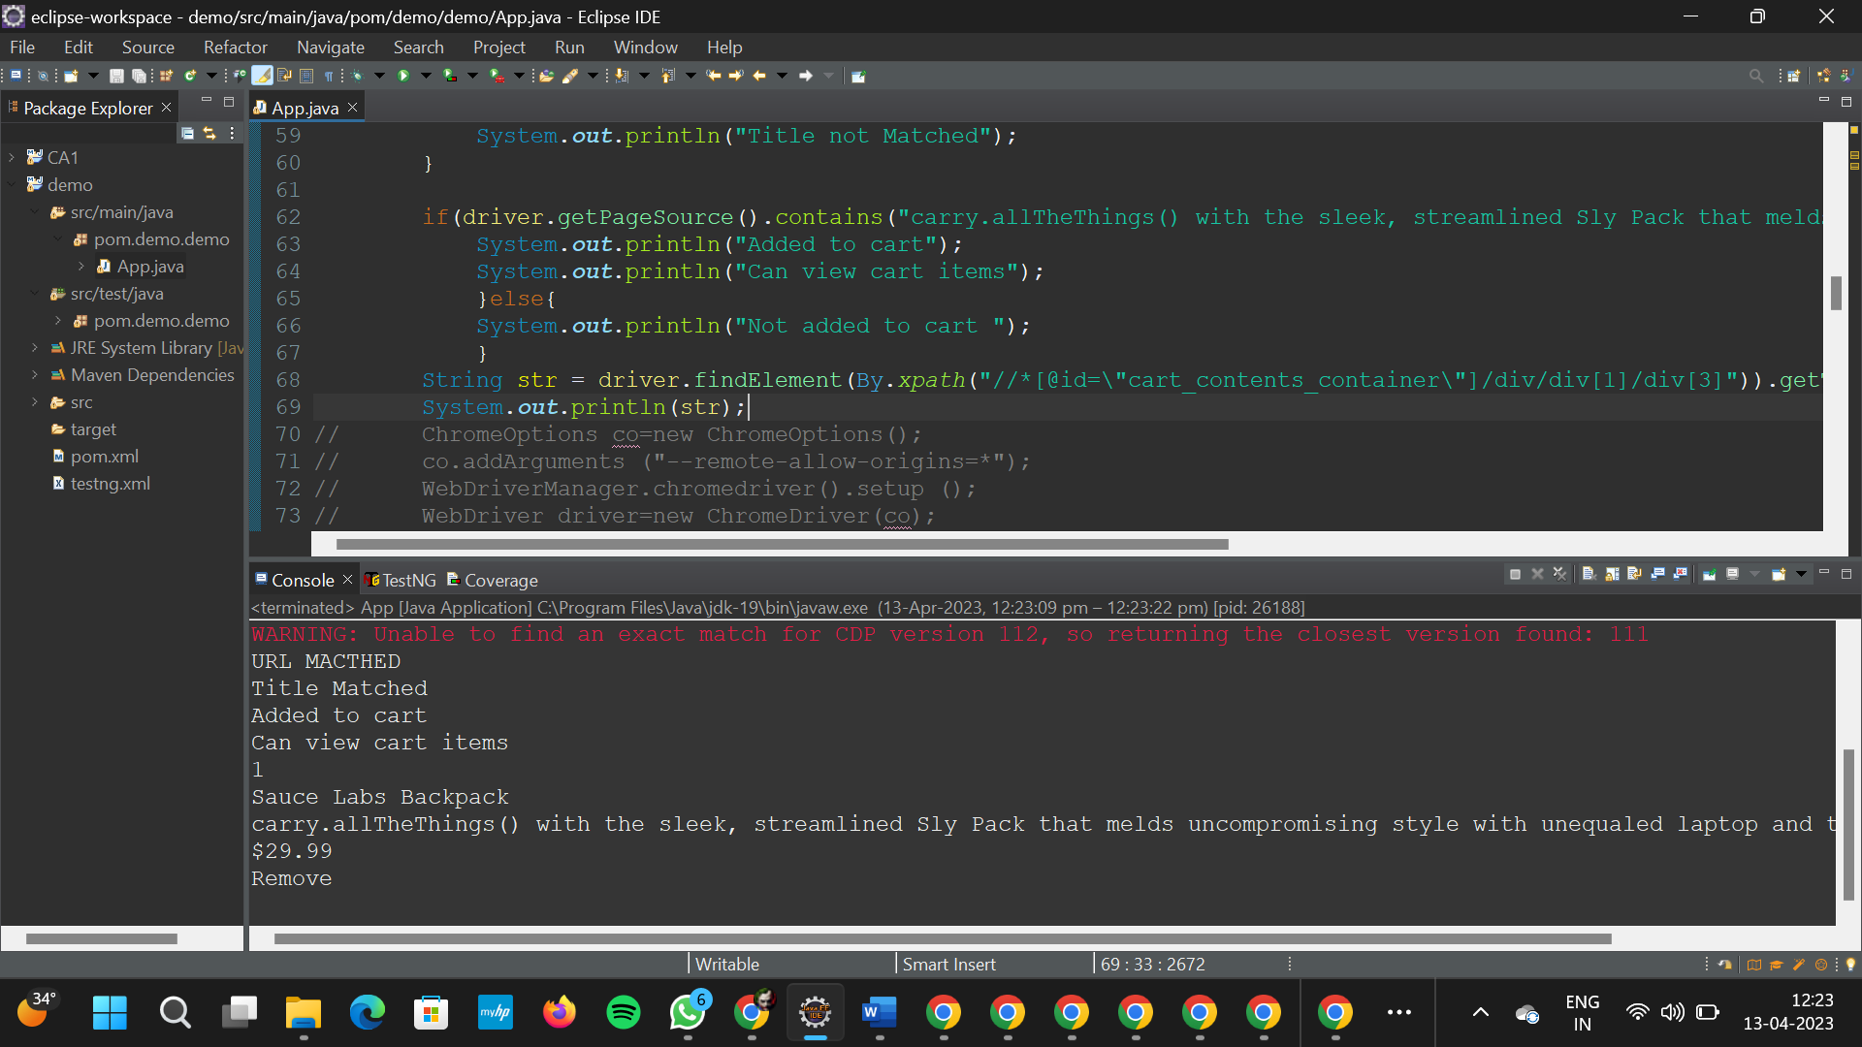

Qno – 2

Code : package porm.test.demo;

import org.openqa.selenium.By;

import org.openqa.selenium.WebDriver;

import org.openqa.selenium.WebElement;

import org.openqa.selenium.chrome.ChromeDriver;

import org.openqa.selenium.chrome.ChromeOptions;

import io.github.bonigarcia.wdm.WebDriverManager;

public class CC1Q2 {

public static void main(String[] args) throws InterruptedException {

// TODO Auto-generated method stub

ChromeOptions co=new ChromeOptions();

co.addArguments ("--remote-allow-origins=*");

WebDriverManager.chromedriver().setup ();

WebDriver driver=new ChromeDriver(co);

driver.get ("https://www.saucedemo.com/");

driver.manage().window().maximize() ;

WebElement txtBoxl=driver.findElement(By.xpath("//*[@id=\"user-name\"]"));

txtBoxl.sendKeys("standard_user");

WebElement txtBox2=driver.findElement(By.xpath("//*[@id=\"password\"]"));

txtBox2.sendKeys("secret_sauce");

driver.findElement(By.xpath("//*[@id=\"login-button\"]")).click();

String txt1=driver.findElement(By.xpath("//*[@id=\"item_4_title_link\"]/div")).getText();

System.out.println(txt1);

driver.findElement(By.xpath("//*[@id=\"header_container\"]/div[2]/div/span/select")).click();

driver.findElement(By.xpath("//*[@id=\"header_container\"]/div[2]/div/span/select/option[2]")).click();

String txt2=driver.findElement(By.xpath("//*[@id=\"item_3_title_link\"]/div")).getText();

System.out.println(txt2);

driver.findElement(By.xpath("//*[@id=\"header_container\"]/div[2]/div/span/select")).click();

driver.findElement(By.xpath("//*[@id=\"header_container\"]/div[2]/div/span/select/option[3]")).click();

String txt3=driver.findElement(By.xpath("//*[@id=\"item_2_title_link\"]/div")).getText();

System.out.println(txt3);

driver.findElement(By.xpath("//*[@id=\"header_container\"]/div[2]/div/span/select")).click();

driver.findElement(By.xpath("//*[@id=\"header_container\"]/div[2]/div/span/select/option[4]")).click();

String txt4=driver.findElement(By.xpath("//*[@id=\"item_5_title_link\"]/div")).getText();

System.out.println(txt4);

Thread.sleep(5000);

}

}

Output :

