|  |
| --- |
| Q2. For the following network, find the new weights by the generalized delta rule. The |
| Activation Function of the neuron is linear, i.e. y = activation. The learning rate (c) is |
| 0.2. The training pair is [2; 3, 2]; i.e. input = 2 and output 1 = 3 and output 2 = 2. The |
| current weights are shown on the link. There is only one input and two outputs. |

|  |
| --- |
| ann-q-ci.bmp |
|  |
|  |
| Q3. For the following network, find the new weight wki (new) by the delta rule. Activation Functions of both neurons “i” and “j” are linear, i.e. y = activation. The learning rate is 0.1. The training pair is [2; 3]; i.e. input = 2 and output = 3. The current weights are shown on the links. There is only one input “k” and only one output “j”. The hidden layer has one neuron “i”. The node “k” is not a neuron and just passes on the input without any processing or modification. |

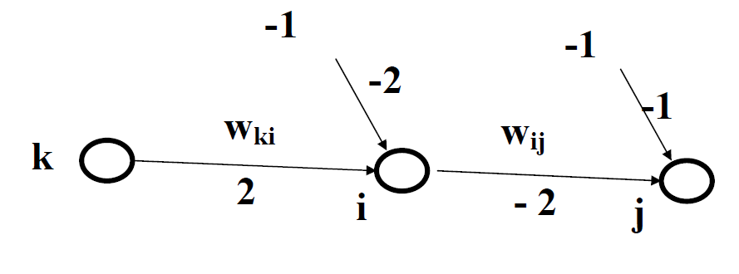

**Solution**

According to the generalized delta rule, the hidden weight change is governed by:

Δ**wki = wki(new) – wki(old) = -c[-2**Σ**j {(yj(desired) – yj(actual)) f’(act)j wij }f’(act)i xk]**

For our problem, there is only one output neuron (i.e. “j” = 1). Hence the Equation becomes

**wki(new) = wki(old) -c[-2**Σ**j {(yj(desired) – yj(actual)) f’(act)j wij }f’(act)i xk]**

We have the following given values:

**wki(old) = 2, c = 0.1, yj(desired) = 3, wij = -2, xk = 2**

Since **f’(act)j** and **f’(act)i** are both linear functions, therefore **f’(act)j** = 1, and **f’(act)i** = 1

For **yj(actual)** we have to first calculate the output of neuron “i", which is the input of neuron “j”.

Activation of neuron “i" is: (Input) (wki)+ (-1) (-2) = (2 x 2) + 2 = 6

Since activation function is “linear function”, hence this activation is also the output of the neuron “i".

Activation of neuron “j" is: (Output of “i") (wij) + (-1) x -1 = (6 x -2) + 1 = -11

Since activation function is “linear function”, hence this activation is also the output of the neuron “j".

Hence **yj(actual)** = -11

Substituting the values in Generalized Delta Rule, we have

**wki(new) = 2 – 0.1[-2 {(3 – (-11)) (1) (-2) } 1 (2)] = 2 – 0.1[112] = 2 – 11.2 = -9.2**