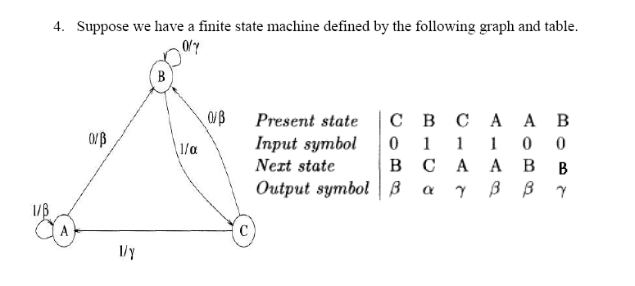
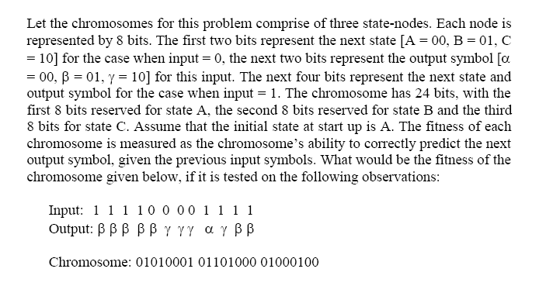

Solution:
The first input is 1. Since at startup the state is A, hence according to the chromosome the output is beta and the next state is A. The next input is again 1. Since according to the chromosome the current state is A, hence the output would be alpha. This would continue for the first four inputs of 1. When a 0 arrives in state A, then according to the chromosome the output would be alpha, and the next state would be B The next three 0s would keep the state to be B, and the output as gamma When a 1 arrives in state B, then according to the chromosome the output is alpha, and the next state is C When a 1 arrives in C, then the chromosome outputs an alpha, and the next state is B When a 1 arrives in B, the output is alpha and the next state is C When a 1 arrives in C, the output is alpha
Hence the last three outputs are wrong. The earlier nine outputs are correct. Hence the fitness is 9. (The maximum fitness possible is 12).

