1. Install **BookStoreManagement.bak** from database backup folder in local server using Microsoft Sql server 2012 .If it does not work follow query.docx file.
2. **First run : BookStore.Web Api**
3. Might be change ManageBookStore.edmx from Models forlder

To do:

* Delete: ManageBookStore.edmx
* Delete connectionstring :

<add name="BookStoreManagementEntities" connectionString="metadata=res://*/Models.ManageBookStore.csdl|res://*/Models.ManageBookStore.ssdl|res://*/Models.ManageBookStore.msl;provider=System.Data.SqlClient;provider connection string=&quot;data source=.;initial catalog=BookStoreManagement;integrated security=True;MultipleActiveResultSets=True;App=EntityFramework&quot;" providerName="System.Data.EntityClient" />

* Then build , Add Models

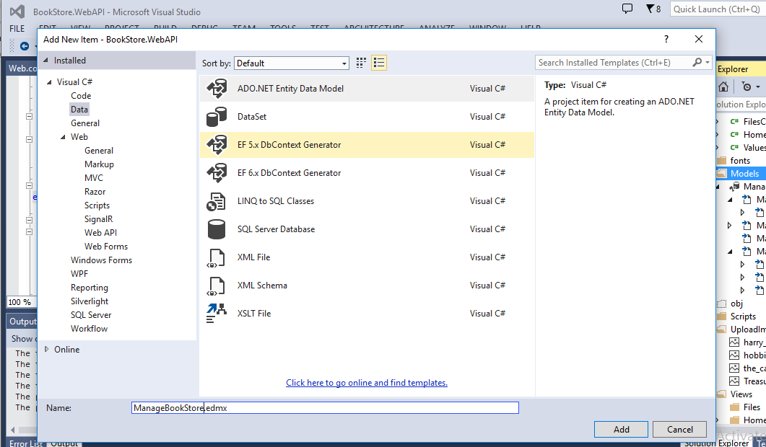

* Then run project.

1. open BookStore.SPA and run the project