**RESUME**

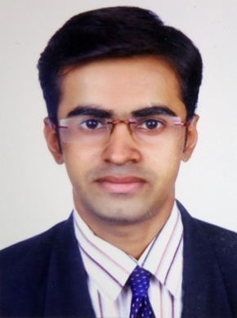

**ANIKET R PANCHAL (B.E E&C)**

Address : 18/Rudhralay colony, Ramdev Tekra, B/H sardar mall,

Nikol gam road. Ahmedabad-382350

E-mail : **aniket.panchal1994@gmail.com**

Phone. : 9408687278

**Objective**

Aligning with Top electronics Professionals and learning to apply the broad principles of Design and Research Development of electronics Engineering with specific Industrial Environment.

**Experience**

* COMPANY NAME:- ELECON CONTROLS
* COMPANY PROFILE :- PANEL BOARD OF ELEVATOR
* DESIGNATION :- SUPERVISING, TESTING, SOLDERING
* DURATION :- AUG 2013 TO JULY 2014

**Educational Qualification**

|  |  |  |  |
| --- | --- | --- | --- |
| **Examination** | **YEAR OF PASSING** | **University/Board** | **Percentage** |
| B.E. (E&C) | (8th sem cont.) | Gujarat technological university | 6.40(CGPA) |
| DIPLOMA(E&C) | June – 2013 | Gujarat technological university | 6.37(CGPA) |
| S.S.C. | March – 2010 | G.S.E.B | 59.38% |

**College Name** : -SAL COLLEGE OF ENGINEERING

Add : - opp. Science City, Village : Bhadaj, Ahmedabad-380060

**Technical Skill**

Embedded system, MS Office, Linux, OS

**Project work**

* **Soldier paramedical system.**

Based on medical data of patient health monitoring.

**Industrial visit**

* Baisag (gandhinagar)

**Personal Detail**

Date of Birth 16/11/1994

Gender Male

Nationality Indian

Marital status Single

Languages known English, Hindi, Gujarati

Hobbies Reading books, travelling, Music

Skill & Abilities Good analytical & learning skill,Gujarati typing

Good communication and interpersonal skill

Willingness to work hard with dedication

Ability to work in team

**Declaration**

I declare that the above furnished information is true to the best of my knowledge and belief and any violation therein should lead to the cancellation of my candidate.

(ANIKET PANCHAL)