**RESUME**

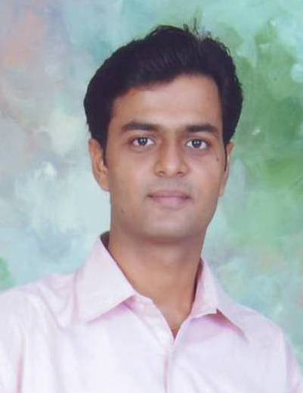

**PATEL ANKIT N.**

**Permanent Address** : **Temporary Address** :

D/221-222, Ghanshyamnagar Society, B/301, Kesar Orchid,

Opp. Bahucharaji Temple, Nr.Sandipani.School, Naroda – Dehgam road,

Karelibaug, Vadodara 390018 Nava Naroda.

**Contact:**7435951105;**Email:**ankitlara@yahoo.co.in ; Birth Date : 13/01/1984.

**CIVIL ENGINEER- CONSTRUCTION**



Offering 13 years of experience; seeking challenging assignments across the industry



**PROFILE**

* Accomplished Civil Engineer, with an career of 13 years in construction supervision of various civil projects with noteworthy project expertise and total commitment to achieve organizational objectives.
* Skilled in drawing well-balanced conclusions when dealing with complex issues and in interpreting procedures and guidelines in order to adapt them to cover complex situations.
* Possess experience inSite Engineering, Coordination skills along with the ability to support projects in a organizational structure.
* Demonstrated ability to manage human and material resources towards the achievement of stated targets/ objectives, to plan and manage work programs and to lead, motivate and provide effective guidance to a team of professional and support staff.

**Core Competencies**

🞛 Technical Specifications 🞛 Site Management 🞛 Civil Construction .



**PROFESSIONAL EXPERIENCE**

**SARNAR BUILDTECH PVT. LTD. SINCE JUNE ’12 – CONT.**

**Sr. Civil Engineer**

* Responsible for inspection and testing of construction materials, site development and deliveries inspection with material entries in ERP. Along with Housekeeping and Safety measures of the site.
* Responsible for construction of industrial units with foundation.
* Coordinate with structural, electrical, mechanical services, landscape and other details/drawings with the architectural plans, details and requirements.
* Strategically, plan, analyze & conceptualize the basic requirements while setting up the technical infrastructure of the project, reviewing all the project proposals.
* Liaise with external agencies, clients & consultants for determining technical specifications.
* Identify & finalize the contractors ensuring quality supply of materials for effective project development.
* Making Bill at various stage of project.

**NARAYAN REALTY PVT LTD SINCE JUL ‘10 – FEB ’12**

**Civil Engineer**

* Responsible for making the residential units ready for giving possession to the customer.
* Accountable for completing of remaining units with required quality and by dealing with various agencies like civil work, finishing work.
* Good working knowledge of Technical specifications.
* Coordinate with structural, electrical, mechanical services, landscape and other details/drawings with the architectural plans, details and requirements.

**PRATHAM DEVELOPERS, BARODA JUN ’08 – MAY ’10**

**Production Engineer**

* Spearheaded efforts across supervising, checking & coordinating the Construction process, so as to achieve efficiency and effectiveness.
* Maintained Contact with suppliers to review & agree quality standards & to resolve/clarify any product drawing or manufacturing related difficulties.
* Responsible for inspection and testing of construction materials, site development and deliveries inspection. Along with Housekeeping and Safety measures of the site.
* Took care of Supervision of Quality Control for ongoing project.
* Involved in Quality Assurance services for raw material used in concrete mix.
* Checked and processed all vendors bills in time with detail checking of measurements / quantities and ensured the compliance with the approved technical specifications and designs.
* Monitored progress report & liaising with contractors for procurement of materials, labors and equipment.



**EDUCATIONAL & PROFESSIONAL CREDENTIALS**

**BE (CIVIL):2008:**M S University; 59%

**DIPLOMA (CIVIL):2005:**M S University (Polytechnic); 69%

**HIGHER SECONDARY CERTIFICATE: 2002:**G.S.E.B; 48 %

**SENIOR SECONDARY CERTIFICATE: 2000:**G.S.E.B; 79 %

**TECHNICAL PROFICIENCIES:**AutoCAD-2006, MS Office, ERP, SAP( Introductory level).

**Extra Curricular Activities**

* Participated in ‘Construct, IIT POWAI, Bombay-An event of making a model of aircraft hanger
* Participated in Footprints’08, M.S.U., Baroda, a National Level Technical Fiesta
* Participated in Footprints ’07, M.S.U., Baroda, a National Level Technical Fiesta
* Undergone the Summer Training at Ashirwad Engineering Consultancy, Baroda
* Participated in Bal Bhavan Rolling Trophy , Baroda



* **Hobbies :** Drawing, Listening music, Playing & watching Cricket.
* **Linguistic Proficiency :** English, Hindi, Gujarati.
* **References :** Available on Request.