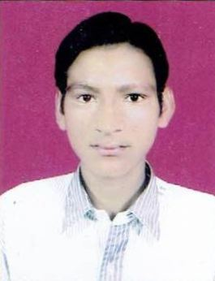**ASHUTOSH JHA**

**Contact No. - +919534273856, 7906848645**

**Email : ashutoshjha197@gmail.com**

**CAREER OBJECTIVE:**

To work with courage and confidence to the best of my abilities, leading towards growth of organization and thus becoming an asset to it.

**ACADEMIC CREDENTIALS:**

* Matriculation from C.B.S.E. in the year 2011 with **72.60%** marks.
* Intermediate from B.S.E.B. in the year 2013 with 62% marks.

**PROFESSIONAL CREDENTIALS:**

* **Complete Diploma in Mechanical Engineering** from **Shaheed Bhagat Singh Polytechnic for Engineering, Rajpura, Khundewala road, Jagadhri, affiliated to HSBTE, Panchkula (Aggregate 67.07%).**

**INDUSTRIAL EXPOSURE**

* 1 month training at **BHEL Ranipur, Haridwar**.

**MAJOR PROJECTS:**

* **Manually operated washing machine** (pedal operated).

**EXPERIENCE:**

* One year nine months, experience from Bajaj Motors Ltd. Begumpur, Haridwar U.K in Production Department.
* Diploma trainee in Adani, Mundra solar techno park pvt. Ltd. Gujarat, to till.

**JOB PROFILE:**

* Machine products audits
* Operate CNC Machine
* Implementation of Kaizen and 5 ‘S’
* Reduce tool and product cost
* Zero rejection and rework.

**SKILL SET**

* **Job Related Skills**:
* Team Building
* Ownership of the work assigned
* Excellent Communication
* Leadership
* **IT Skills**:
* Basics, MS-Office

**STRENGTHS:**

* Good Communication
* Positive attitude
* Ability to face and deal with issues in a mature and professional manner.
* Highly motivated
* Sincere
* Hardworking
* Fast learner and willing to take up challenging assignments and an excellent team player.

**HOBBIES**

* Listening Music
* Playing cricket
* Singing
* Making New Friends.

**PERSONAL DETAILS**

* **D.O.B. – February 15 - 1996**
* **ADDRESS–H.No.162 Laxmisagar, Saraswati Vihar Bank Colony, Darbhanga, Bihar, Pin code -846009.**
* **MARITAL STATUS - UNMARRIED**

**ASHUTOSH JHA**