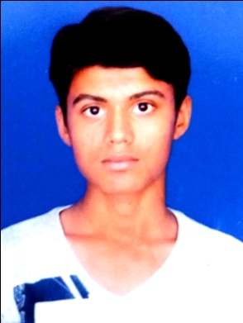

# Resume

Name : PAHADIYA ATUL VELAJI

E-mail : [atulpahadiya9298@gmail.com](mailto:atulpahadiya9298@gmail.com)

Contact No. : +91 8849286819

# PERSONAL DETAILS

Address : Ramdevnagar,

Khari Cenal, Dehgam Road,

Naroda, Ahmedabad.

Gujarat – 382330

Date of Birth : 06/10/1998

Nationality : Indian

Religion : Hindu

Sex : Male

Marital Status : Unmarried

Languages Known : English, Hindi & Gujarati

Hobbies : Working, Music.

# EDUCATIONAL QUALIFICATIONS

|  |  |  |  |  |
| --- | --- | --- | --- | --- |
| **Examination** | **School / College** | **Board / University** | **Year of Passing** | **Percentage / Grade** |
| S.S.C | NUTAN VIDHYALAYA | GSEB | 2014 | 61.67% |
| H.S.C. | SATYAM VIDHYALAYA | GHSEB | 2016 | 43.00% |

# STRENGTH AND SKILLS

* M.S.OFFICE

# DECLARATION

I hereby declare that the above mentioned information is true to the best of my knowledge.

# PAHADIYA ATUL

