**PERSONAL DETAILS**:-

**NAME: - BAPPADITYA PAL**

**FATHER’S NAME: - Mr. JOY RAM PAL**

**SEX : -MALE**

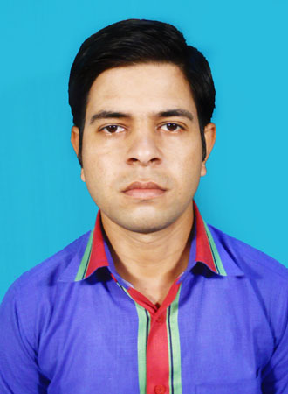

**DATE OF BIRTH: - 09/04/1990**

**NATIONALITY: - INDIAN**

**CASTE :-GENERAL**

**RELIGION :-HINDUISM**

**LANGUAGE KNOWN: -Bengali& English & Hindi**

**MARITAL STATUS**: -**UNMARRIED**

**PRESENT & PERMANENT ADDRESS**:-

**NAME: - BAPPADITYA PAL**

**C/O:-Mr. JOY RAM PAL**

**VILL: - KEOURA**

**P.O:-GADADHAR PUR**

**P.S:-PANRUI**

**DIST: - BIRBHUM**

**PIN: - 731129**

**STATE: - WEST BENGAL**

**MOBILE NO: -9002365596/7573986302**

**E-MAIL ID: -**[**bappaditya.pal10@gmail.**](mailto:bappaditya.pal10@gmail.com)**com**

**OBJECTIVE: -TO ACQUIRE EXPERIENCE TO BE A GOOD ENGINEER, FIT IN THE CORPORATE**

**STRUCTURE AND GROW PROFESSIONALLY.**

**ACADEMIC QUALIFICATION**:-

|  |  |  |  |  |
| --- | --- | --- | --- | --- |
| **NAME OF THE EXAM** | **BOARD/COUNCIL/UNIVERSITY** | **YEAR OF PASSING** | **MARKS** | **PERCENTAGE** |
| **MADHYAMIK** | **W.B.B.S.E** | **2006** | **468** | **58.50** |
| **HIGHER SECONDARY** | **W.B.C.H.S.E** | **2008** | **200** | **40.00** |
| **B.A** | **BURDWAN UNIVERSITY** | **2012** | **482** | **35.70** |

**TECHNICAL QUALIFICATION**:-

|  |  |  |  |  |
| --- | --- | --- | --- | --- |
| **NAME OF INSTITUTION** | **NAME OF EXAMINATION** | **BOARD/ COUNCIL** | **YEAR OF PASSING** | **OVERALL%** |
| **SURI BENIMADHAB INSTITUTION** | **ENGINEERING & TECHNOLOGY** | **W.B.S.C.V.E.T** | **2012** | **72.00** |
| **BENGAL INSTITUTE OF POLYTECHNIC** | **DIPLOMA IN CIVIL ENGINEERING** | **W.B.S.C.T.E** | **2014** | **78.80** |

**EXTRA CURRICULUM ACTIVITIES:-**

**(1) COMPUTER “O”-LEVEL CERTIFIED FROM DOEACC.**

**(2)VOCATIONAL TRANING ON PUBLICE WORKS DEPERTMENT (PWD).**

**(3)VOCATIONAL TRANING ON PUBLICE HEALTH ENGINEERING (PHE).**

**JOB EXPERIENCE:-**

**TOTAL EXPRIENCE :-3 YEARS 6 MONTHS.**

**(1)COMPANY NAME :-GDCL.**

**PROJECT NAME :-ULTRA TECH CEMENT PLANT.**

**DURATION :-7 Months (July-2014 to Feb-2015)**

**(2)COMPANY NAME :-PLATICON CONSTRUCTION.**

**PROJECT NAME :-WIND POWER PROJECT.**

**DURATION :-20 Months (Feb-2015 to Oct-2016)**

(3)COMPANY NAME :-KINTECH SYNERGY PVT Ltd.

PROJECT NAME :-WIND POWER PROJECT.

DURATION :-(Oct-2016 to Present Time)

**Hobbies and Interest :-**

1. **Like to play cricket & football.**
2. **Surfing internet.**
3. **Watching cricket matches and other sports events.**
4. **Reading newspaper and storybook.**

**Declaration:-**

**I hereby declare that all statement made in the above information are correct to the best of my knowledge and belief. The same can be supported by relevant documents as and when required. Given a chance I assure you of my best services.**

**DATE.......................................**

**PLACE...................................... ........................................**

**(Signature)**