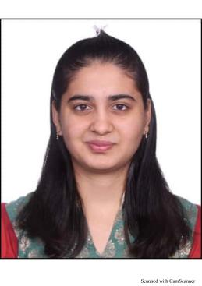

**Desai Bansari**

Highly motivated , Hardworking and passionate job seeker with strong organizational skills eager to secure an Administrative position in Finance and Accounting environment. Ready to help team achieve organization goals.

**SUMMARY**

Email : [desaibansari17.com](mailto:Hello@wps.com)

Phone：9426882364

Address:8-b,Dipmala Apartment,Nr.Maniasha Society,Maninagar(East),Ahmedabad-

380008.

**CONTACT ME**

COMMUNICATION

HARDWORKING

MS EXCEL

Client Handling

Traget Achieving

Processing Speed

Quality Checking

**SKILLS**

Being familiar with accounting theory,

Hardworker , able to achieve goals with in the time given, good at communication, can handel team easily.

* Awards

1. BADLAV ICON (June 2021)
2. WOMEN ACHIEVERS AWARD (March 2022)
3. ROCKSTAR OF THE QUARTER (Febuary 2023)

**SPECIAL SKILLS**

**March 2022 to Present**

**Payroll Administrator**

(QX Global Group - Finance & Accounting Division)

* Responsible for generating Invoices and Payment processing
* Responsible for processing Timesheets
* Responsible for Qaulity Checking of the processed timesheets
* Responsible for Co-Ordinating with On-shore client and allocating the task within the team
* Responsible for Quality client servicing and resolving their queries.

**July 2021 To January 2022**

**Internship In Radio Station**

( RADIO ONE FM 95 , AHMEDABAD , GUJARAT)

* Accounts handling
* Voice Over
* Song Manager
* Show Producer
* Music Manager

**April 2021 To June2022**

**Junior Bank Officer**

(AU SMALL FINANCE BANK, Ahmedabad , Gujarat)

* Was responsible for handling Accounts and Smooth Transcationsof Corporate , reslove queries , grow Liabilities business for bank , Achieve weekly and monthly tragets.

**EXPERIENCE**

**Jain University**

Currently Purusing

Masters in Internatinal Finance

**ACCA(UK)**

Completed with intermited stage **,**

Currently Purusing Final level

**Shree Narayan College Of Commerce**

**Advance Auditing And Accouting 2018-2021**

Bachelor’s in commerce CGPA-6.81

**EDUCATION**

CREARIVE

LEADERSHIP

TEAMWORK

CONFIDENT

**PROFESSIONAL**