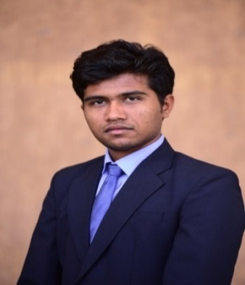

**GARODA CHANDRAKANT**

**mobile no-: 6351257707**

**E-MAIL:-**[**chandrakant281295@gmail.com**](mailto:chandrakant281295@gmail.com)

**Career objective**

To work in progressive and innovative environment to a growth oriented organization and aim to grow professionally by enhancing my skills & contributing to organizational growth. I aspire to work in a financial organization.

**Academic qualification**

|  |  |  |  |  |
| --- | --- | --- | --- | --- |
| **EXAM** | **BOARD/ UNIVERSITY** | **School &College Name** | **PASSING YEARS** | **PERCENTAGE/ CGPA** |
| Master Of Business Administration /finance | Gujarat Technological University | Oakbrook Business School | 2016-2018 | 65%cpi  (1st&2nd sem) |
| Bachelor of business administration | KADI SARVAVISHWAVIDYALA | Bhola BhaiPatel collage of business administration | 2013-2016 | 63% |
| Higher Secondary Certificate | Gujarat Secondary & Higher Secondary Education Board | Shree Swaminarayan high school & m. h secondary high school | 2013 | 58.42% |
| Secondary School Certificate | Gujarat Secondary & Higher Secondary Education Board | Sheth M. J high school | 2011 | 68% |

**COMPUTER SKILL**

Basic knowledge of MS-office (Word , Excel and power point).

Passed C.C.C. examination conducted by Doeacc Society

**ACADEMIC PROJECT:**

1. **Summer Internship Program**: 13th june2017 to 22nd july2017

**Company name:- AXIS BANK**

**Project title:** “A STUDY ON UNDERSTANDING CUSTOMERS BEHAVIOUR FOR USAGE OF DIGITAL BANKING SERVICE OF AXIS BANK IN GANDHINAGAR AREA”

I have completed internship from axis bank. I learn, which type of work do in bank, how to solved customer problem and how to work in pressure with responsibility. Internship help me in increase my punctuality skill, responsibility related work etc.

1. **Summer internship program**: 2nd November 2015 to 21st November 2015 and 24thDecember 2015 to 2nd January 2016

**Company: CAPITAL FIRST**

1. **CP project in BBA**

**Project title:**”A STUDY ON CUSTOMER SATISFACTION AND BUYING BEHAVIOUR ON LCD AND LED TV OF LG, SONY, AND SAMSUNG COMPANY”

**PERSONAL INFORMATION:**

DATE OF BIRTH : 28 December 1995

GENDER : MALE

NATIONALITY : INDIAN

LANGUAGE KNOWN : GUJARATI, HINDI, ENGLISH

ADDRESS : 543, Anusuchitjati vas, Trent, Trent-382151,

Taluka. -Mandal, Dist.-Ahmedabad.

**DECLARATION**

I hereby declare that the above information corrects and true to the best of my knowledge and belief.

Place:

Date:

(CHANDRAKANT)